**Mobile Computing**



**Submitted to: Sir Haq Nawaz**

**Submitted by: Muhammad Nouman Rana**

**Roll no: BSEF18A016**

**Repository Created:**

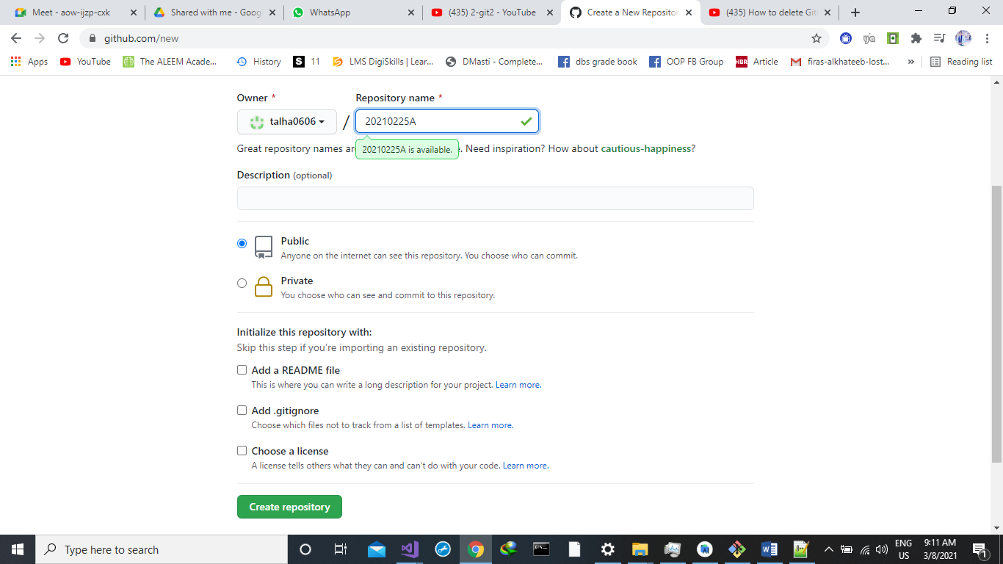

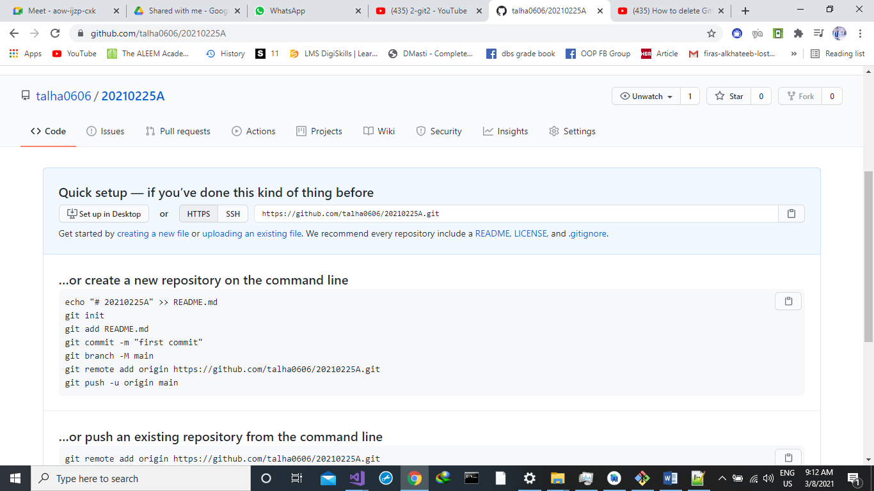

**First Commit:**

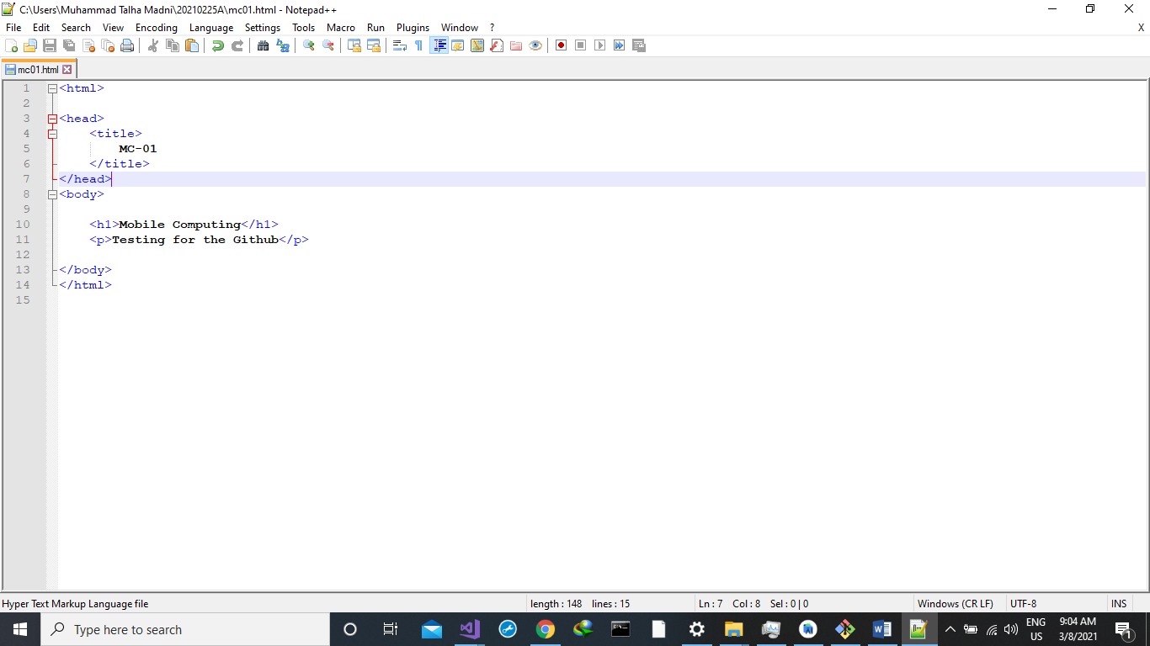

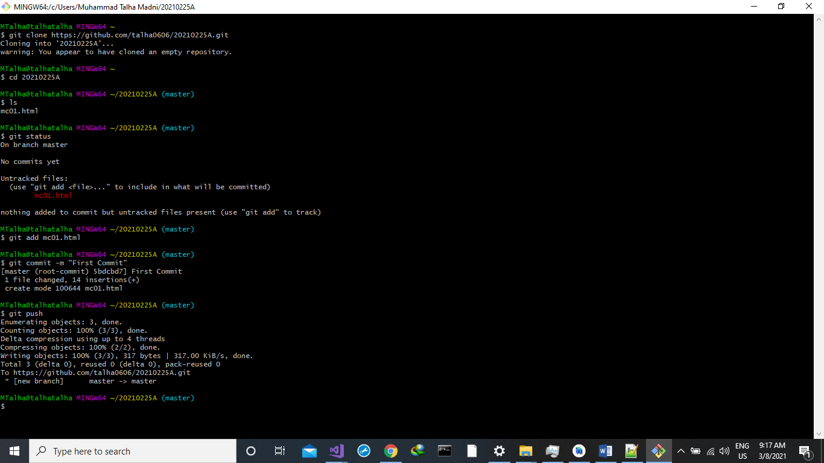

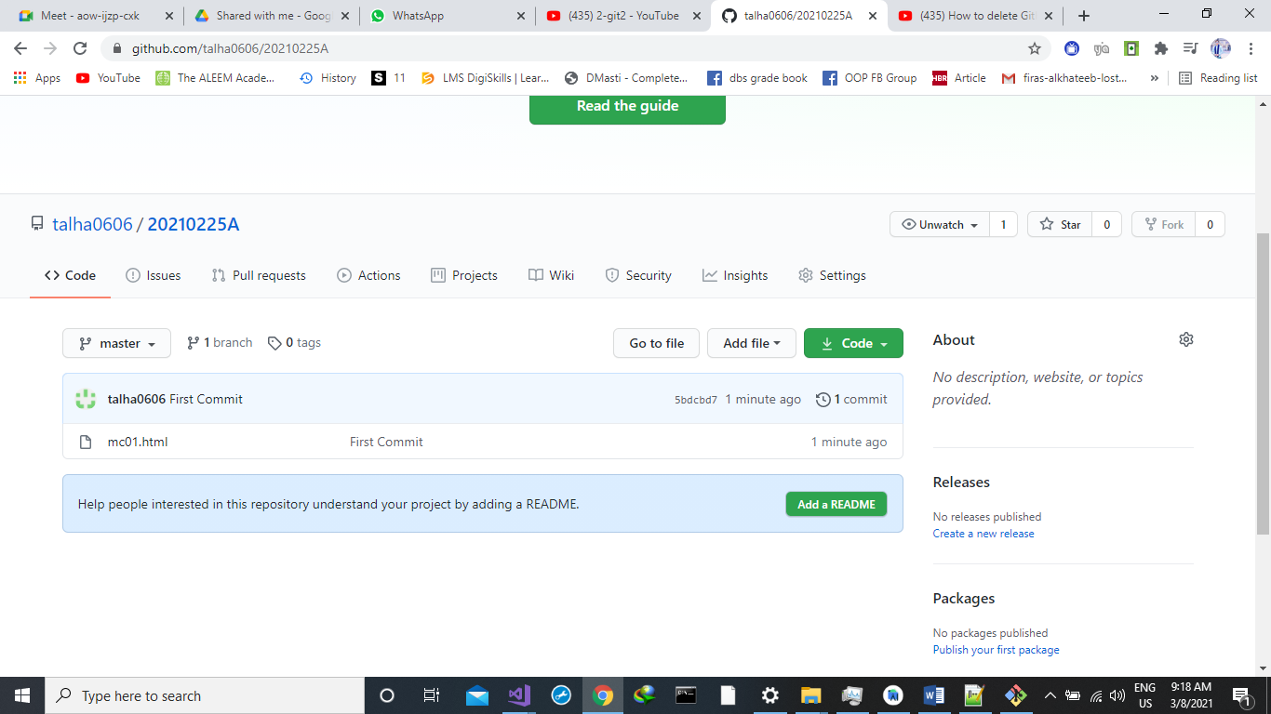

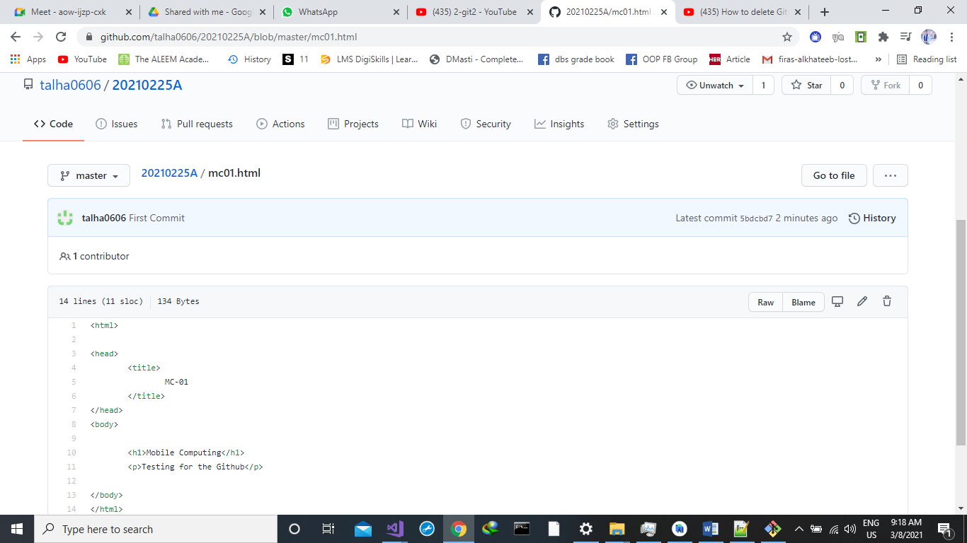

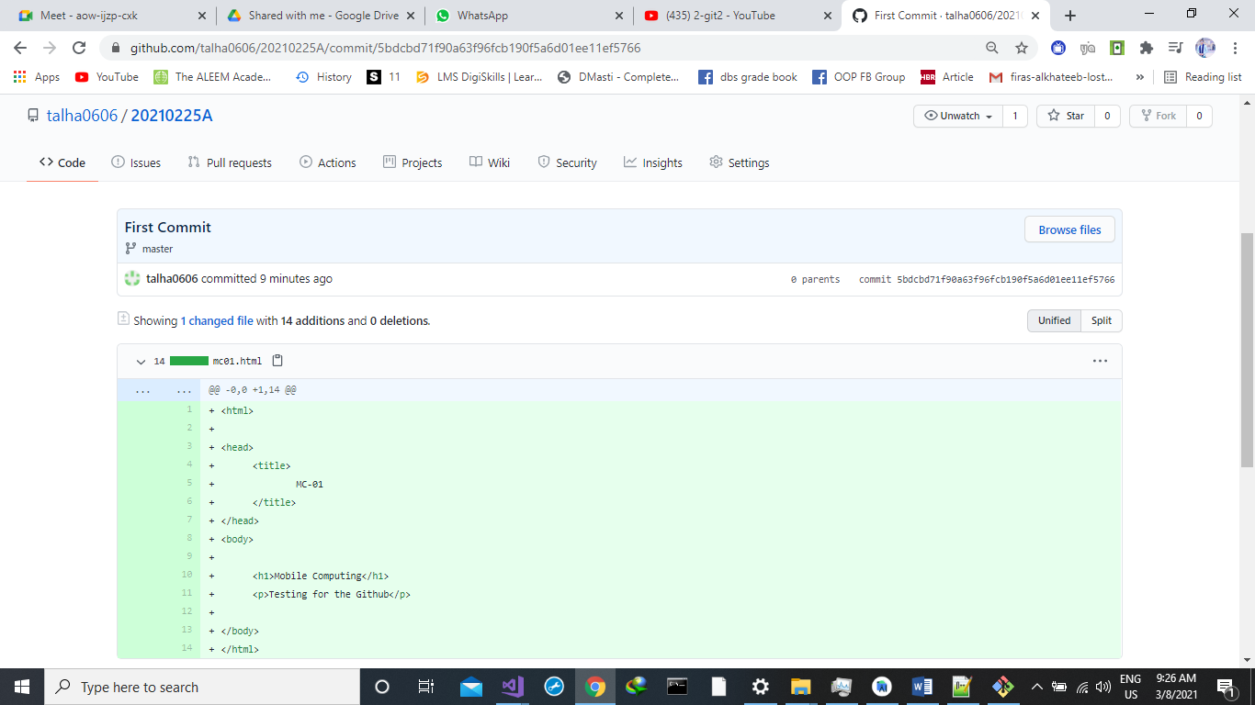

**New Heading Added:**

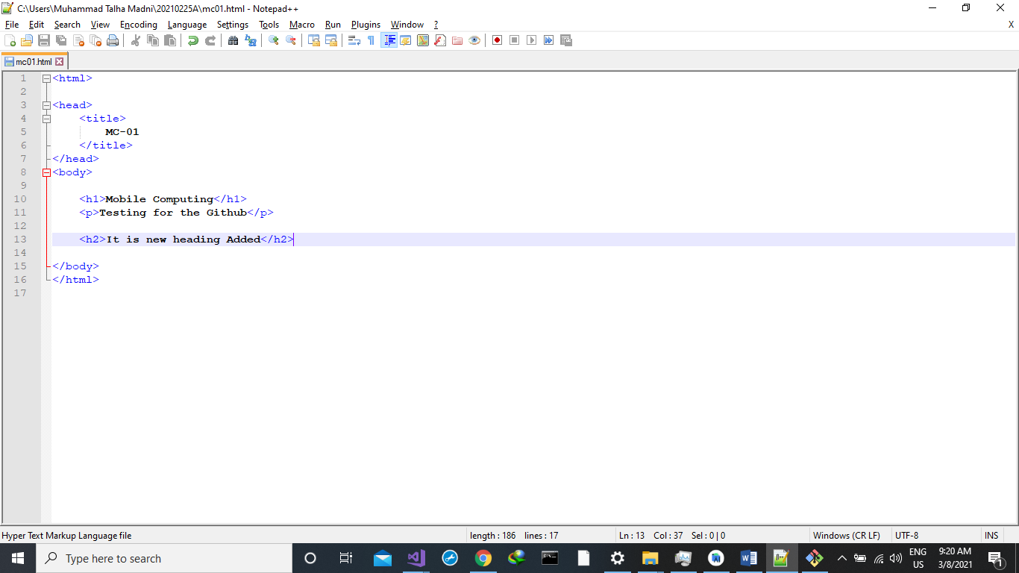

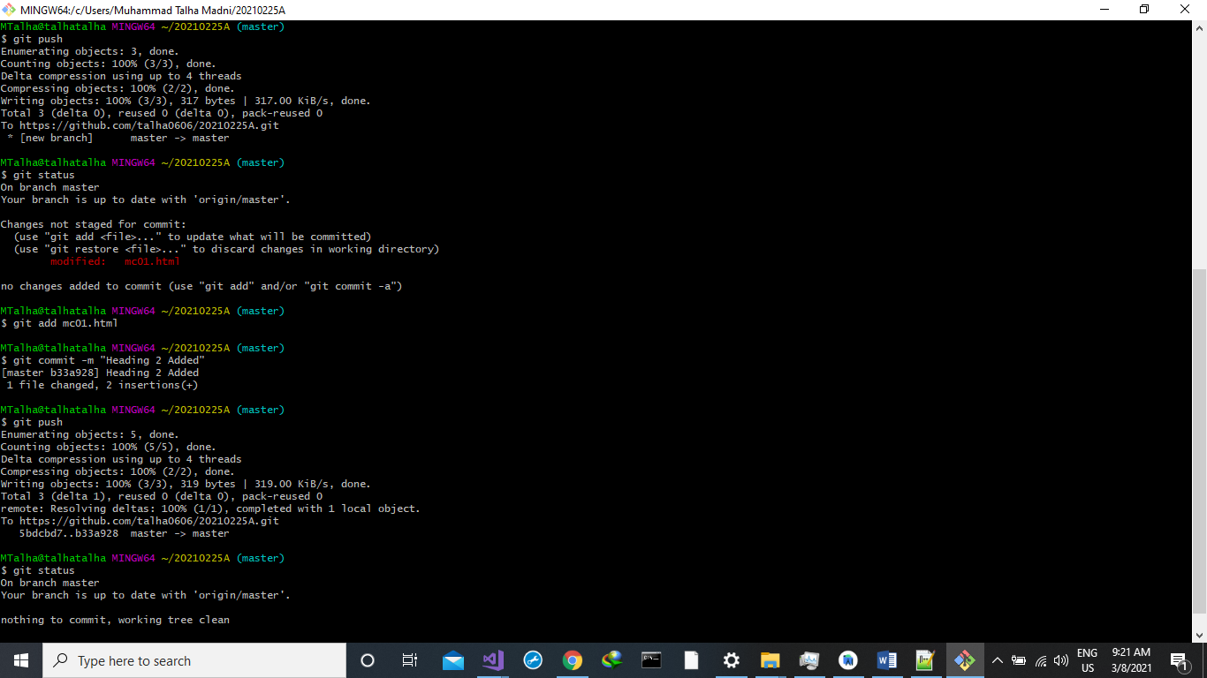

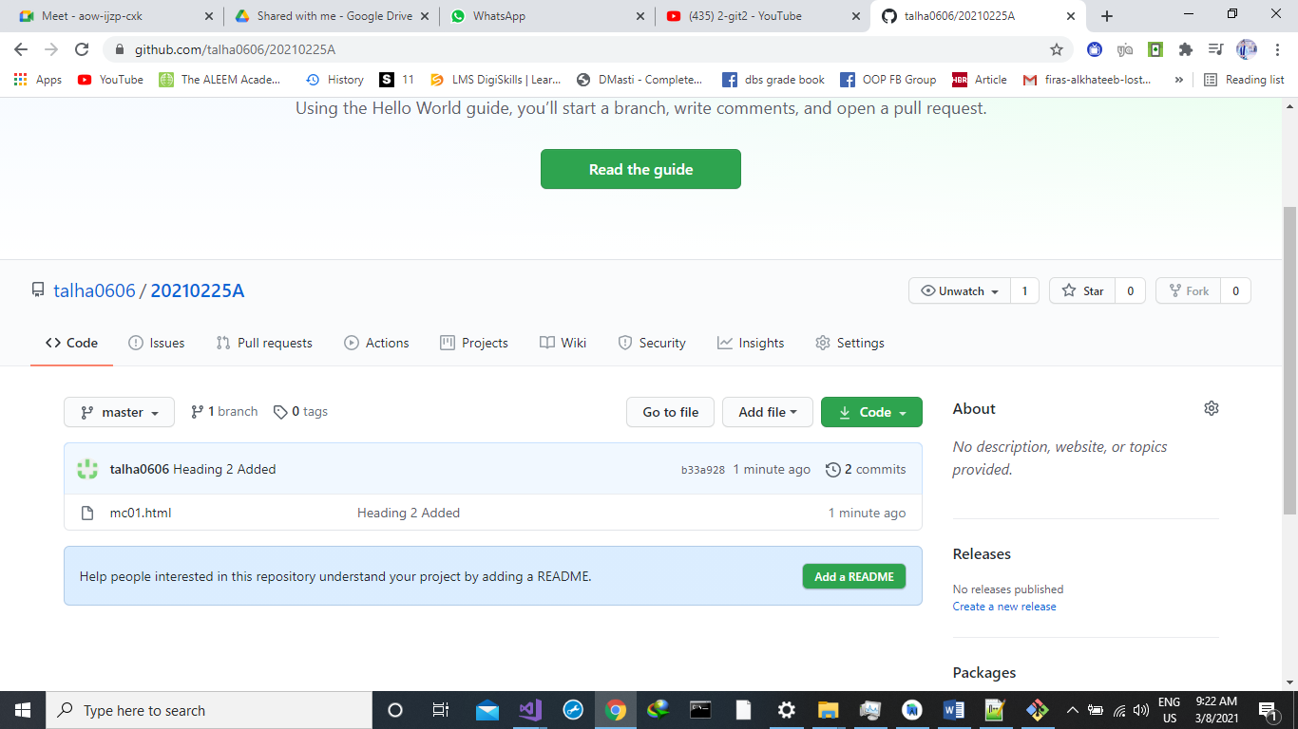

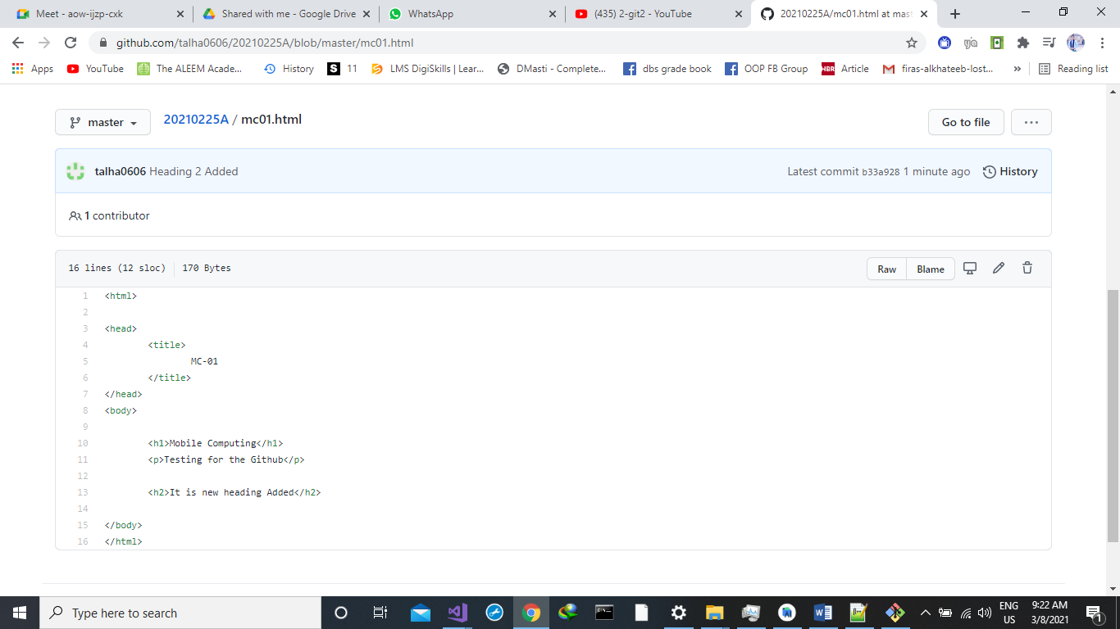

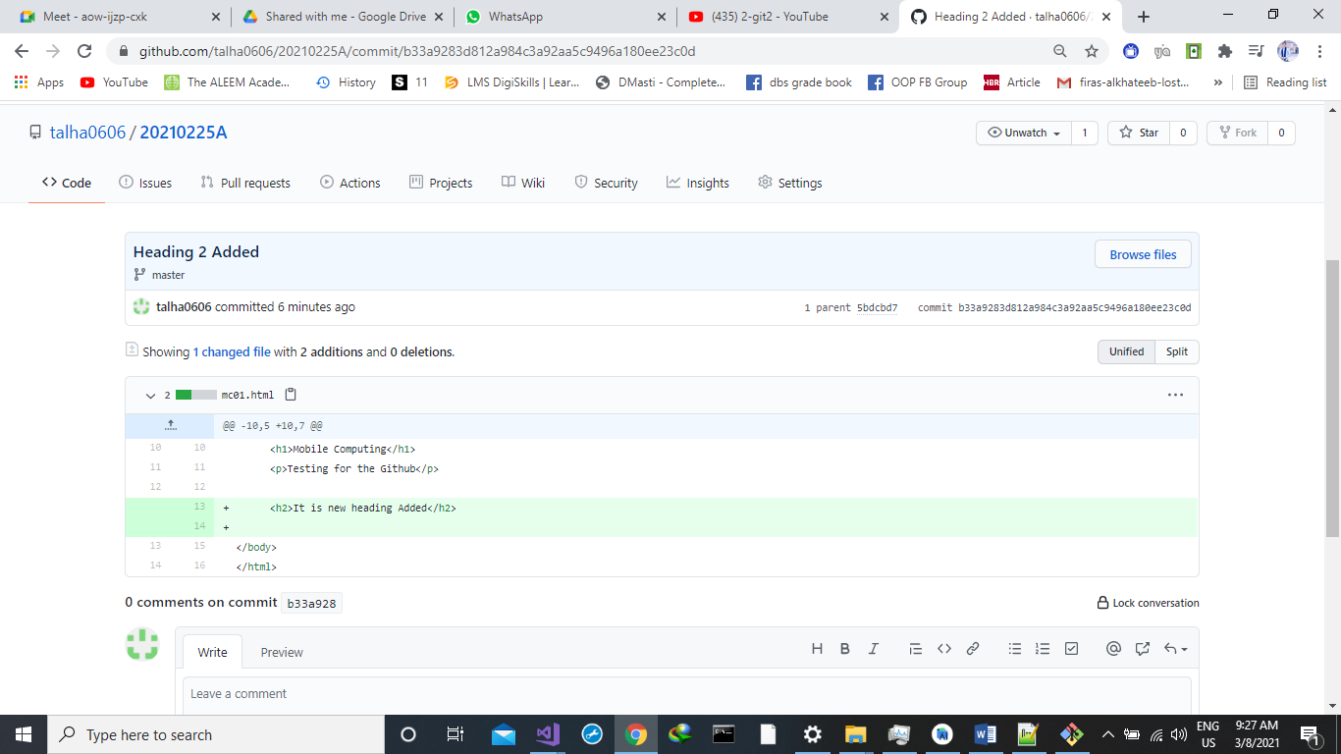

**Change at web version then PULL:**

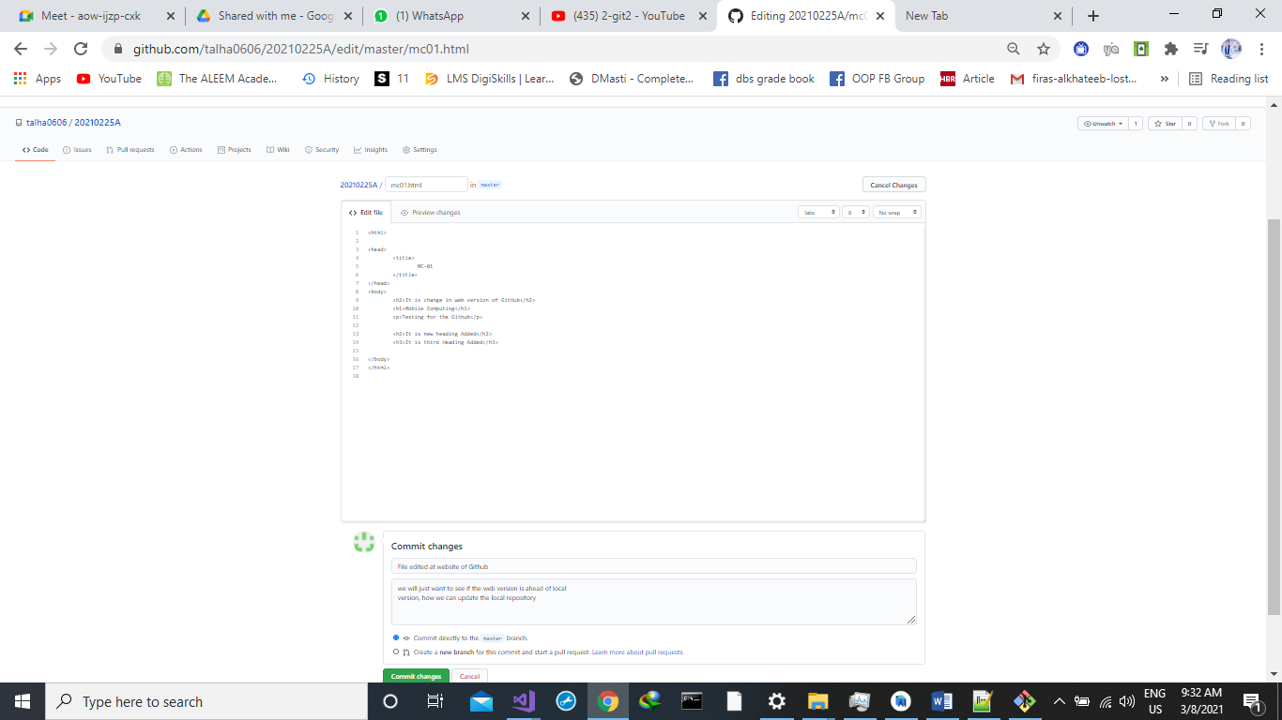

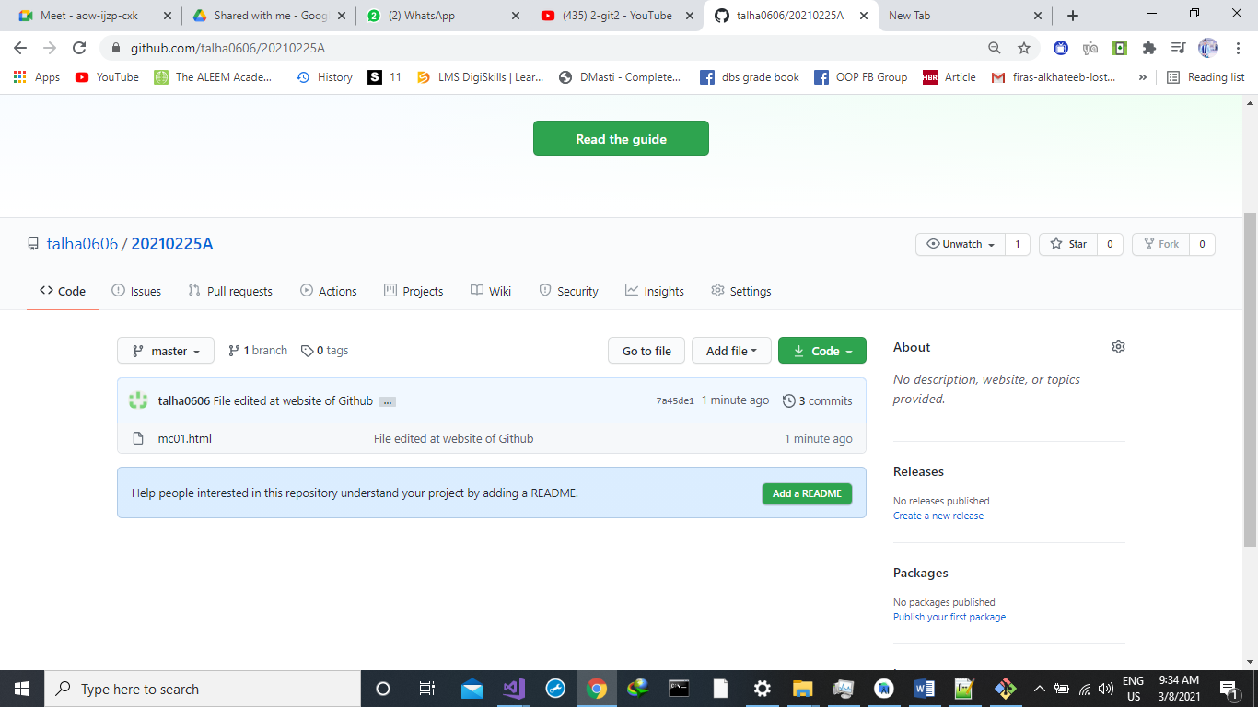

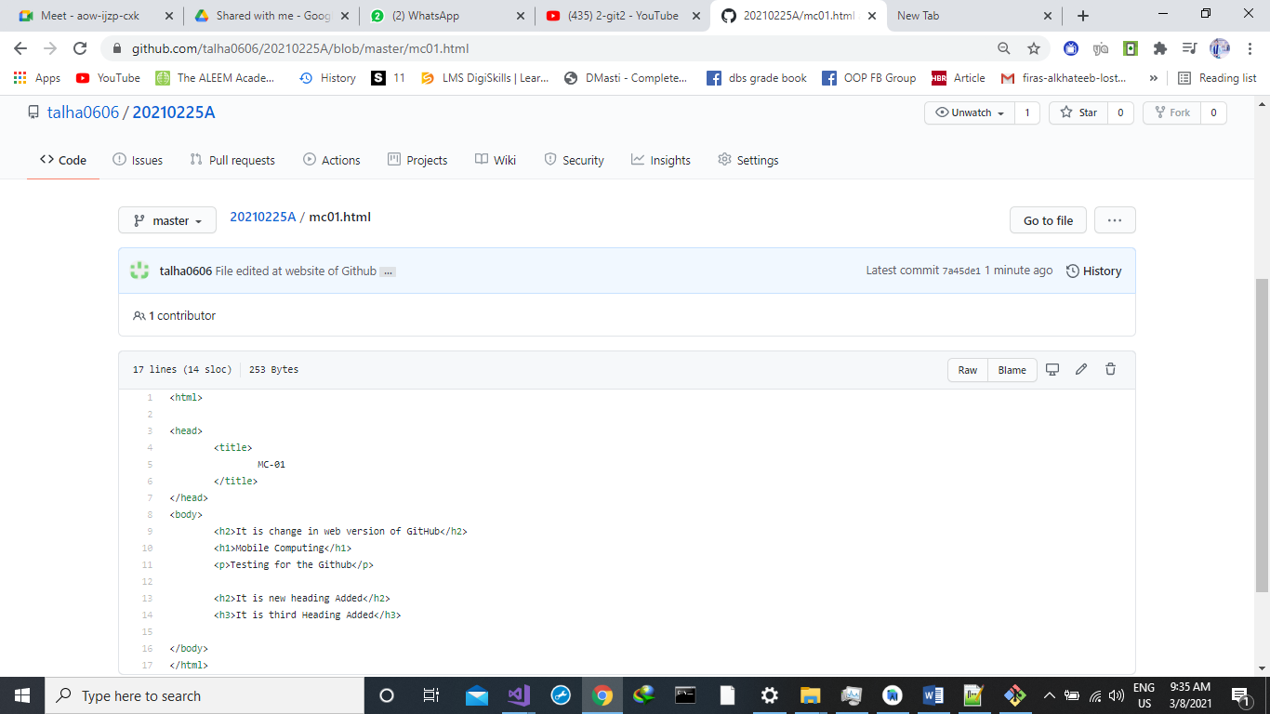

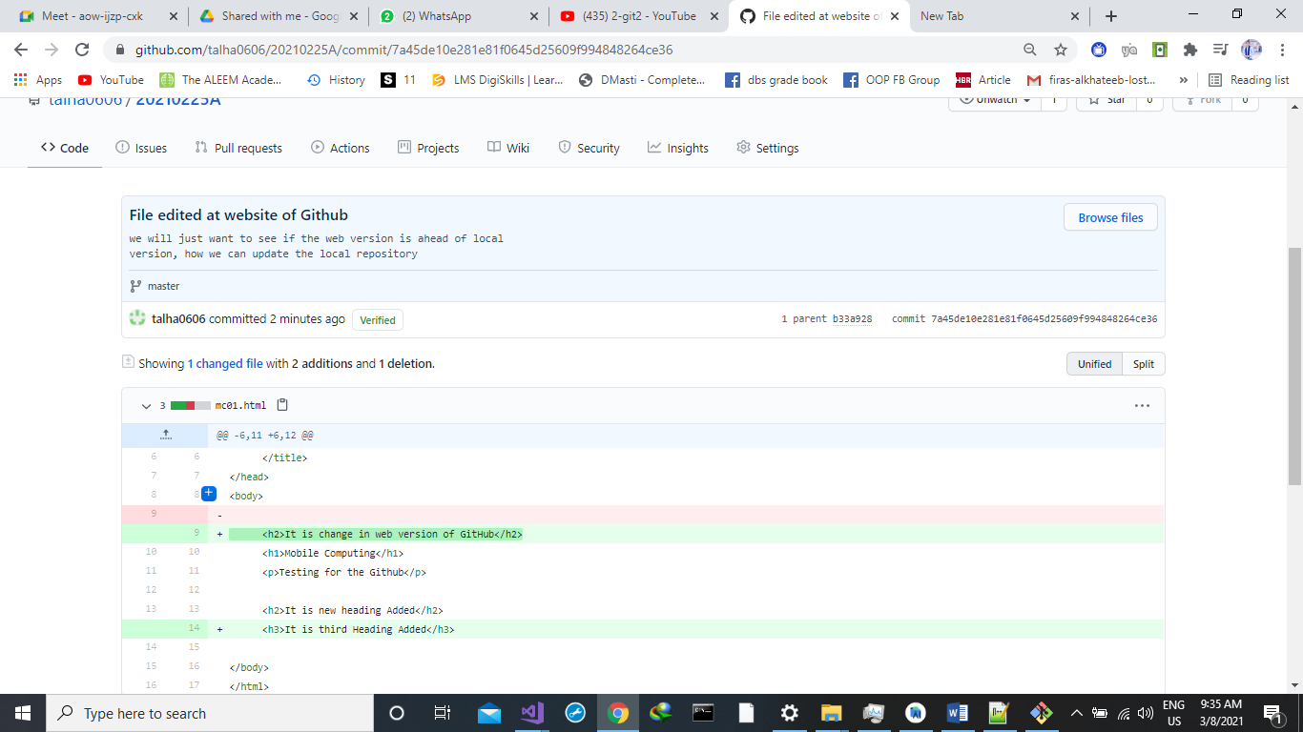

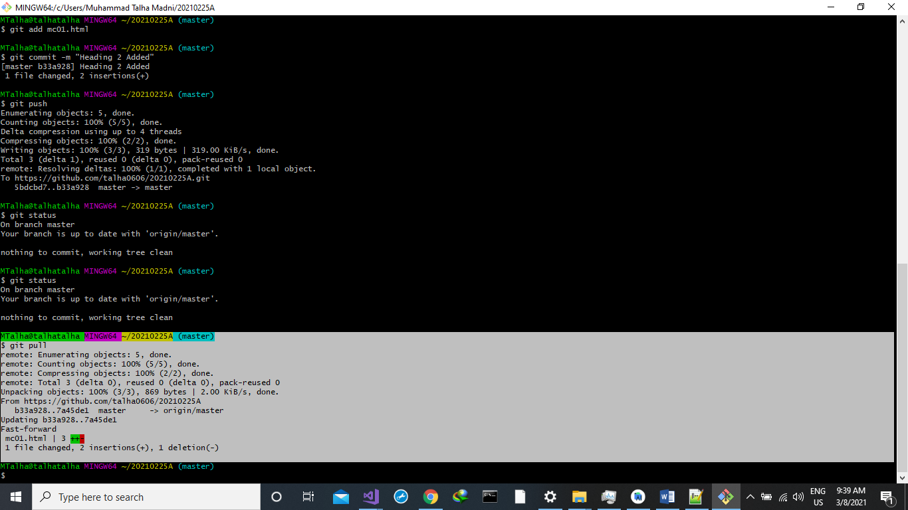

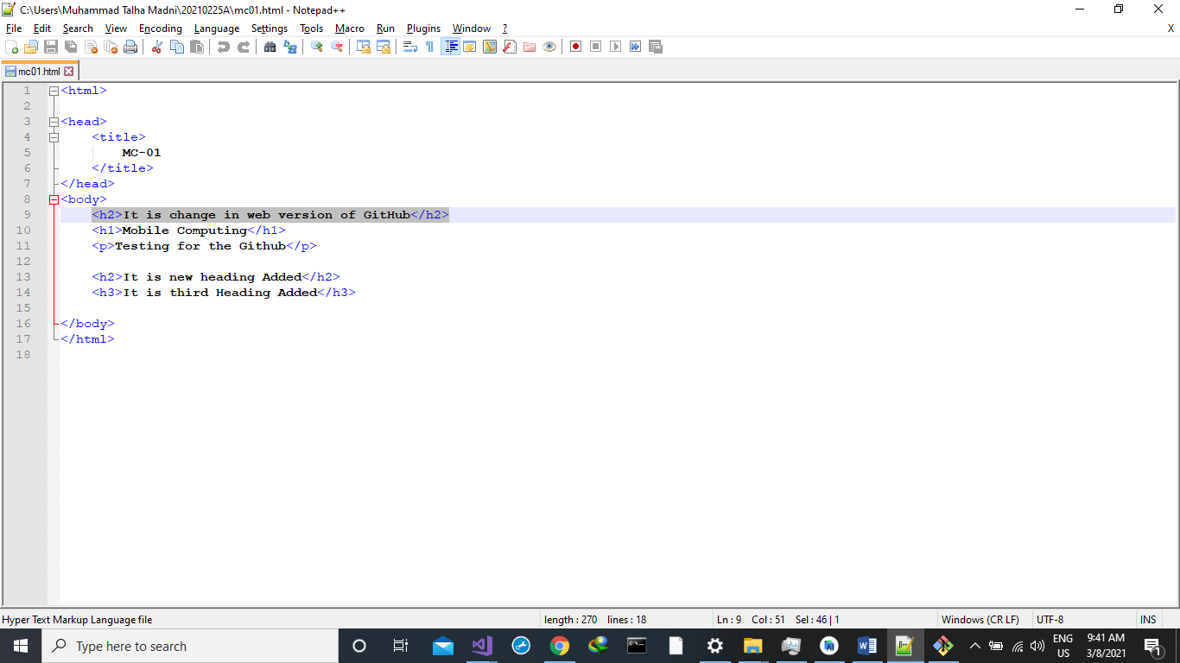

**Merge Conflicts:**

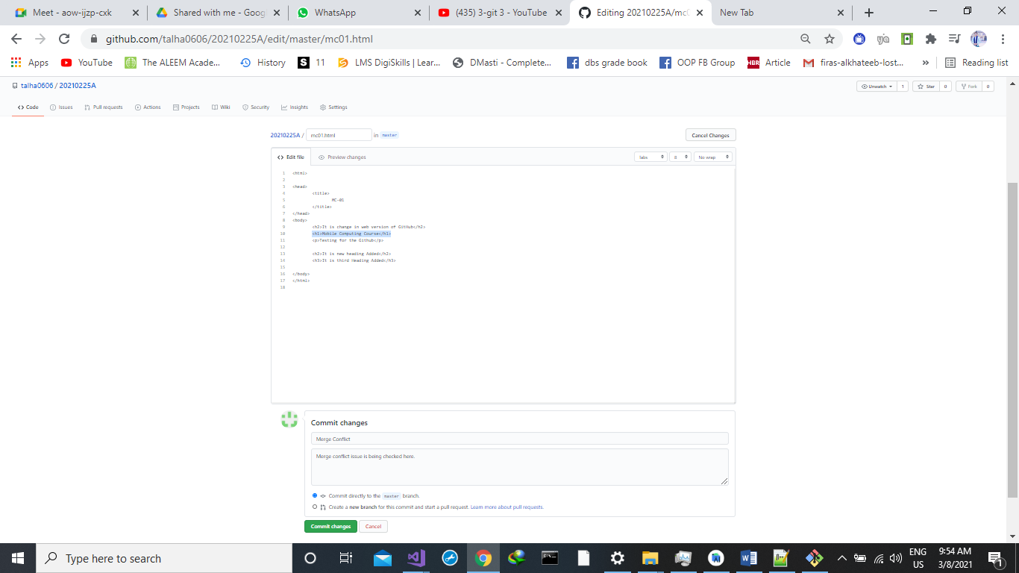

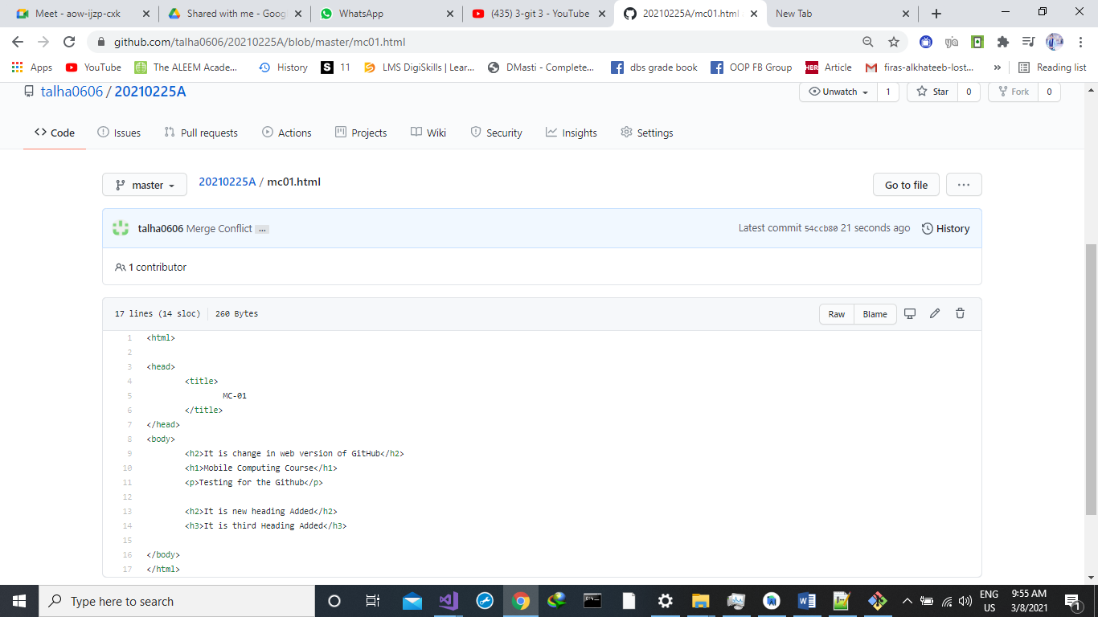

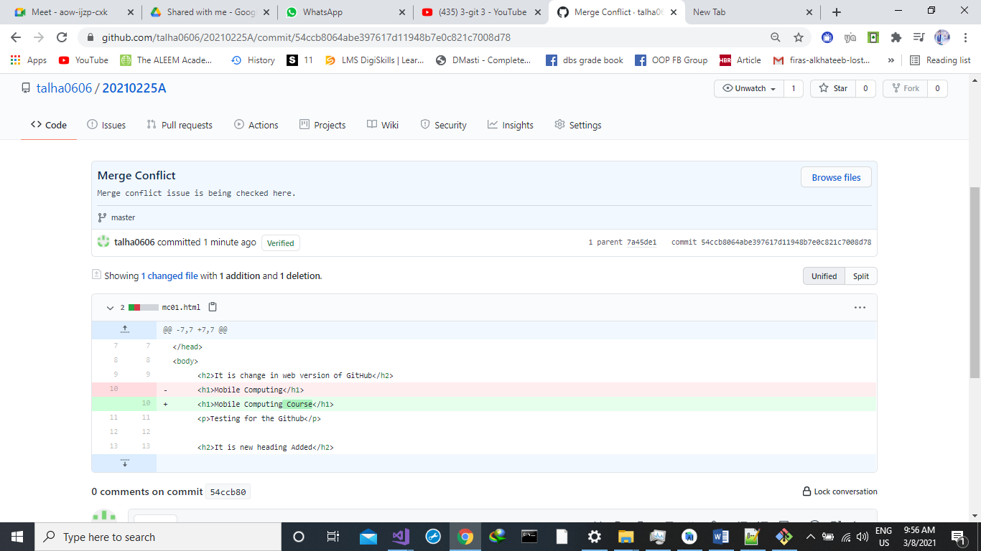

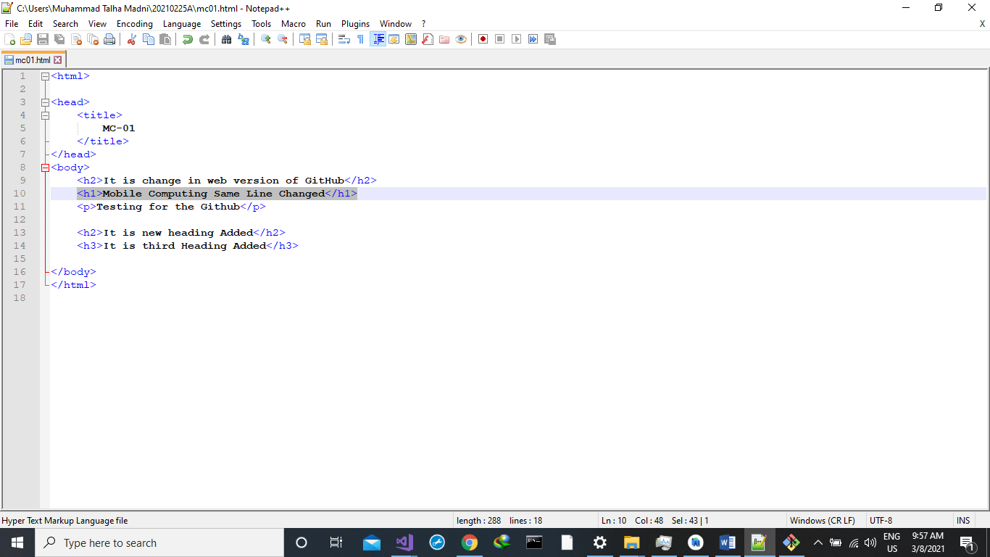

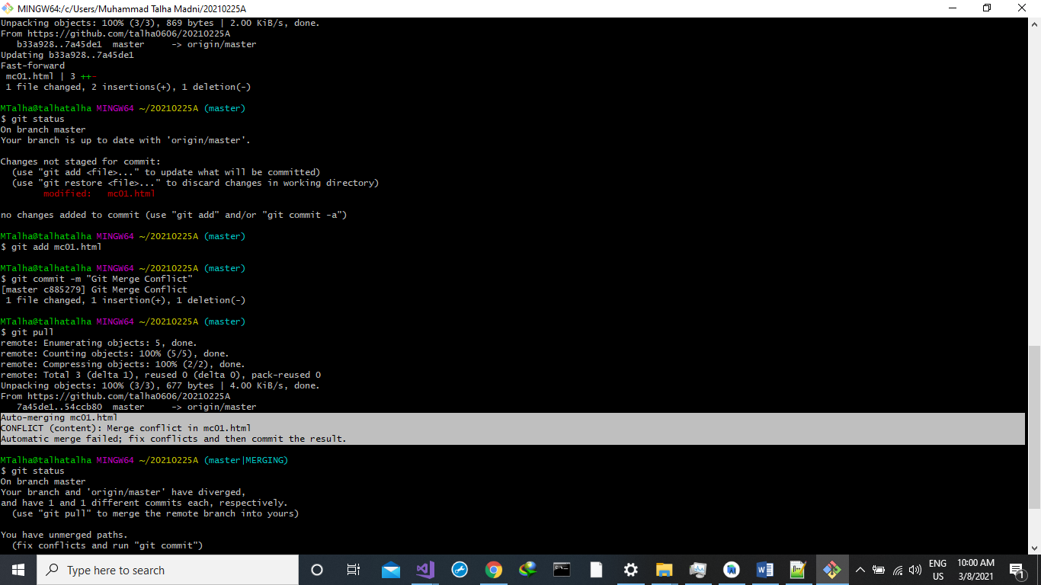

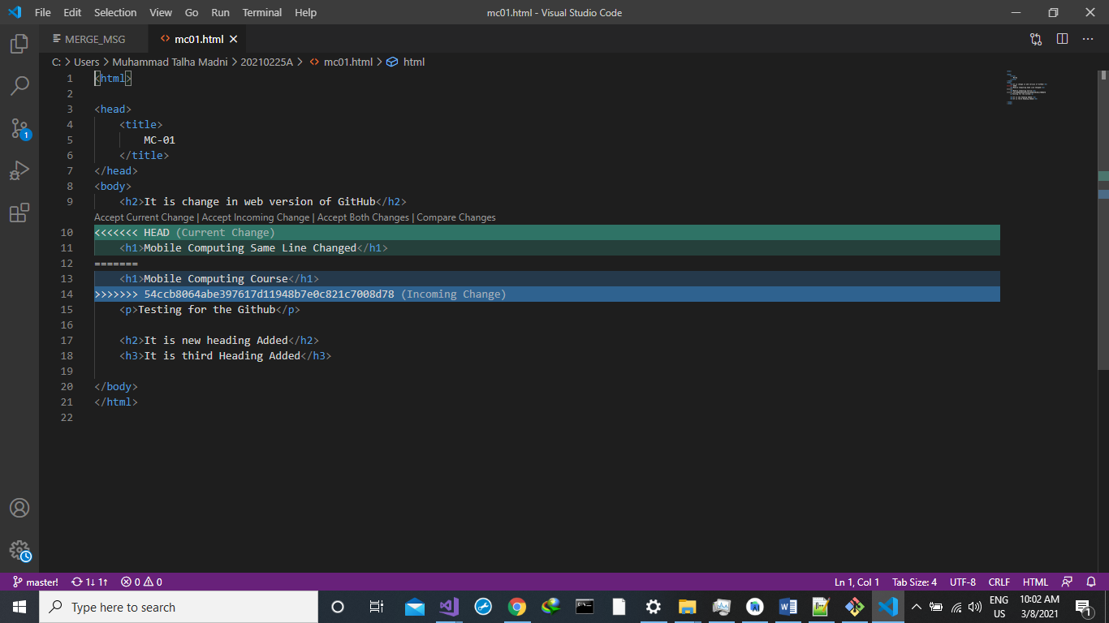

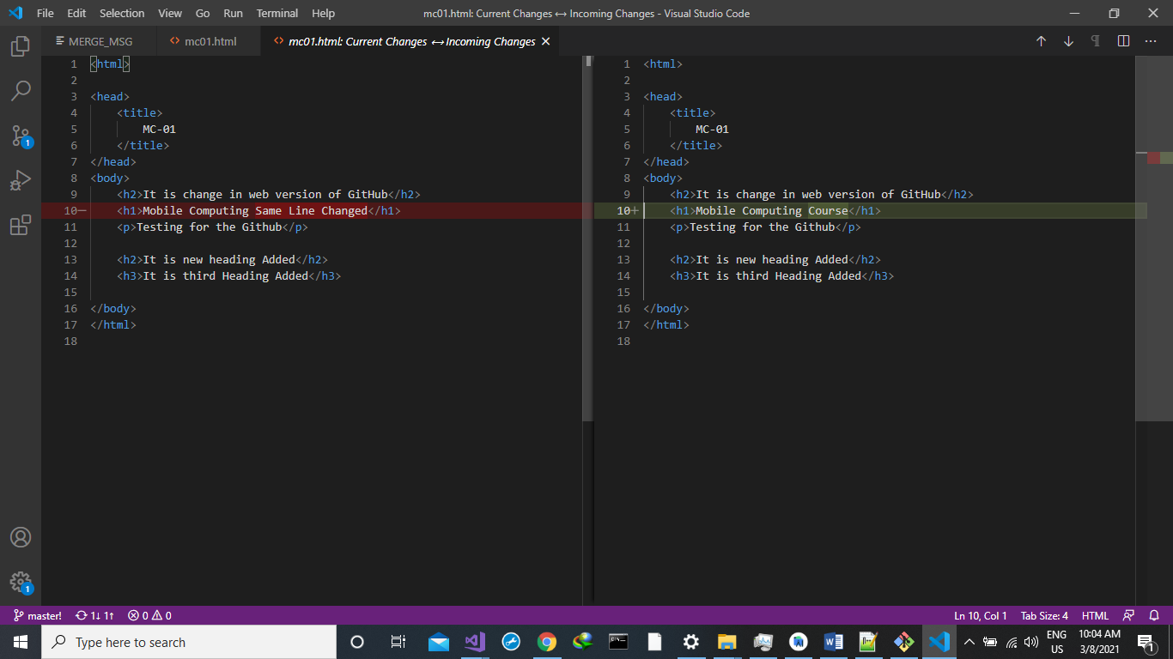

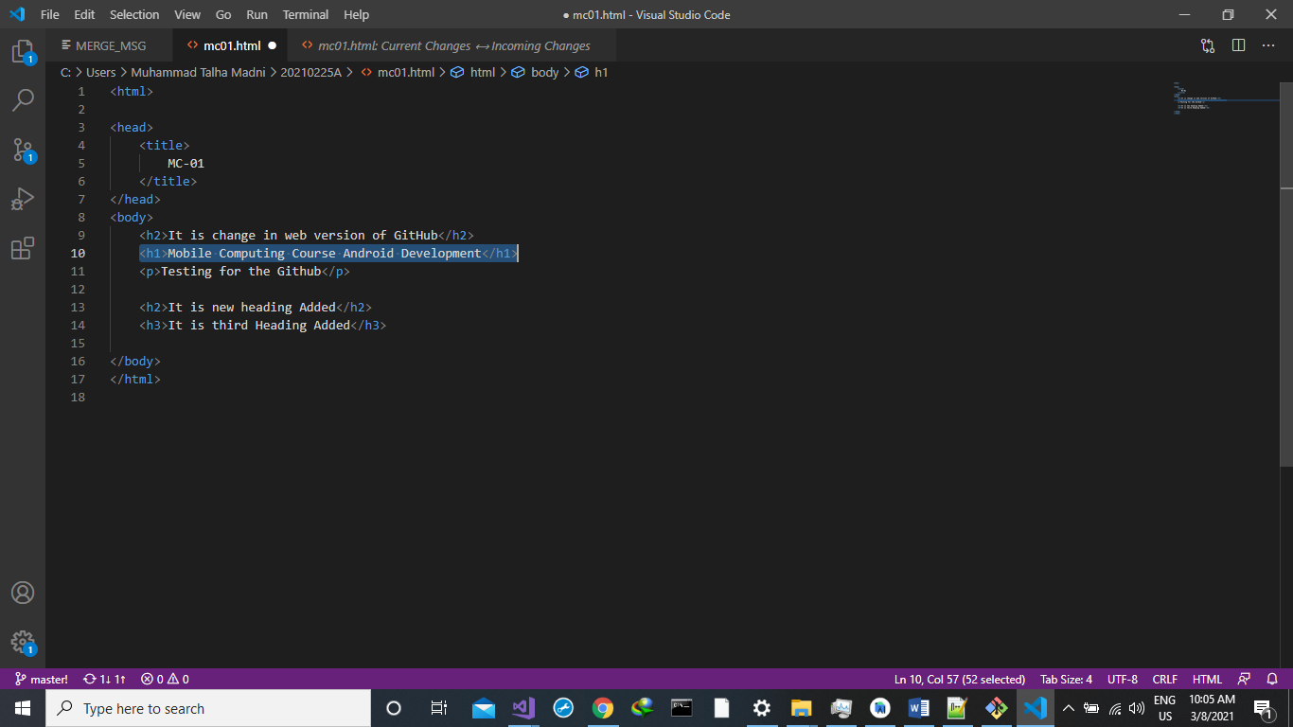

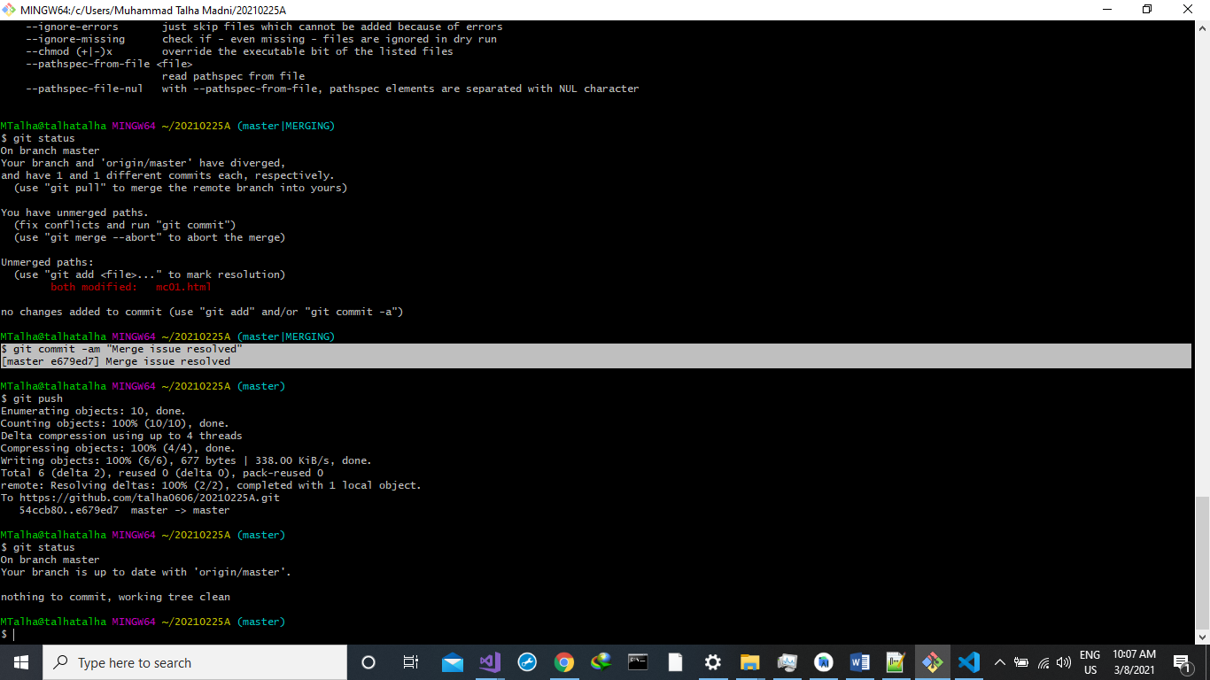

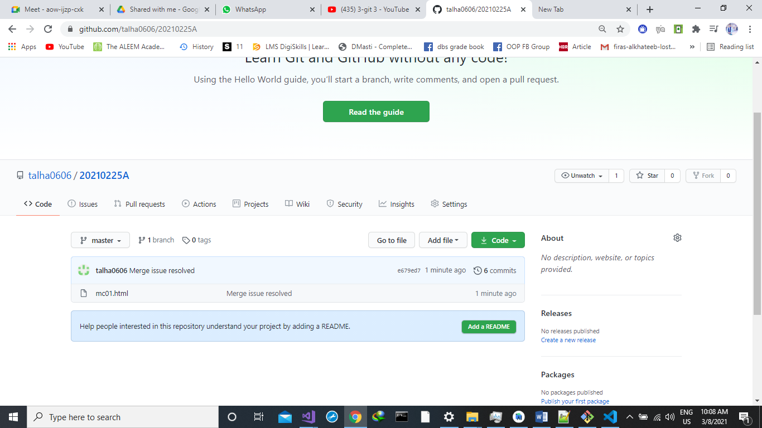

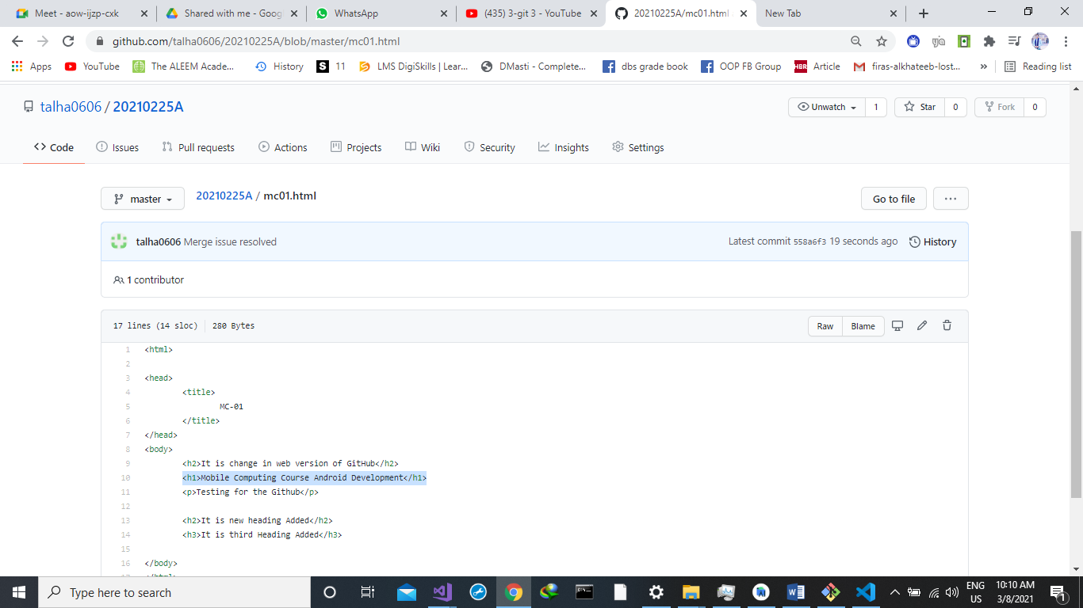

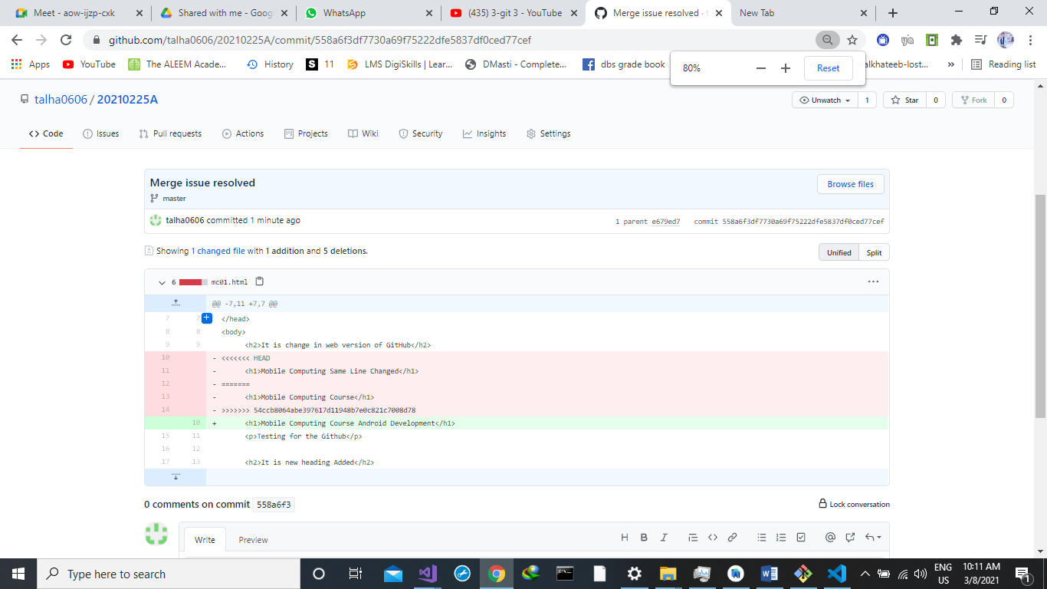

**Git Log Command:**

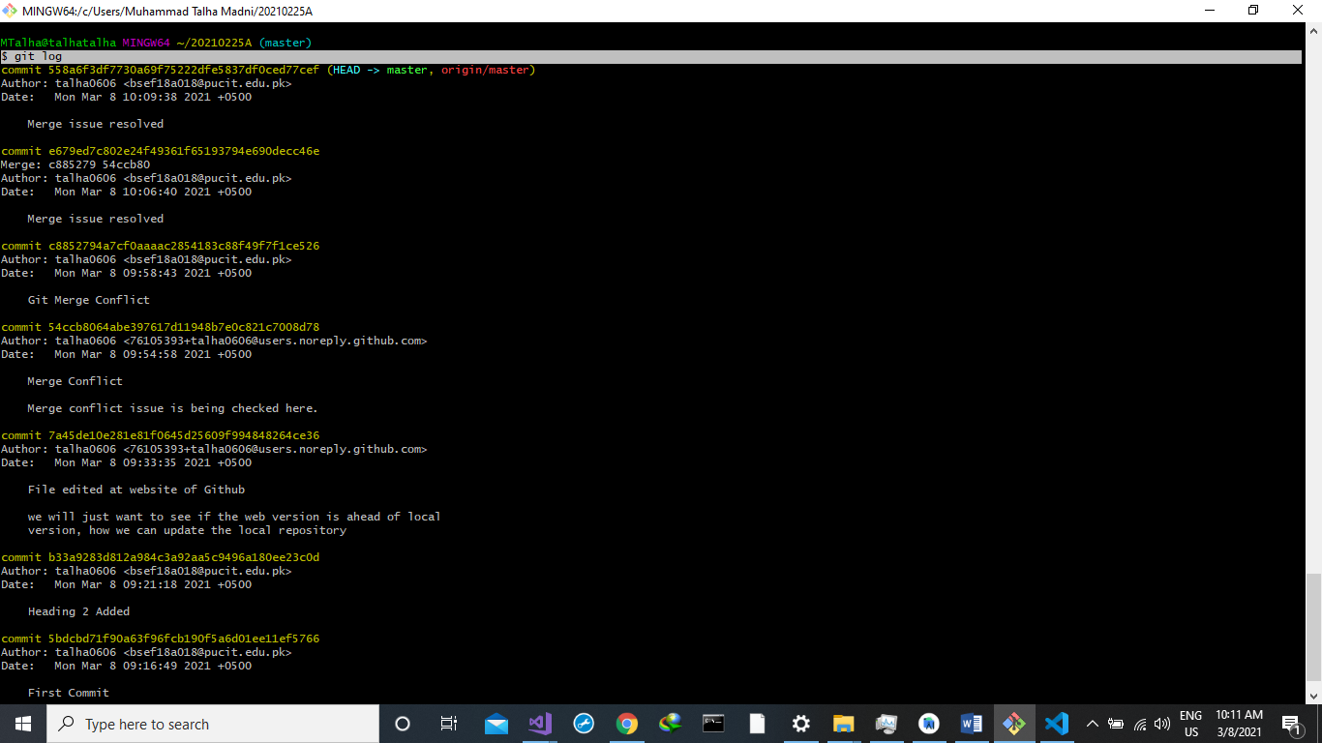

**Git rm**

First of all we create 2 new files on our local repository.

* file1.txt
* file2.txt.



now add these two files on our central repository by using these commands on git bash.



You can see 2 file1.txt and file2.txt is uploaded on our central repository. 

Now we remove file2.txt by using

**Git rm file name**

on git bash



You can see file2.txt is deleted from our central repository. 

File2.txt is also deleted from central repository. 

**BRANCHING**

* git branch
* git checkout
* git merge

git branch

by using git branch we can check our current branch just like this. It shows master as our current branch.

git checkout –b branch_name

by using this git checkout –b branch_name, we make a branch just like this.



now you can check that your branch is changed from master to newbranch1



now we updated MC01.html and added some CSS in it. 

by using git commit –am we added and committed with a single command 

now we move back to master branch 

and we can see that our MC01.html file is reloaded by the previous code. And there is no CSS applied here. 

by using

**git merge branch_name**

this command we merged both branches. 

we can see that both branches are merged now..and the content of both files are updated.



**Delete Branch**

For deleting a branch we use this command

**Git branch –D branch_name**

Here we can see that NewBranch1 is deleted.



At last, we update our last commit.

On central repository you can see MC01.html is updated.



Android Studio

## First project

Open android Studio and select Create New Project option. 



Chose Empty activity and then click on  button.

Write the name for your project and Package Name. after writing these names chose the location where you want to save your project on local disc. From language drop down menu: select Java. And then select Minimum SDK version.

NOTE: try to choose that SDK which will run on Maximum number of devices.

And then click on Finish button.

It will take some time. (it depends on your machine and its efficiency.

After loading the required files and allocating memory. You will see this window. That means your Project is ready to edit. 

Here we have two different file structures.

1. **Android**



1. Project



we can also choose these file structures.



But we will work on Android File Structure.

In our project we have two main files.

1. MainAcitvity.java
2. Activity_main.xml



Our coding part will be in MainActivity.java

And our GUI (Graphical User Interface) related things will be in activity_main.xml



## Component tree

Out components will be placed here.



## Project Resources

These project resources files are built in available in our new project by Android Studio



## app icons

Here you can find the icons of different resolutions which will be used for your app. These icons are measured on dpi scale.



You can find these icons on that path.



## buil.gradle (project)

If you are using some third party tools then you can find their information in build.gradle file



And you can find this file here.



## build.gradle (module app)

You can find all these information there:

* Version name
* Version code
* SDK’s info

And you can find dependencies there which are essential for running your project.



## todo

We place our pending things here. This will help us to continue our work from last activities.

And you can find it on lower left corner of the android studio.

**//TODO: message..**



## terminal

You can run all commands of command prompt on its given terminal

## build

For building your project you can click on this option. Which is available on upper right corner of the android studio.



It will take some time for execution of your project. If there are some errors, then you can see there.

After completing the execution process your app will run on an emulator/your own android device.

You can find the relevent info about your running task here.



## logcat

Information about your running process are located in LogCat menu.



You can see errors/problems/warning there by switching in these options.

* Verbose
* Debug
* Info
* Warn
* Error
* Assert



## avd manager

By clicking on AVD manager you can download a virtual device on which you can see your running project’s output.



You can download or Create Virtual Device and choose that virtual device for running your app.

Available virtual devices are given below.



By clicking on **Create Virtual Device** option this window will appear.



By selecting your desired device click on Next Button.

Now you can run your app on selected device.

From this drop down menu you can choose from your available devices.



Now by clicking on this button your app will build and run on selected virtual device. 

Your virtual device will look like this.



## setting for real devices

For using your own device for developing apps, you have to connect your mobile device to your PC/Laptop with a data cable and then enable Developer Options on your mobile device. Then Enable USB Debugging option on your mobile. By doing these steps you can run your app on your own mobile device.

## android profiler

It provides the information regarding the usage of system resources.



Here you can see the usage of resources by your app.

## design and blueprint

On design section you can choose among different designs.

 

## design and text view

By using these options you can changes among the Code view/split view/design view. These options are available on upper right side of the screen.



You can also use text view for changing design/content of your app. Here you can update the text of your Text View Item from “Hello World!” to something else or you can change other properties of text view.



## constraint layout

Here we are using constraint layout which sets the position of our item by setting its upper, lower, left and right constraints.



## dependensies

In **build.gridle** file you can see the dependencies which are used in our project are available. Just like dependency for our layout is given here.



**SCREEN TASKS**

**LEC # 4**

# SCREEN1

First of all create an empty project.

Open activity_main.xml



Then from upper right corner select **Design**



This window will appear



Select text view in which Hello World is written by Clicking on the text.

On right side of the window you will find Attribute option. Select on Attributes then this menu will appear

From text option you can change the text of textView item. We write

بِسمِ اللہِ الرَّحمٰنِ الرَّحِيم



Your text will be changed to بِسمِ اللہِ الرَّحمٰنِ الرَّحِيم

Now you can see your text is updated



Now click on lower spring/constraint and press Delete key from keyboard



Your text will look like this one.



Now in attributes option, under layout >> constraint Widget, give upper constraint value = 32 and press enter. It will place some space from top.



You can see the difference in design



**Now in attributes >> Common Attributes >> textSize**

**Now in attributes >> Common Attributes >> textColor**

Change text size and text color and press enter



You can see your design is updated now



From this menu drag and drop these items to your design

1. textView
2. 3 buttons





Set the constraints of the text view by selecting the constraint head and fix to the sides (left and right) and upper side with upper text view. Just like



Set Its top margin up to 32



Updated design



Change its color and text as we did before.



Updated design



Now drag these buttons to the lower side of the design



And set their constraints just like this one.



Now update the text of these buttons



Now copy this image from your local directory



And paste in the res >> drawable folder



Click on OK



Type name and click on Refactor



Here you can see logo.png is added in drawable folder



Now add an Image View in design



Select your desired image. In my case it is logo. And click on OK



And set the constraints for this image view and text view. And then the final screen is ready now.

Now open git bash and move to MC-Screen1 repository and then add and push Screen 1 project (MC01)





On central repository you can check that screen one is added

# Screen 2

Select this text view and press delete key from key board



Your screen is updated



Now remove these buttons too



Current layout.  


Now add email and password items in your design from edit.

Now add a text view and two buttons to your design



Our current design will be like this one.



Now we have to set the constraints and size of our items by drag and drop procedure.

Our second screen will look like this. By joining the constraints.



Now select email editor and go in attribute >> Common Attributes >> hint = Enter Email



And for password editor follow the same procedure as given above.



For text editor go in attribute >> Common Attributes >> text



And for buttons, change their text property to Sign up and sign in respectively





Now your second screen is ready now.





Now push your second screen by using these commands



**Lecture 7 Layouts:**

**Project Build Successfully**

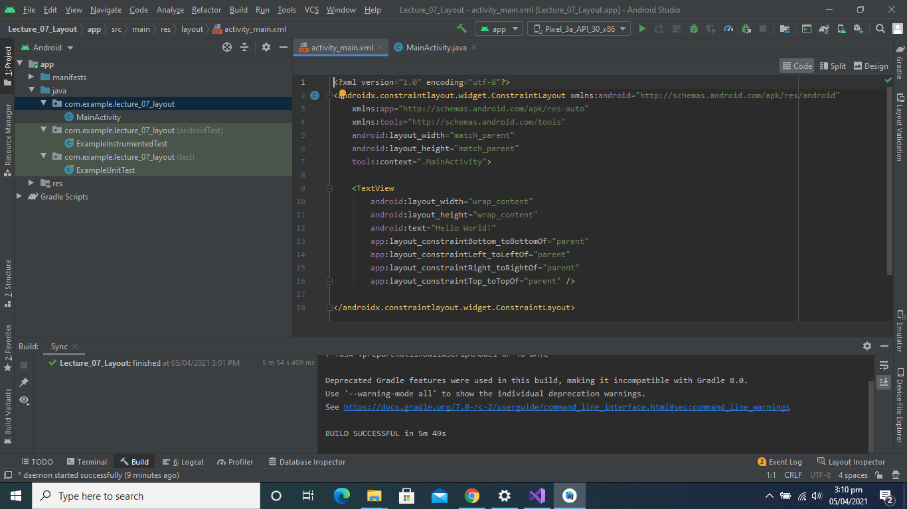

**New Layout Created**

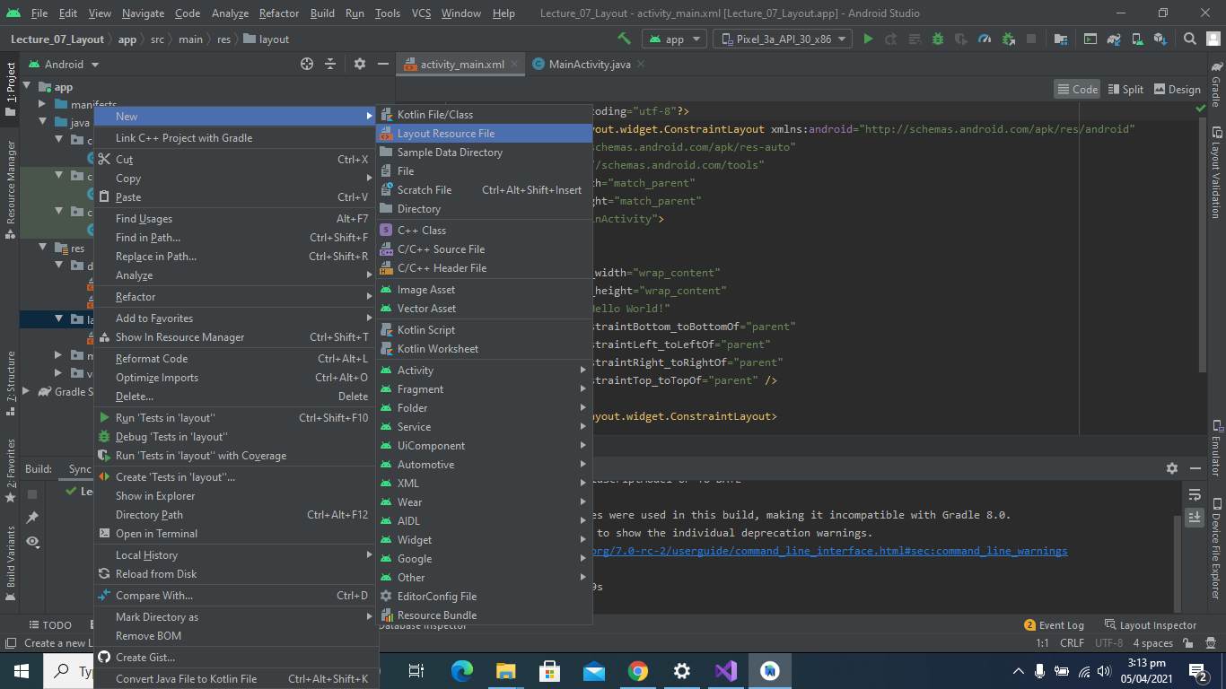

**Linear Layout Created**

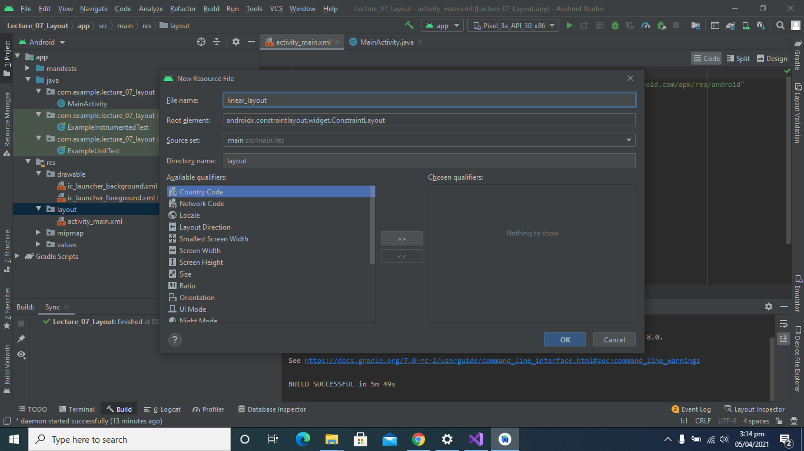

**Add Some Widgets in Linear Layout**

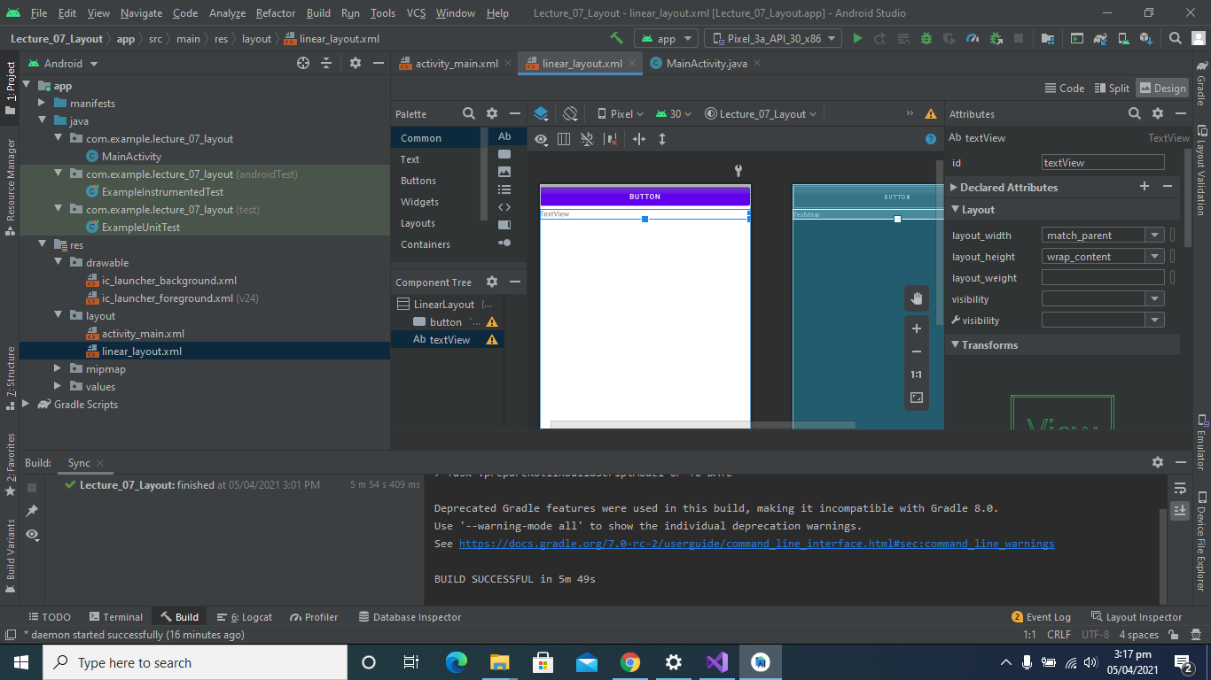

**Linear Layout Code Part**

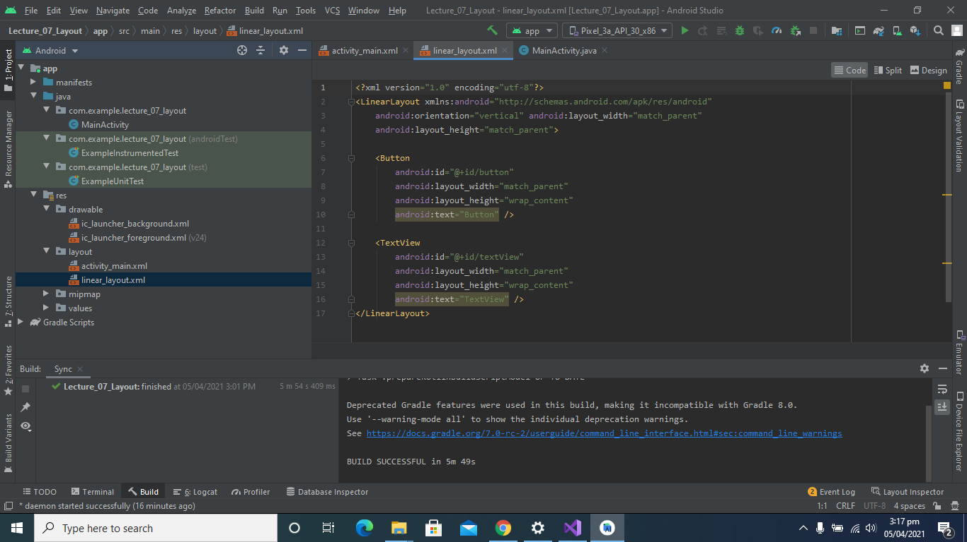

**Change content View to Linear Layout:**

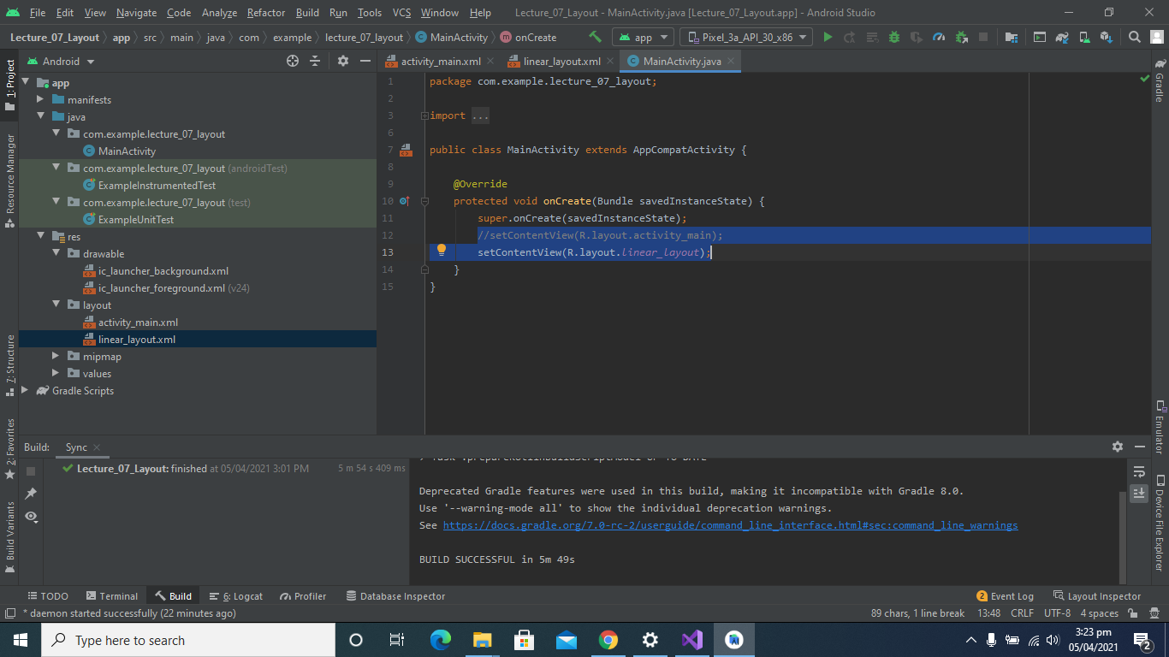

**After Running:**

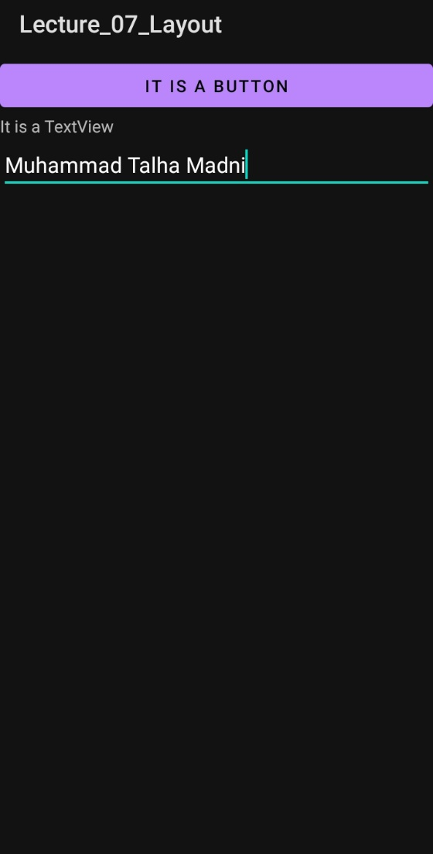

**Check Dependencies in Gradle**

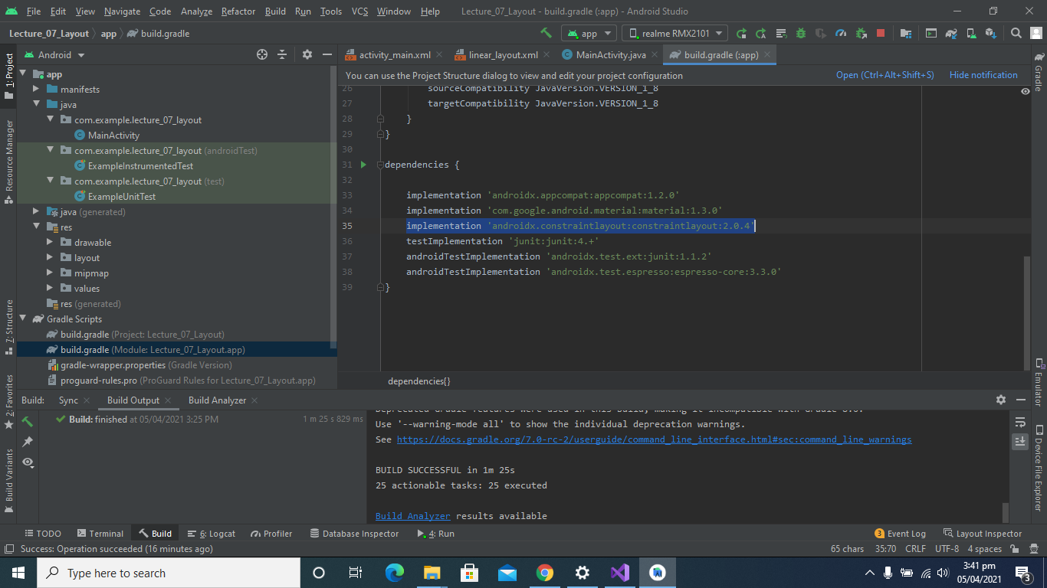

**Clear All Constraints:**

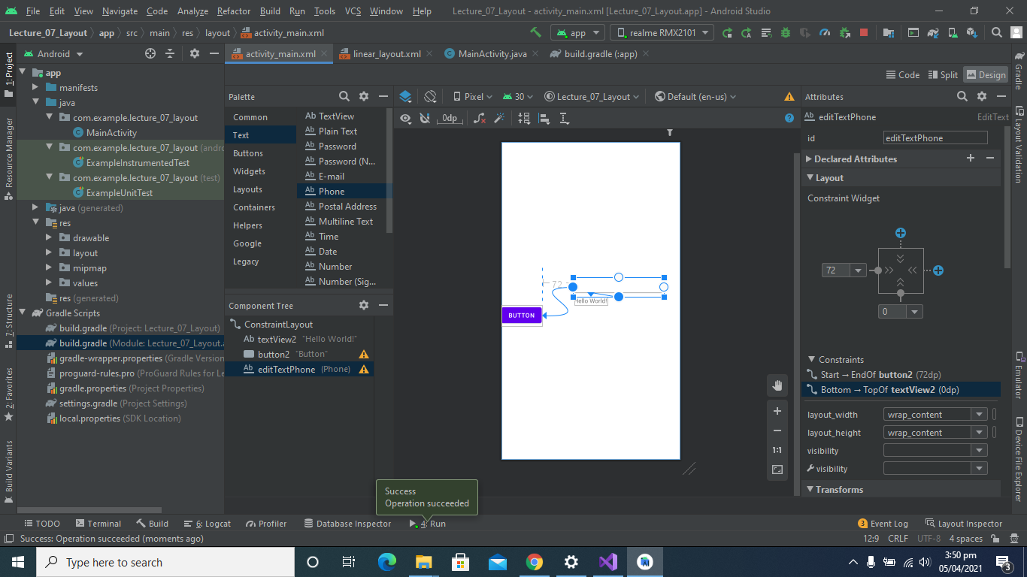

**After Running:**

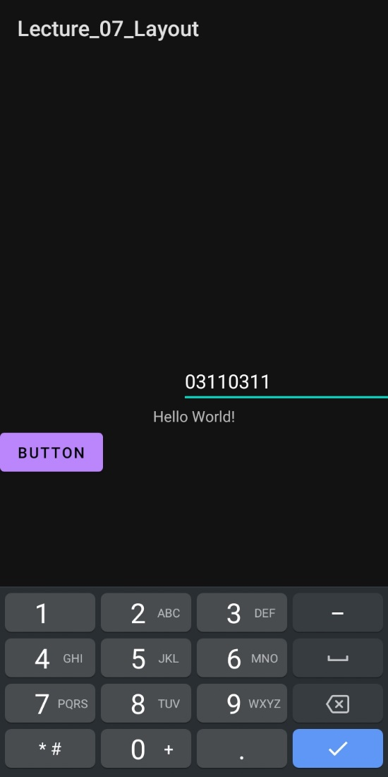

**Clear All Constraints:**

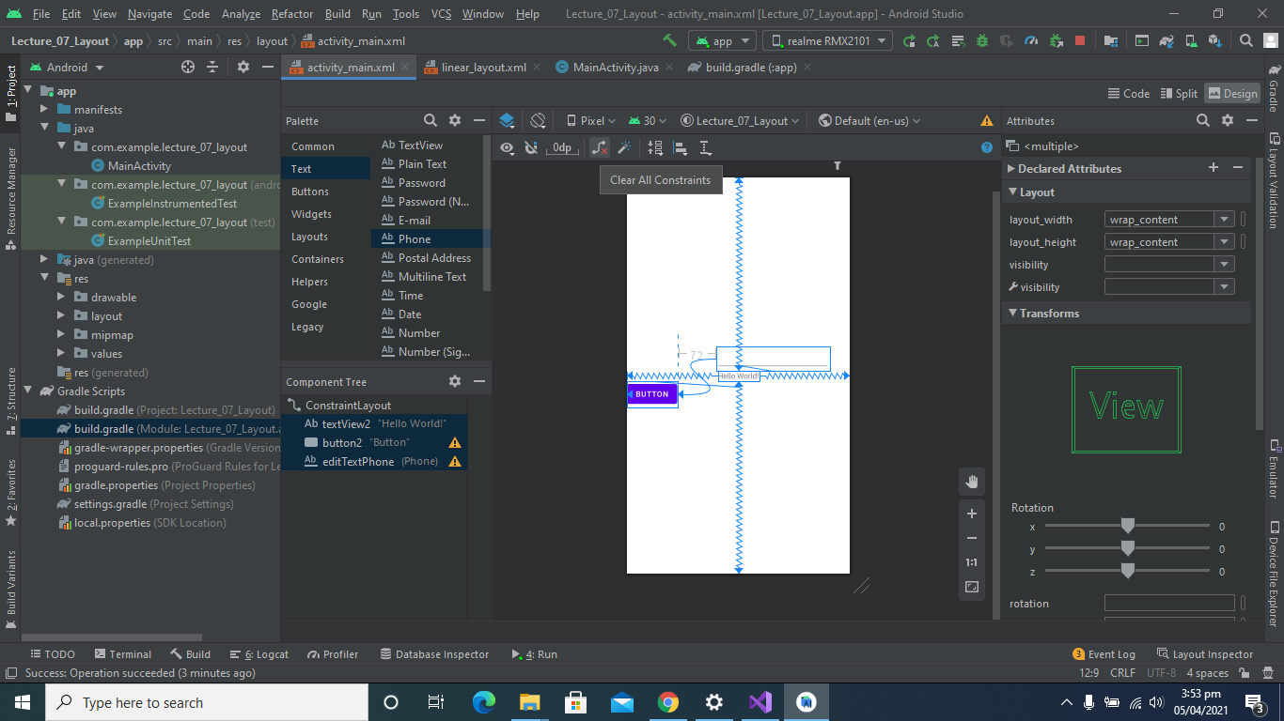

**After Removing Constraints:**

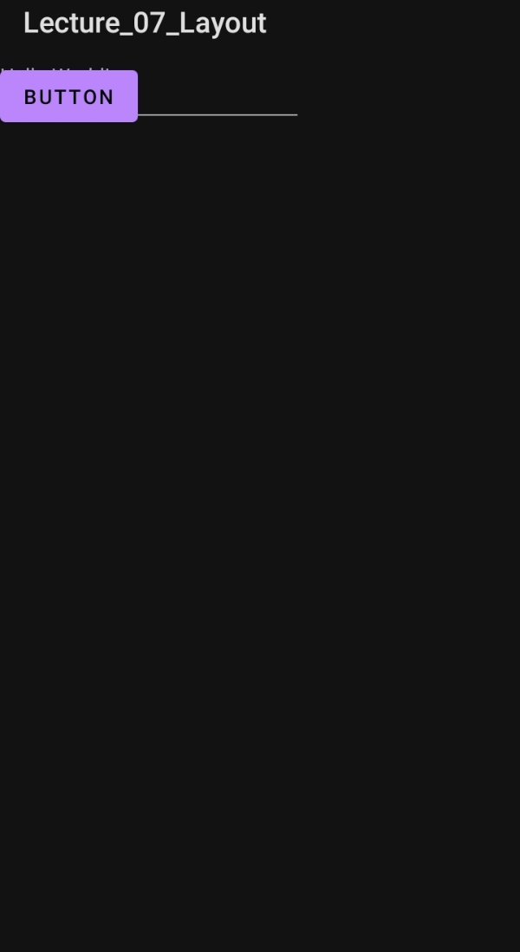

**Added Images**

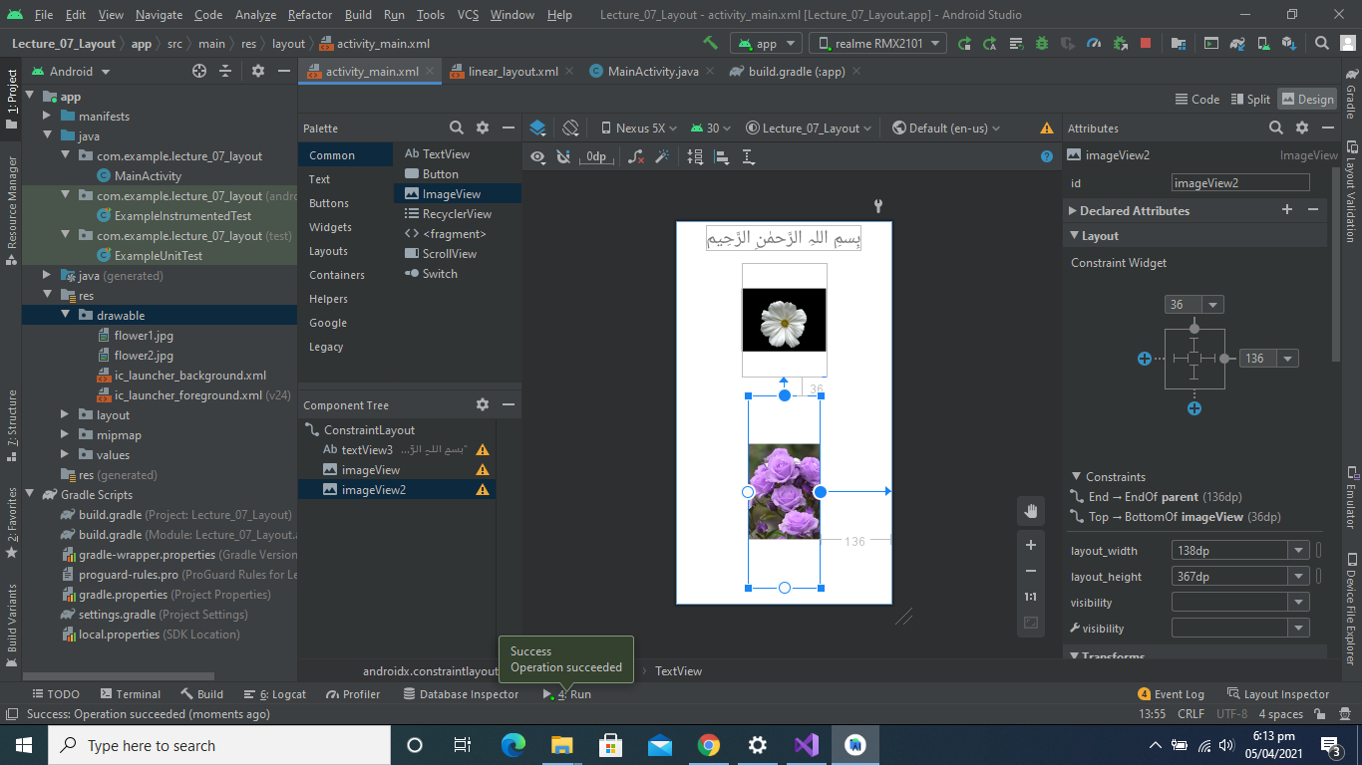

**After Running:**

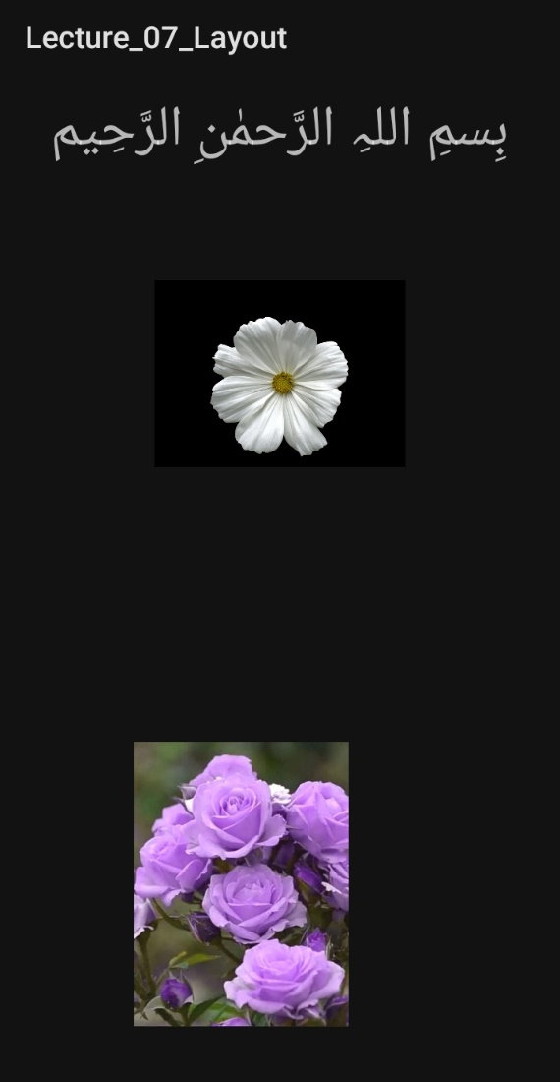

**Show All constraints**

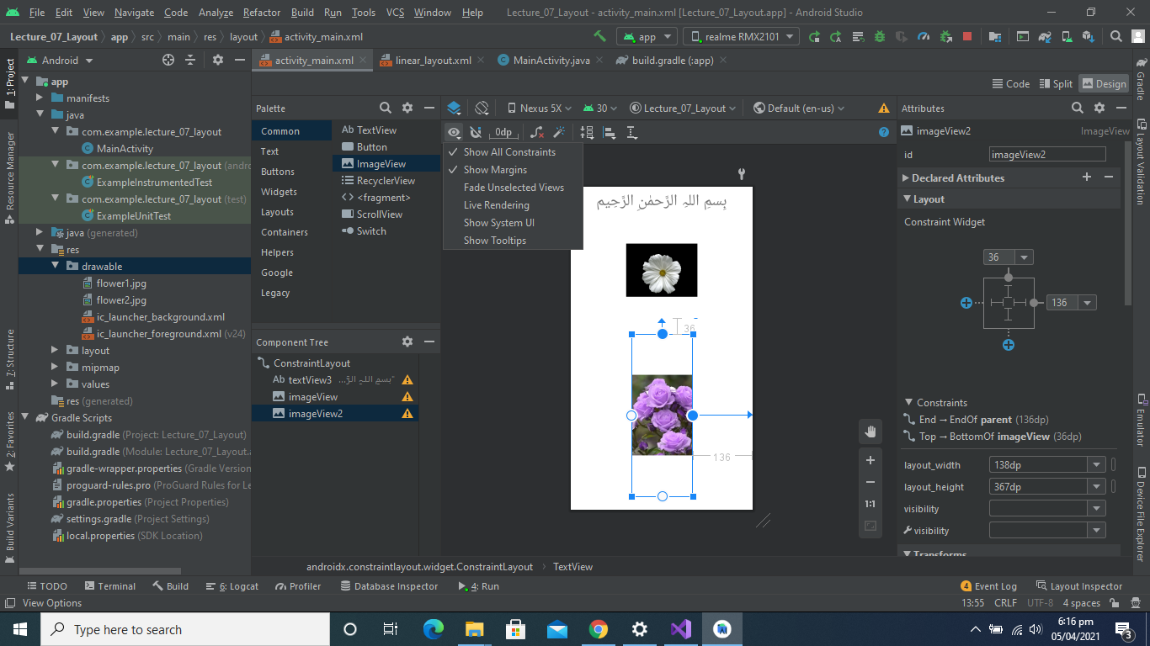

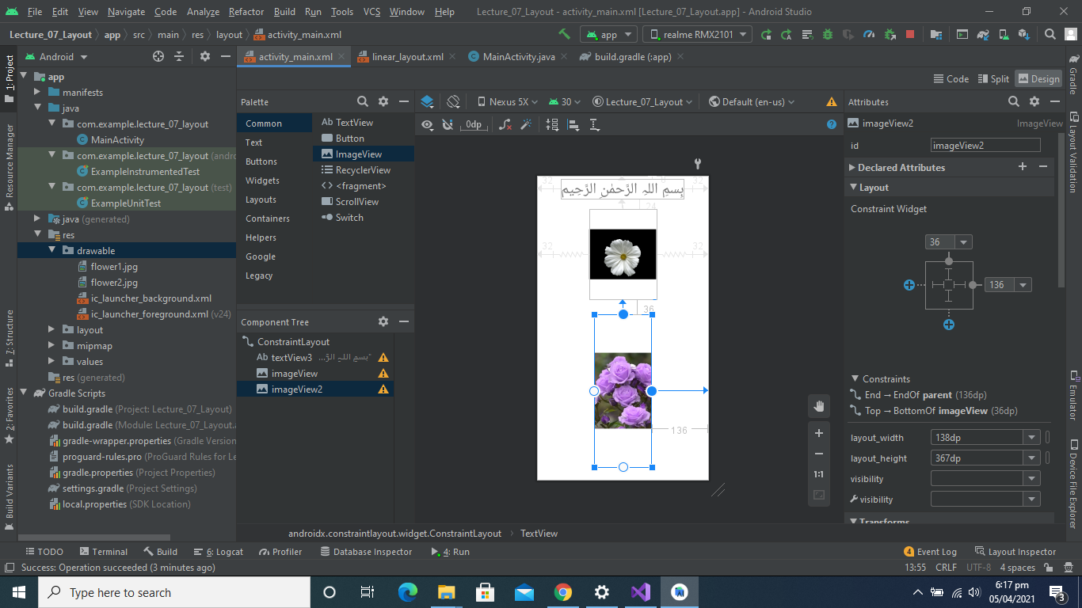

**Pack Buttons Horizontally Or Vertically**

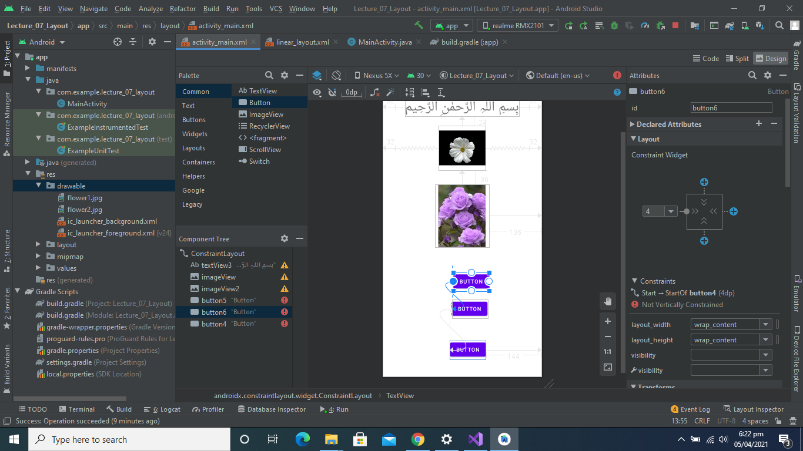

**Center Horizontally Buttons**

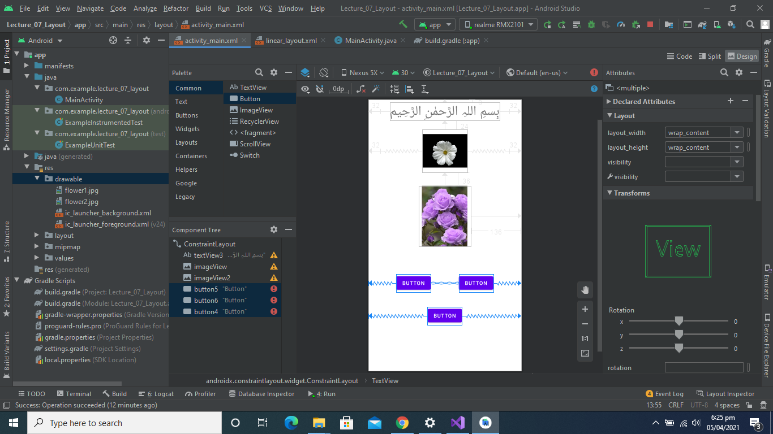

**Center Vertically Buttons**

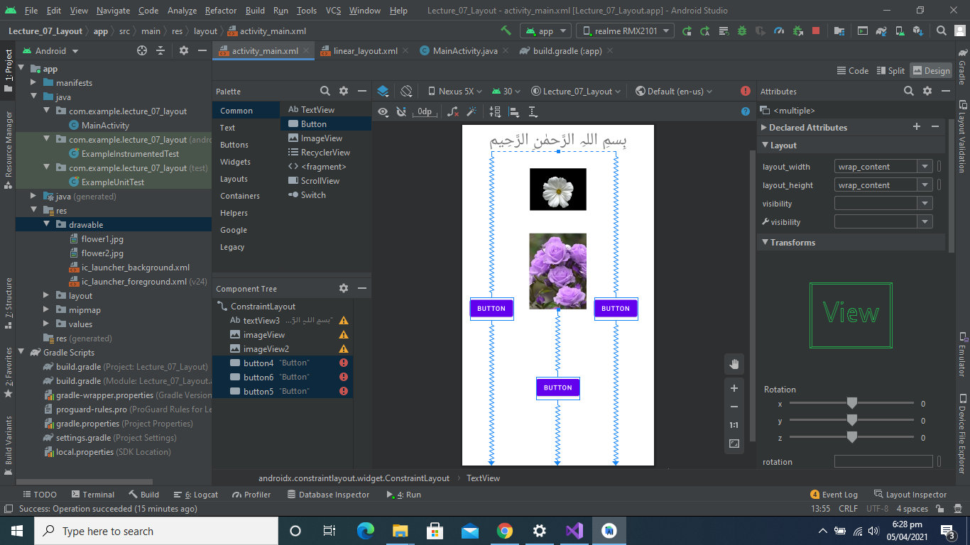

**Expand Buttons Horizontally and Vertically**

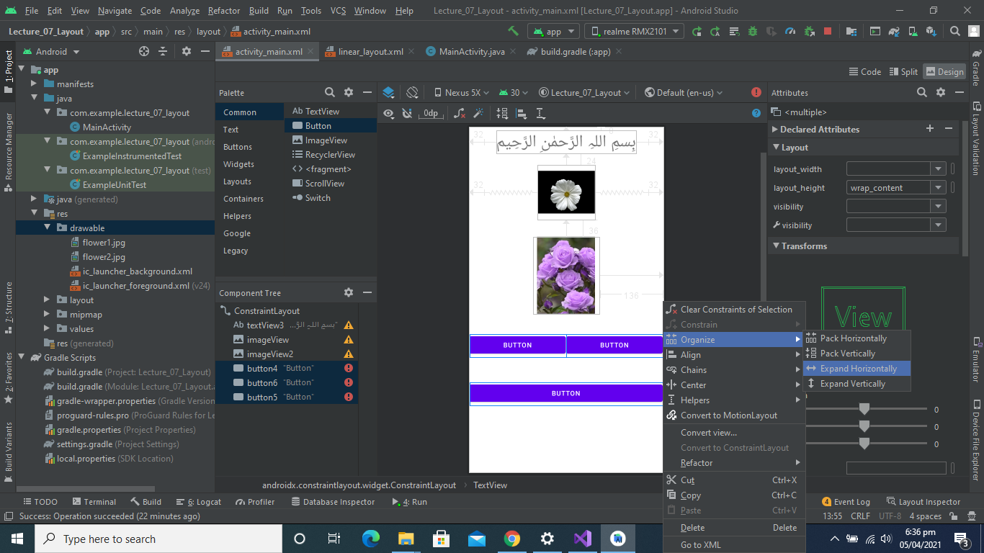

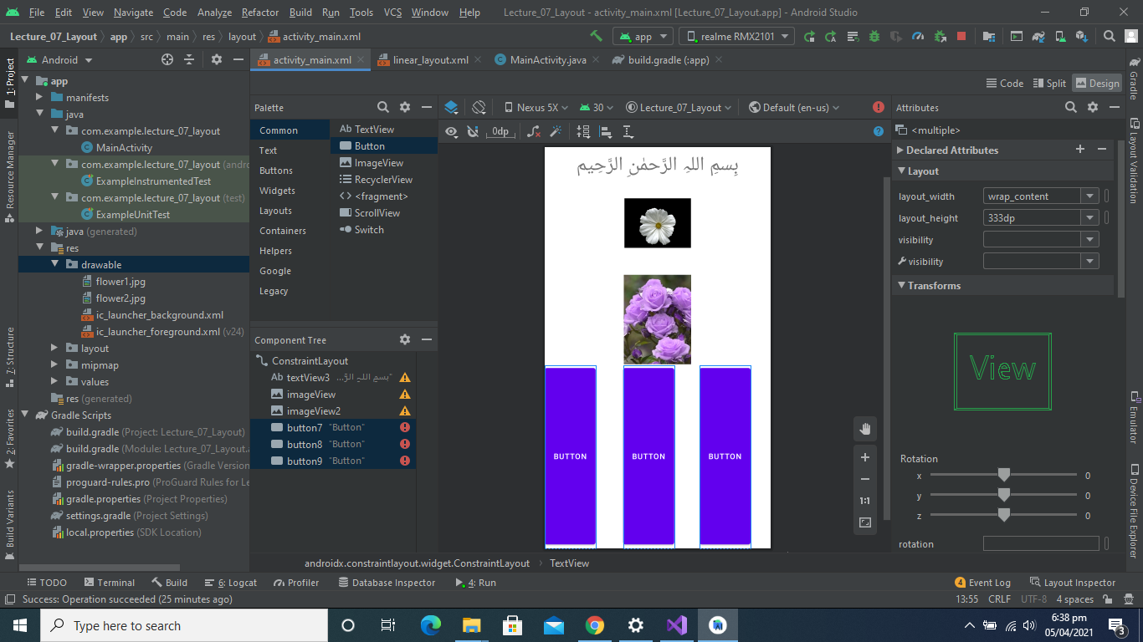

# SCREEN 3

First of remove all items from your app.

Then your app will look alike.

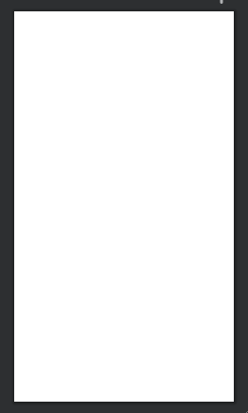

Then copy a pic from your local directory. Suppose download.png and paste it in drawable folder.

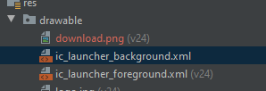

Add image view and then select this image.

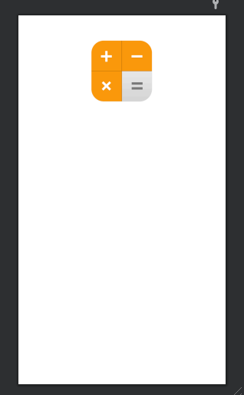

Set the constraints of your image as given below.

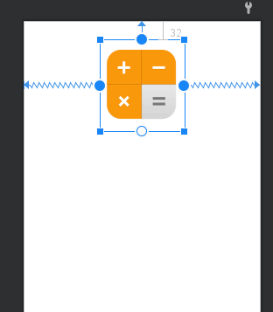

Then add NUMBER (DECIMAL) editors in your app.

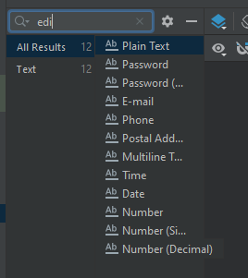

Add 4 button too.

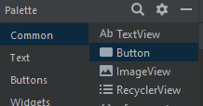

Your app will look like. As given below

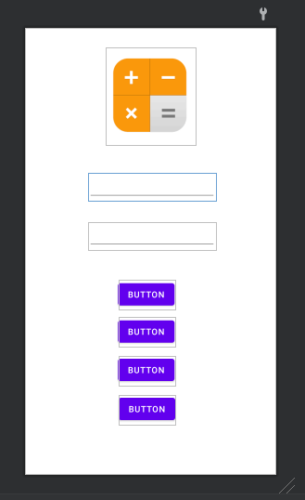

We have to apply these constraints for a better view (professional view)

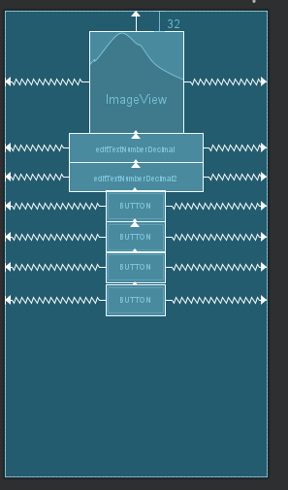

Select 1st edit view and set a margin of 50.

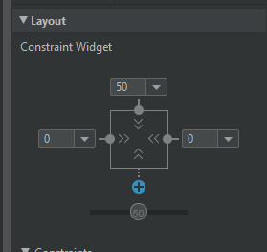

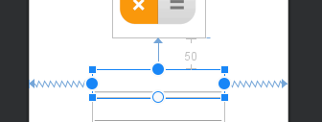

Now remove the upper constraint of 1st button.

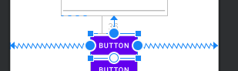

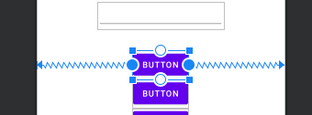

Add a text view there.

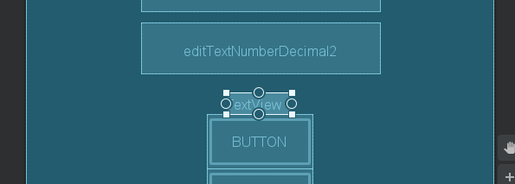

Set its constraints as given in below picture.

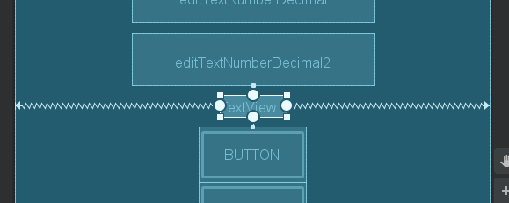

Select a button

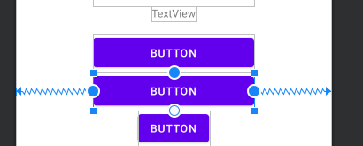

Set these properties to selected button as given below

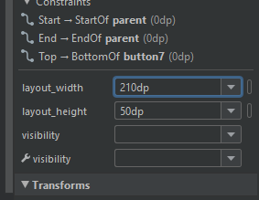

Do the same work for all the buttons.

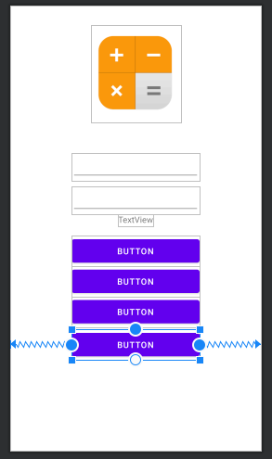

Select 1st button

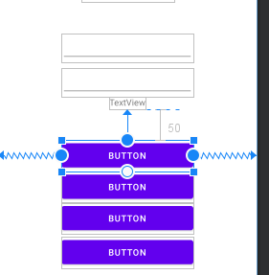

Set upper margin as 50.

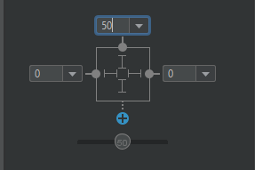

Select 1st edit number item

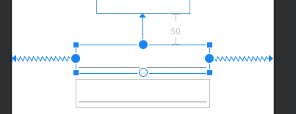

Set its hint property as given.

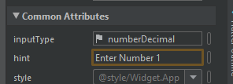

You can see the result in the ss given below.

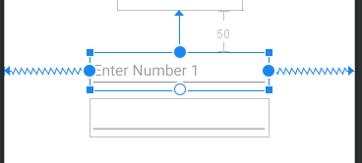

Follow the same procedure for second editor.

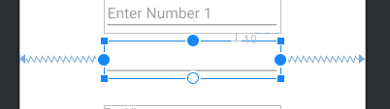

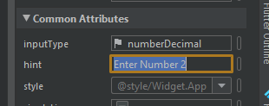

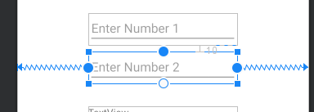

Now select the text view

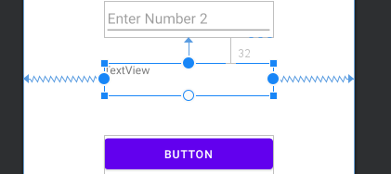

Set its text property to Result: and press enter.

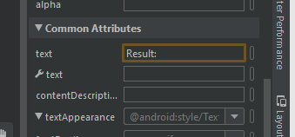

You output will look alike.

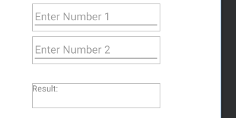

Now change the text of all buttons by selecting then one by one and changing their properties as given in screenshots.

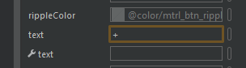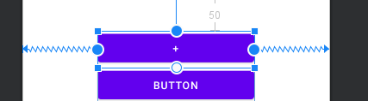

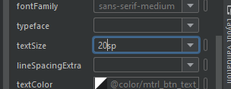

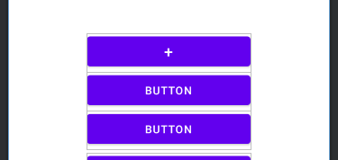

Final result for your buttons output will be.

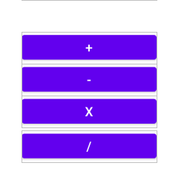

Check your all constraints. If constraints are not like that change them according to your own choice.

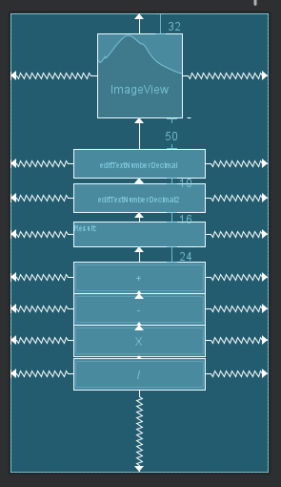

Now your design will look like this one

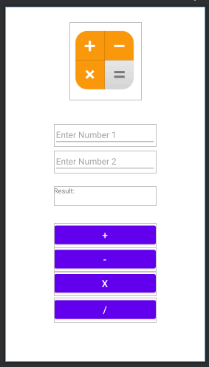

After running your app on a virtual device. Your final output will be.

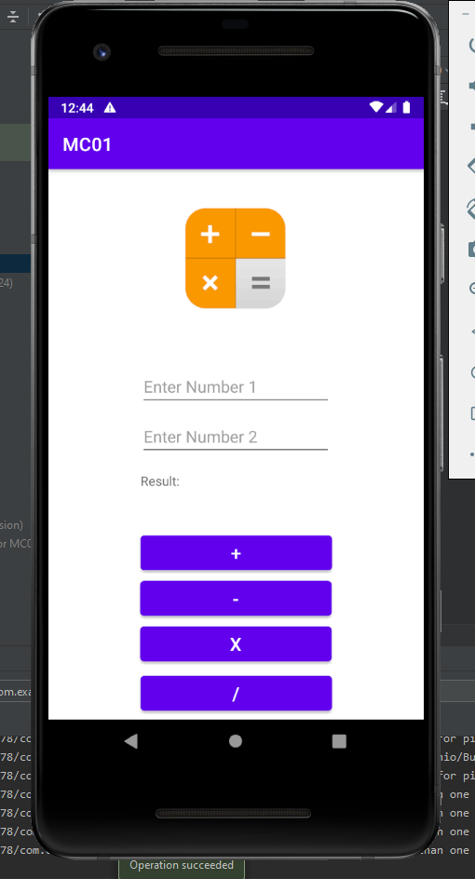

By running these commands on your git bash you can update your previous screen2 project.

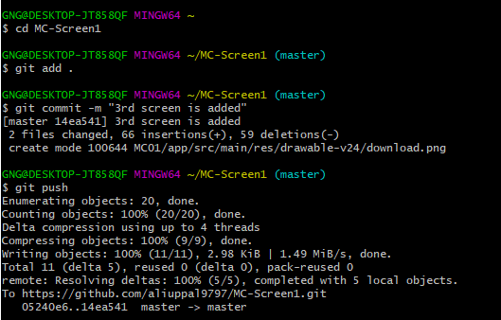

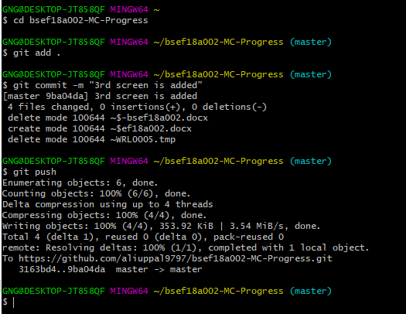

# **layouts**

## view and view group

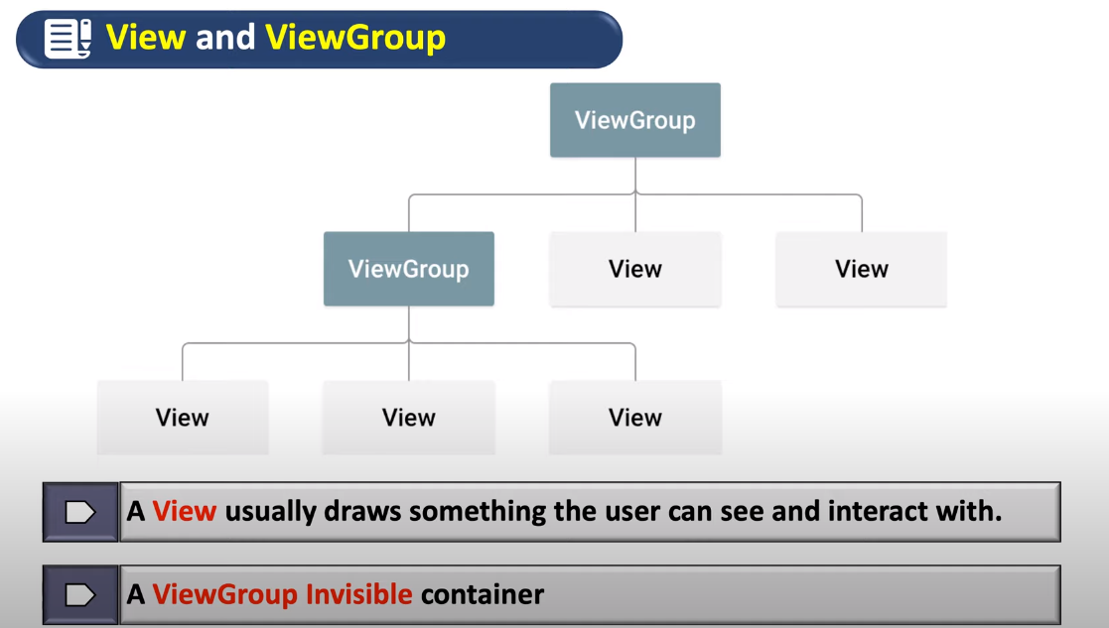

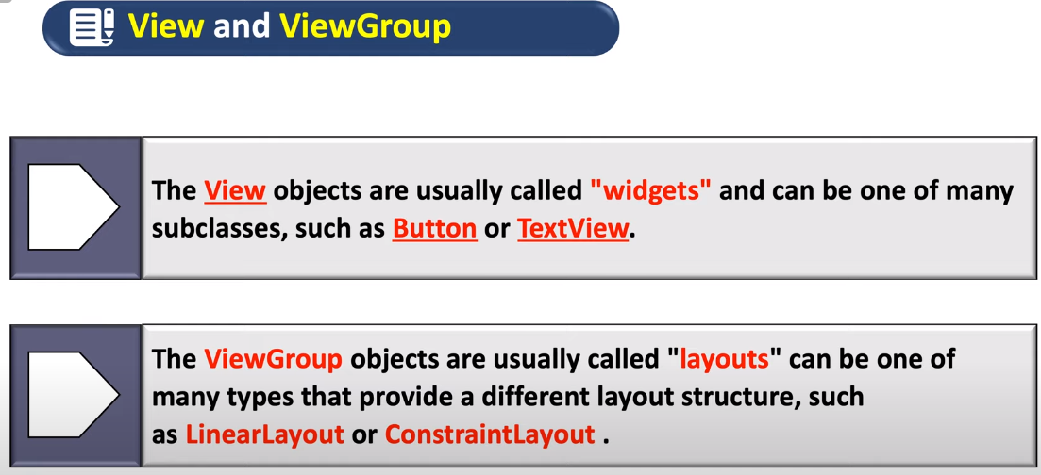

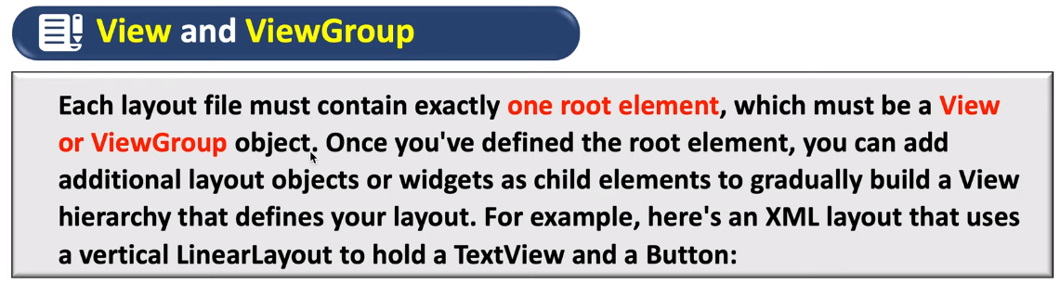

Linear layout with vertical orientation.

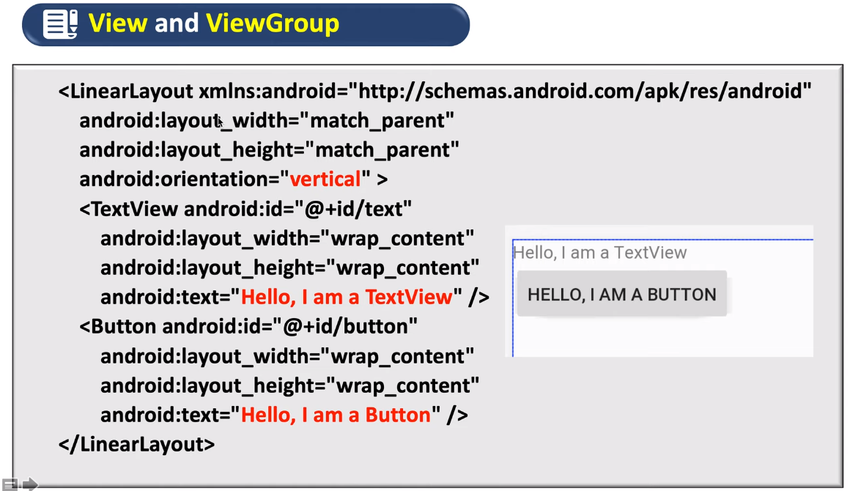

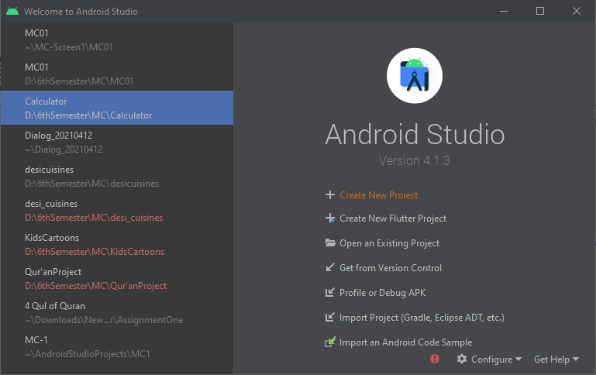

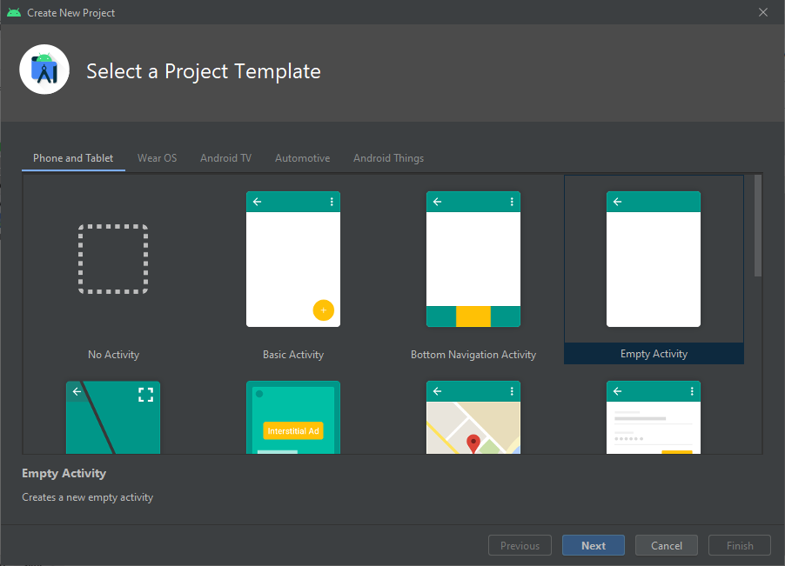

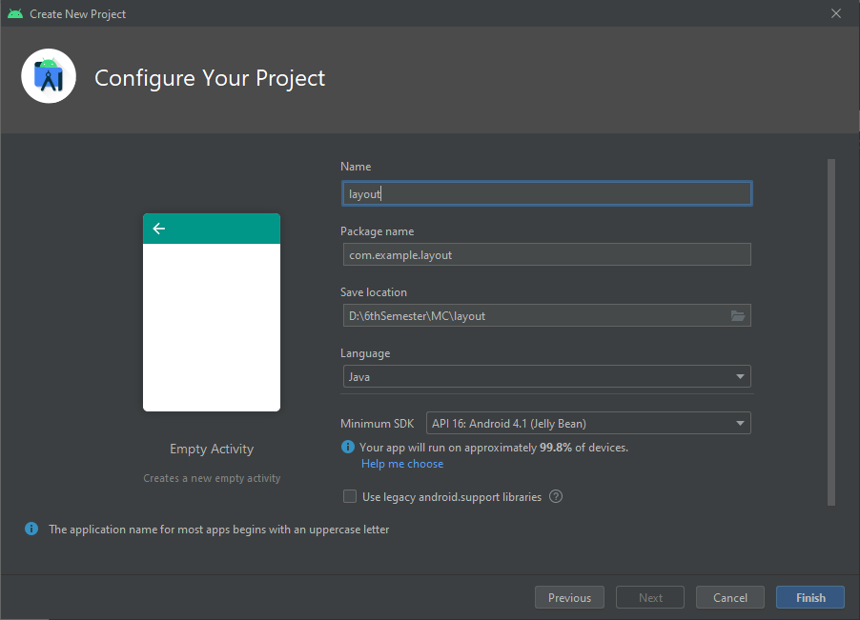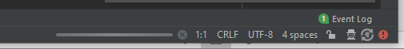

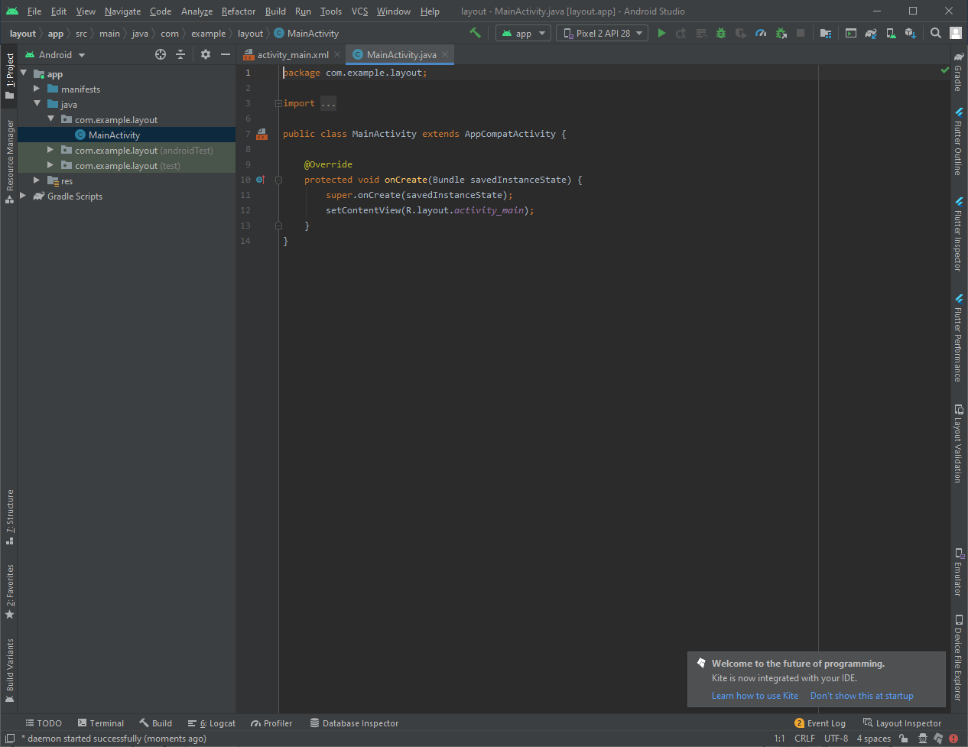

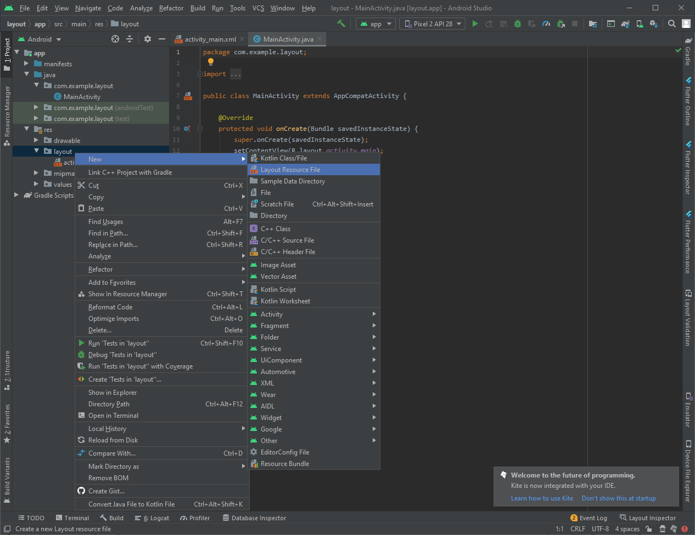

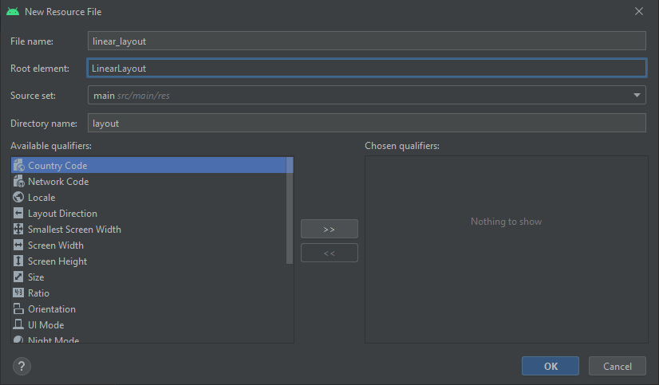

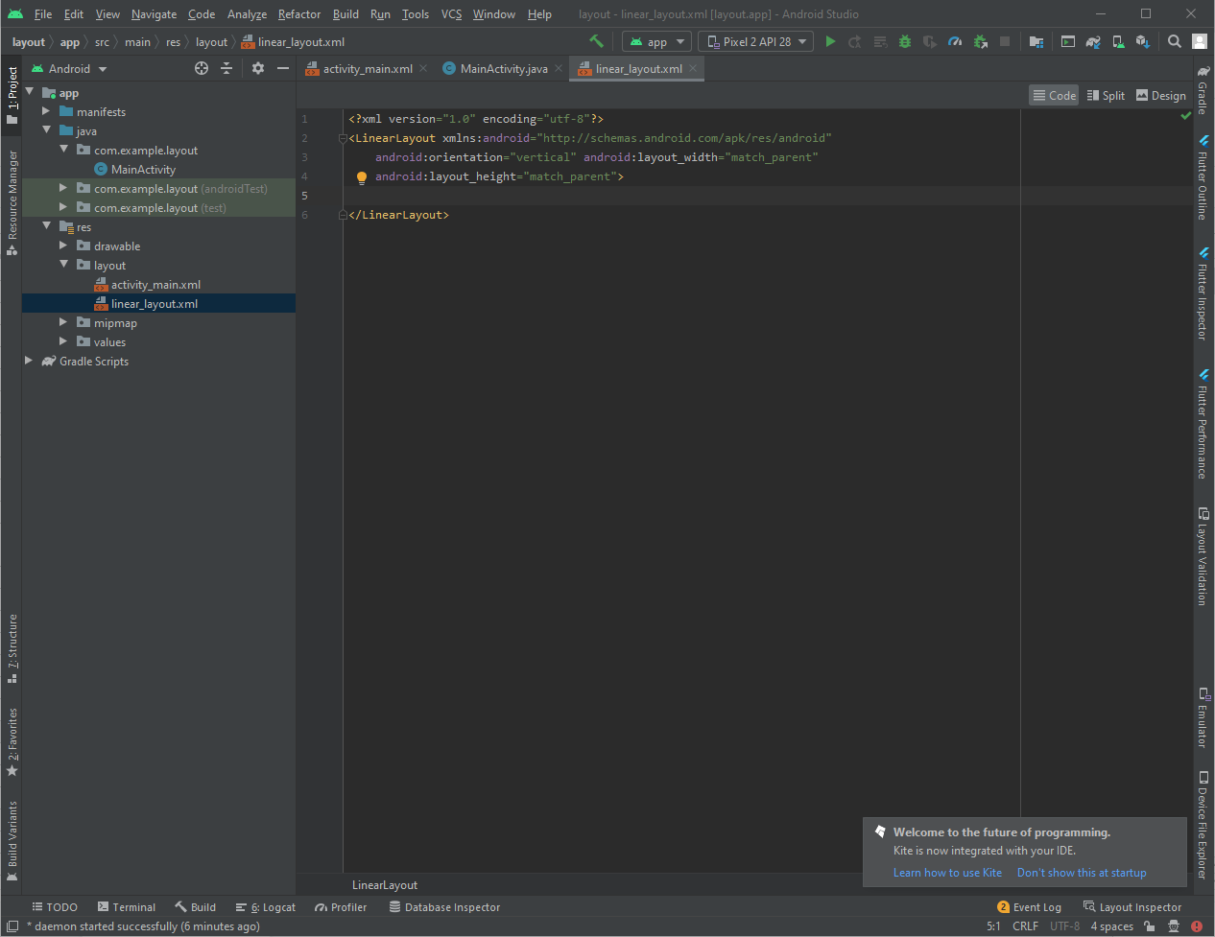

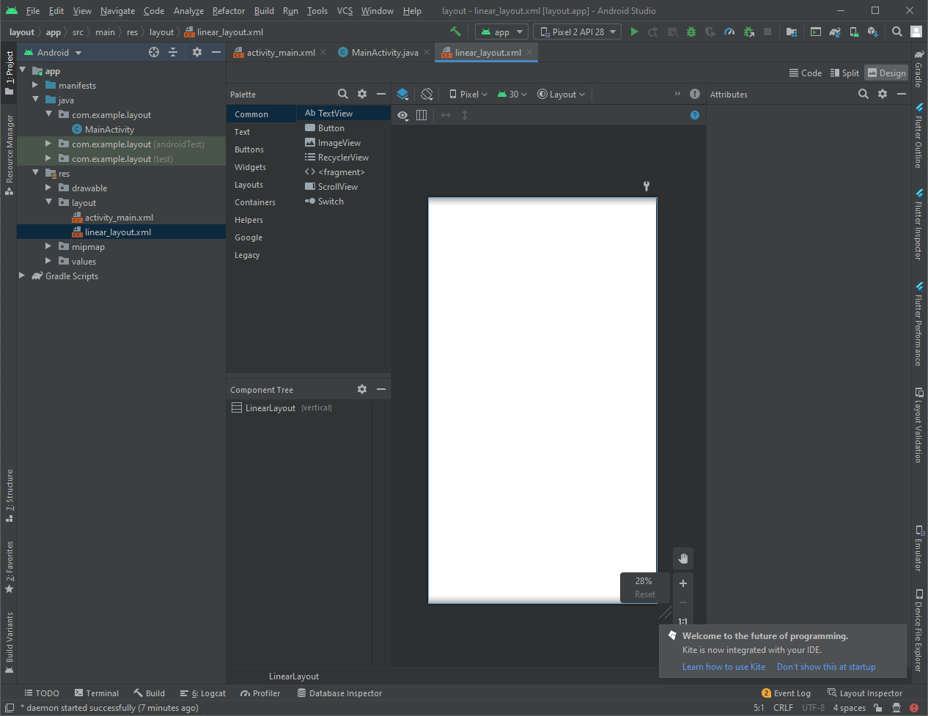

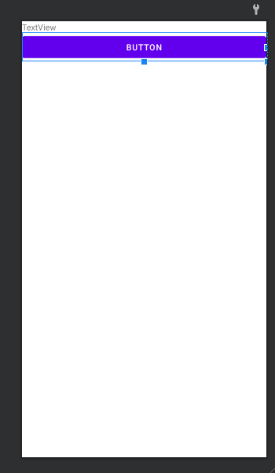

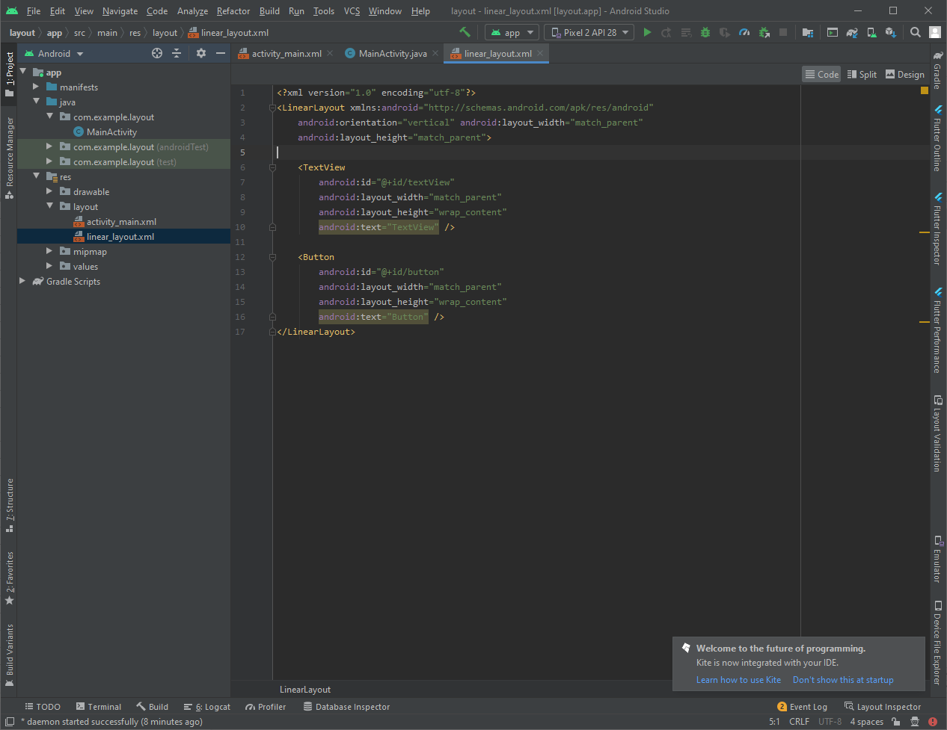

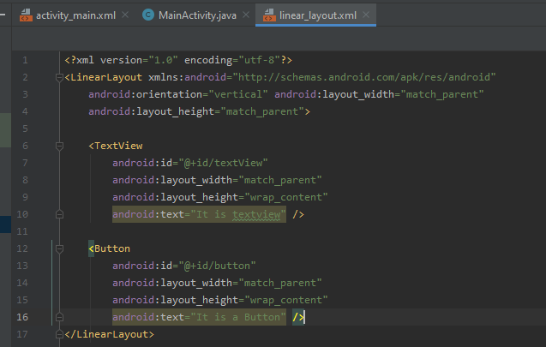

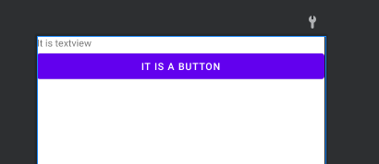

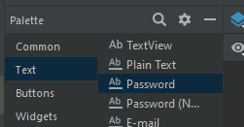

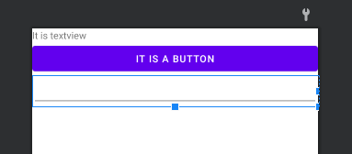

Starting point

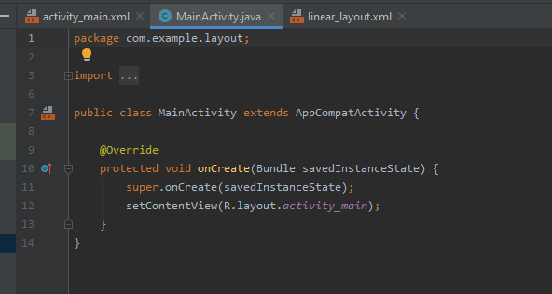

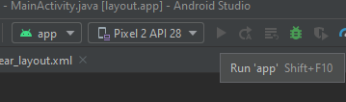

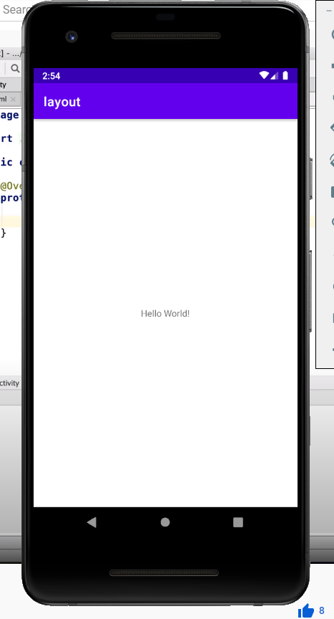

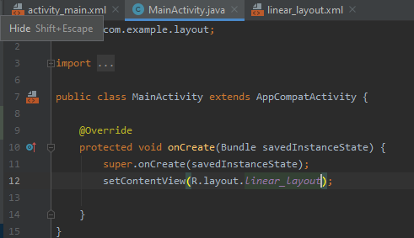

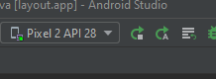

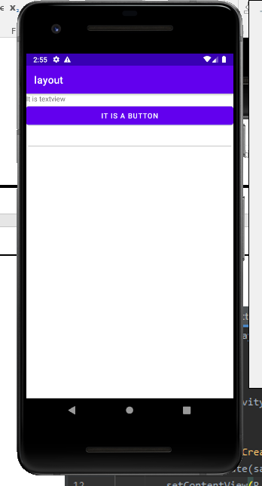

## layout parameters

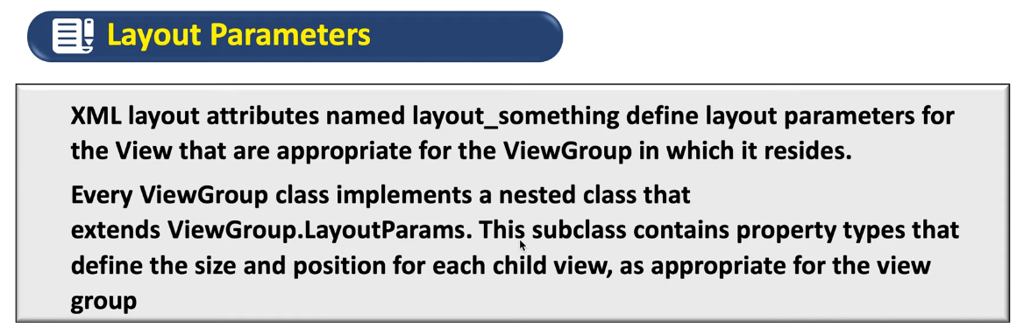

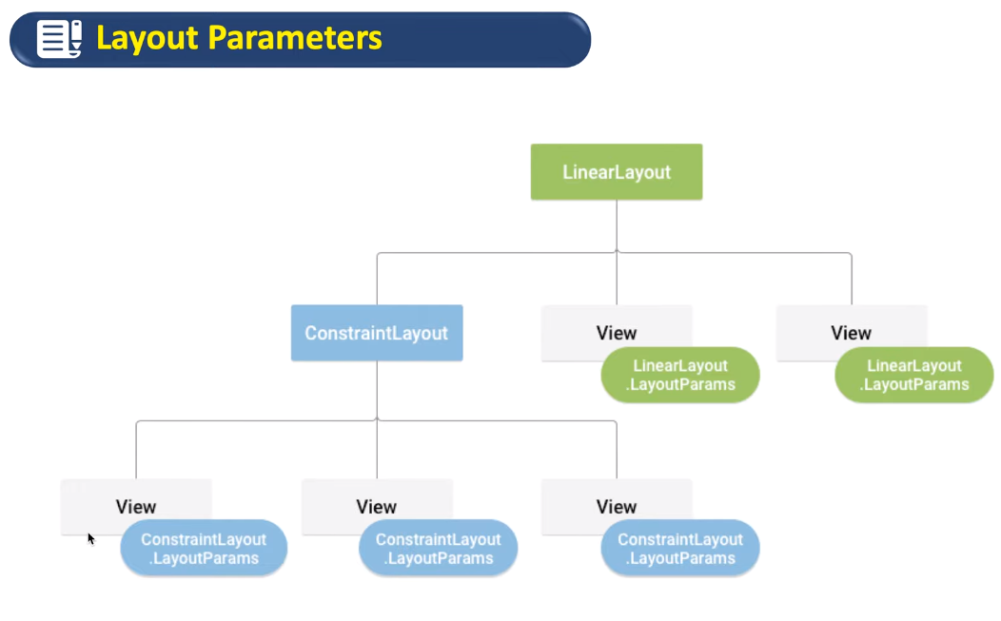

## Constraint layout

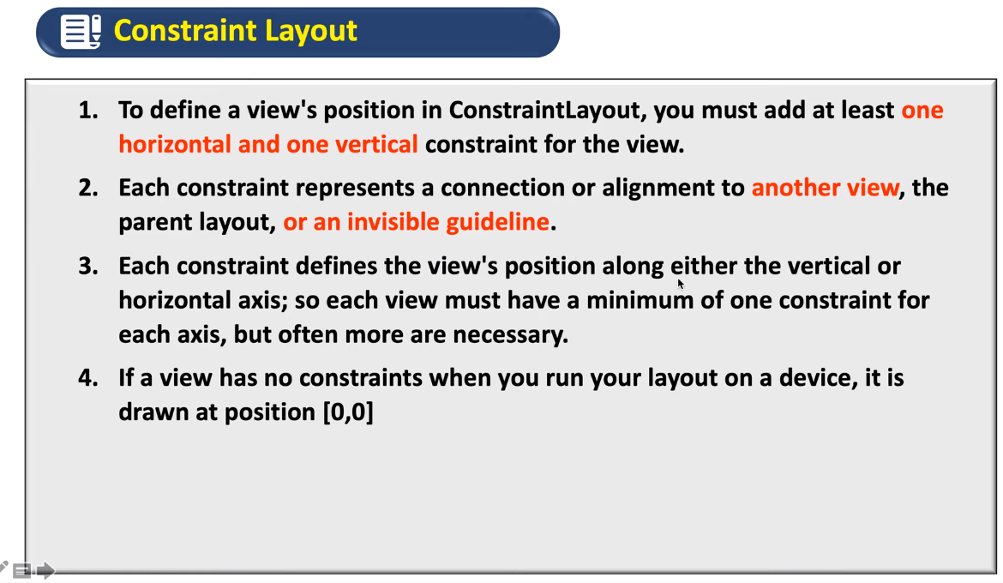

Guess

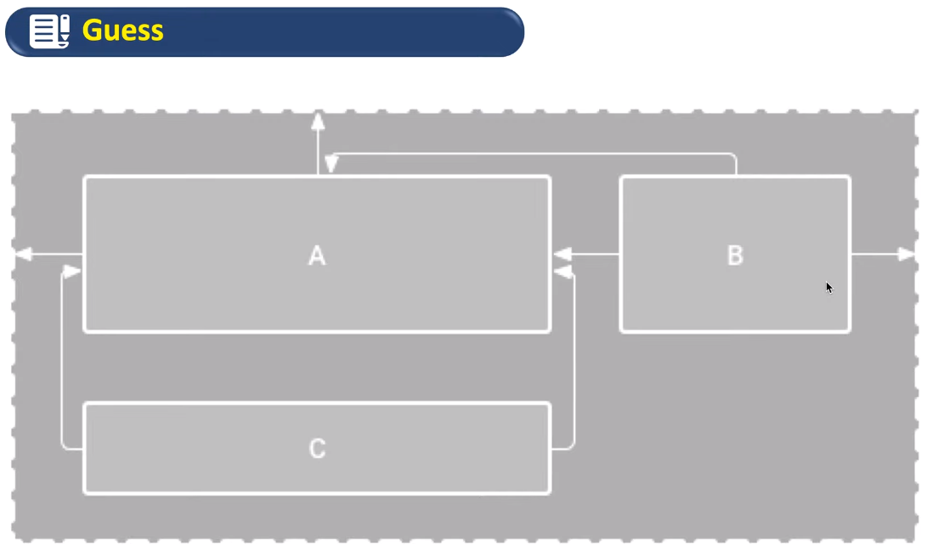

Issue is C’s Y axix component is missing

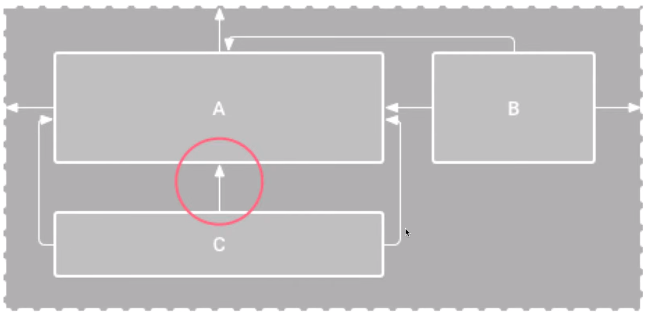

## Required dependency

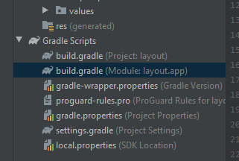

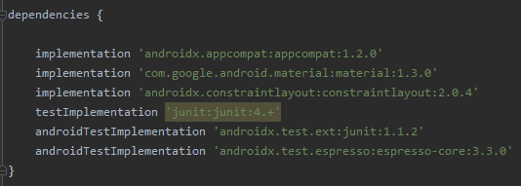

Example of constraint layout

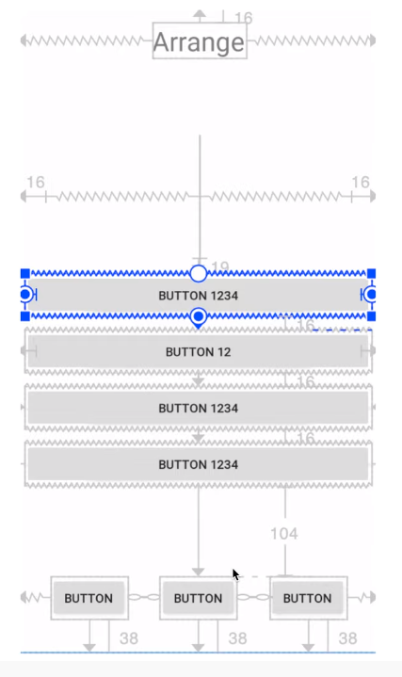

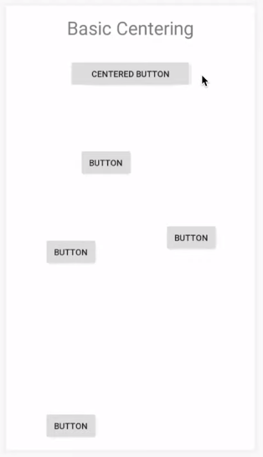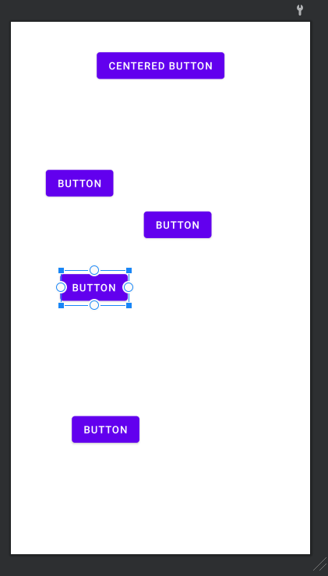

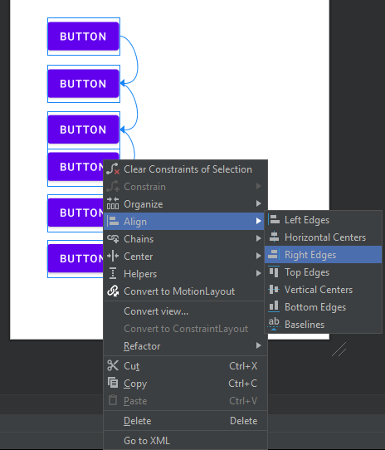

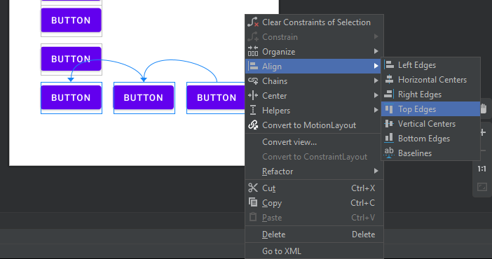

Is all left series of buttons move together?

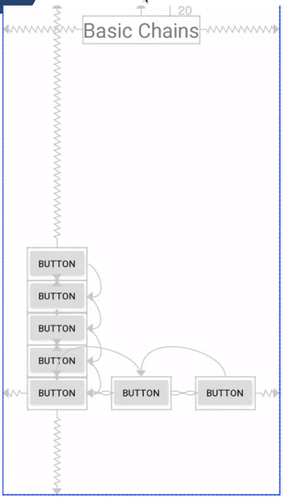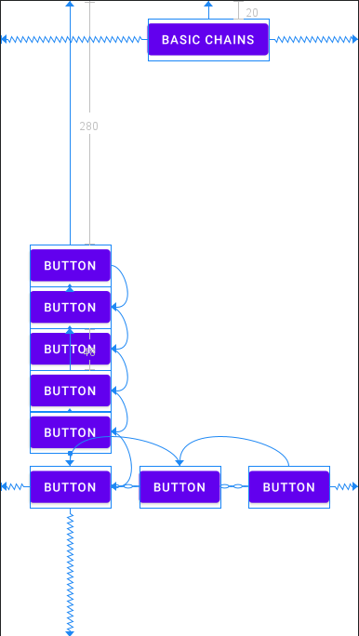

Calculator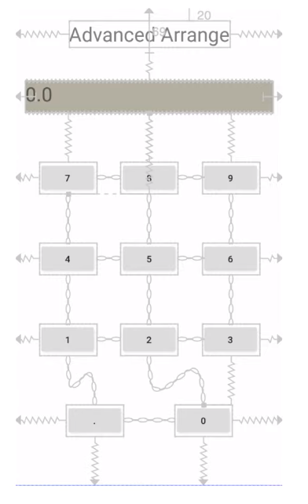

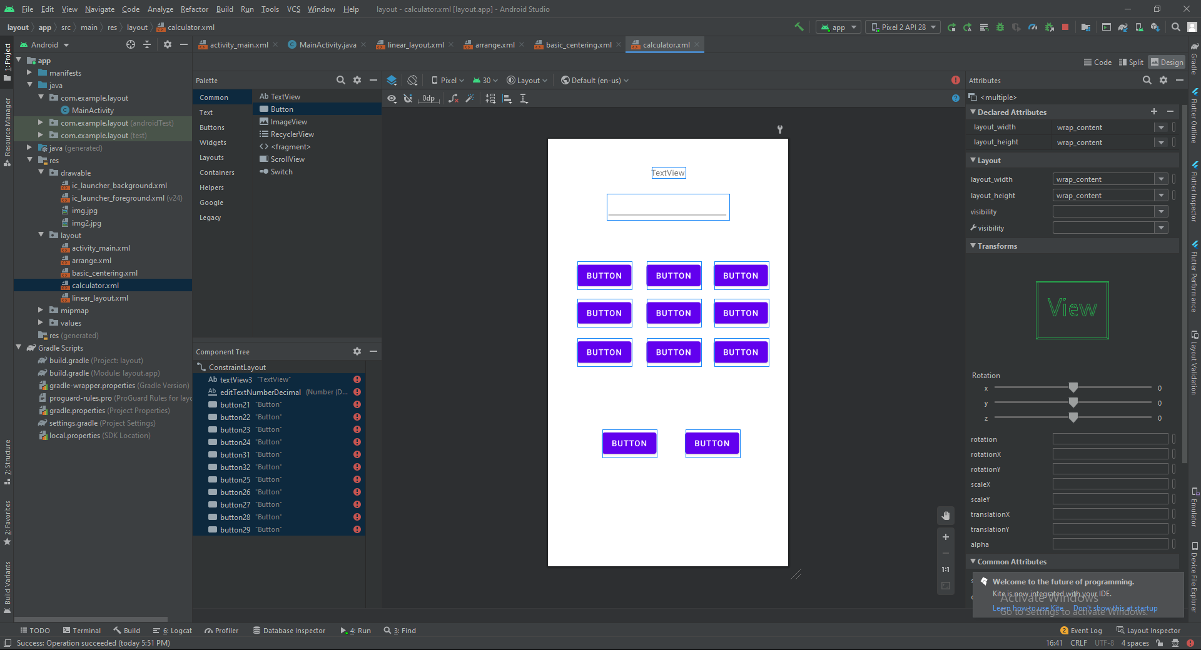  
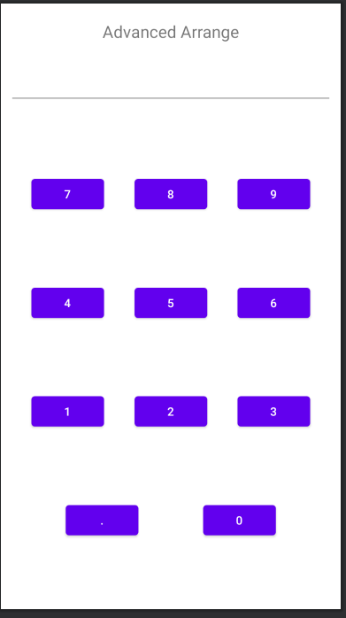

## Clear all constraints

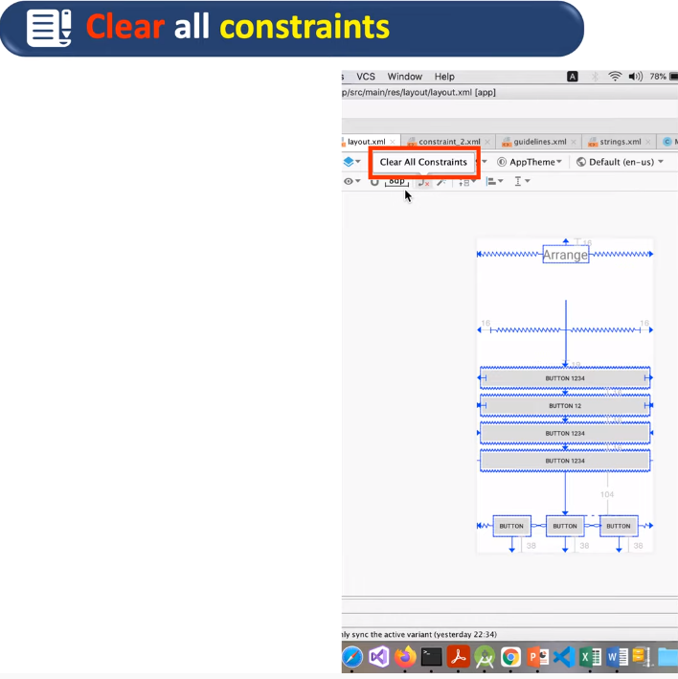

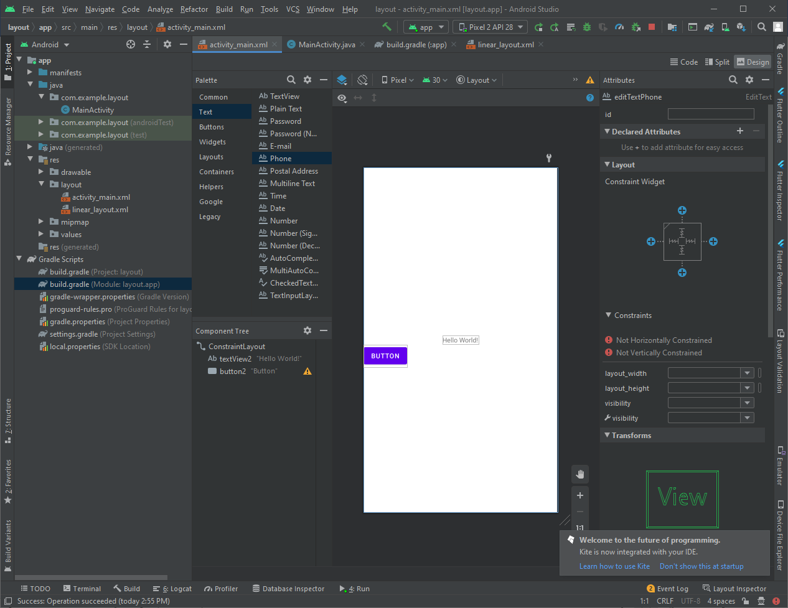

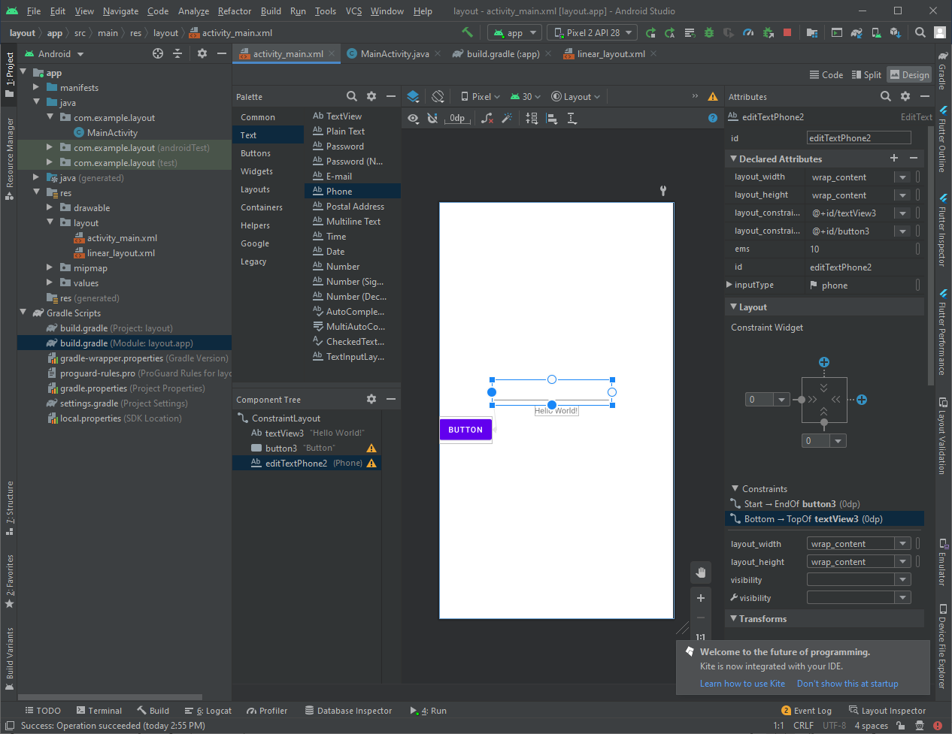

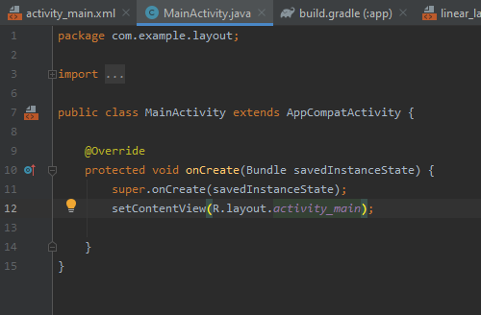

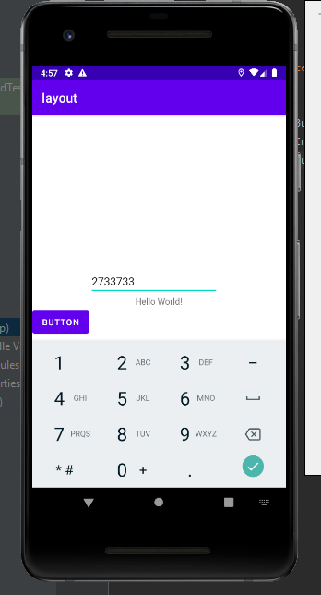

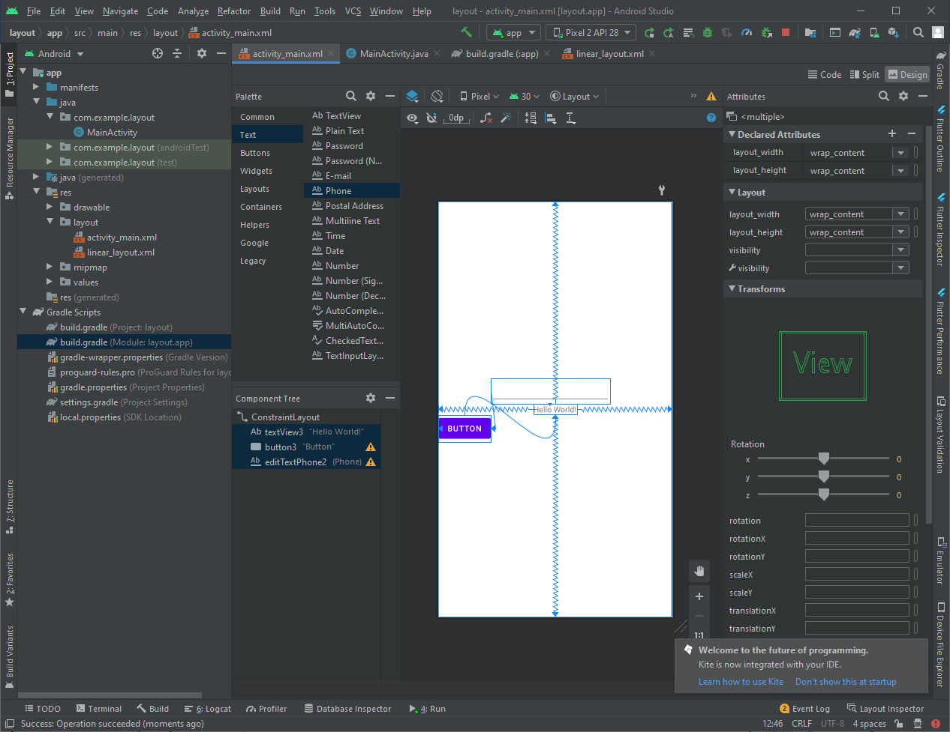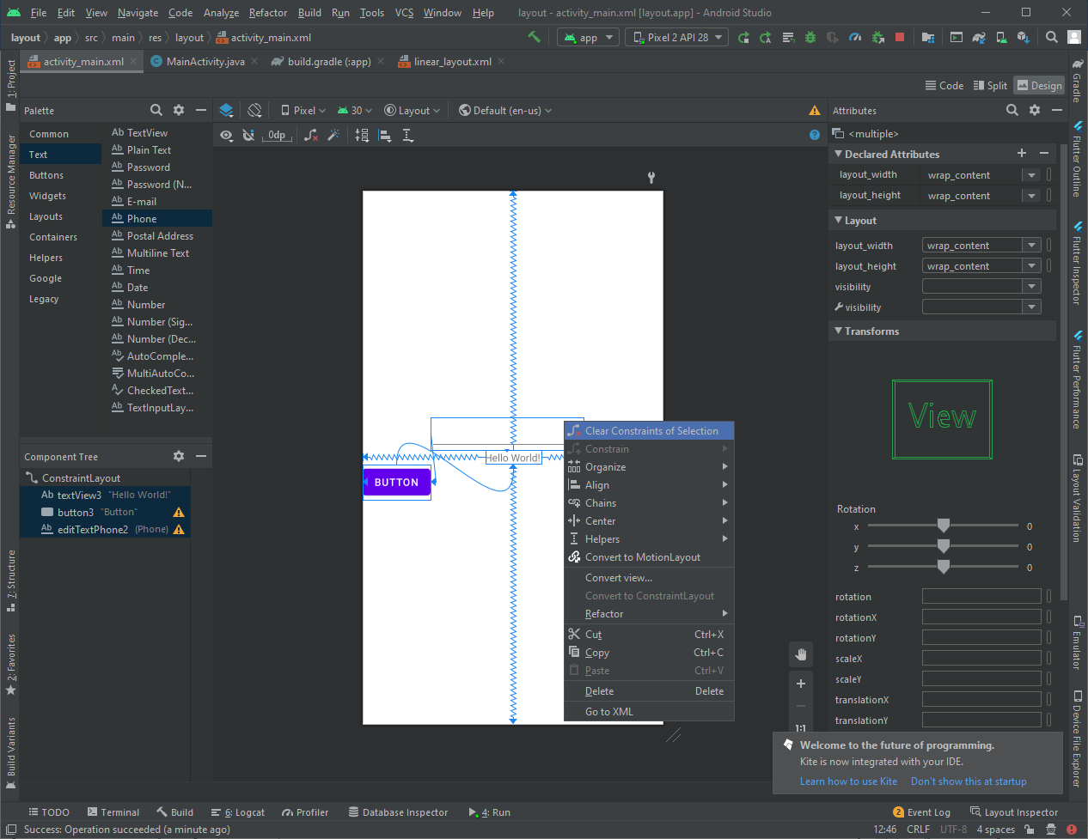

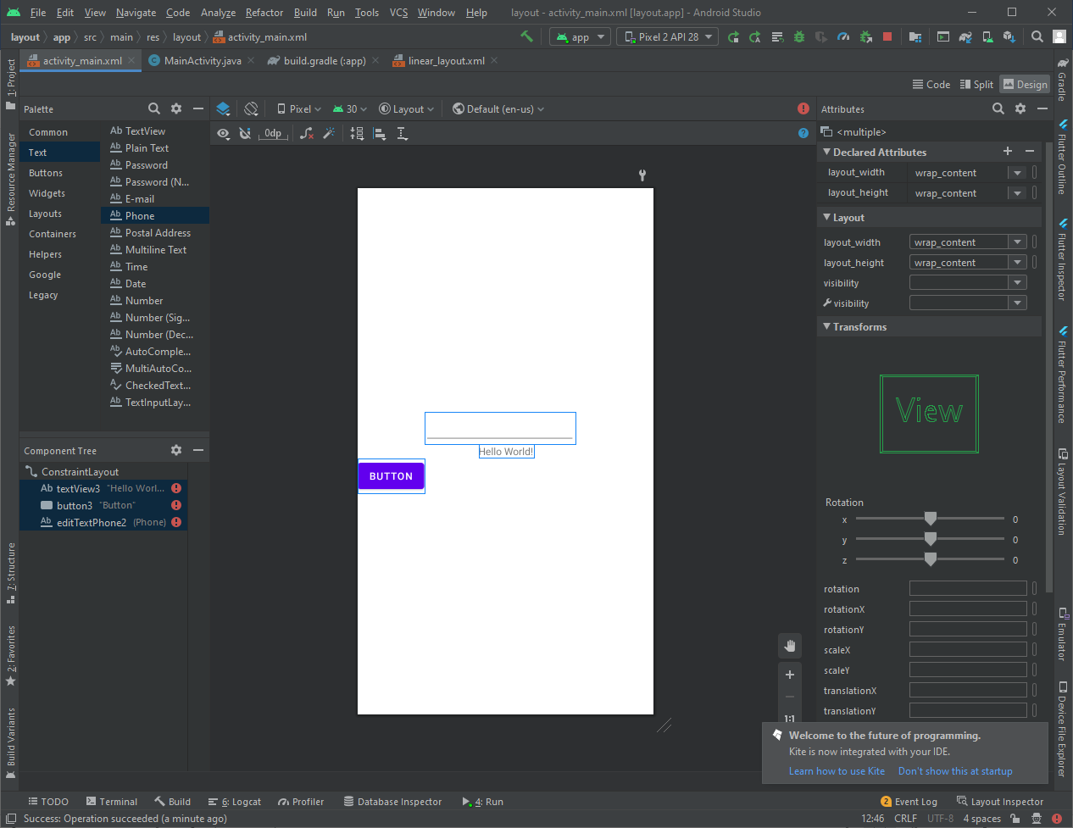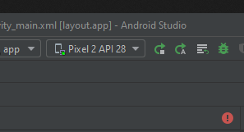

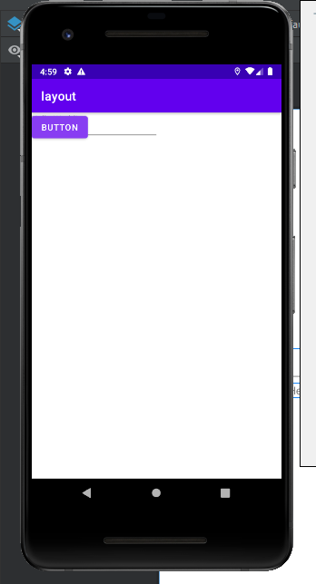

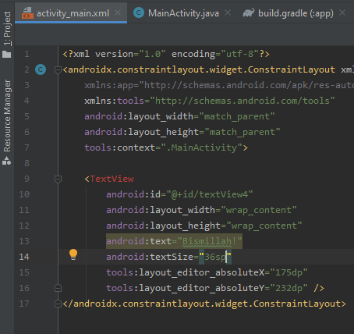

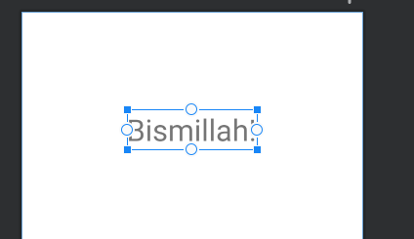

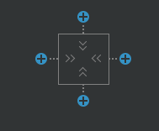

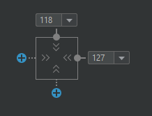

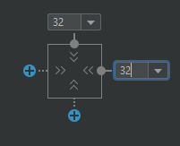

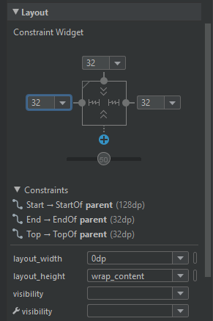

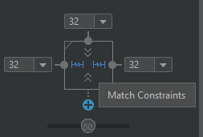

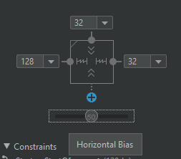

## Add or remove constraint

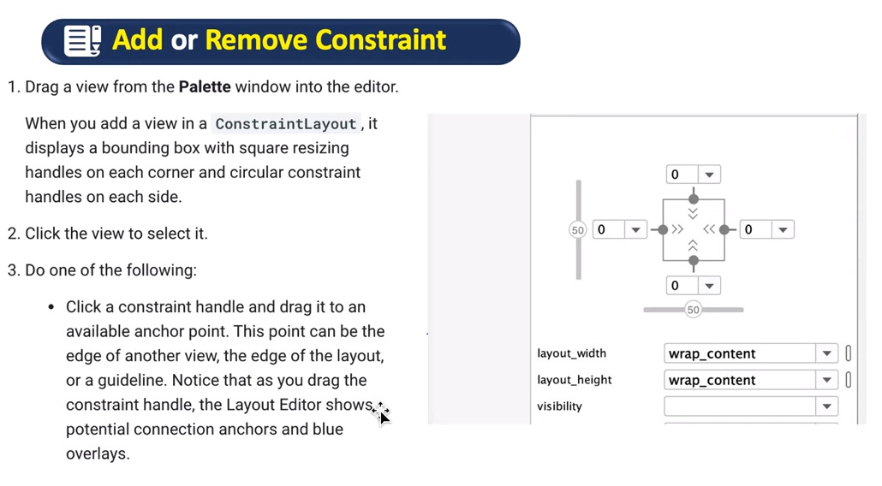

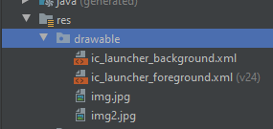

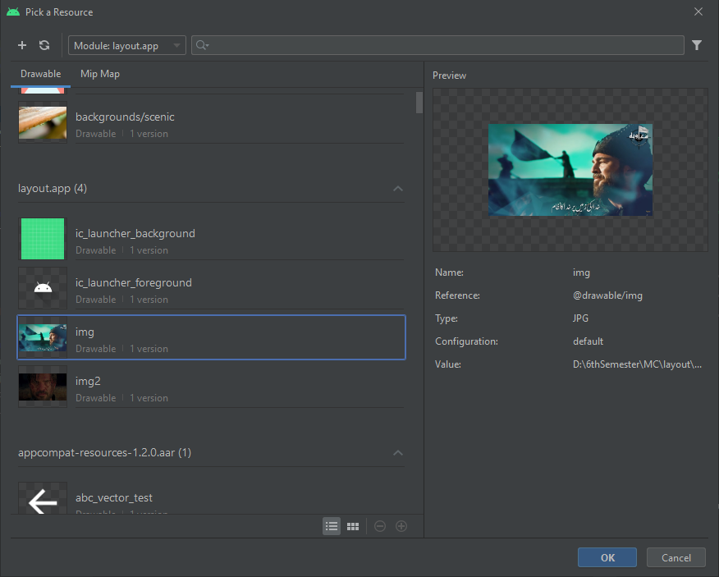

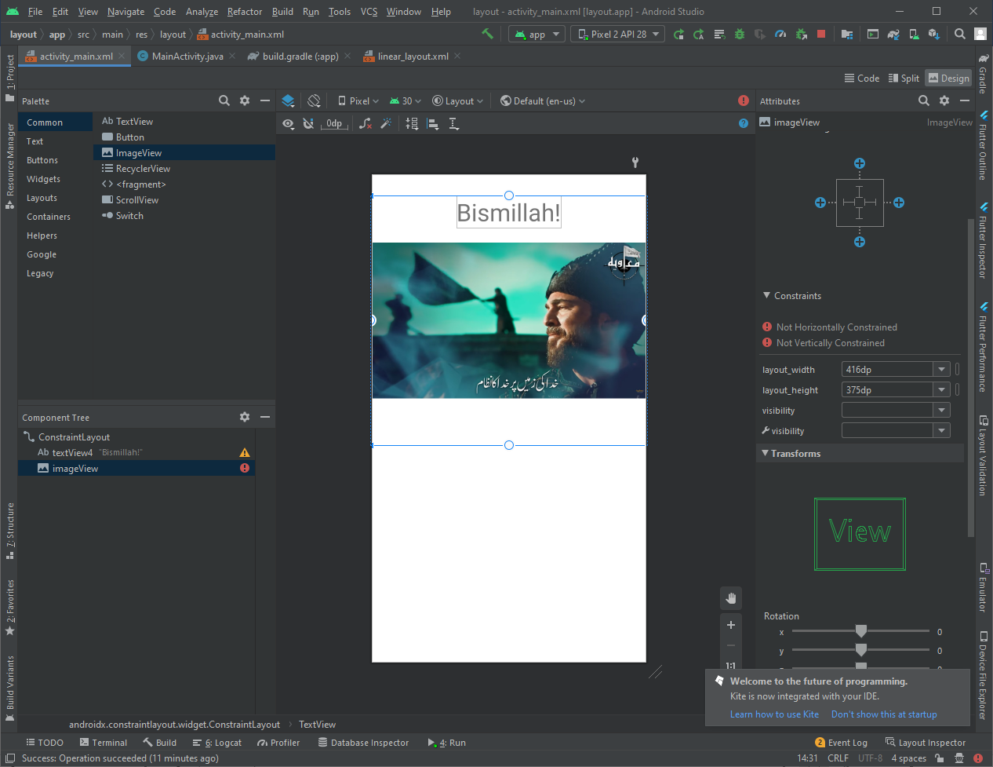

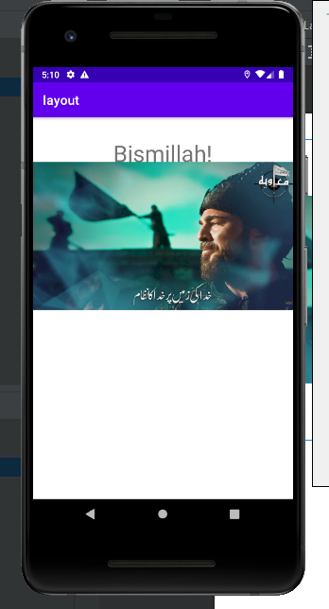

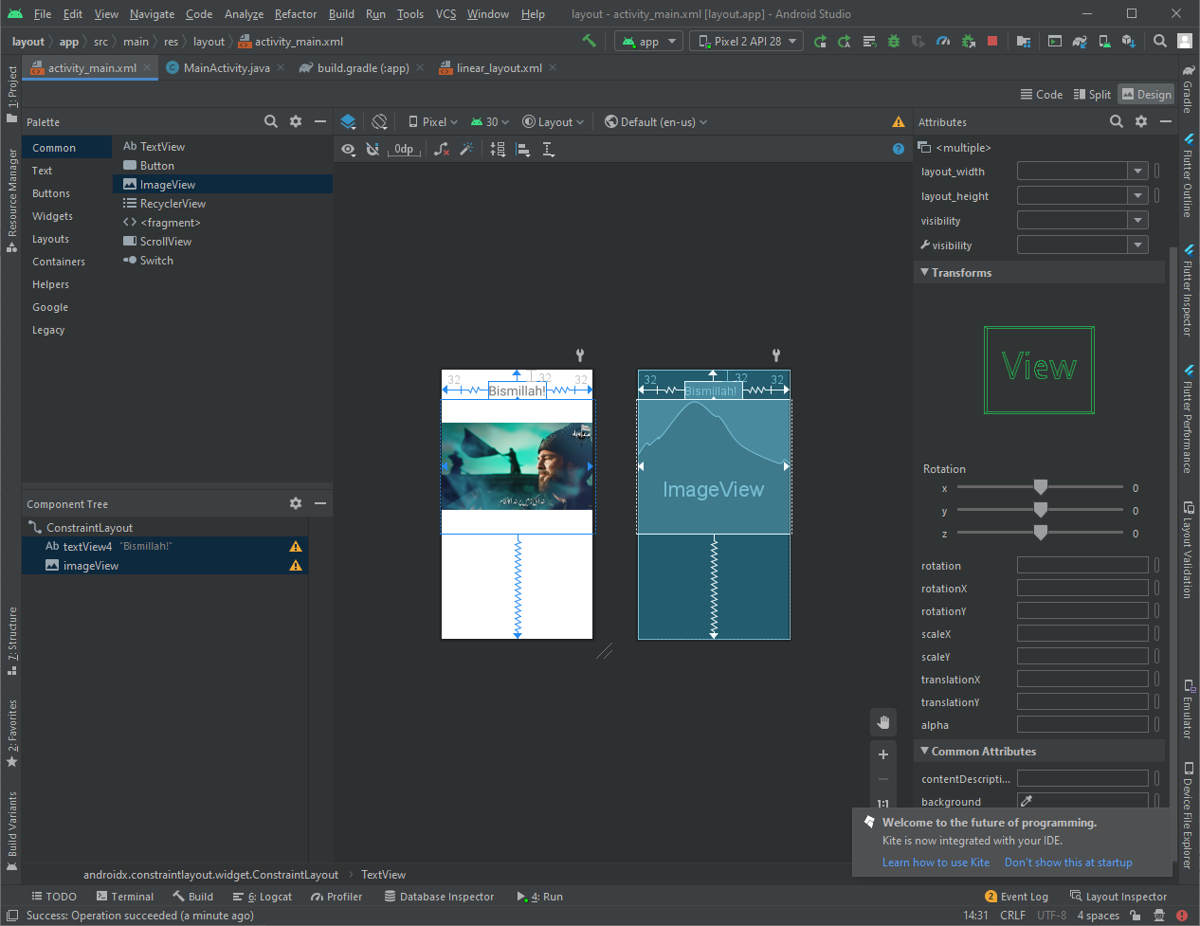

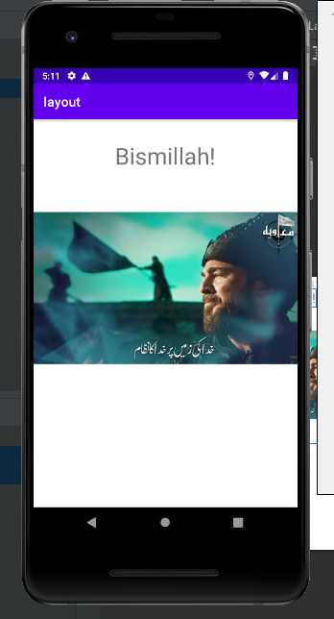

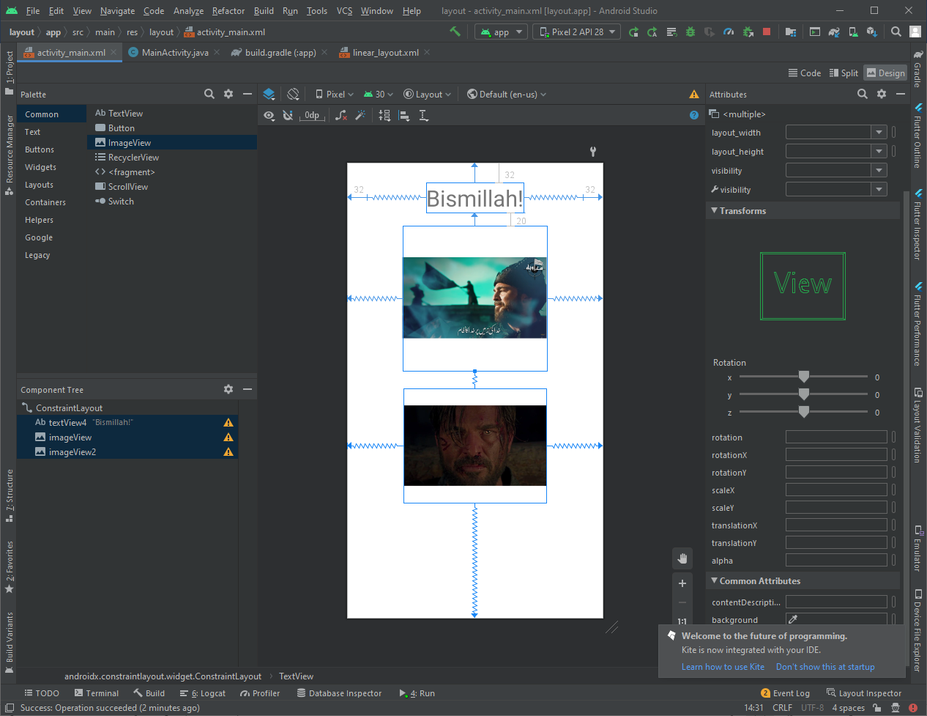

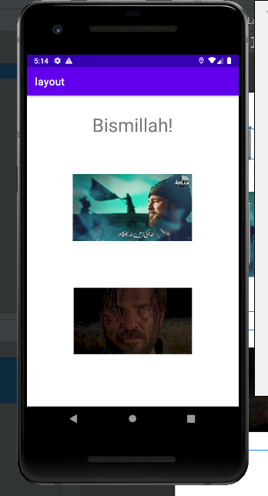

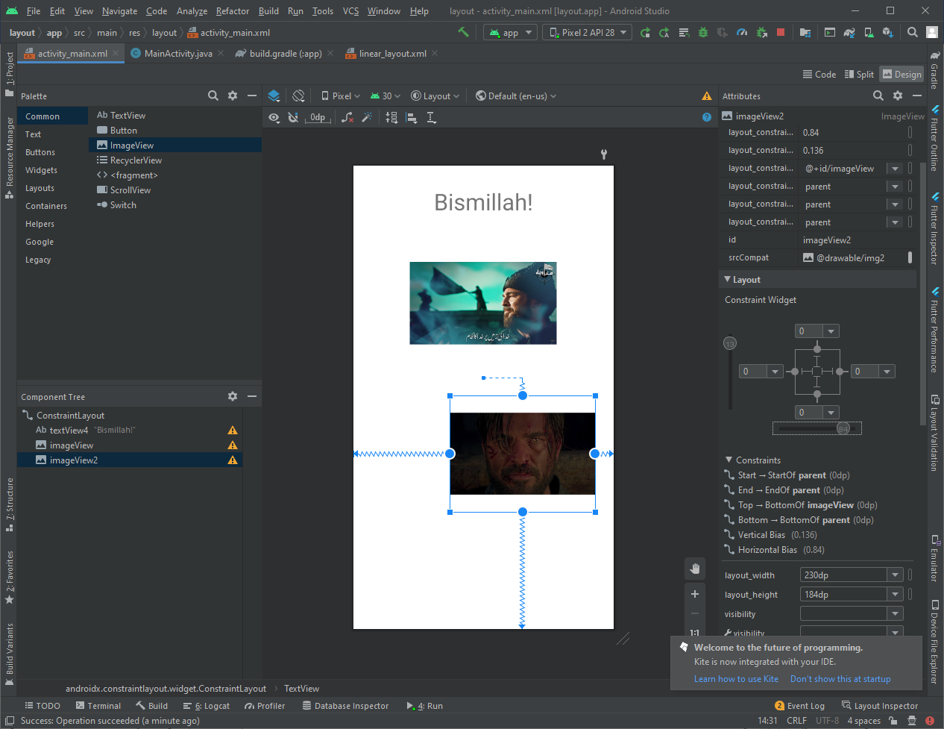

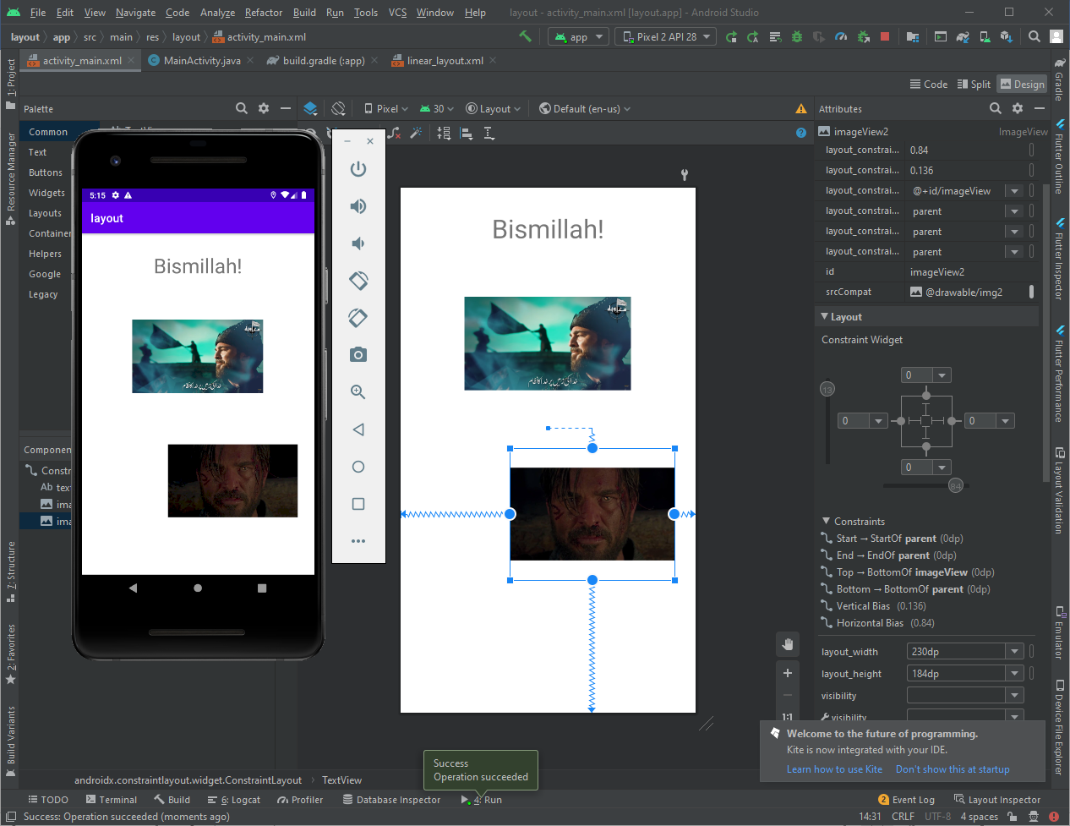

## Constraint baseline

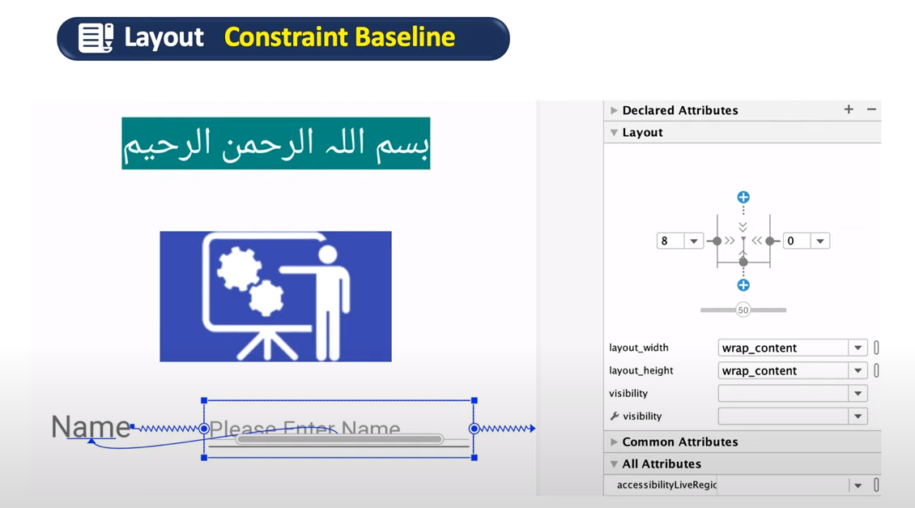

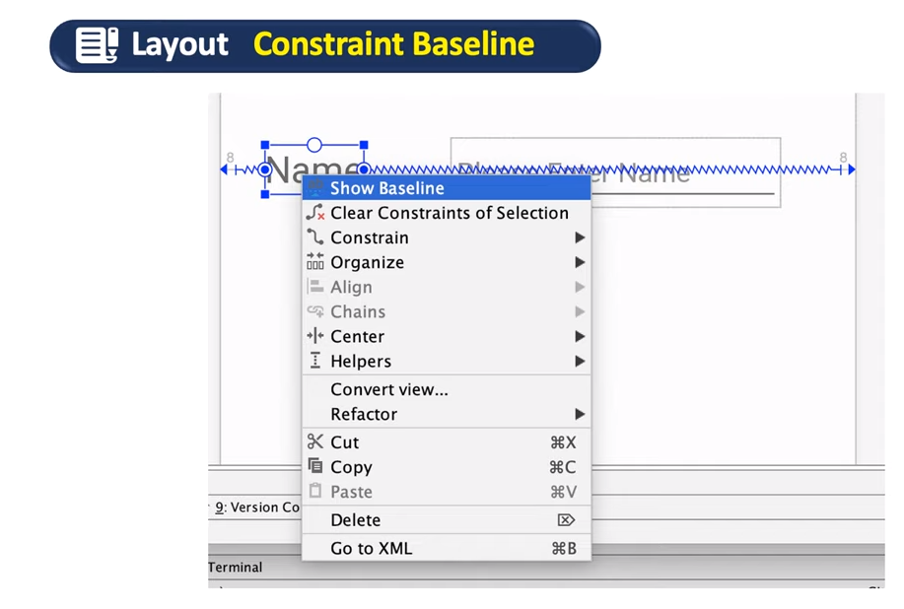

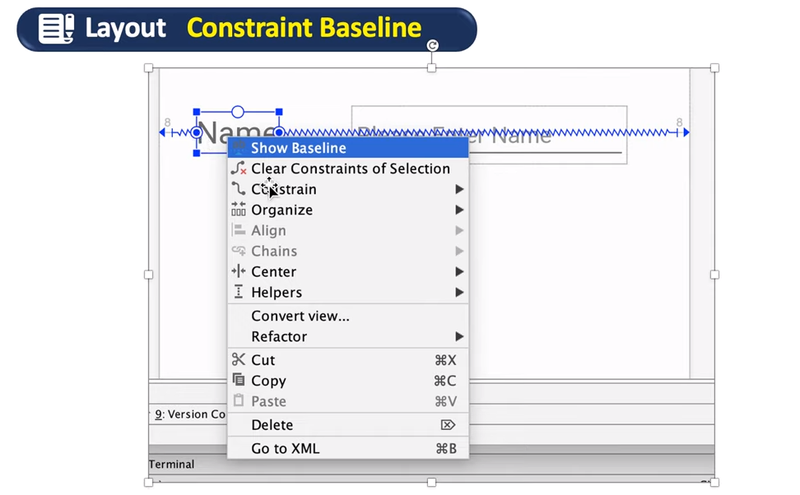

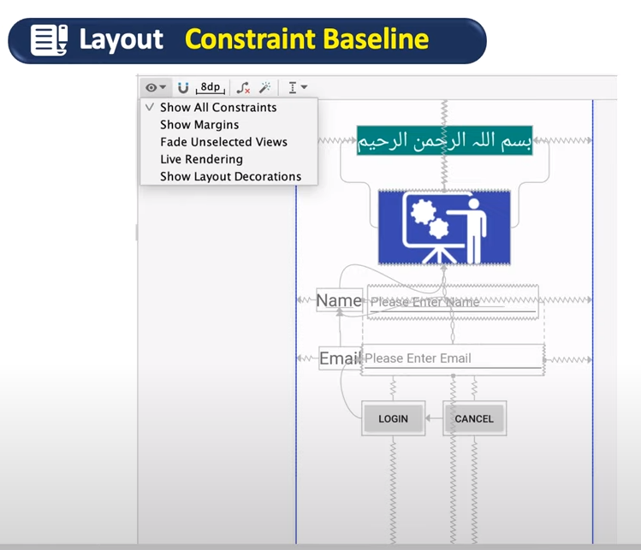

Show All constraints

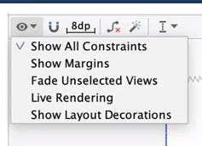

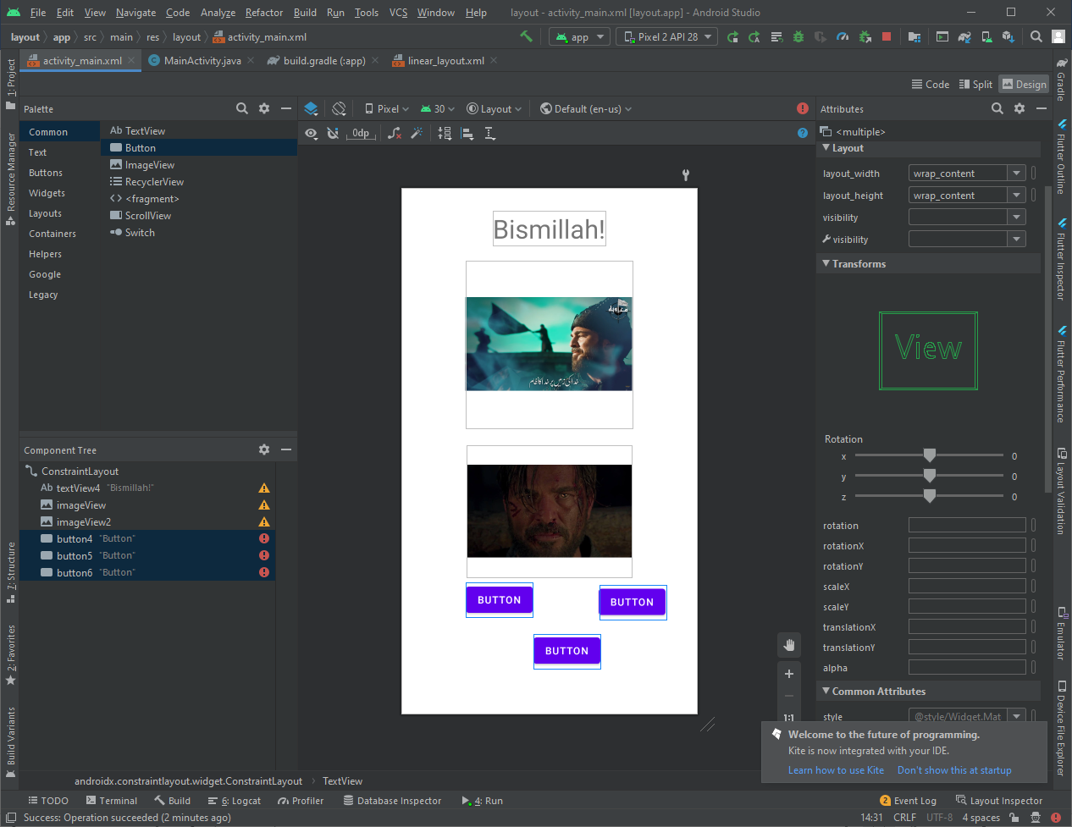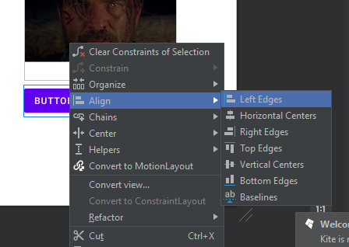

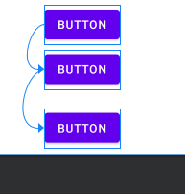

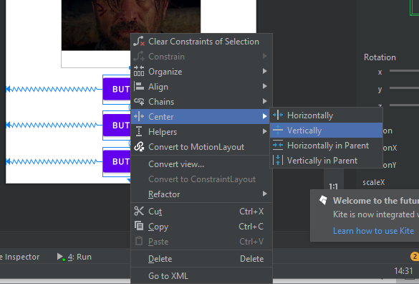

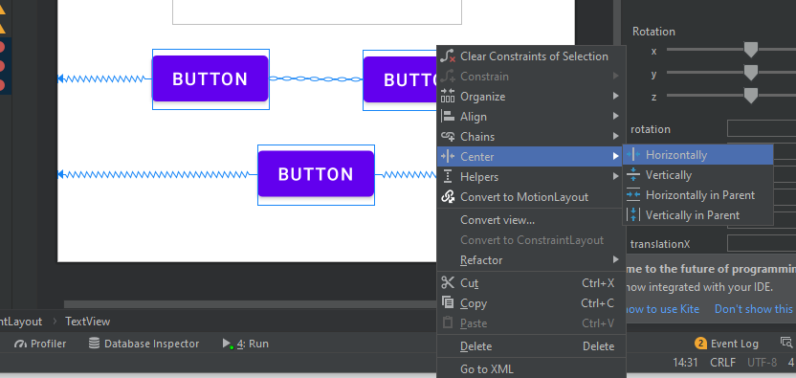

Horizontally align (chain)

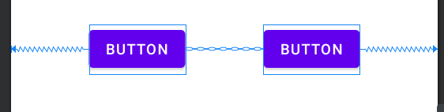

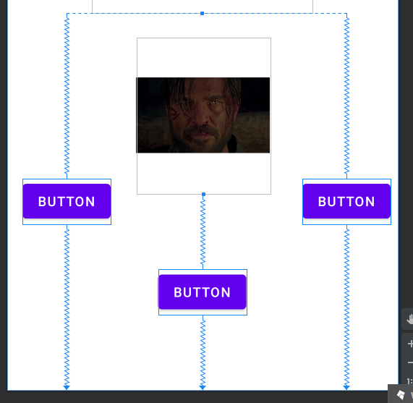

## Match constraints

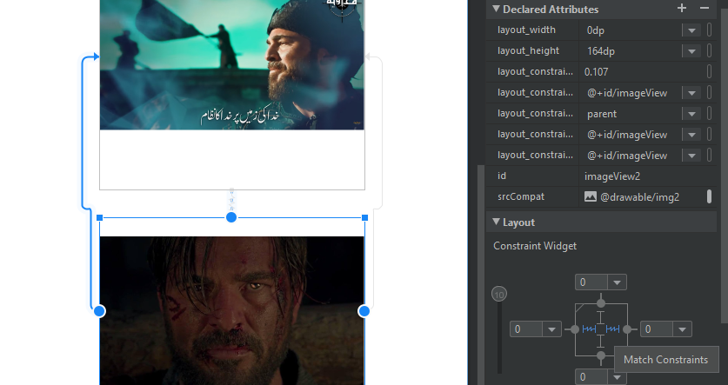

## Layout constraint Expand Horizontally/vertically

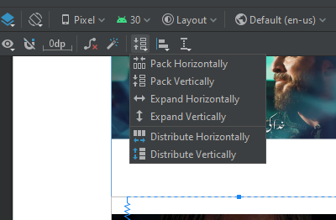

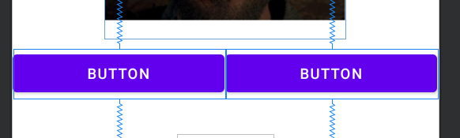

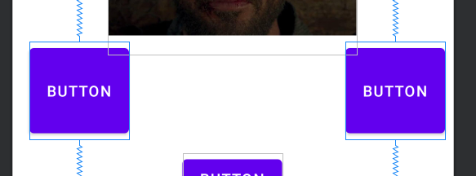

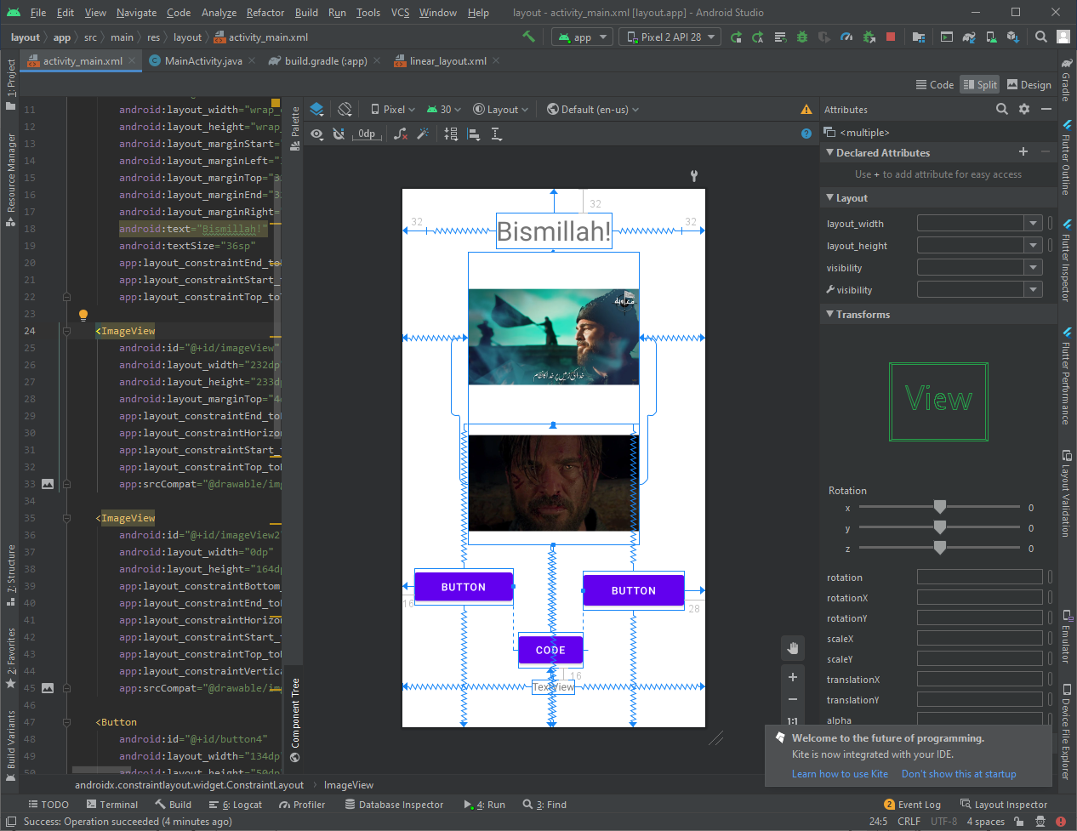

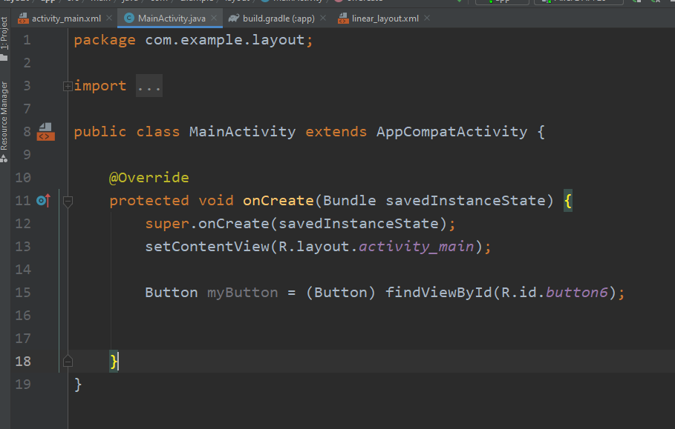

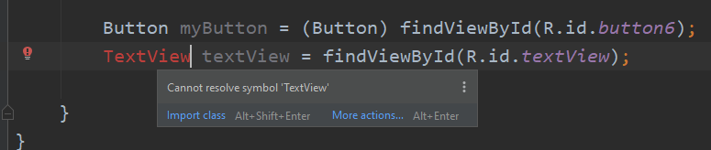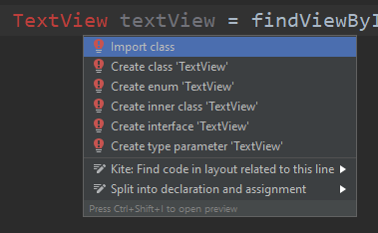

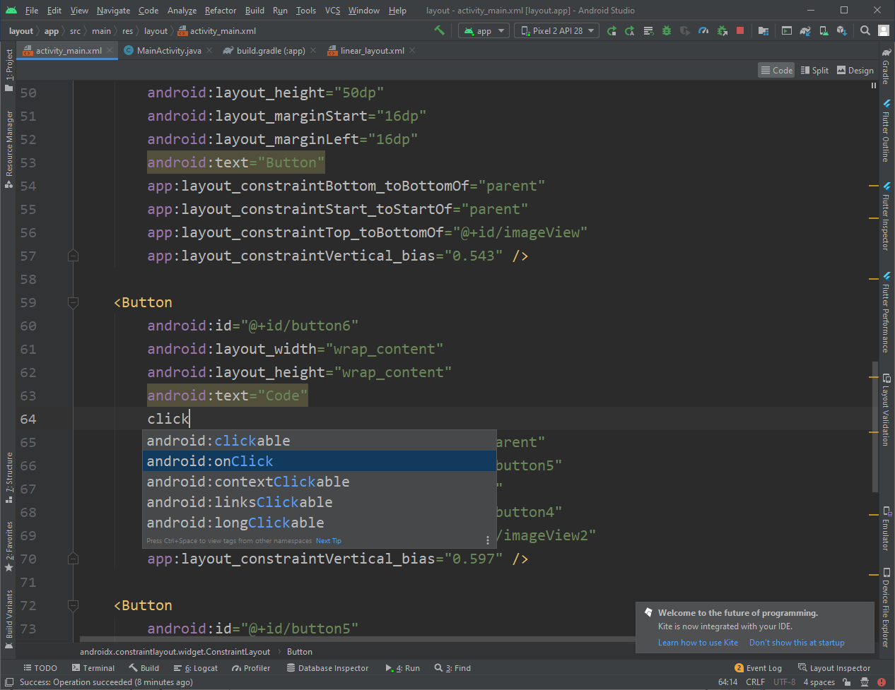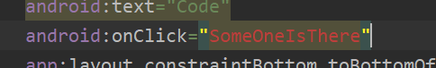

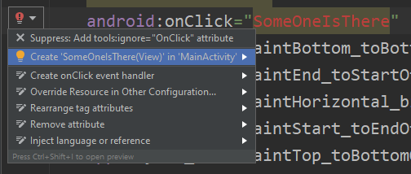

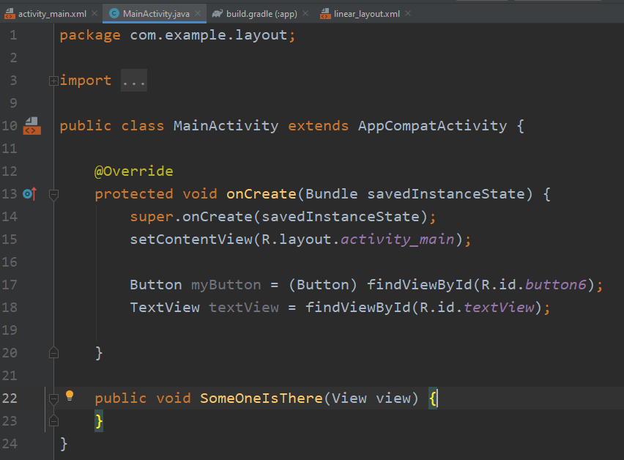

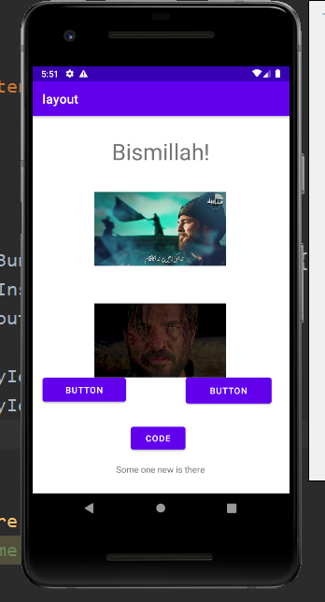

**Lecture_08_Intent**

**Project Created:**

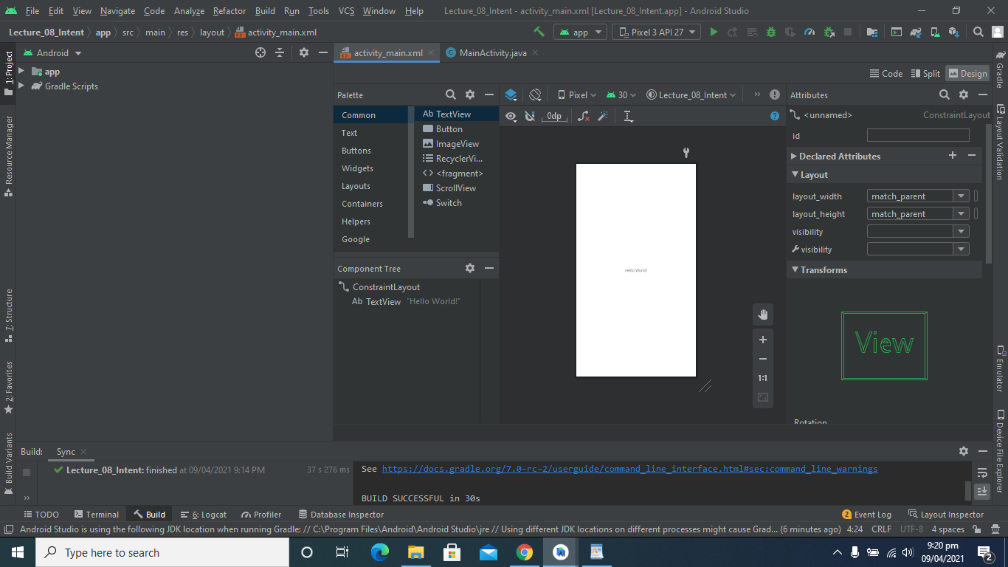

**Make Strings Instead of Text:**

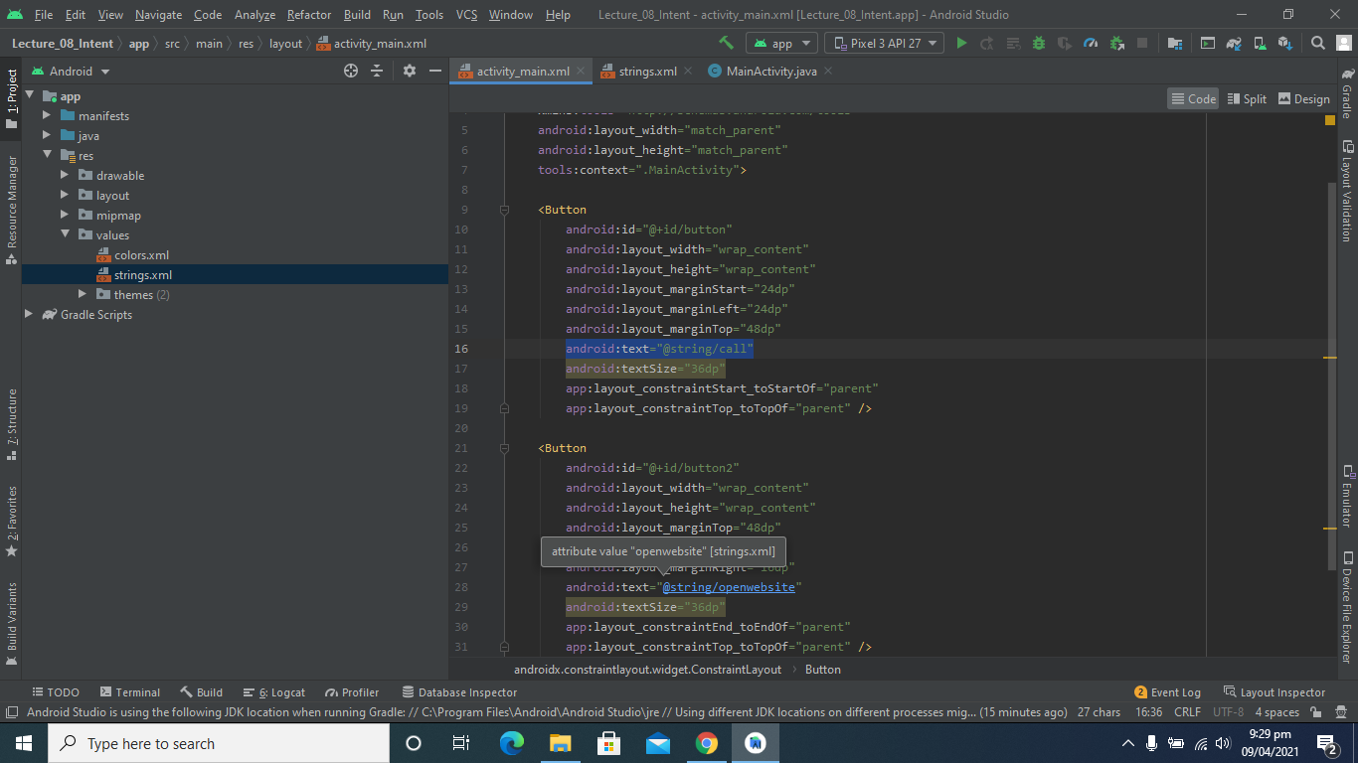

**Make Call and Website Buttons:**

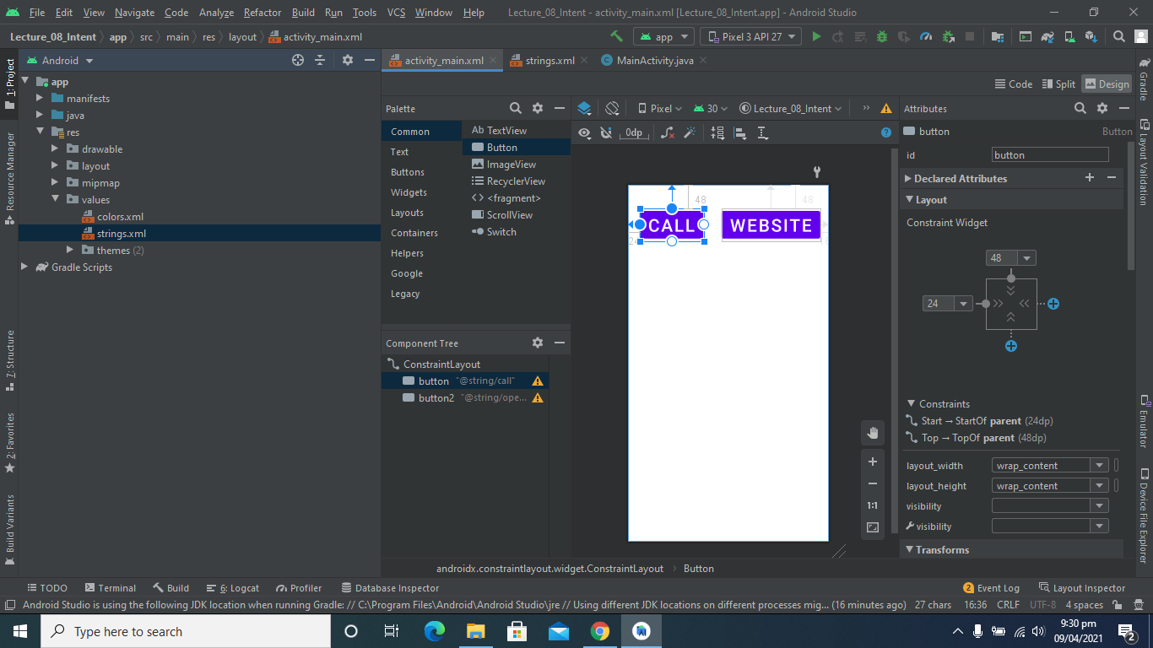

**Output:**

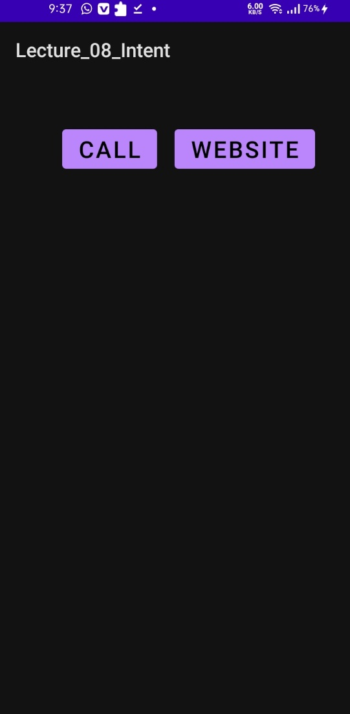

**Write Functions Definitions:**

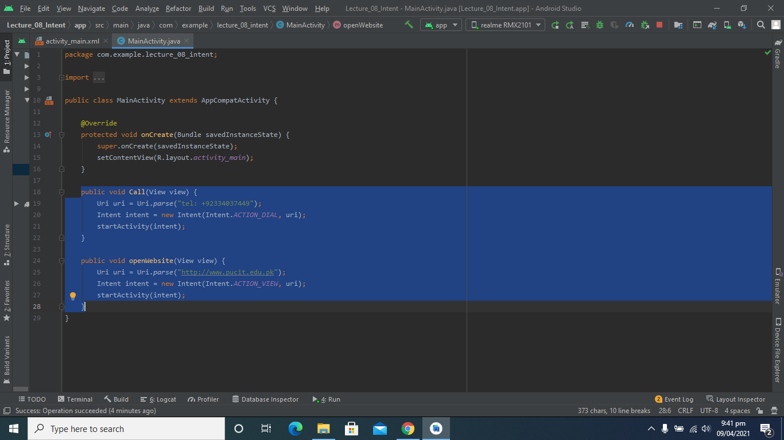

**New Activity Created:**

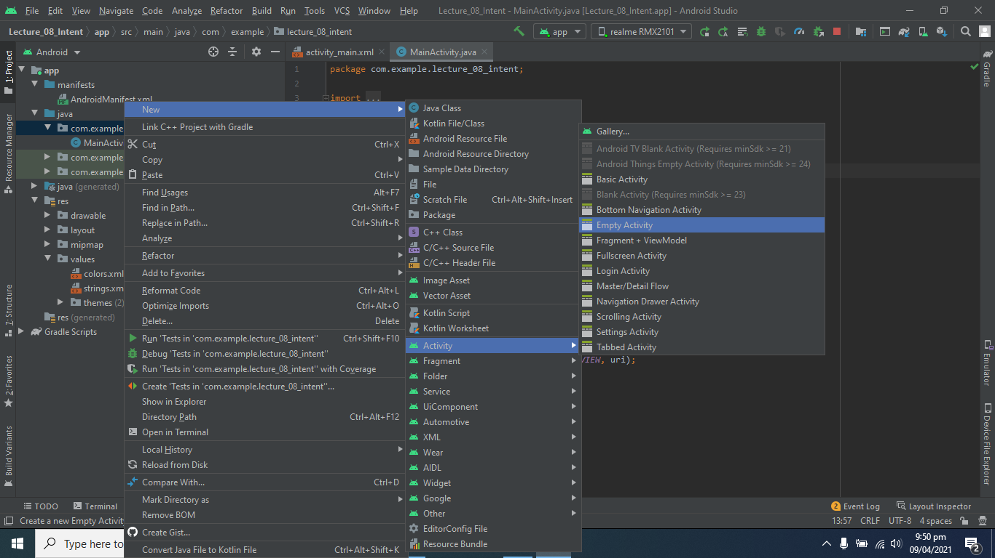

**Make button to move on another Activity:**

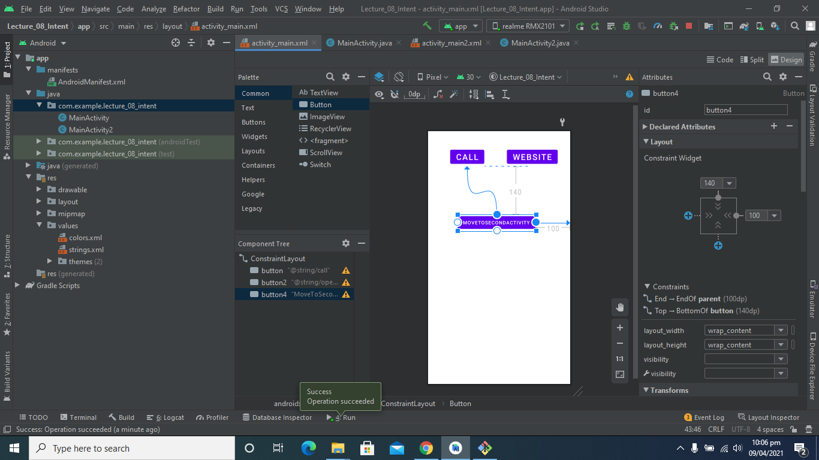

**Make button to move on another Activity:**

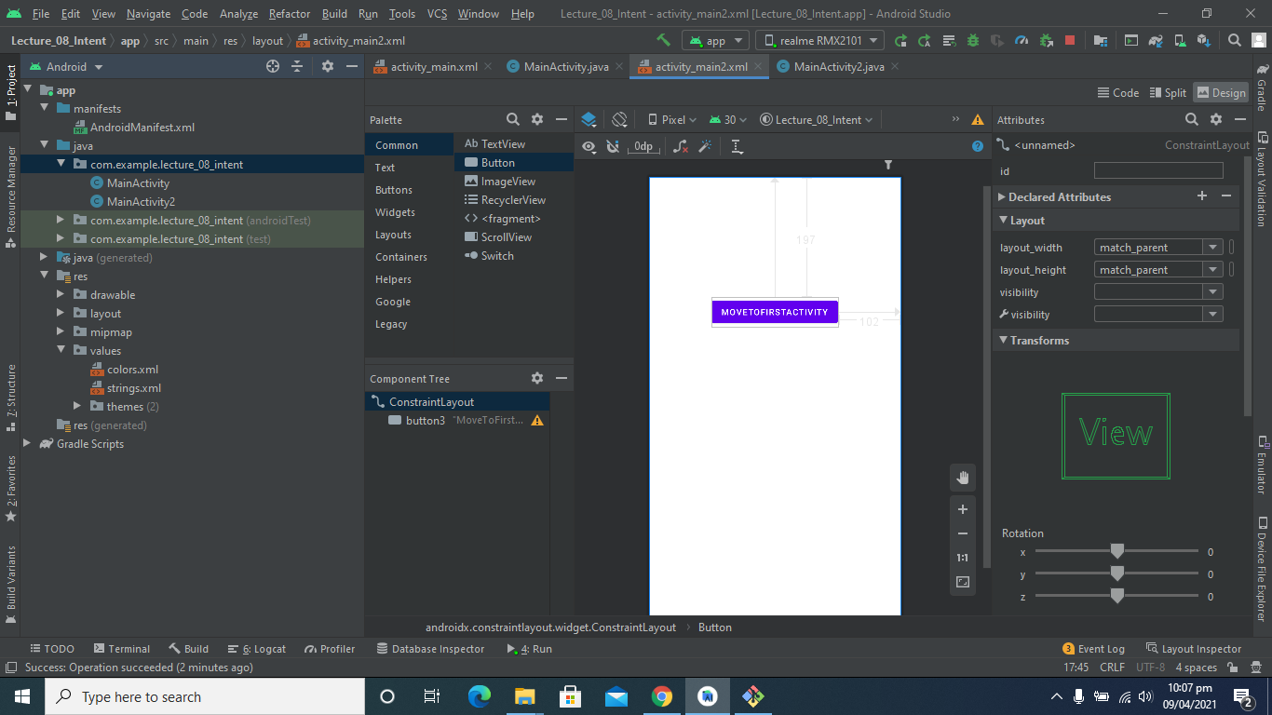

**Lecture_09_Activity_Life_Cycle**

**Project Created:**

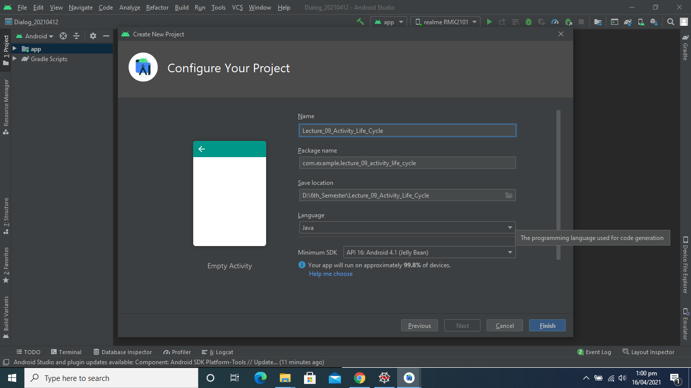

**Linear Layout Added:**

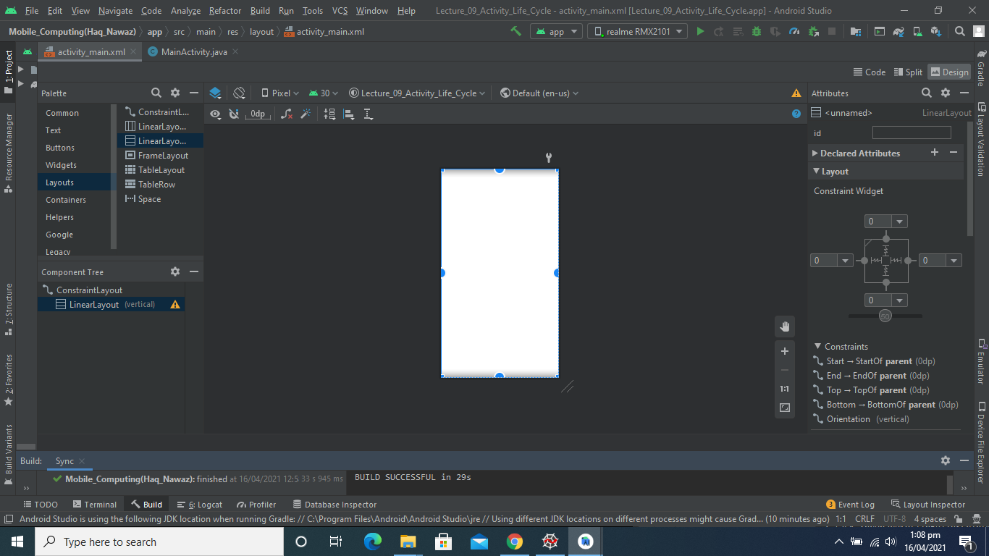

**TextView Added:**

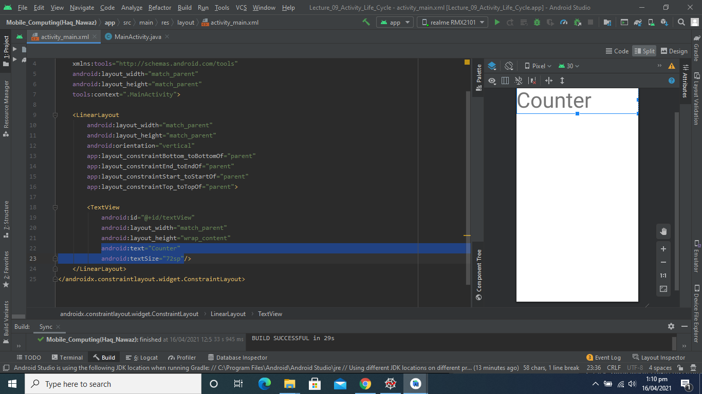

**One More Textview and Button Added:**

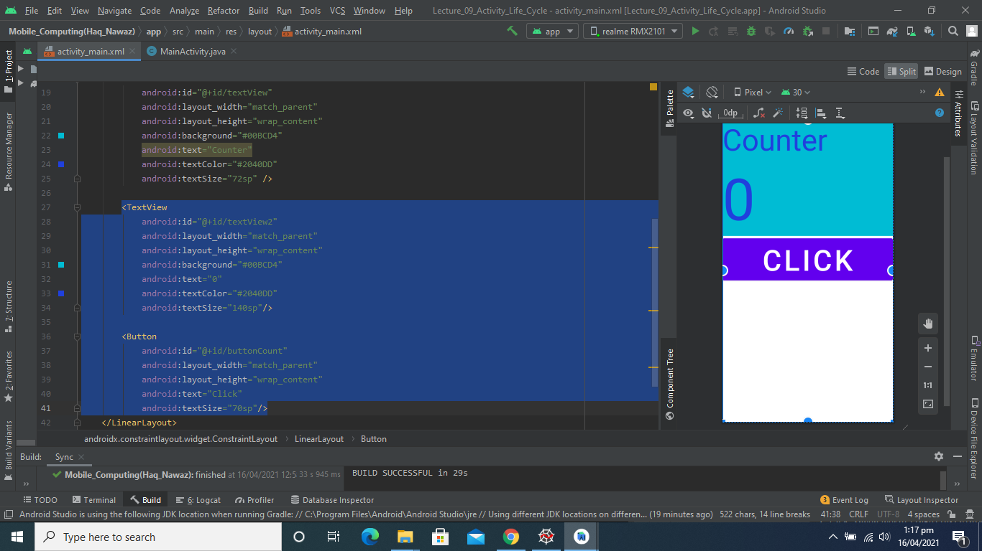

**Output:**

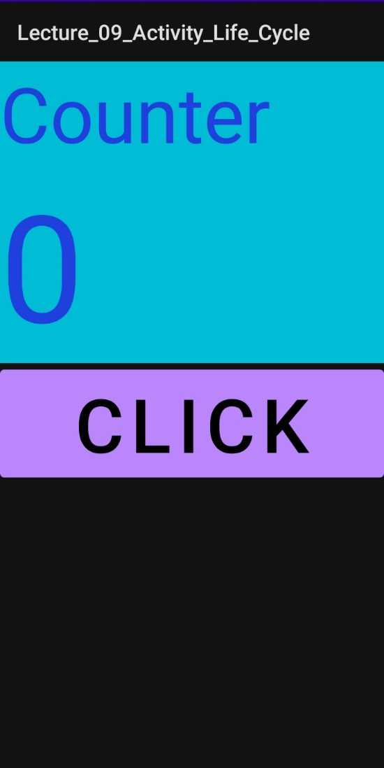

**Get Values and Create Function:**

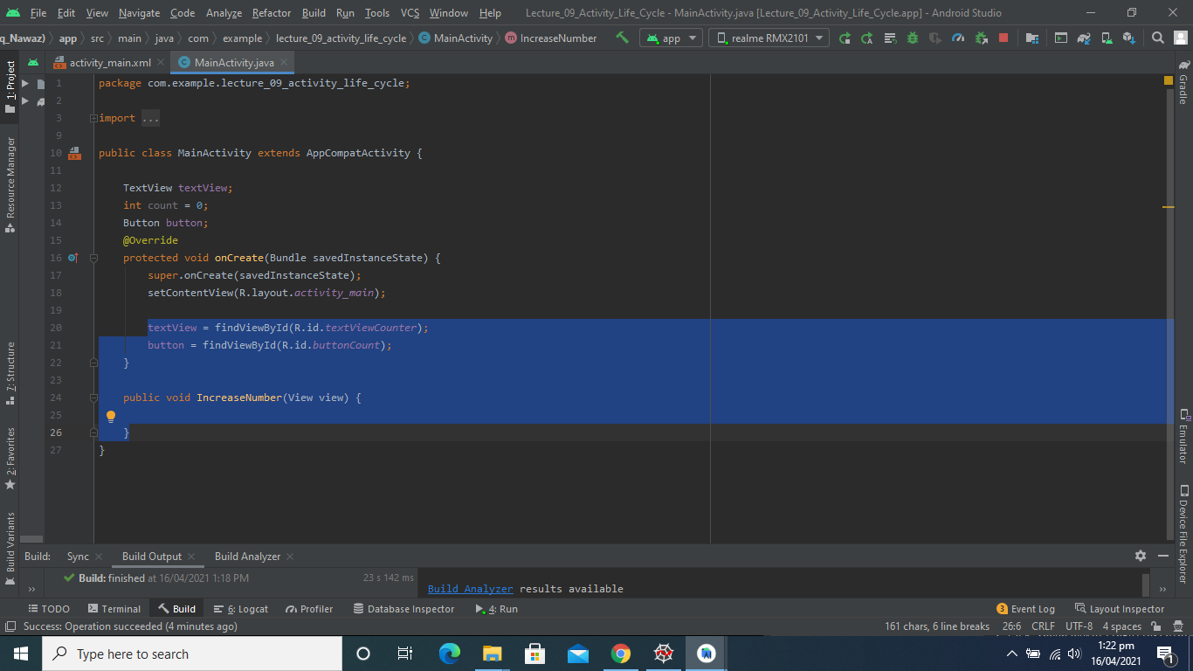

**Function Definition:**

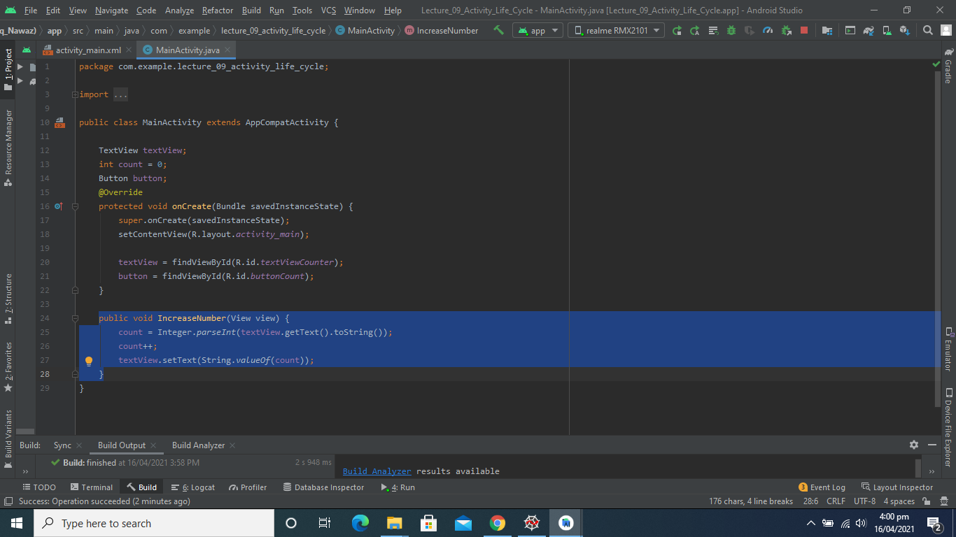

**Output:**

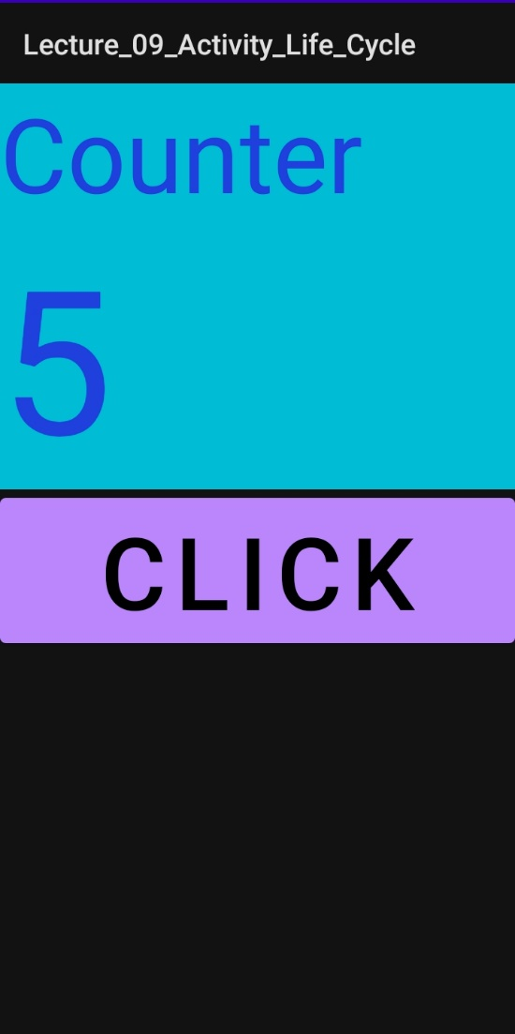

**Activity LifeCycle Functions Override:**

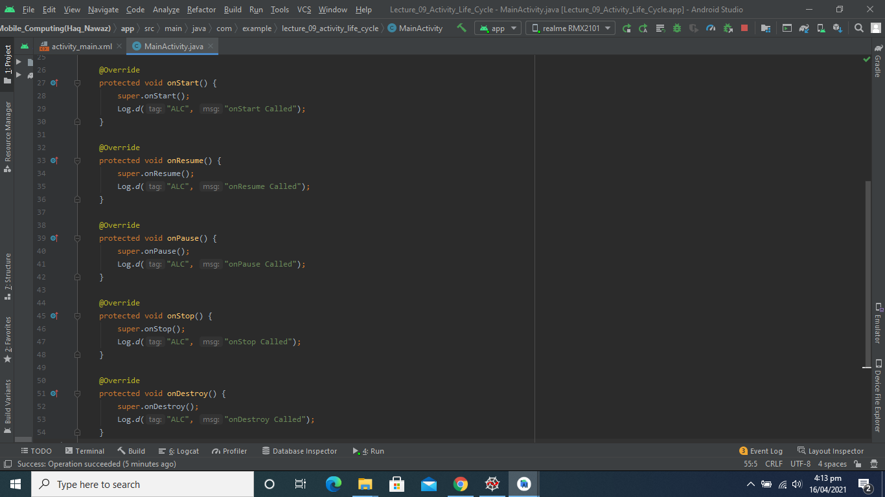

**Activity LogCat:**

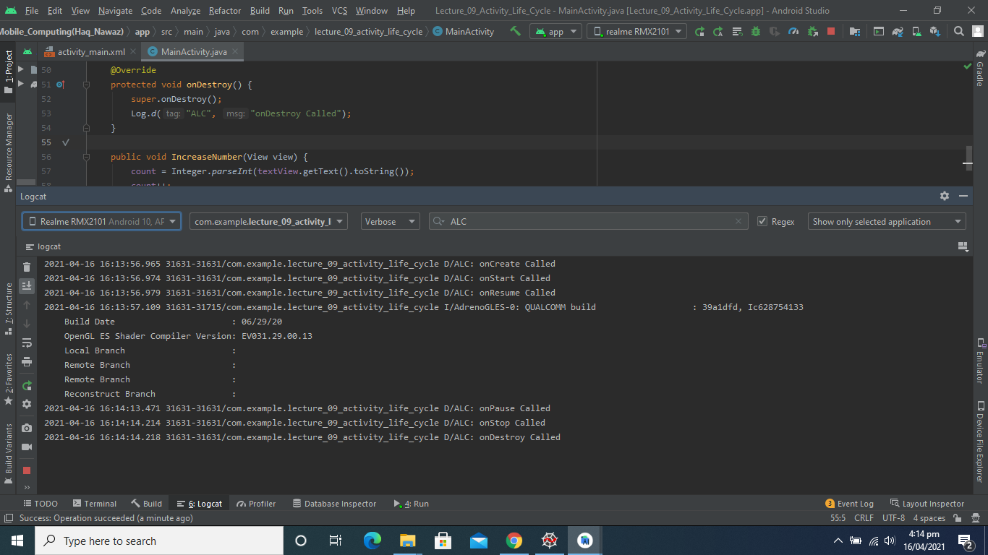

**New Activity Created:**

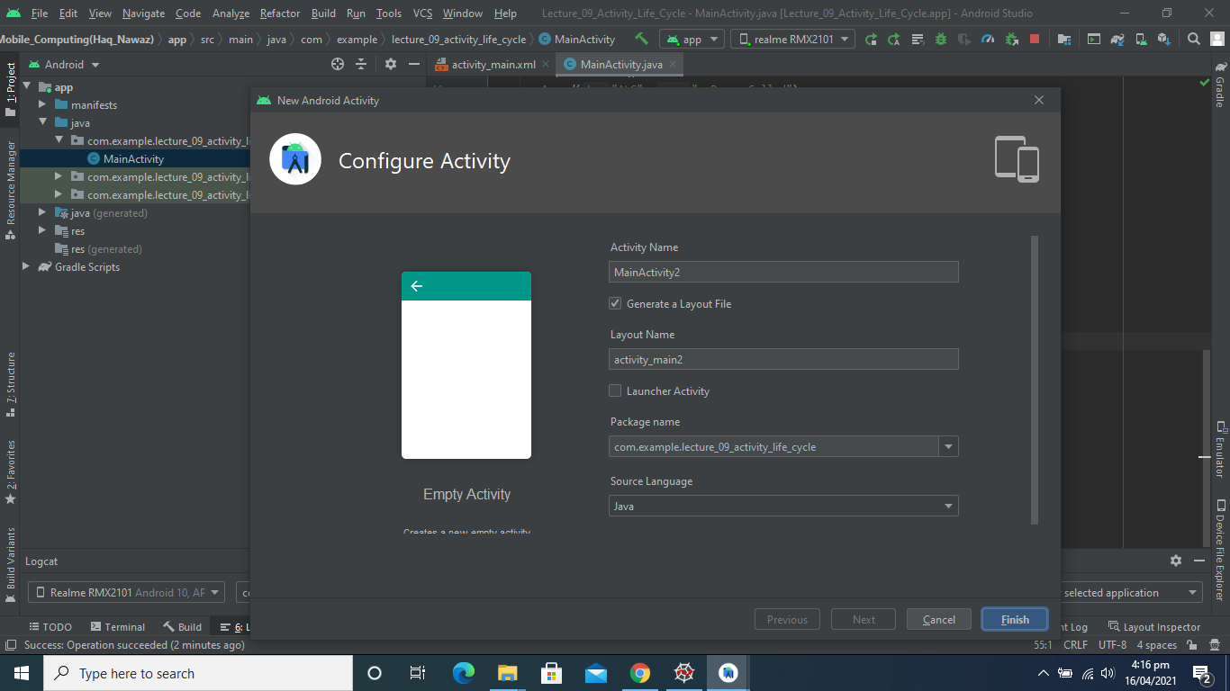

**One More Activity Created:**

T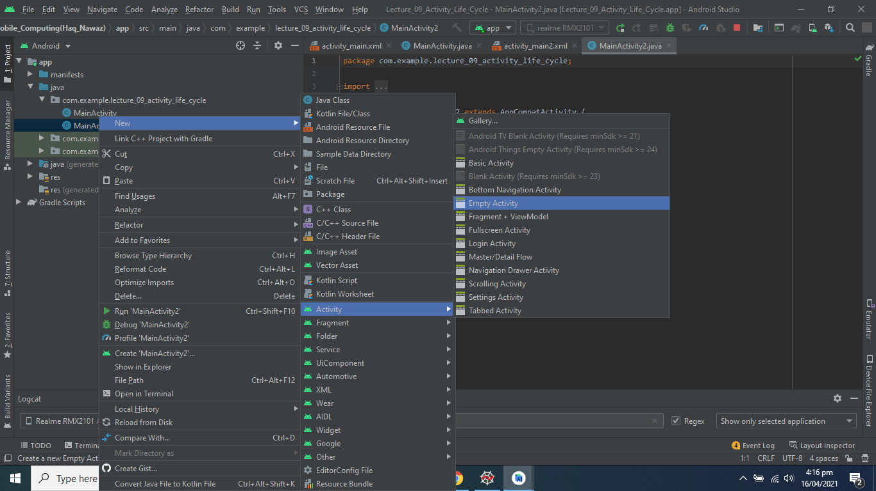

**Two More buttons Added Moving to Other Activities:**

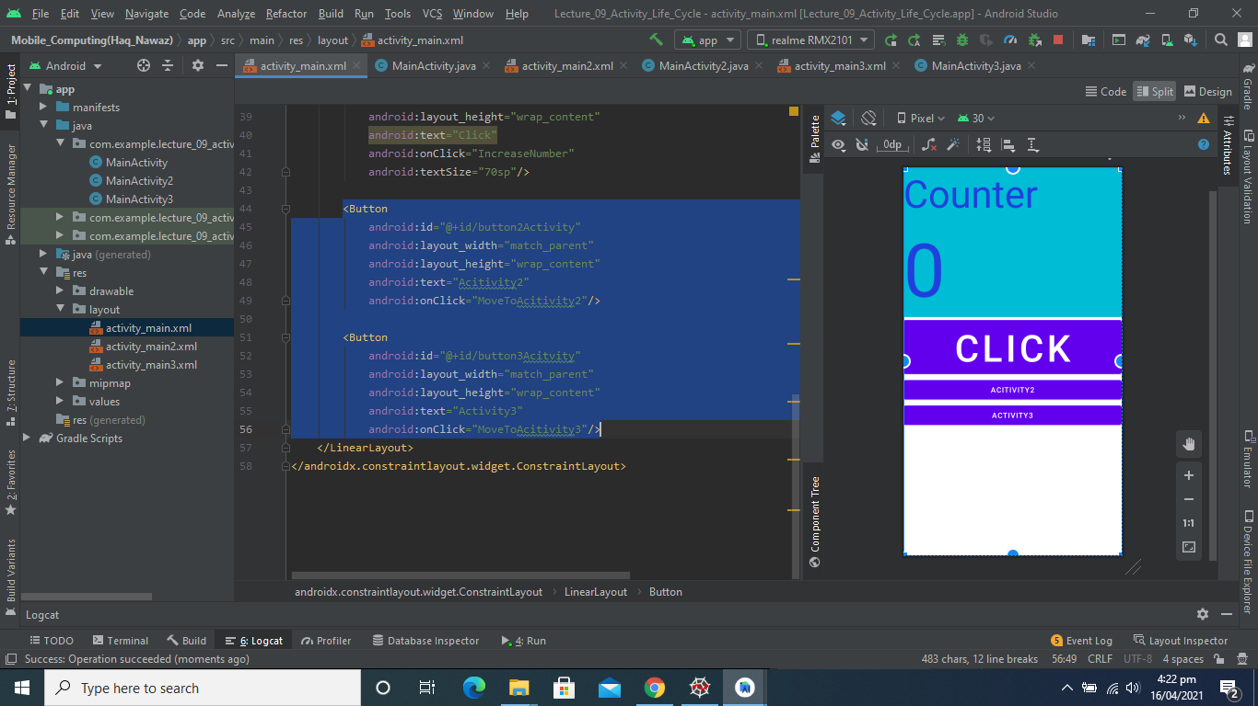

**Code for Moving to Other Activities:**

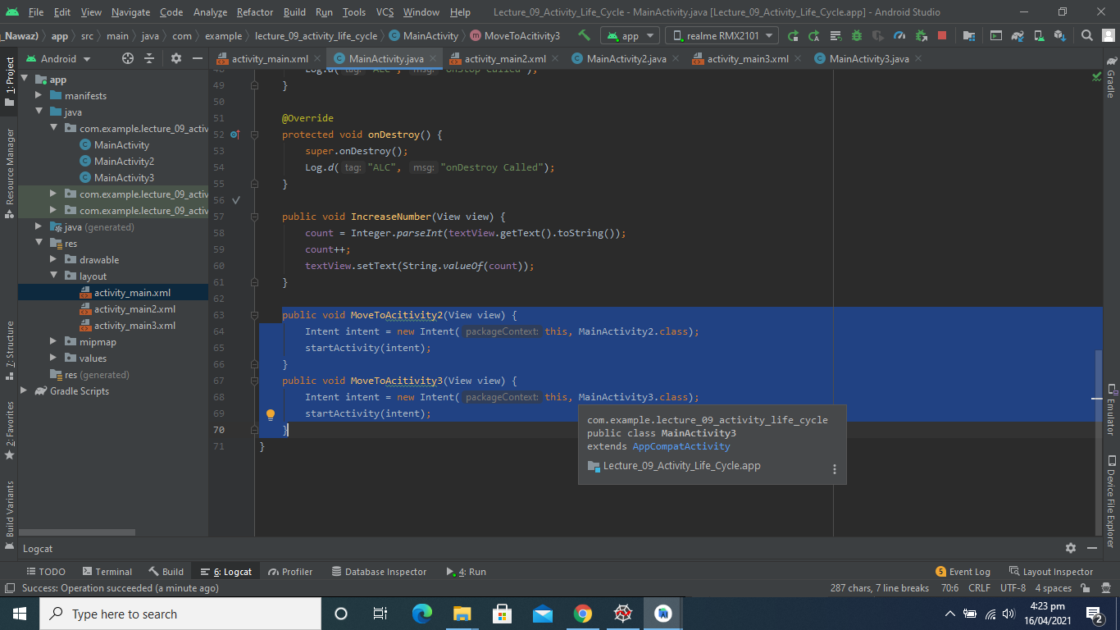

**Output:**

[Video Link](https://github.com/talha0606/MC_Progress/blob/master/L09V01.mp4)

**Activity2 LifeCycle Functions Override:**

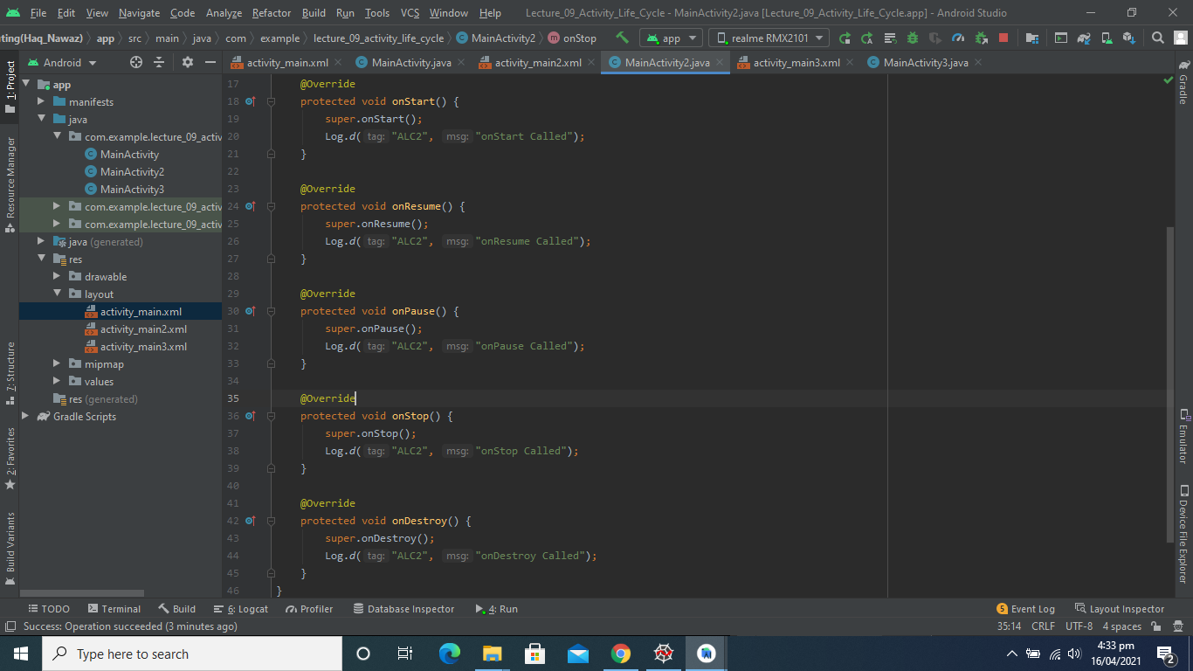

**Activity3 LifeCycle Functions Override:**

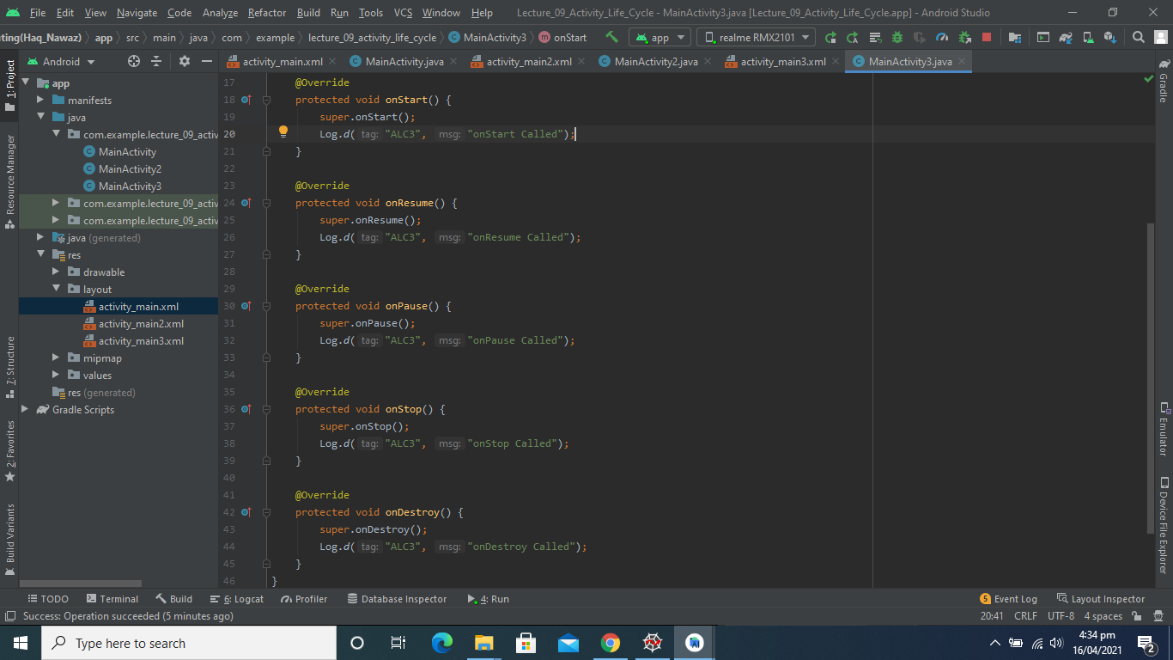

**Activity_lifecycle of Different Activities:**

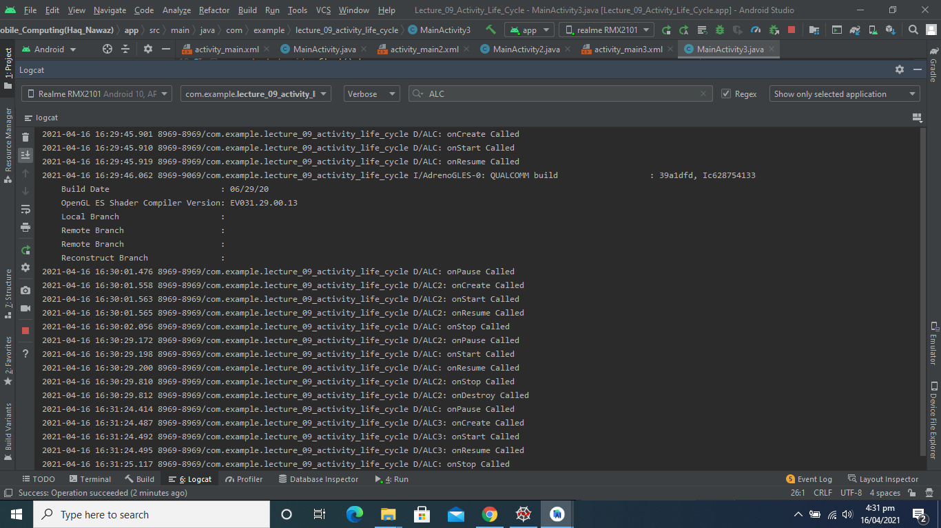

# **acticity life cycle**

Activity life Cycle: <https://github.com/aliuppal9797/activity_lifecycle.git>

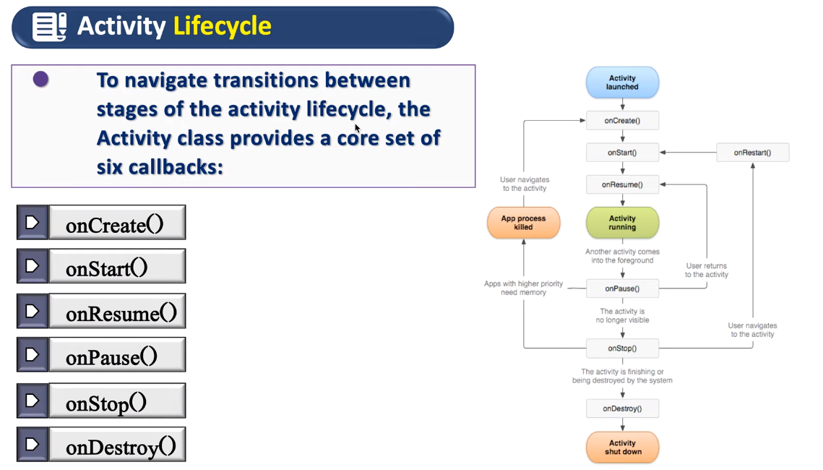

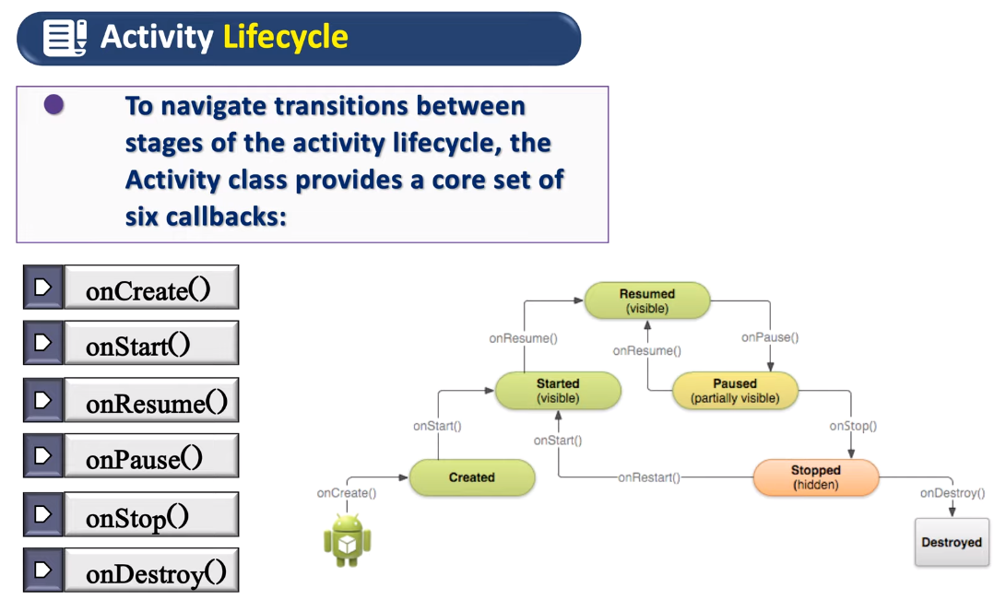

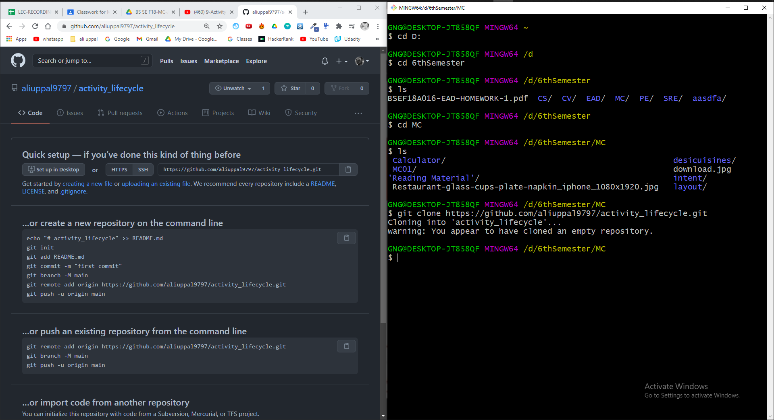

Linear vertical layout

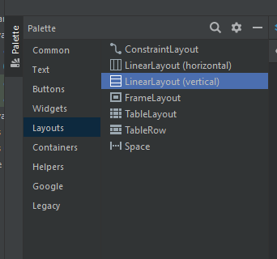

Set constraint widget

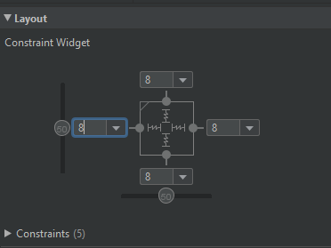

Text and text size

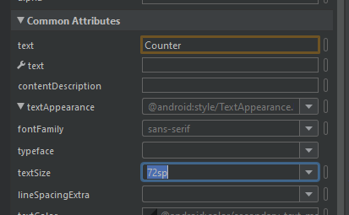

Text color

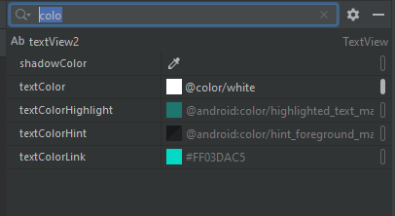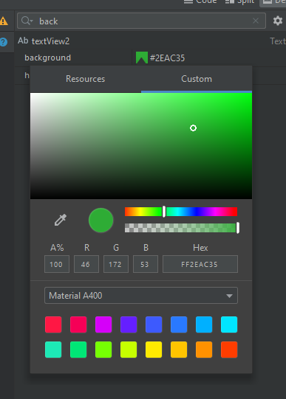

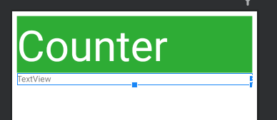

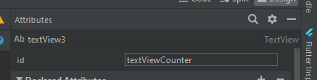

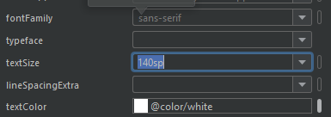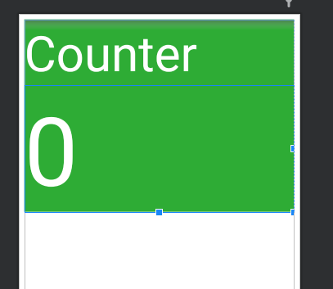

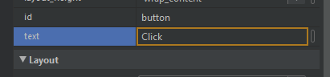

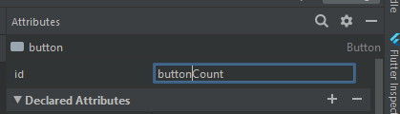

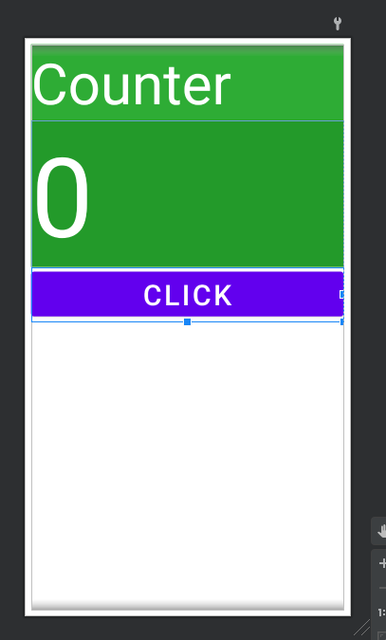

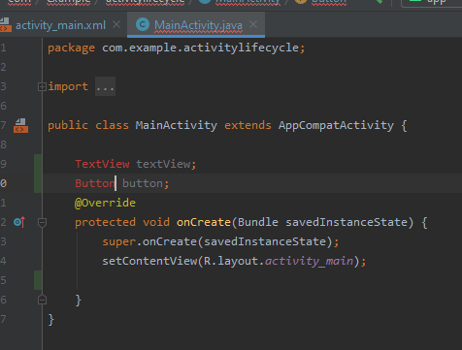

Alt + enter

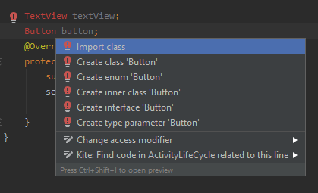

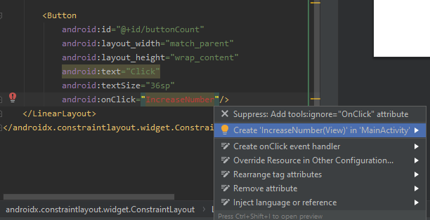

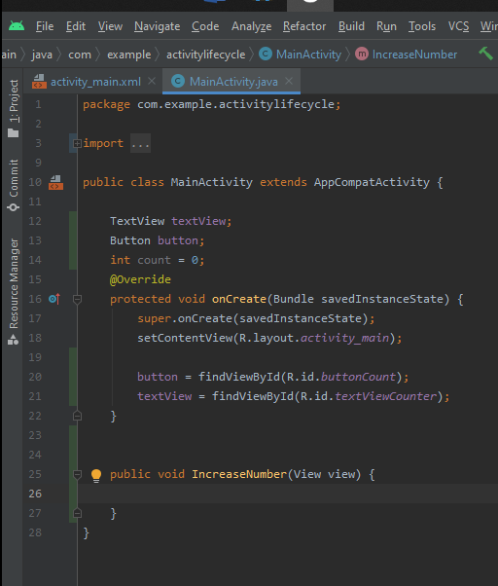

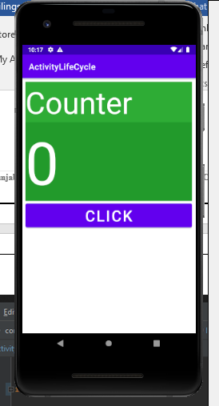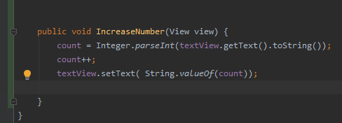

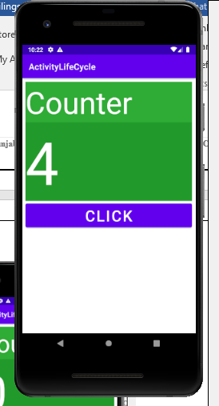

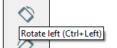

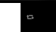

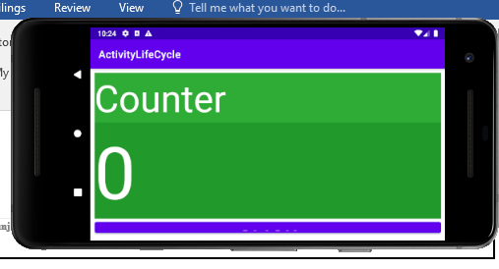

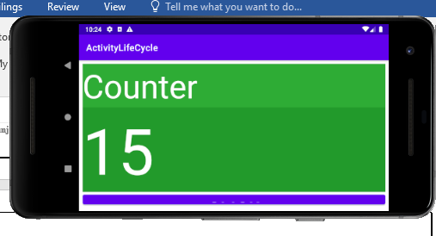

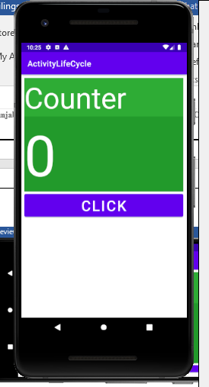

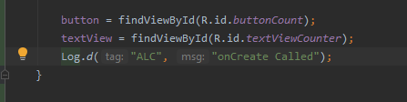

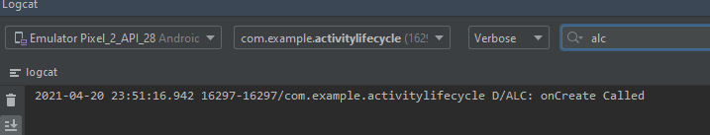

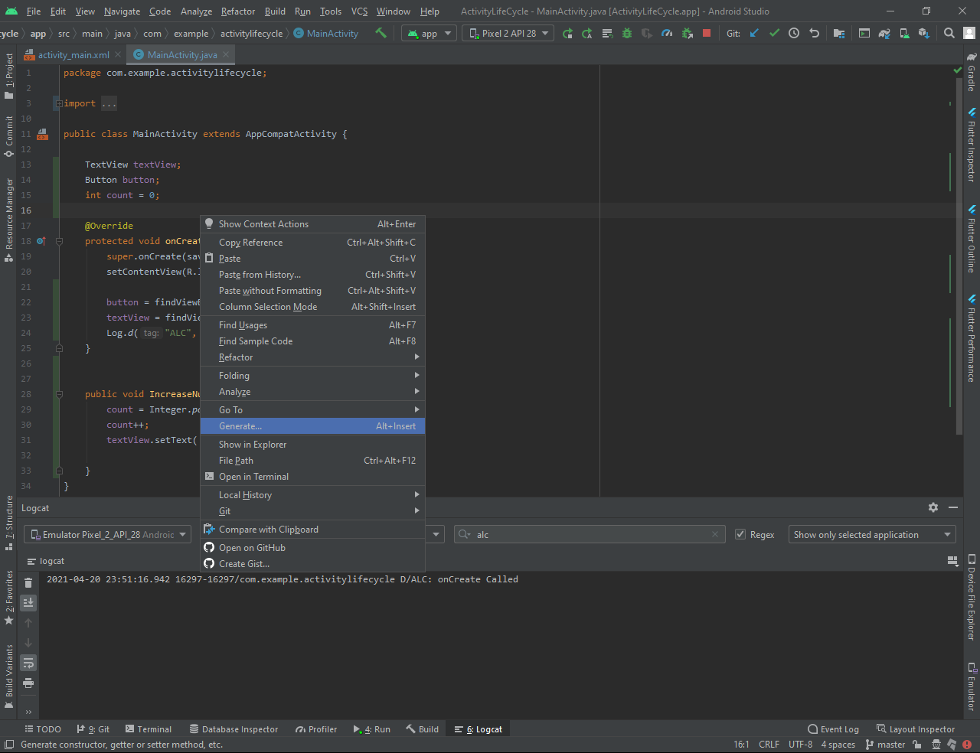

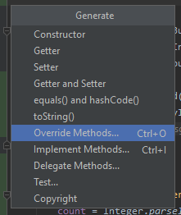

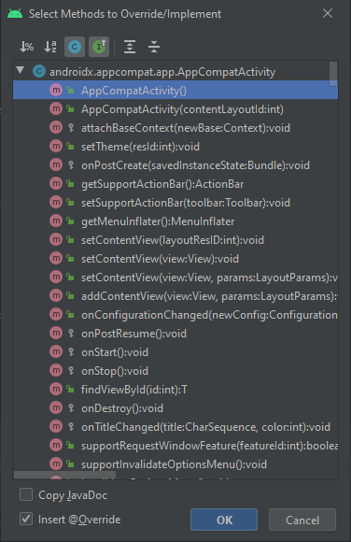

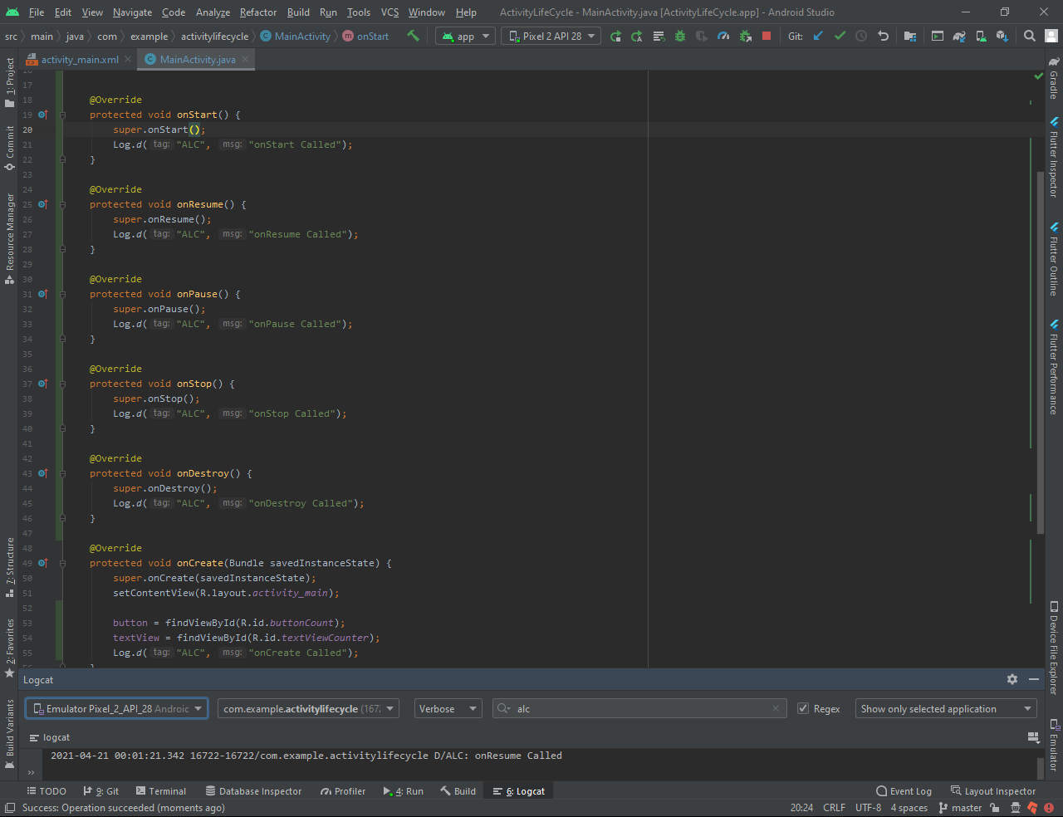

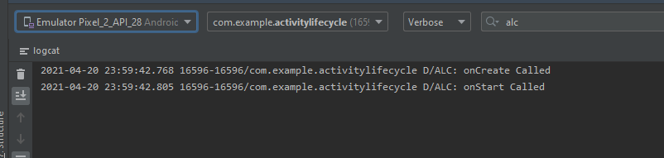

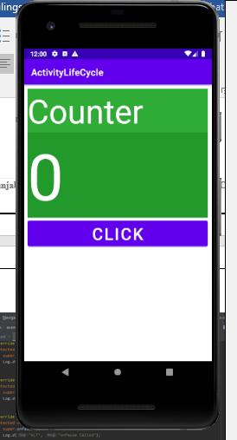

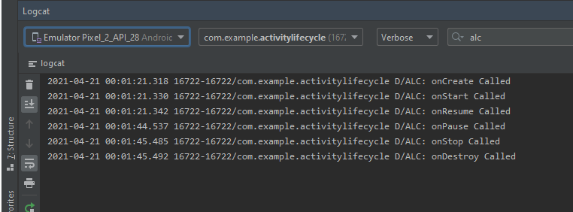

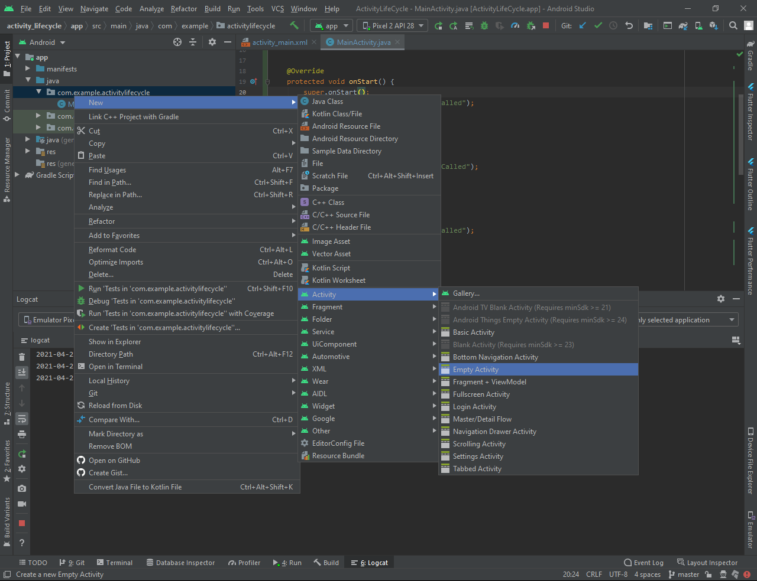

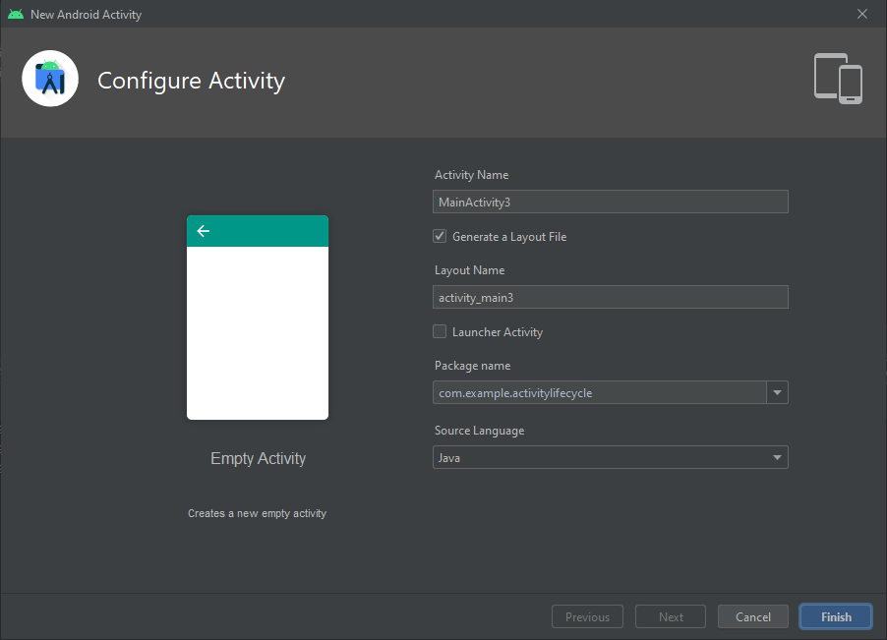

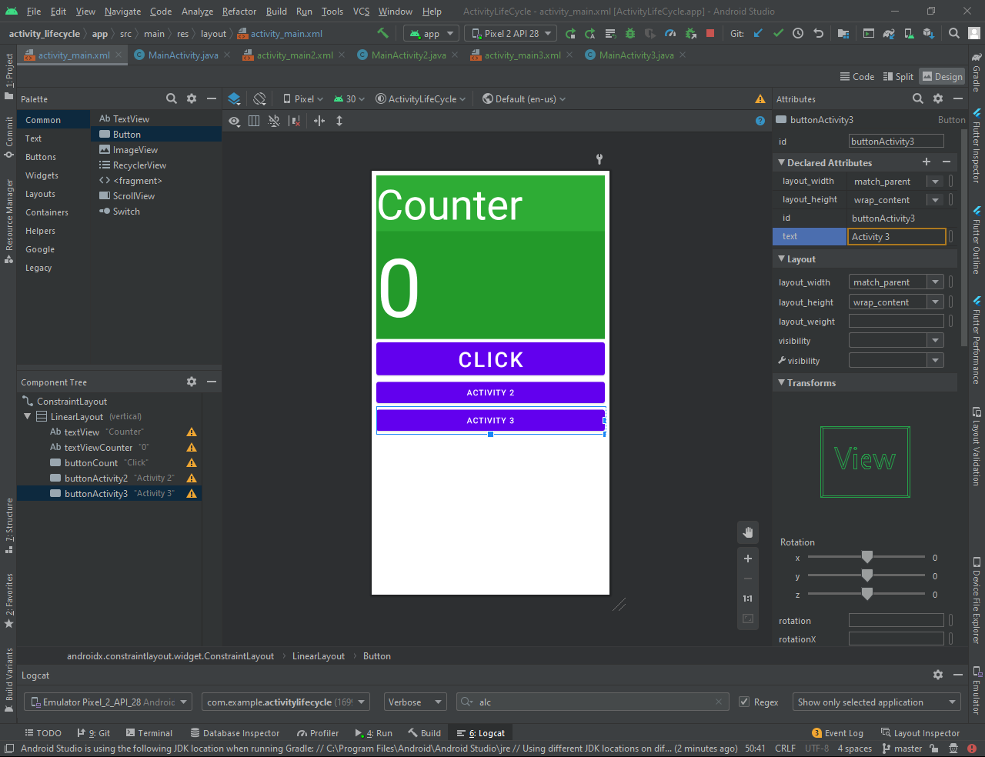

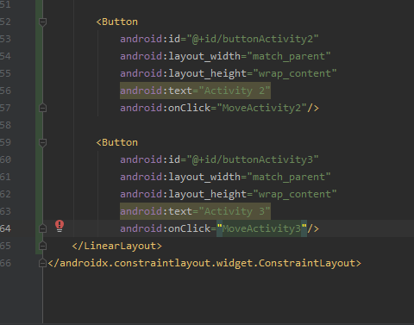

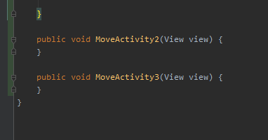

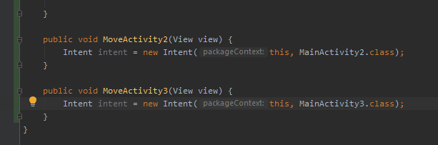

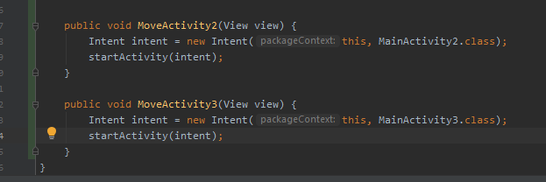

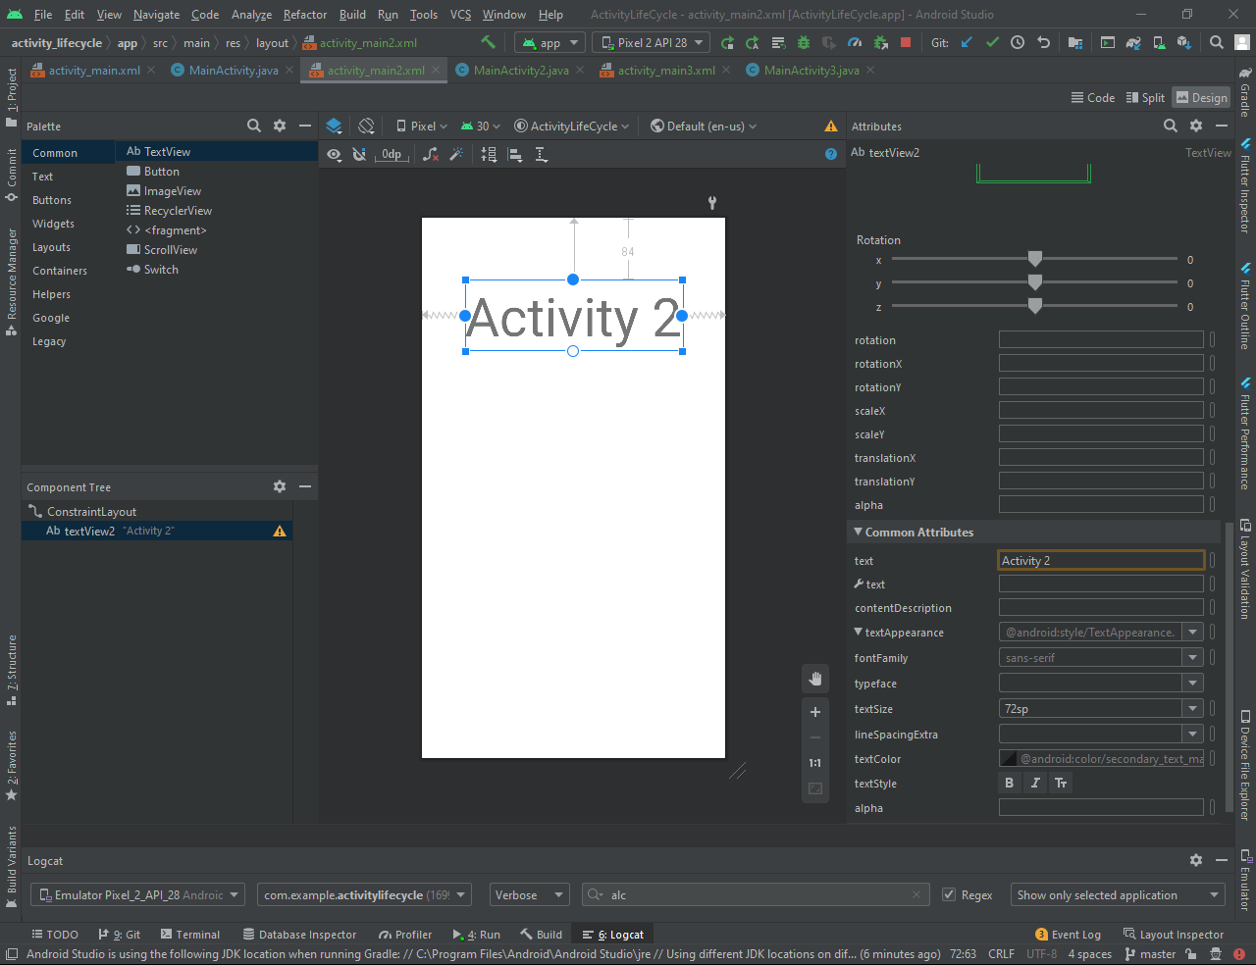

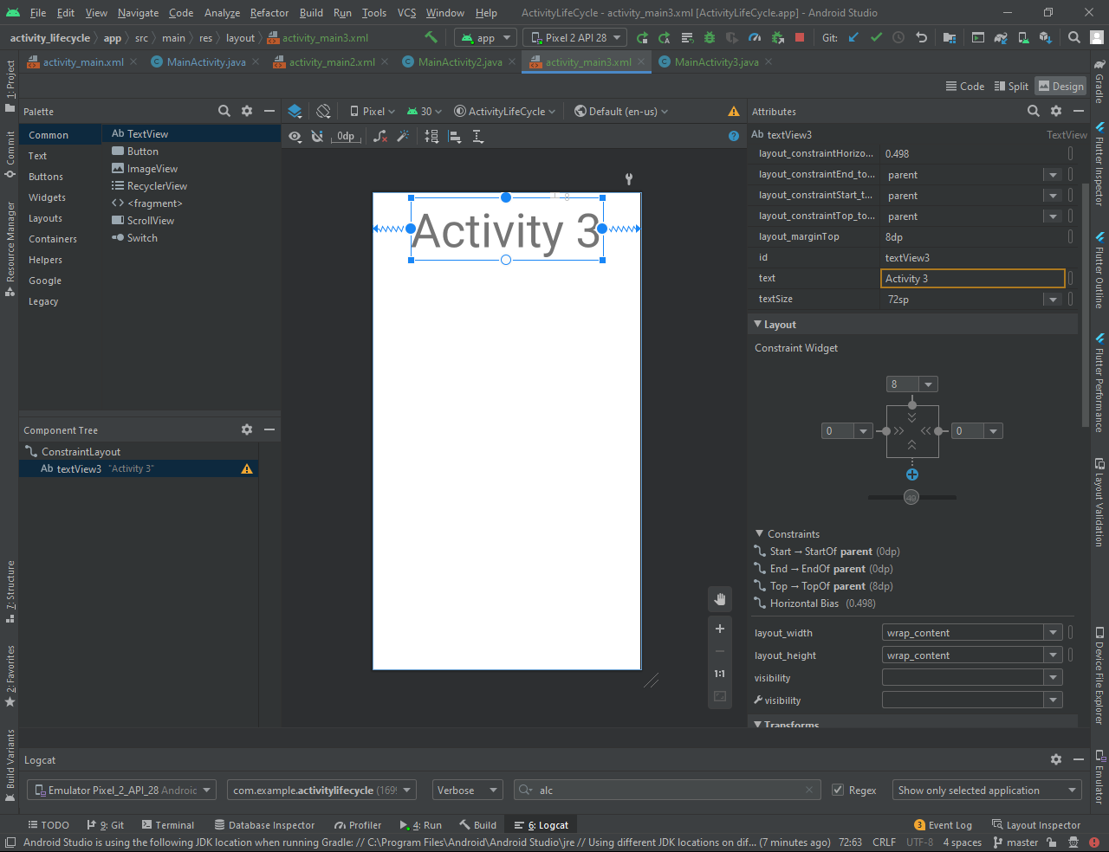

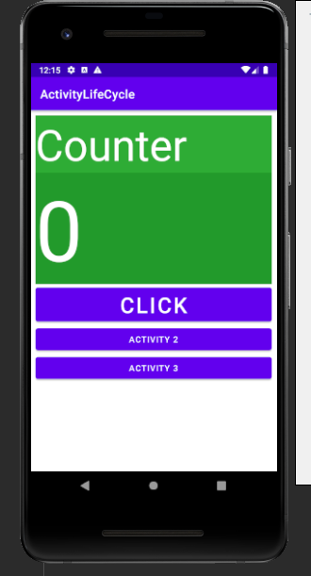

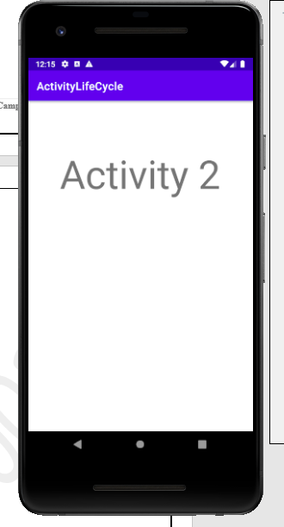

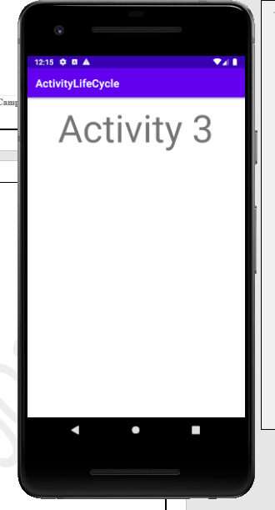

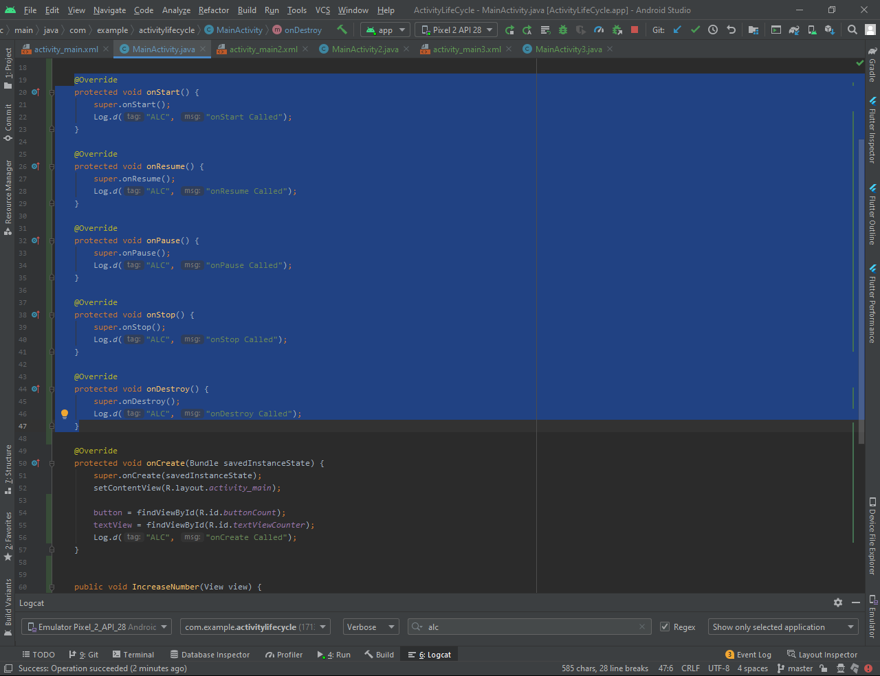

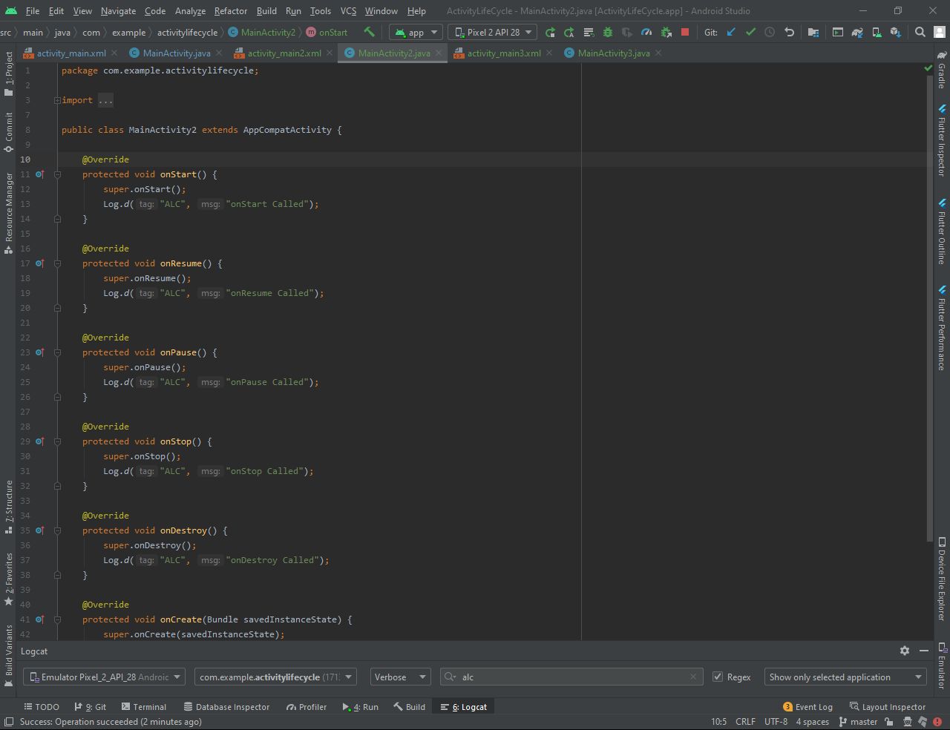

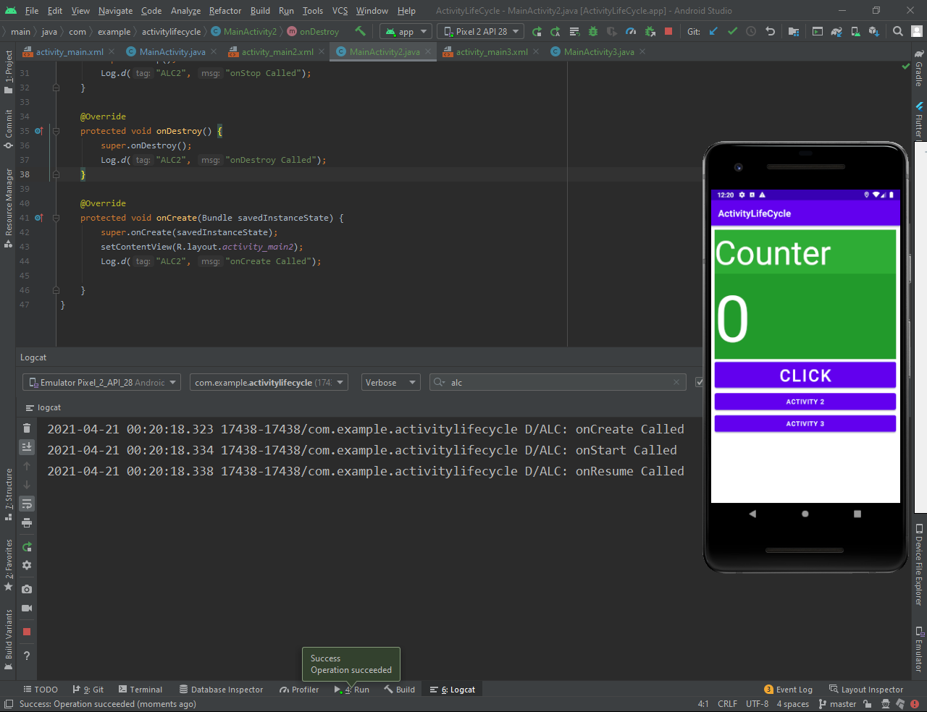

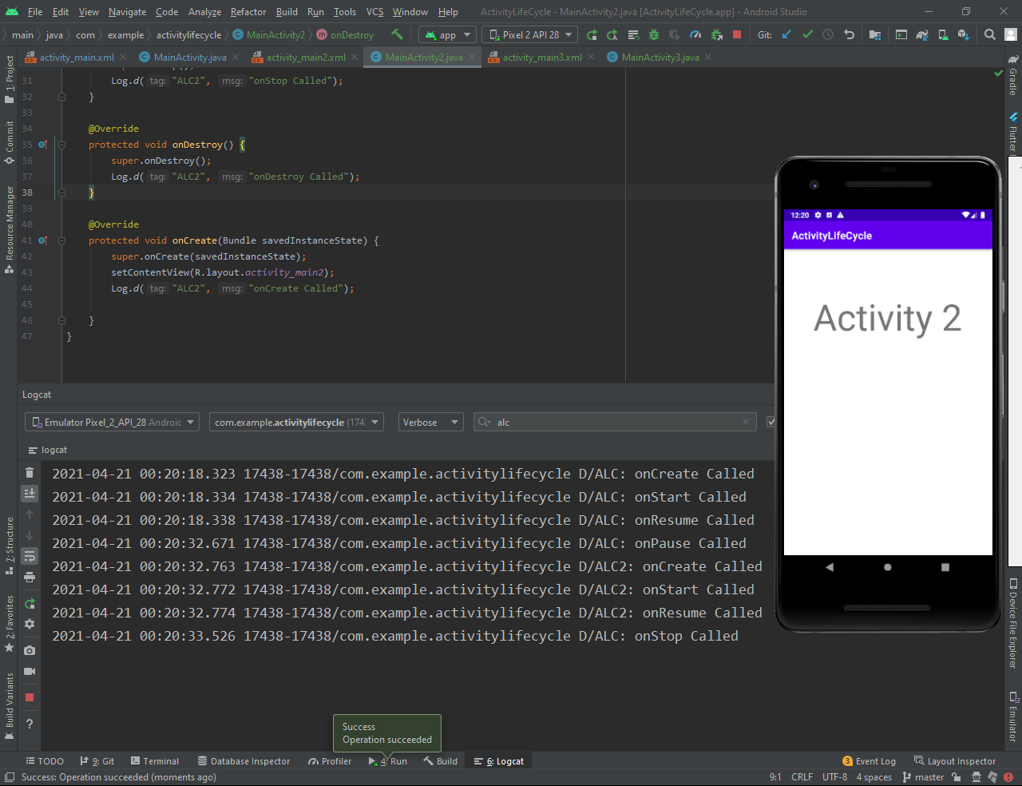

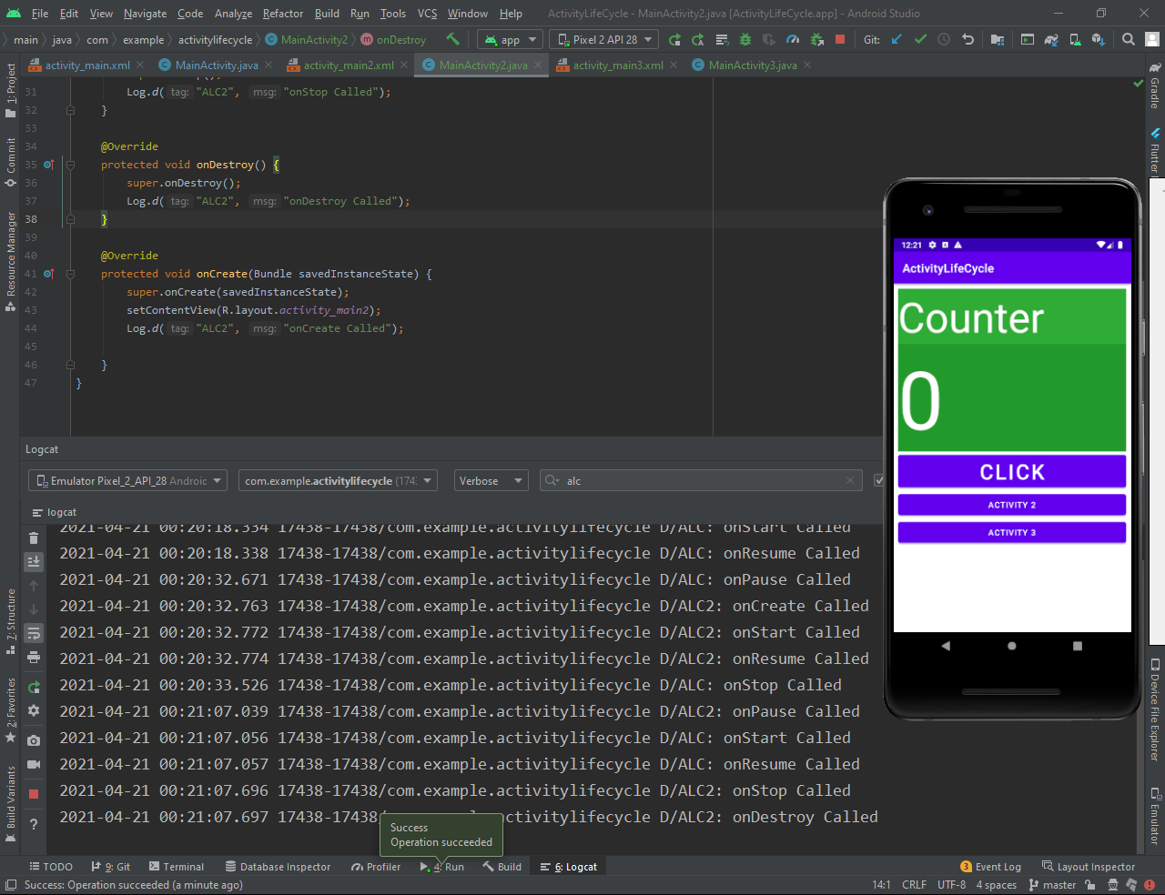

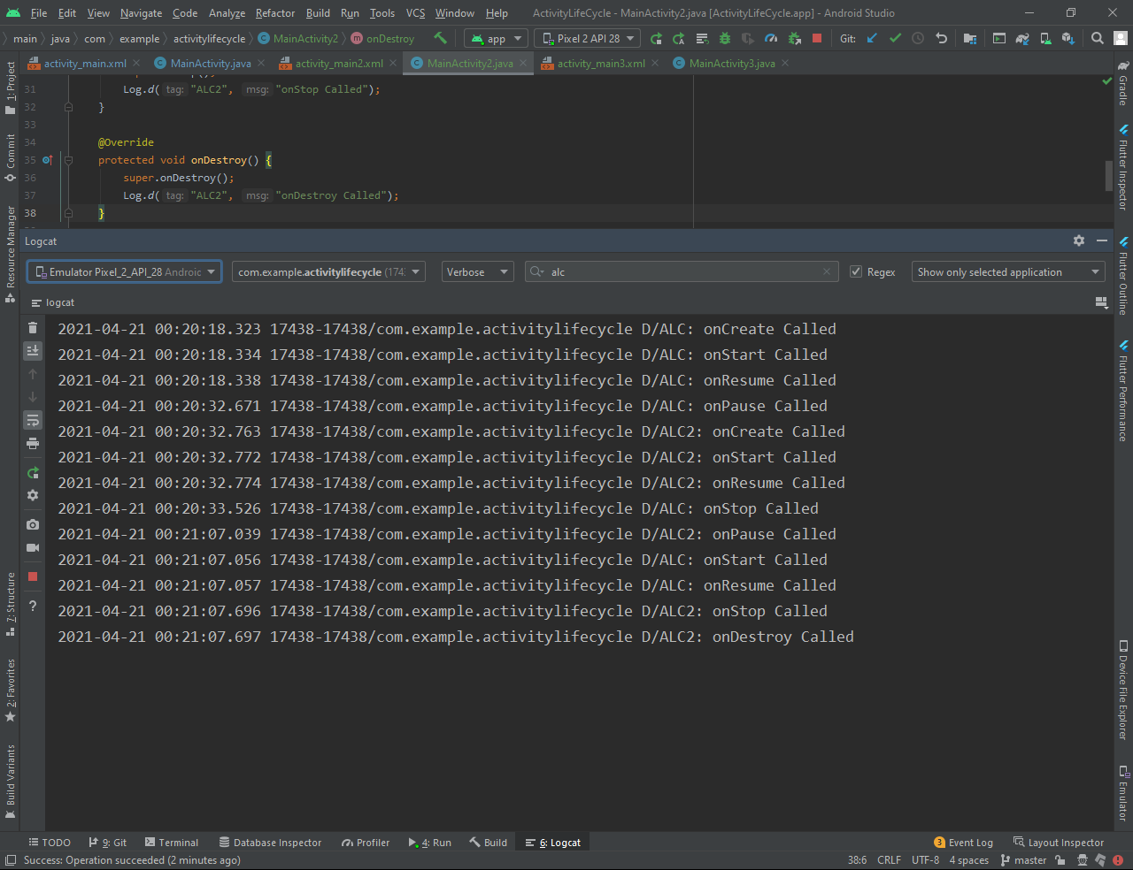

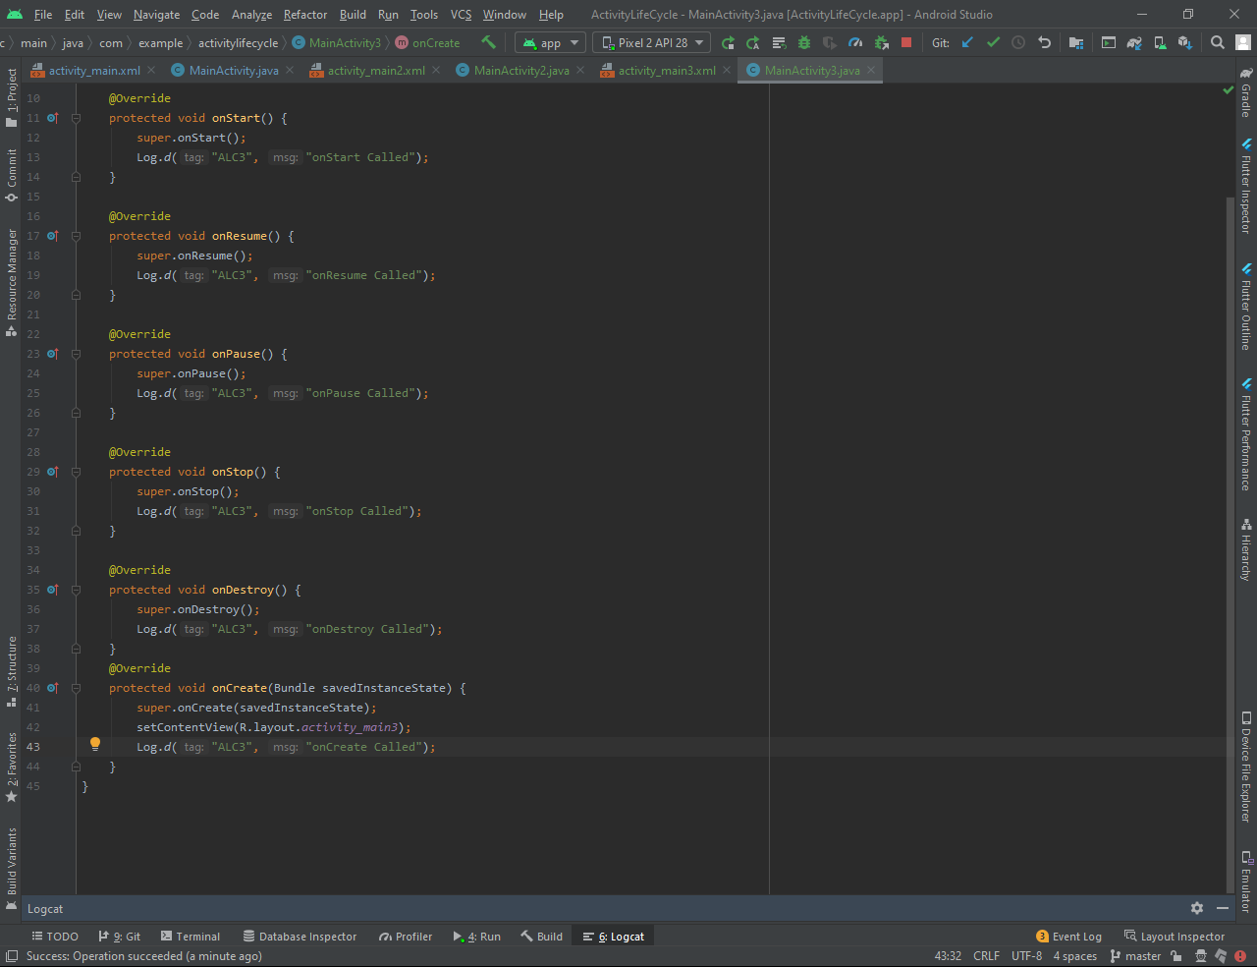

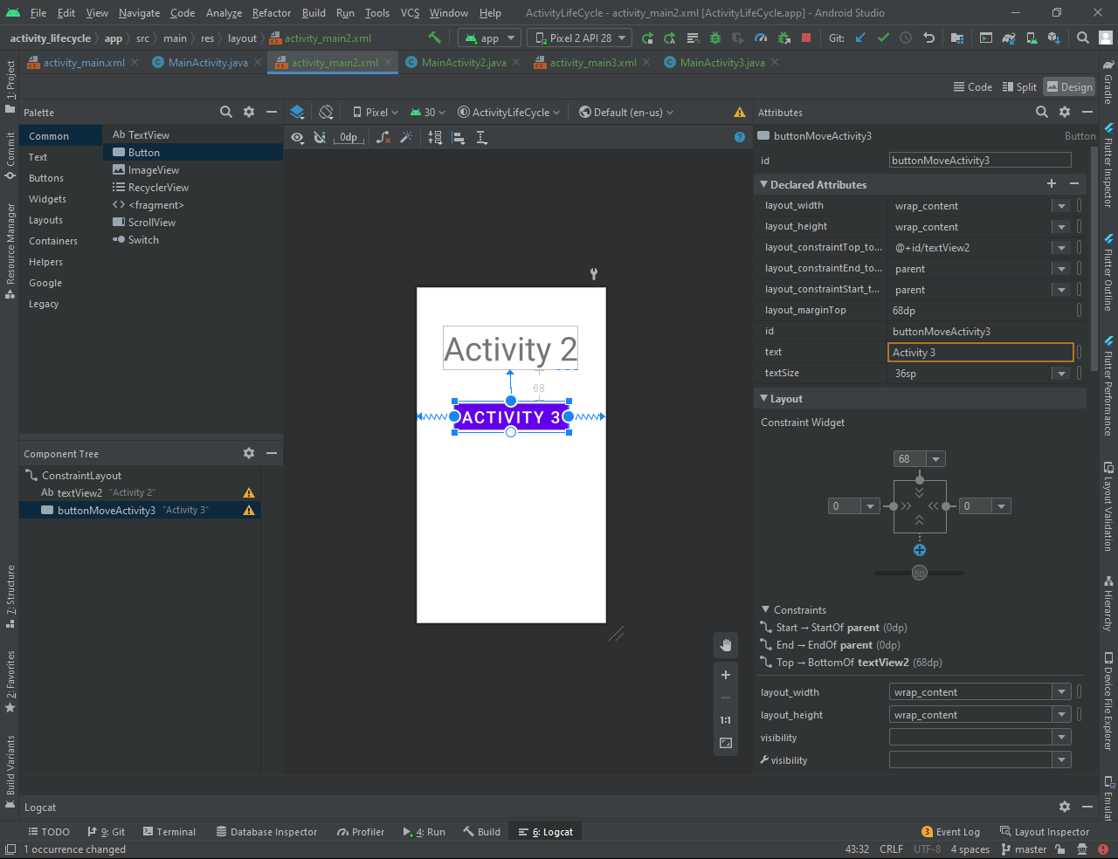

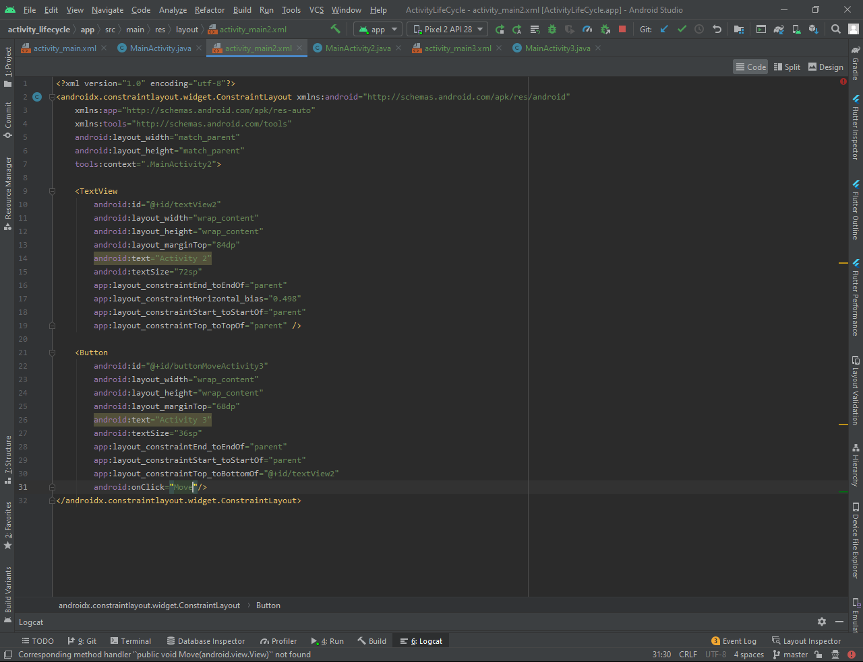

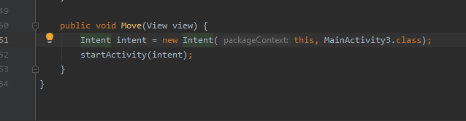

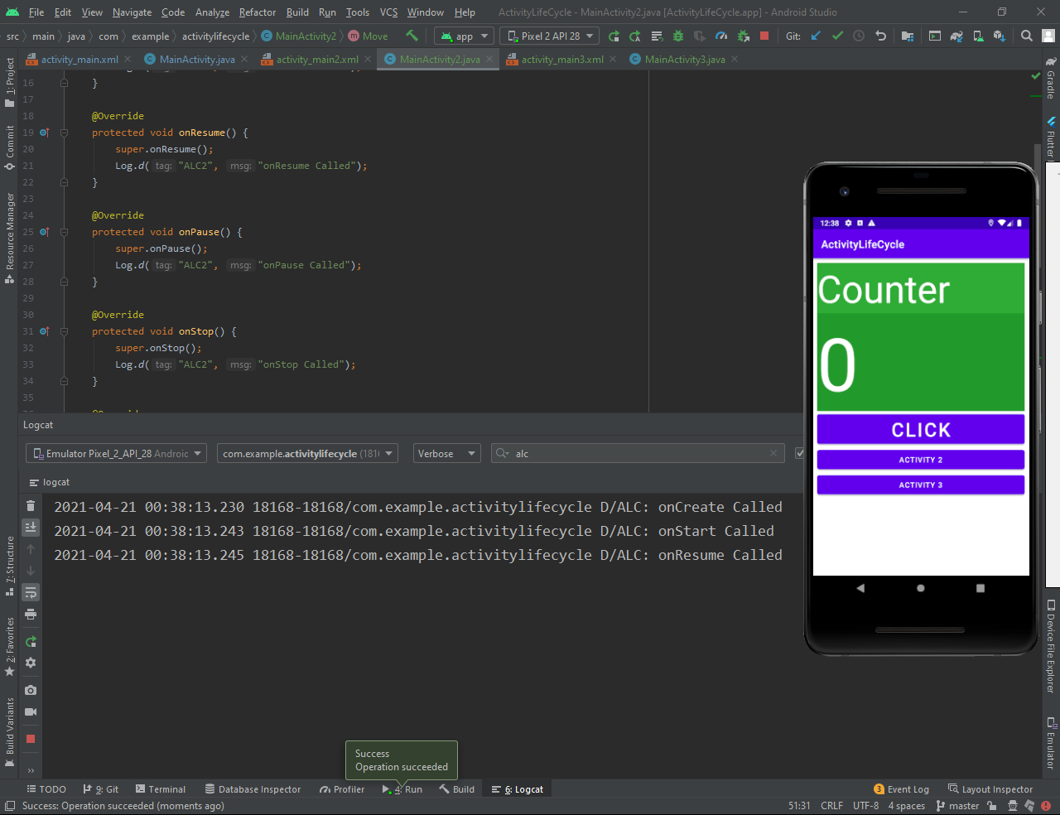

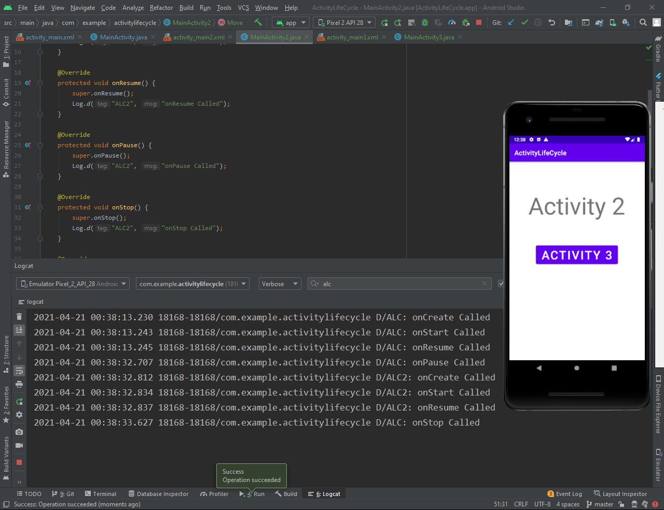

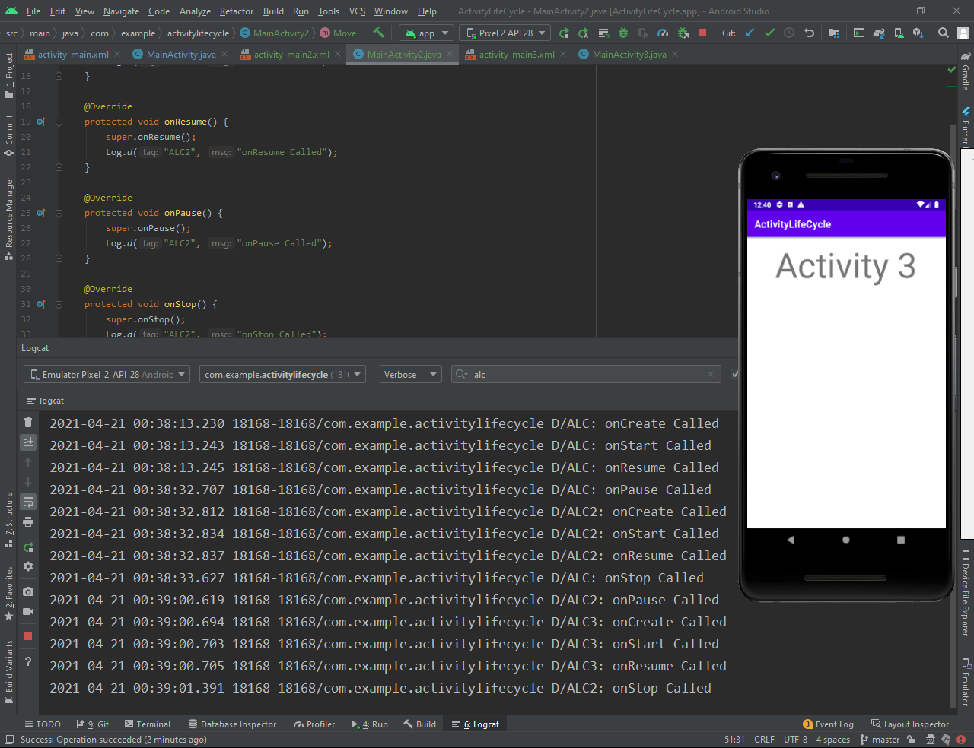

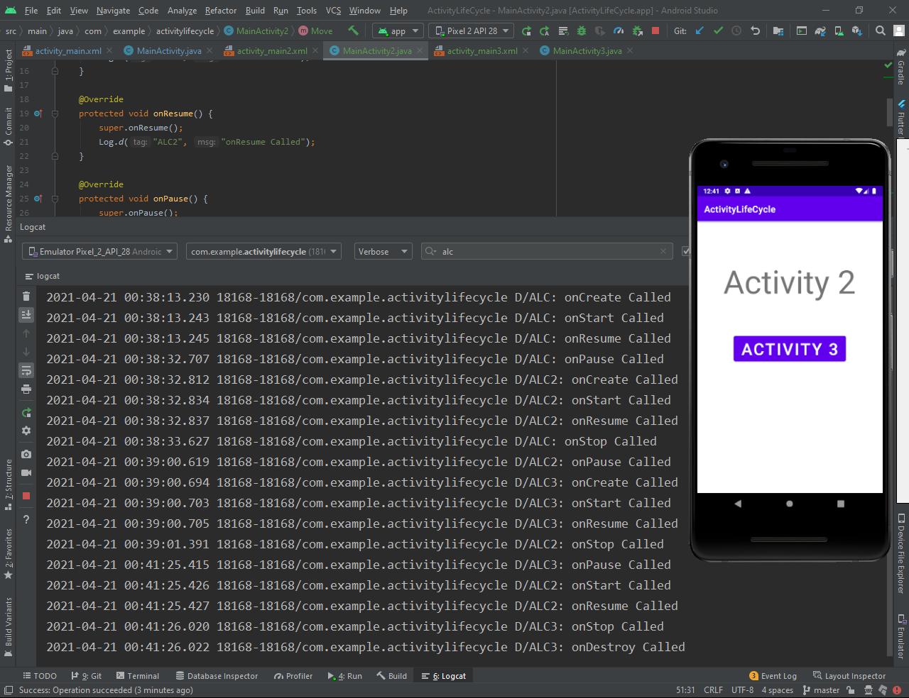

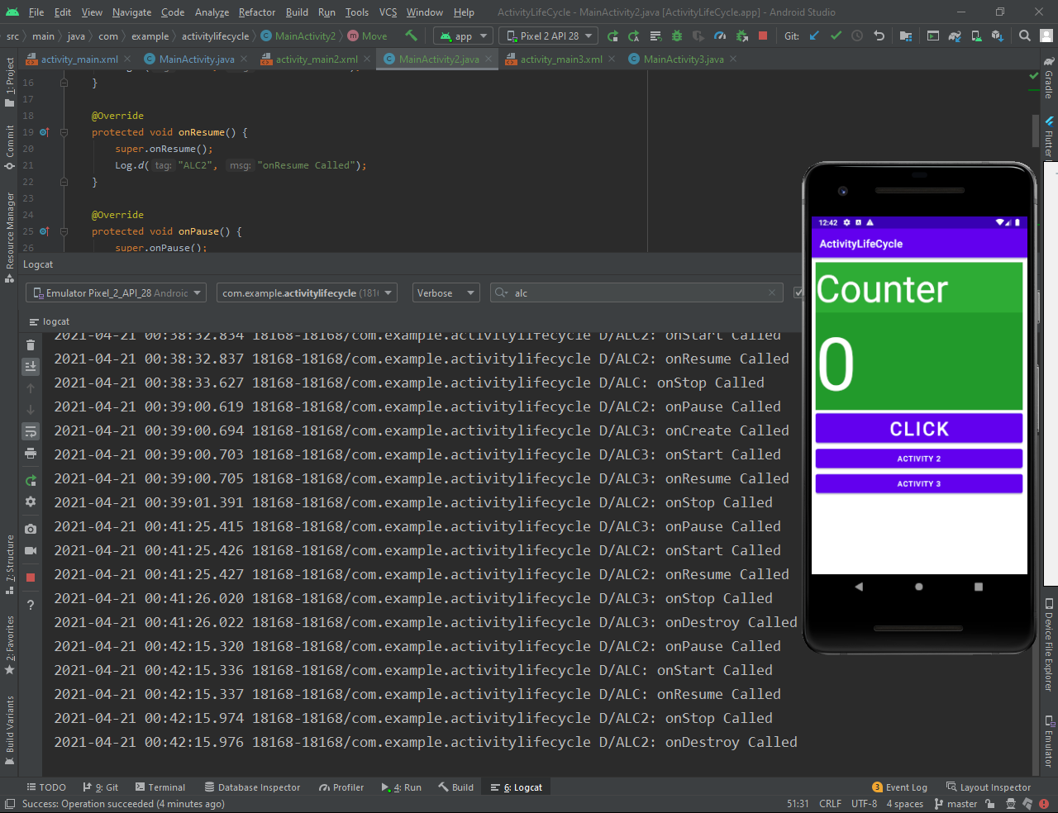

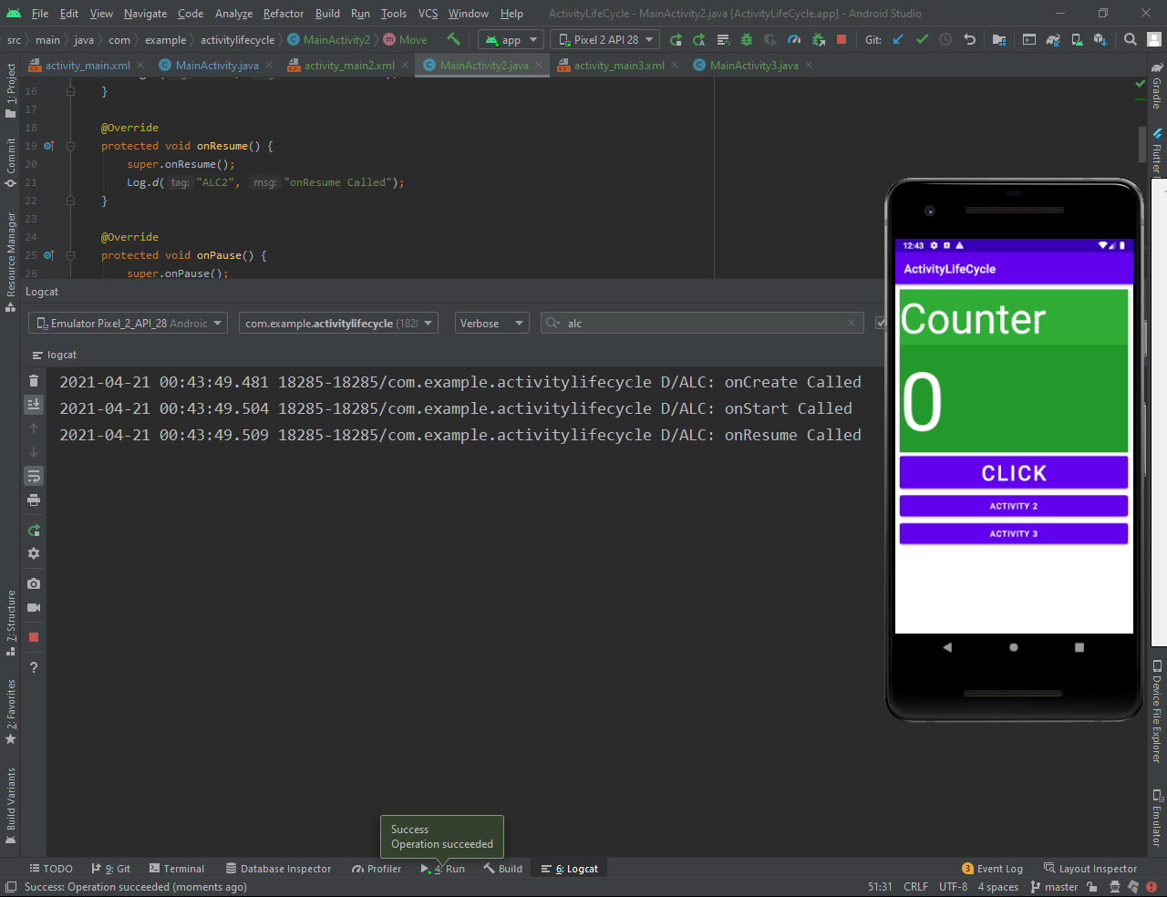

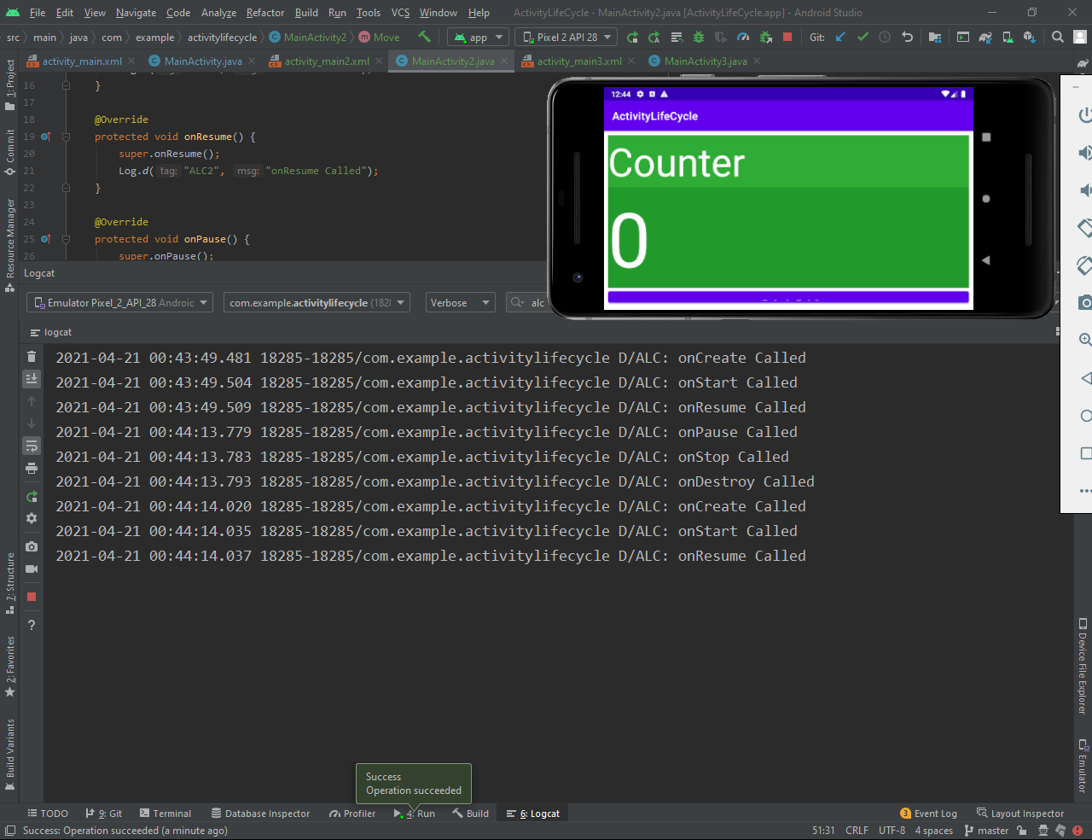

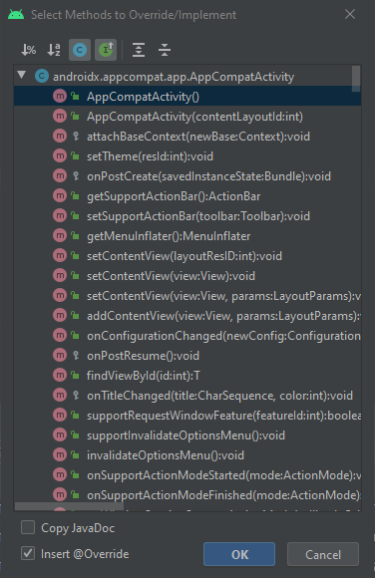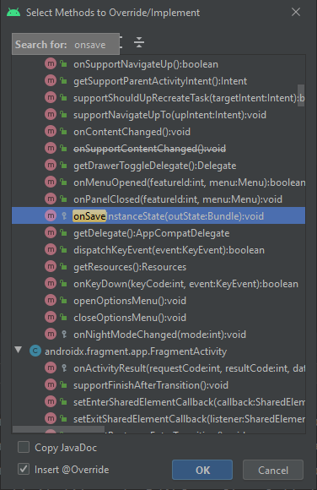

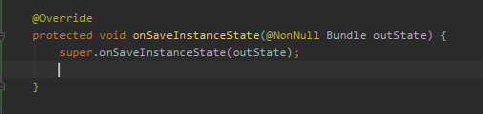

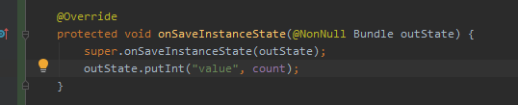

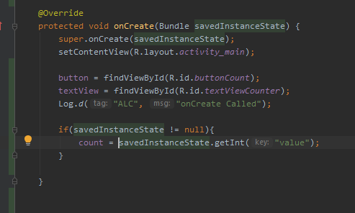

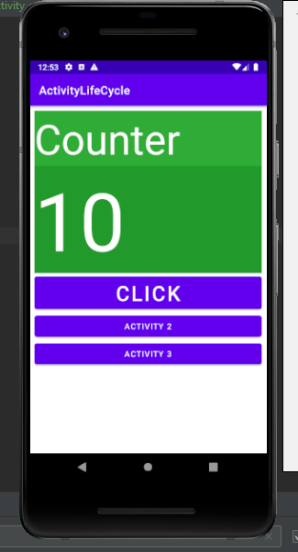

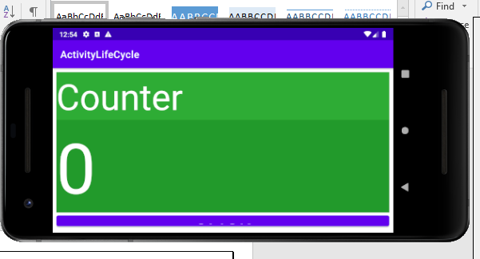

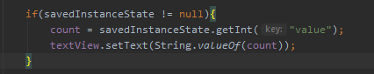

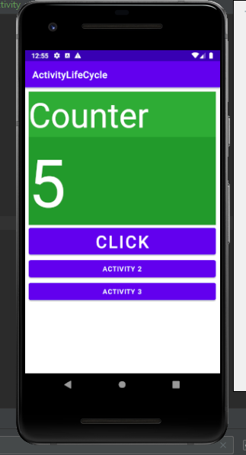

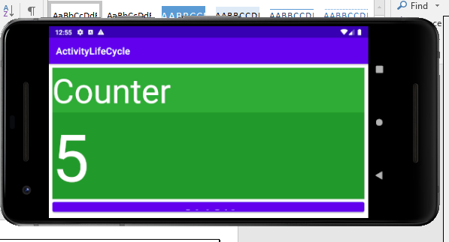

# **list views**

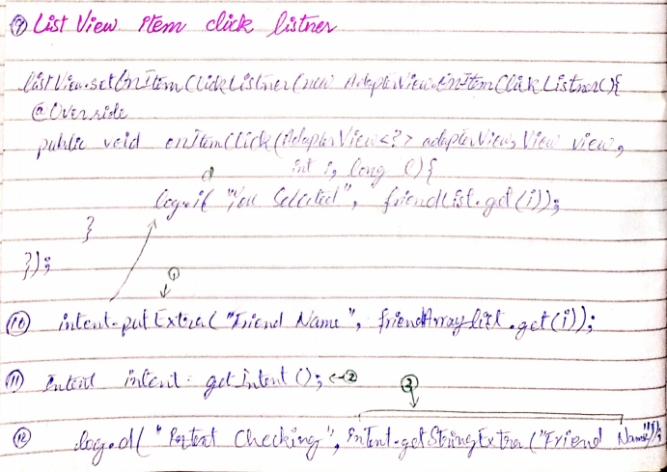

Array list of type string

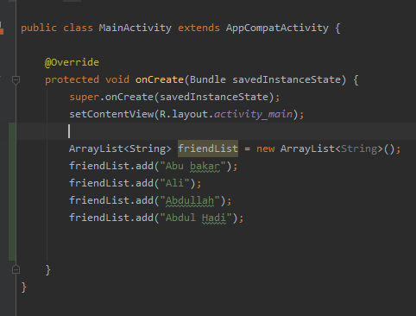

Array Adapter of type string

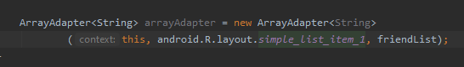

Add list view from Legacy

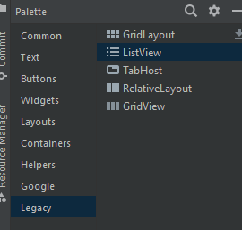

**Animation:**

Property Animation API was introduced by Google in Android 3.0 which gives us the flexibility to change object properties over a certain time interval. The Animations Framework allows us to create visually attractive animations and transitions in our apps. Using the animations, one can turn their good looking app into an excellent and highly usable app.

Animations are useful when the screen changes state, i.e when the content loads or new actions become available.

Animation is the process of creating motion and shape change. In this Tutorial we will show how simple animations encourage you to use them more freely and confidently.

Animations notify users about what’s going on in your app and improve the mental model of your app’s interface.

We can use different functions for different type of animations:

**To fade the Image:**

imageView.**animate**().alpha(0).setDuration(50);

**To move along X-axis:**

imageView.animate().translationXBy(250).setDuration(500);

**To move along Y-axis:**

imageView.animate().translationYBy(250).setDuration(500);

**For Rotation:**

imageView.animate().rotation(720).setDuration(2000);

**For Rotation with fade:**

imageView.animate().rotation(720).alpha(0).setDuration(2000);

**For Scaling along X-axis:**

imageView.animate().scaleX(0.5f);

**For Scaling along Y-axis:**

imageView.animate().scaleY(0.5f);

**Scaling w.r.t both Axis:**

imageView.animate().scaleX(0.5f).scaleY(0.5f);

**Rotation with Scalization:**

imageView.animate().rotation(720).scaleX(0.5f).scaleY(0.5f).setDuration(2000);

**For video we can use this Code:**

We Store videos in the resource/raw/ folder

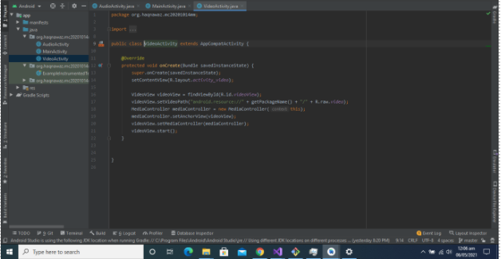

**Audio use this code:**

We Store audios in the resource/raw/ folder

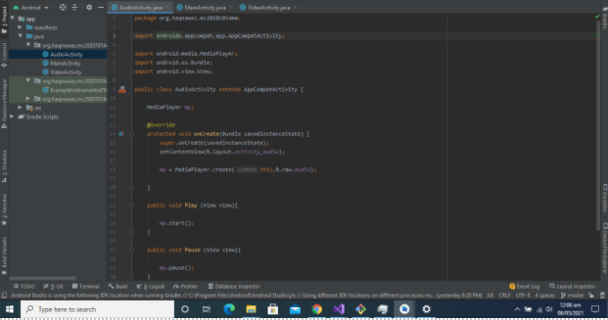

**Video Layout Code:**

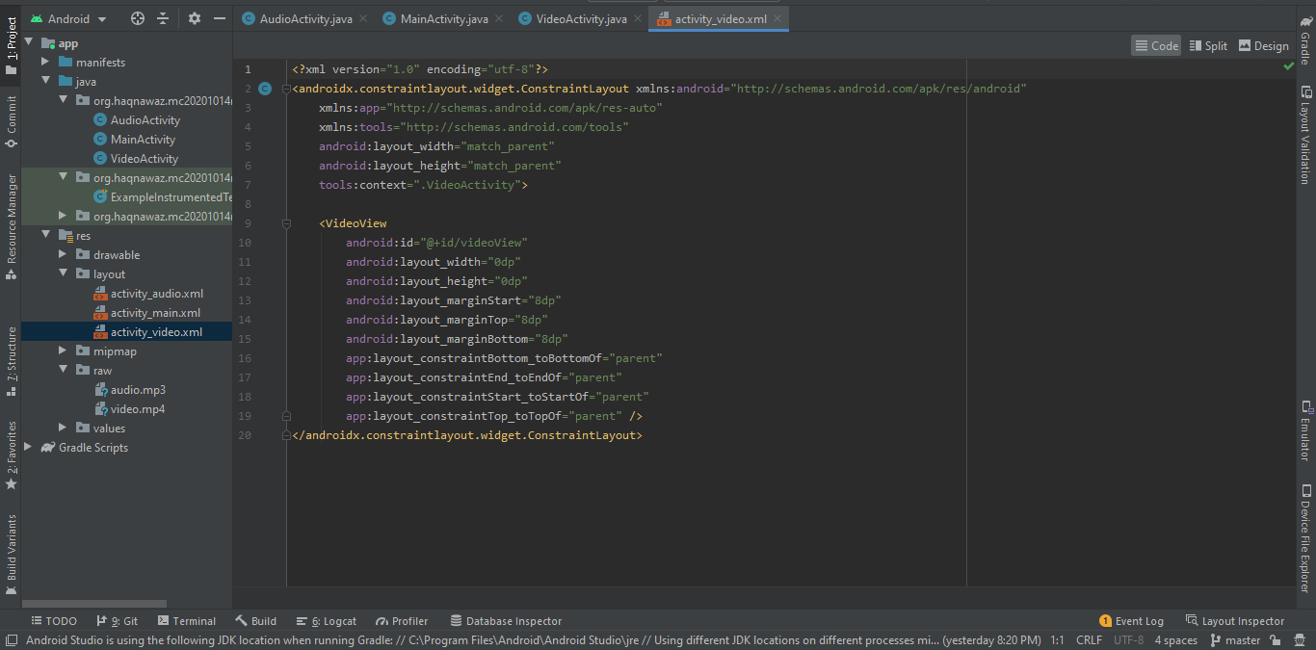

**Video Layout:**

Include videoView in the layout

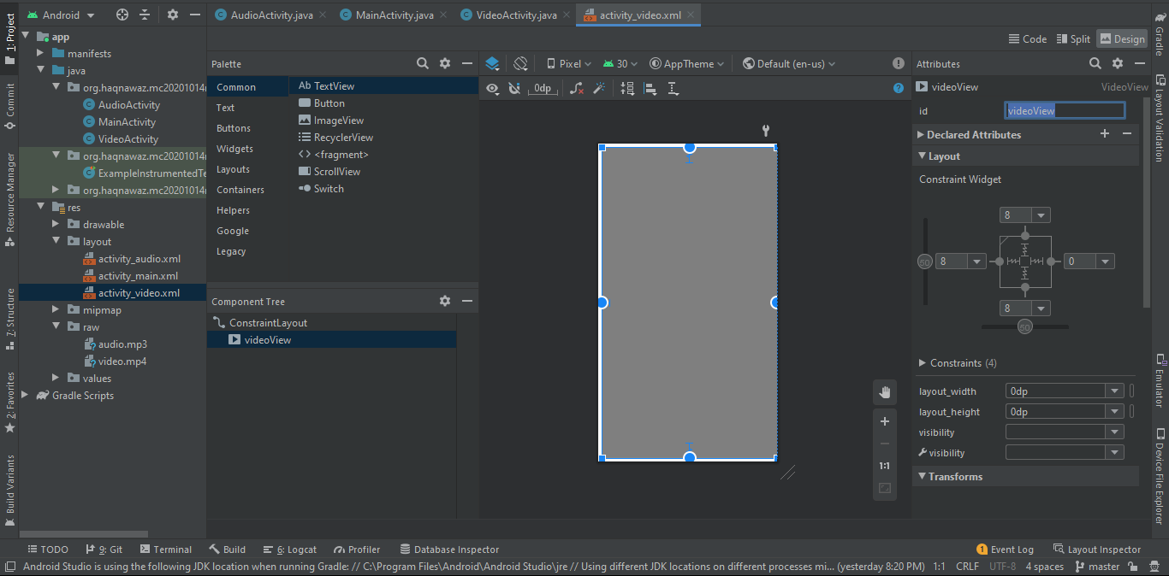

**Audio Layout Code:**

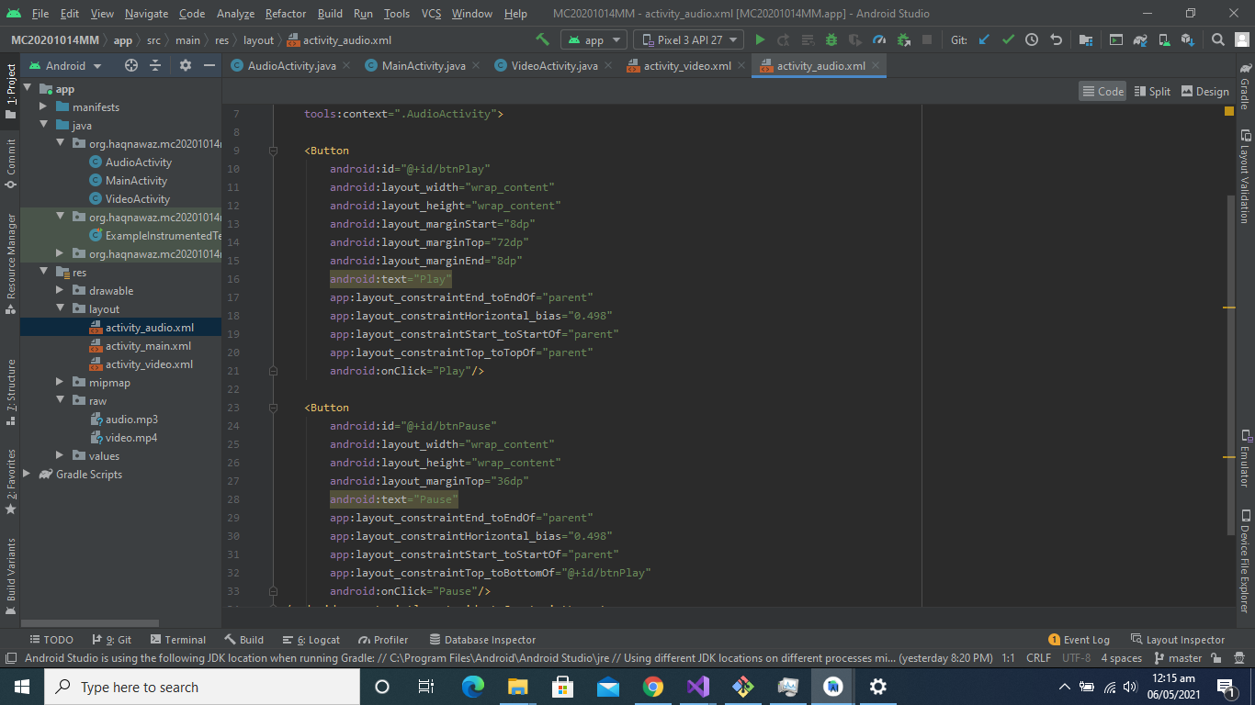

**Audio Layout:**

Add two buttons named as Play and Pause

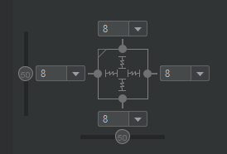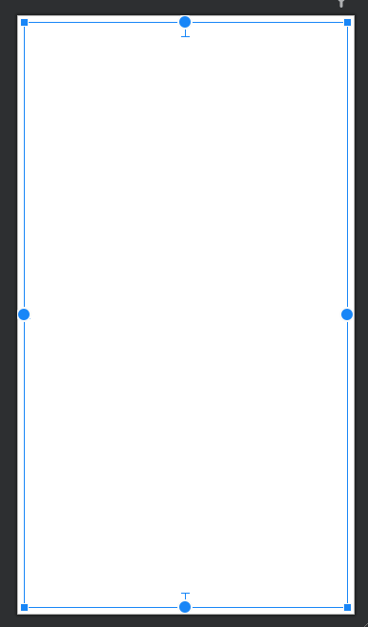

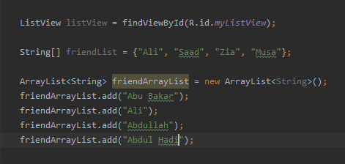

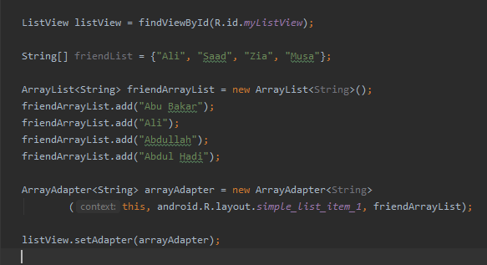

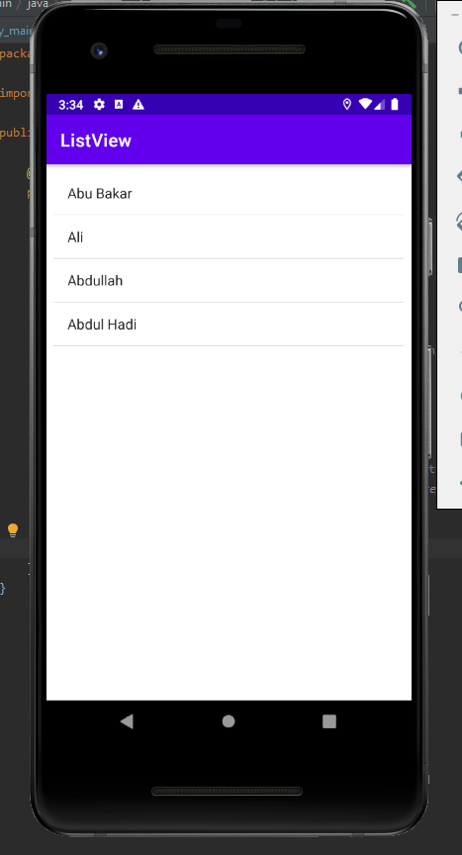

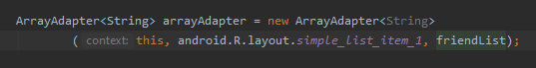

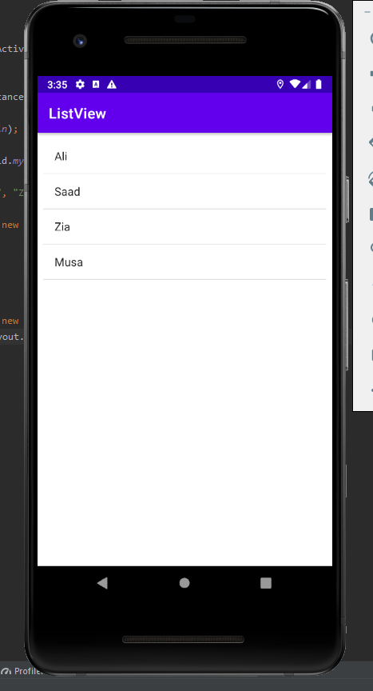

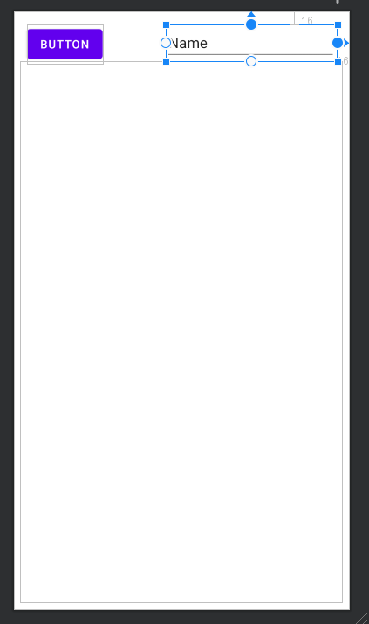

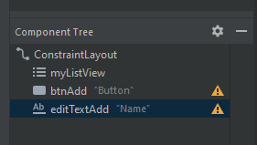

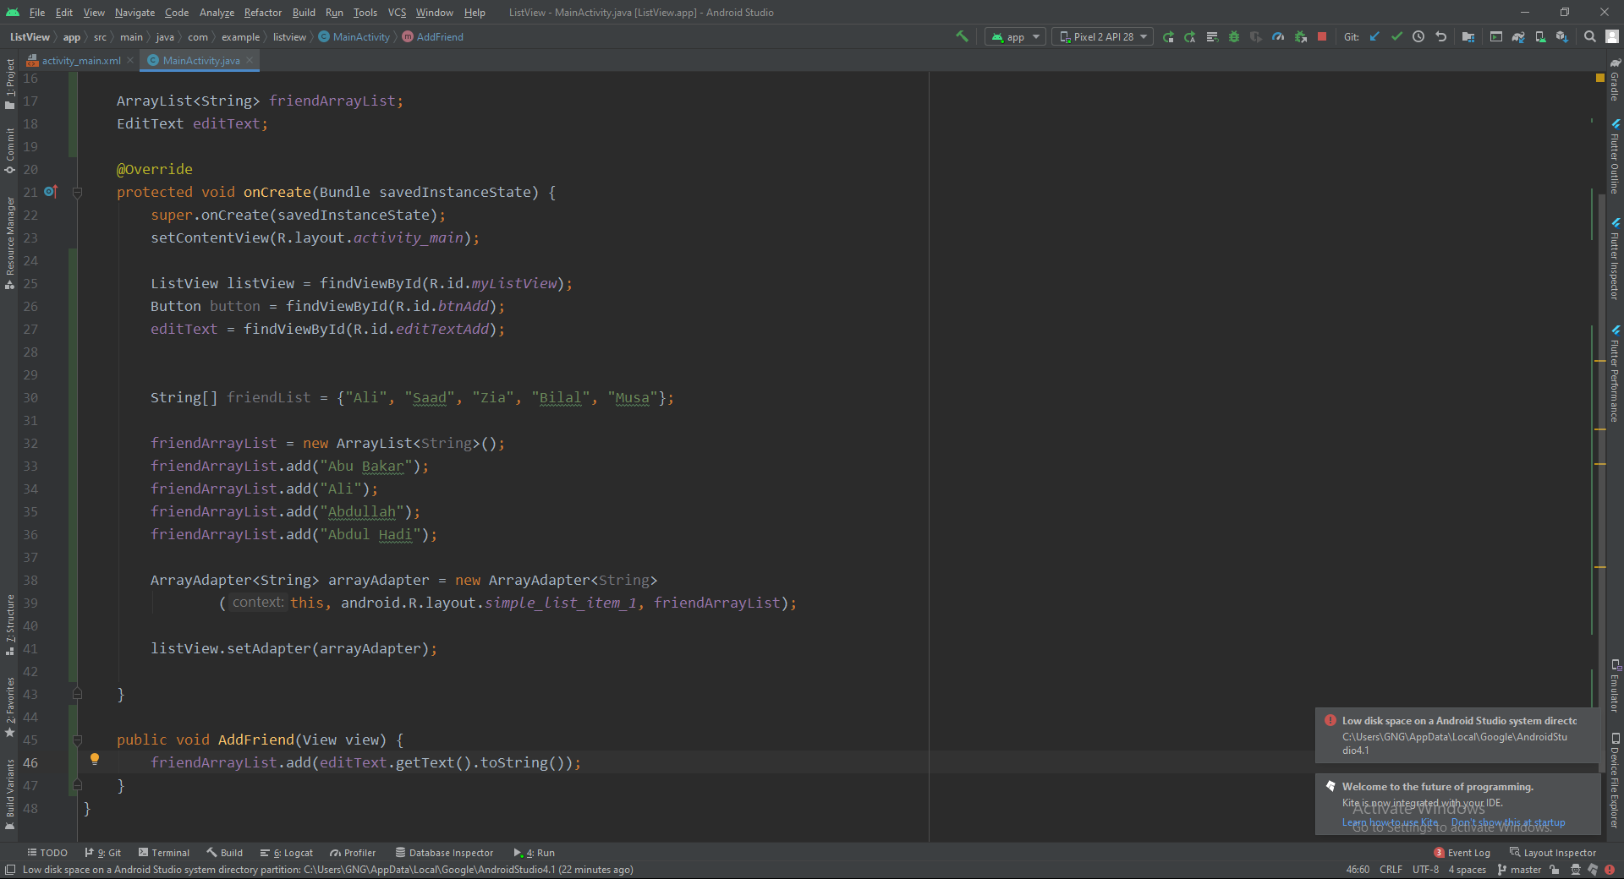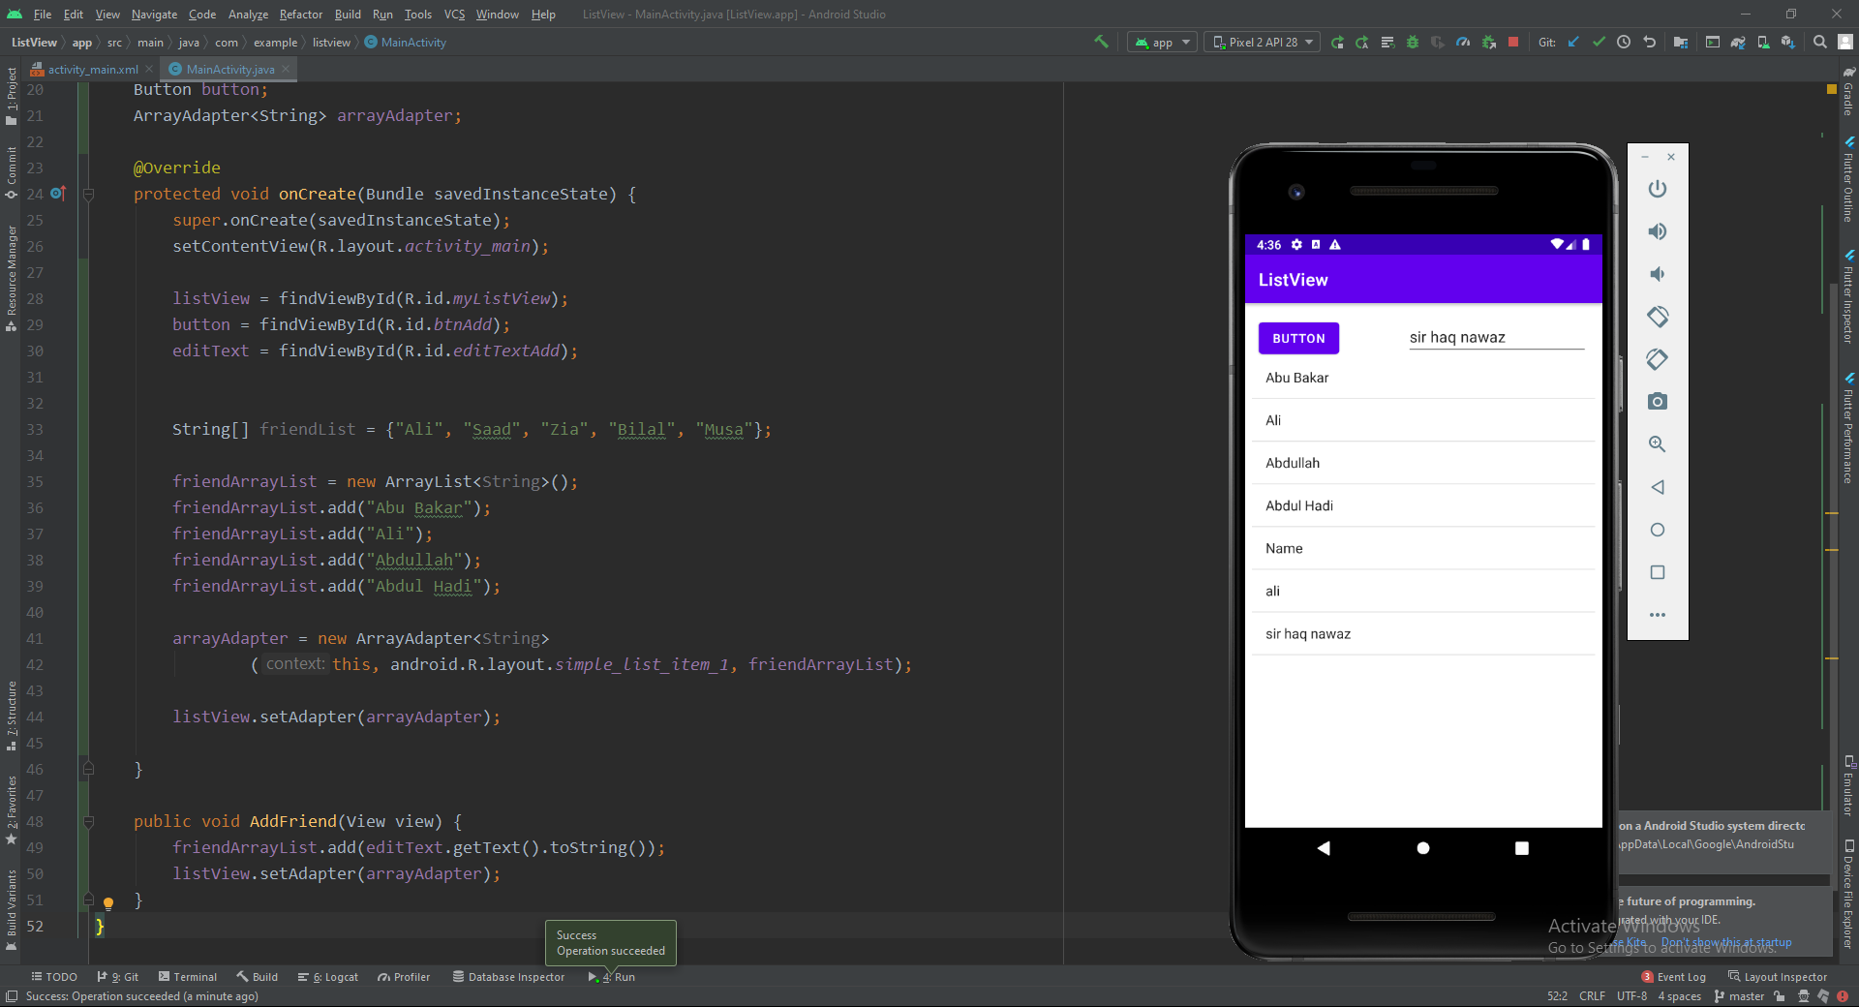

## Update of Records

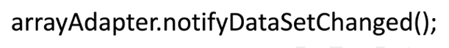

## Sorting of Records



## ListView Item Click Listner

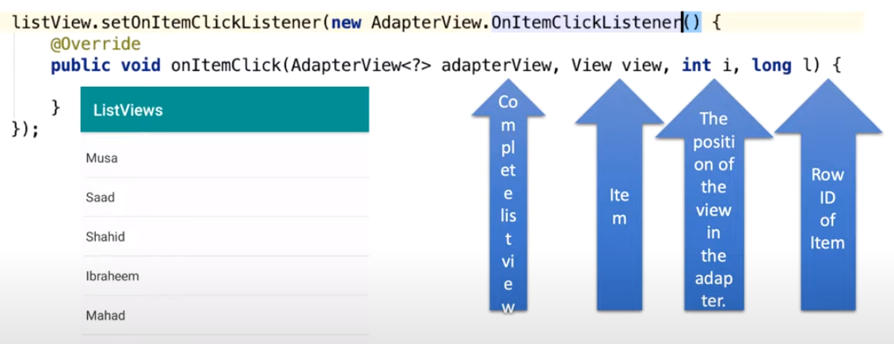

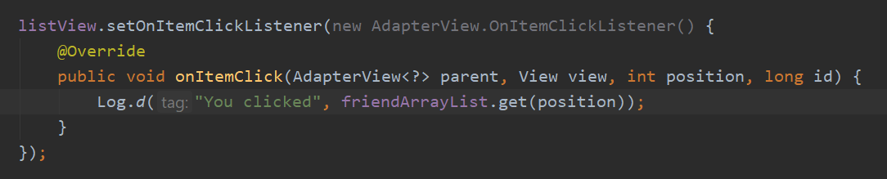

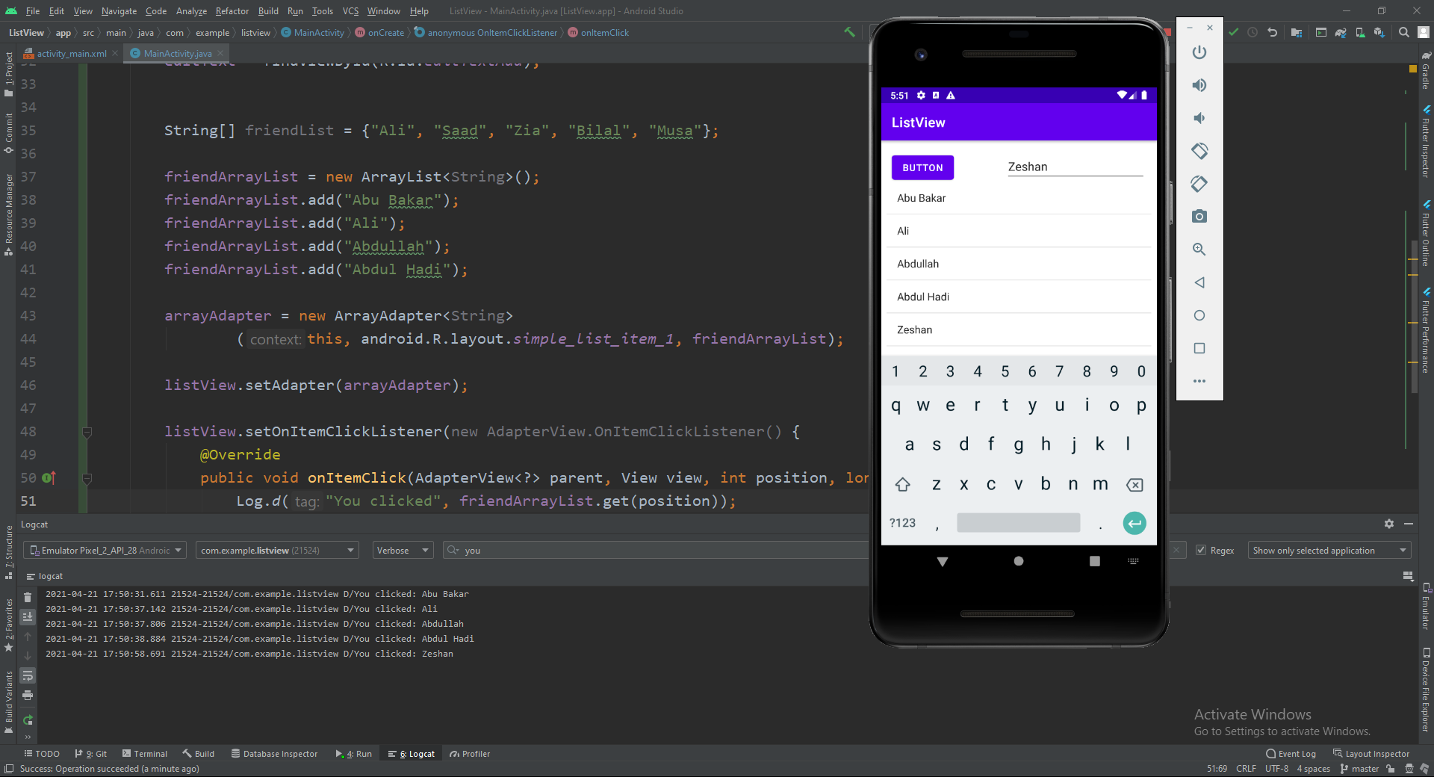

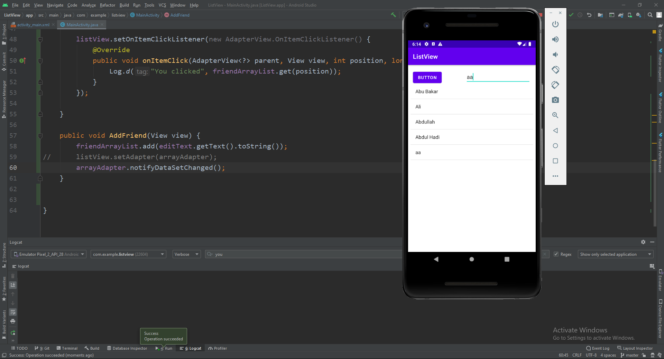

sorted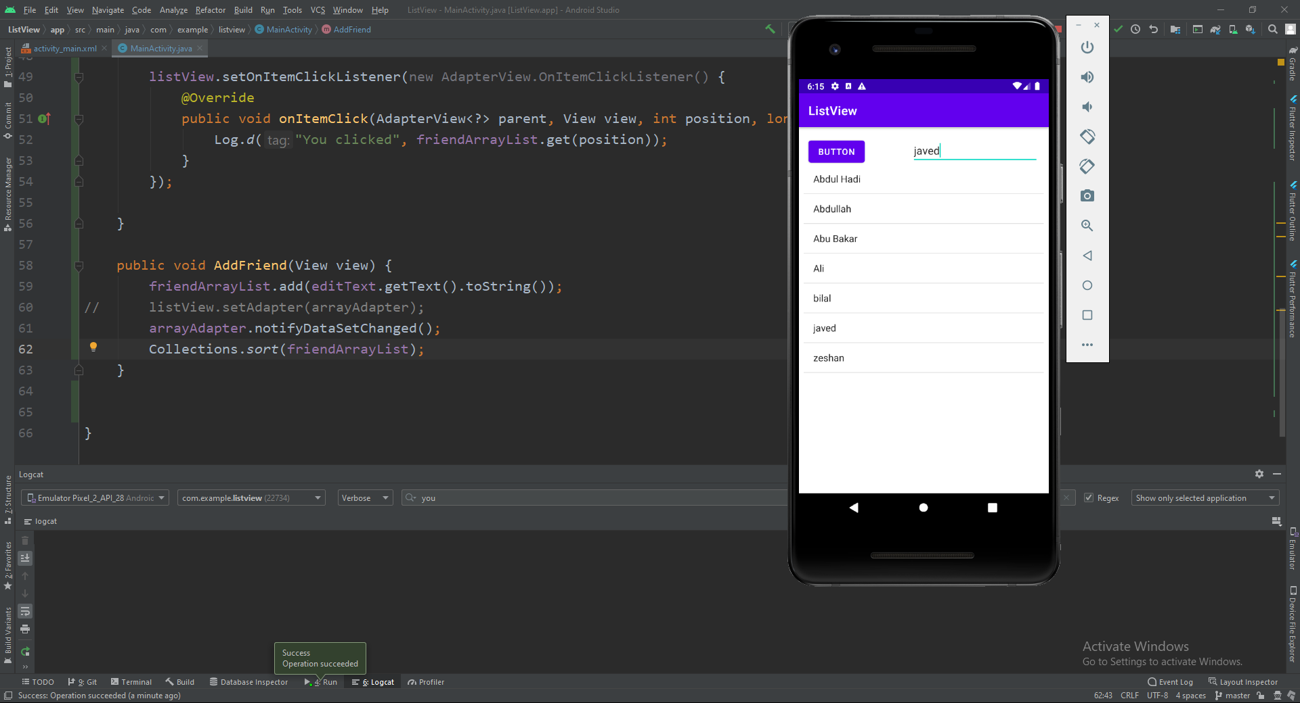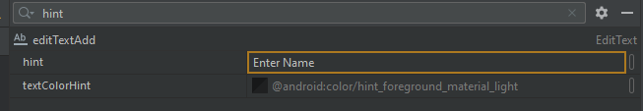

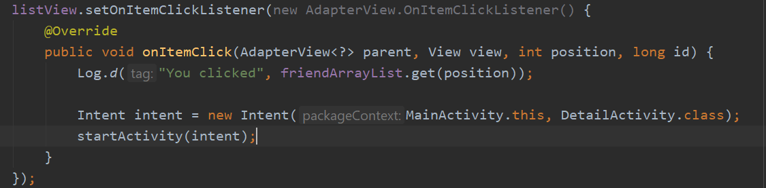

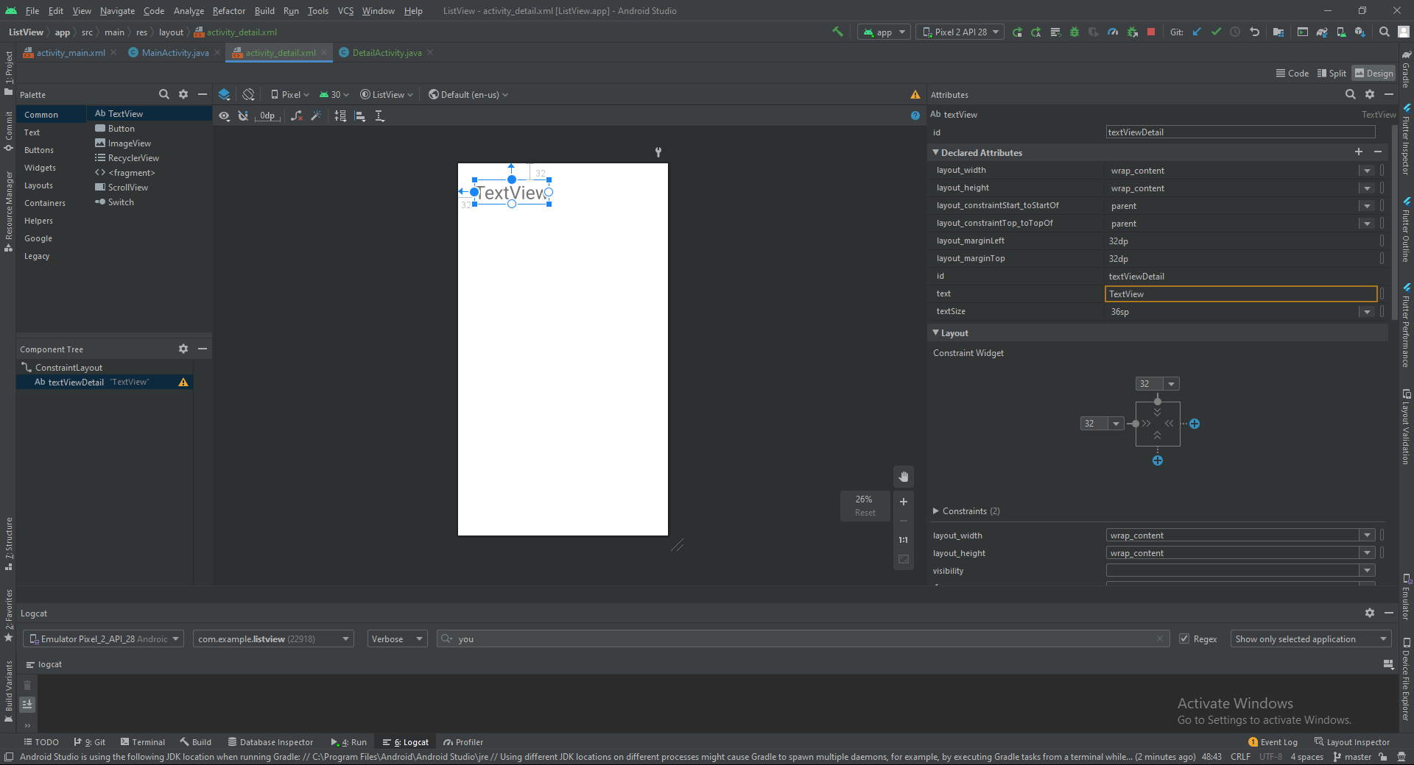

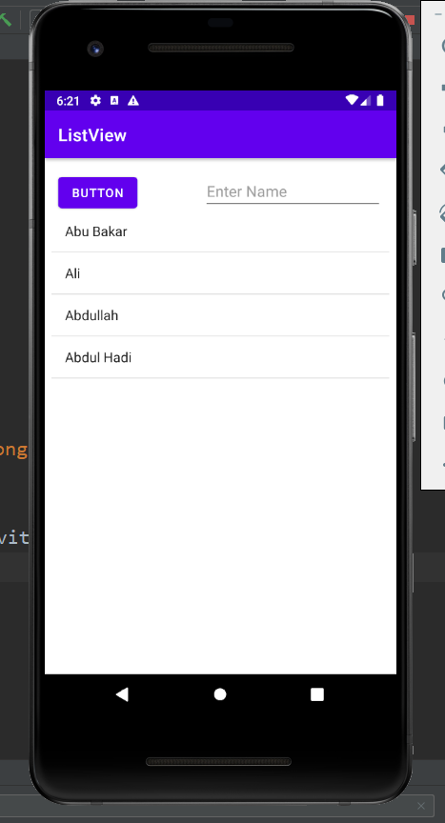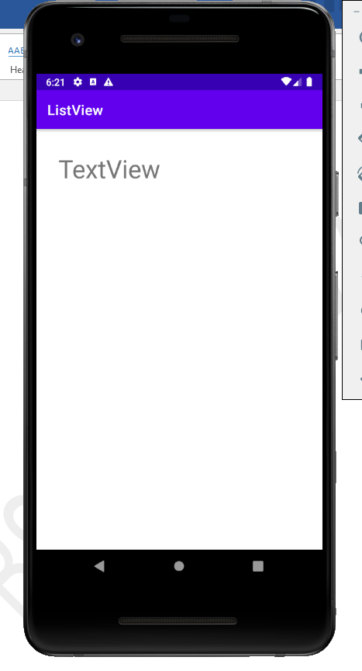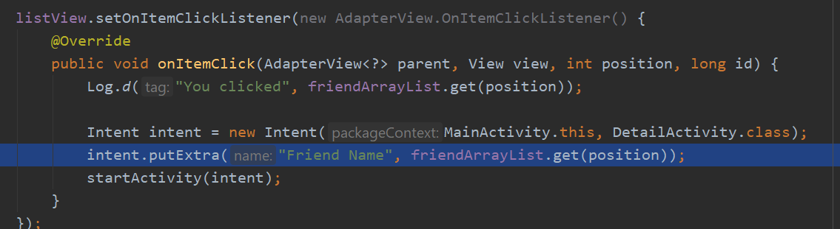

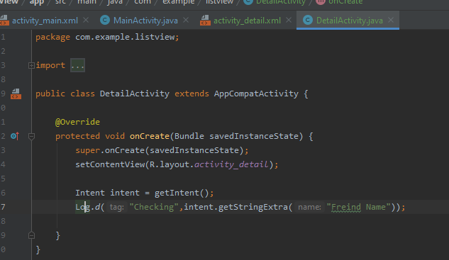

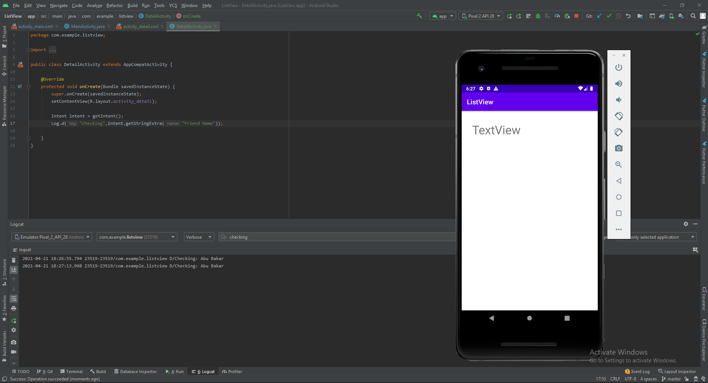

Values got in second activity from first activity

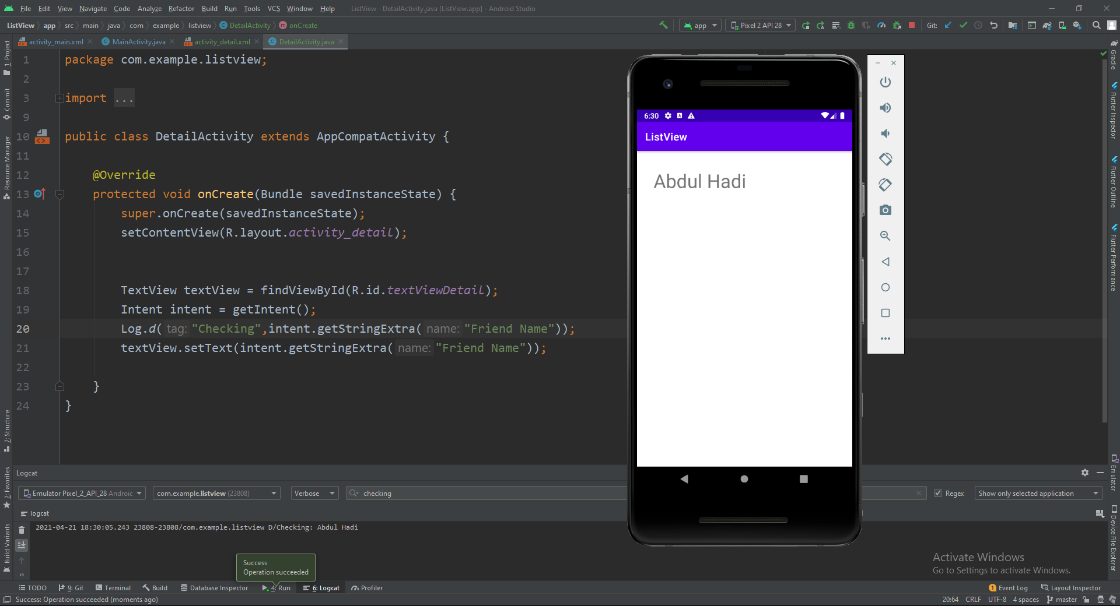

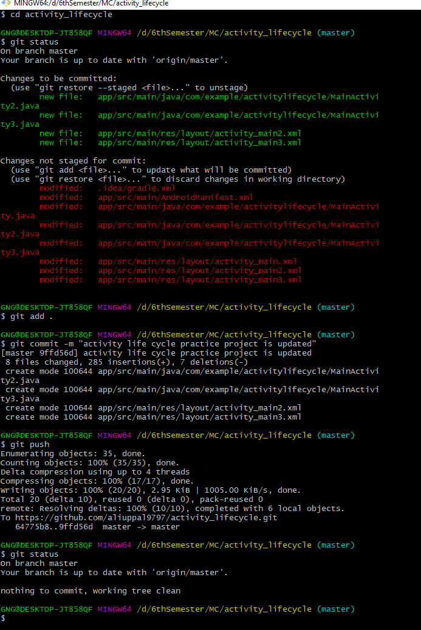

Animation repository: <https://github.com/aliuppal9797/Animation.git>

Add a **SeekBar** from widgets and set it’s constraints

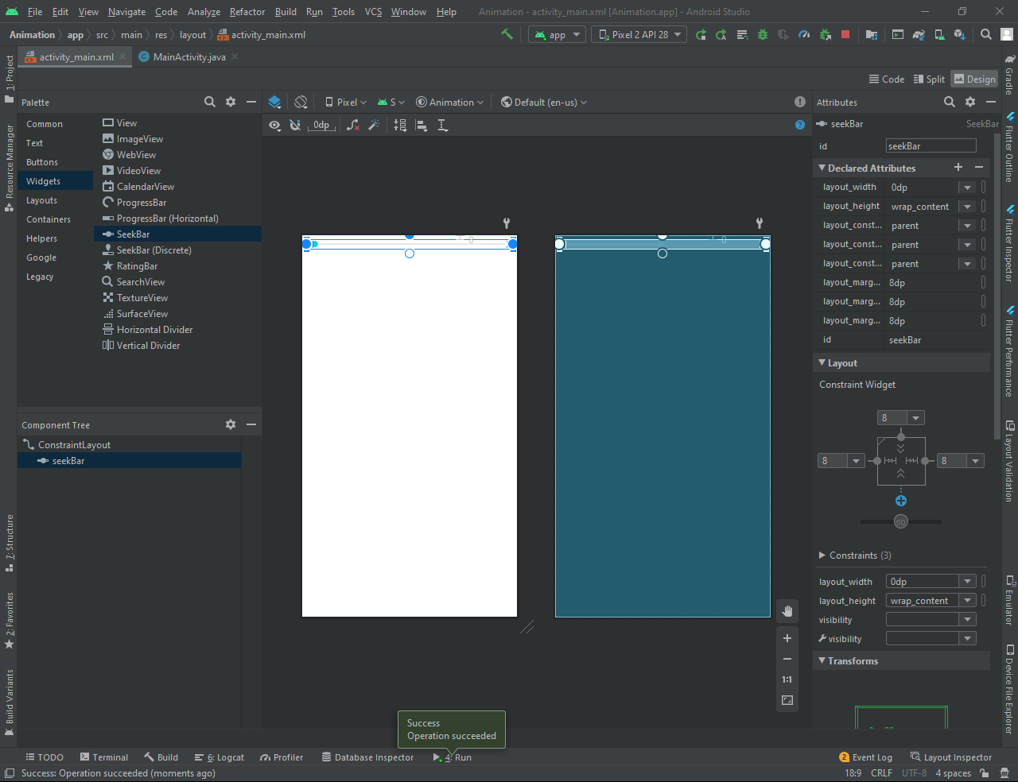

Add this code to your java file and run this app and check in the logCat

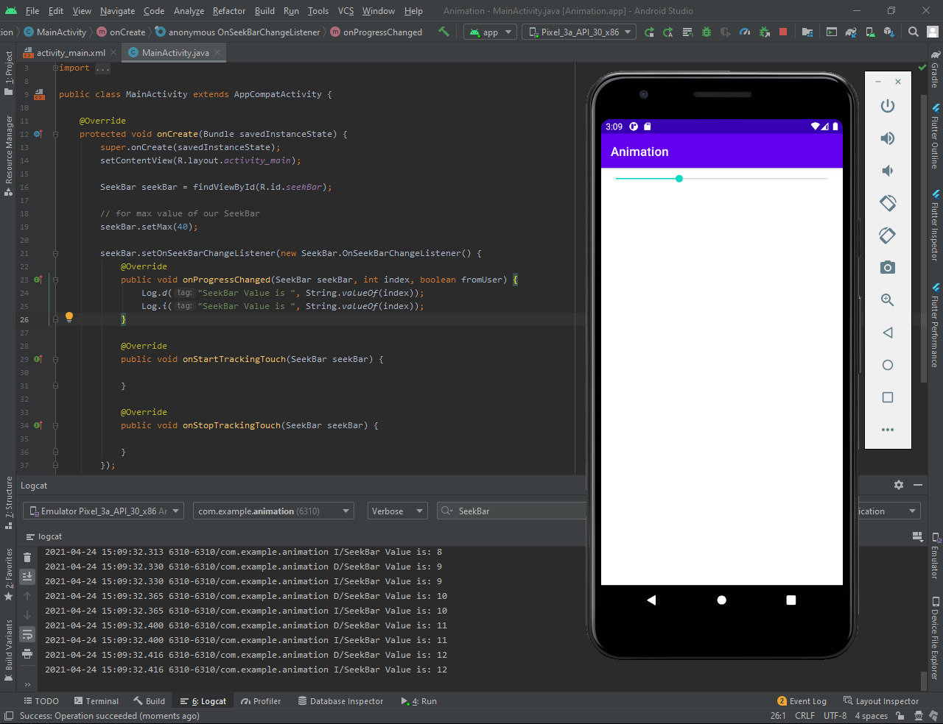

Add a list view and set its constraints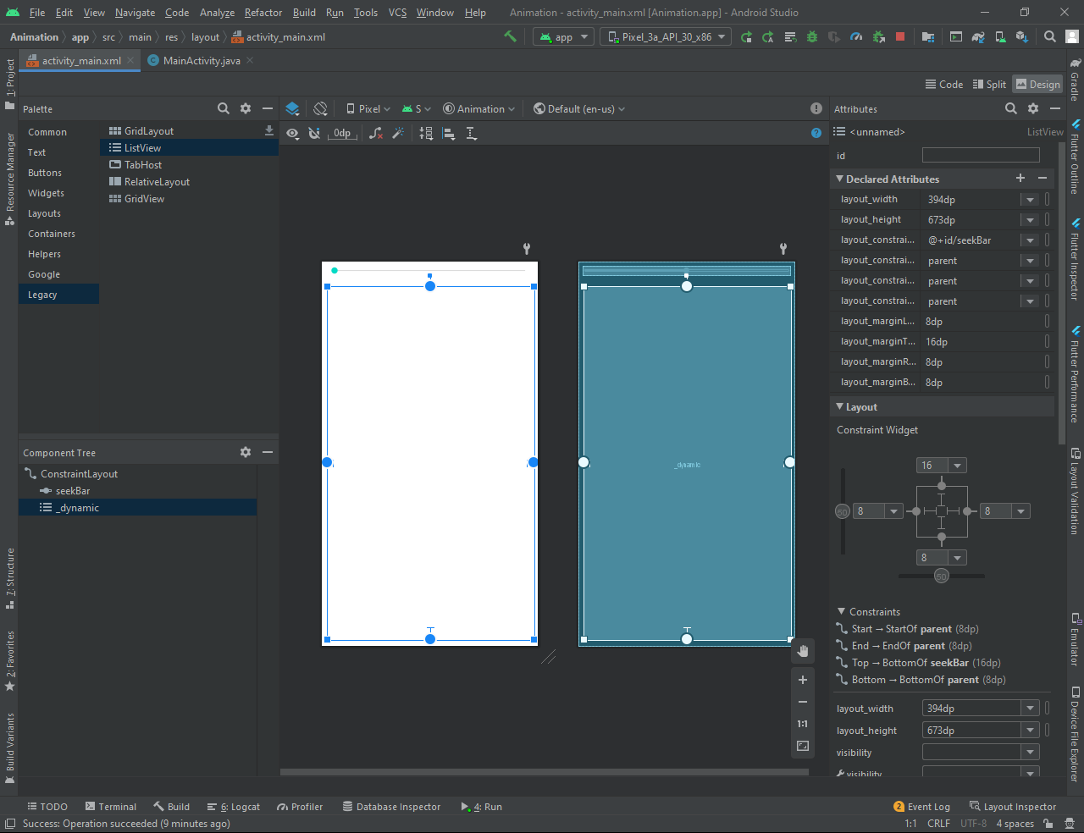

Add this code for ListView and ArrayList<String> and for ArrayAdapter and rerun your project. 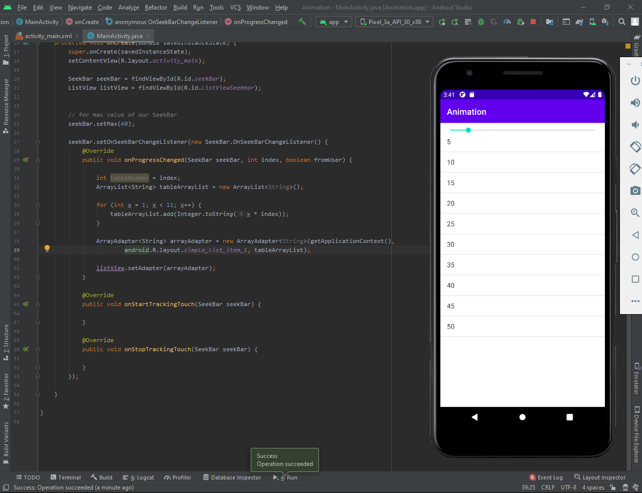

# **image animation**

Create a new activity and add an image and then set it’s constraints as shown in figure and run your project.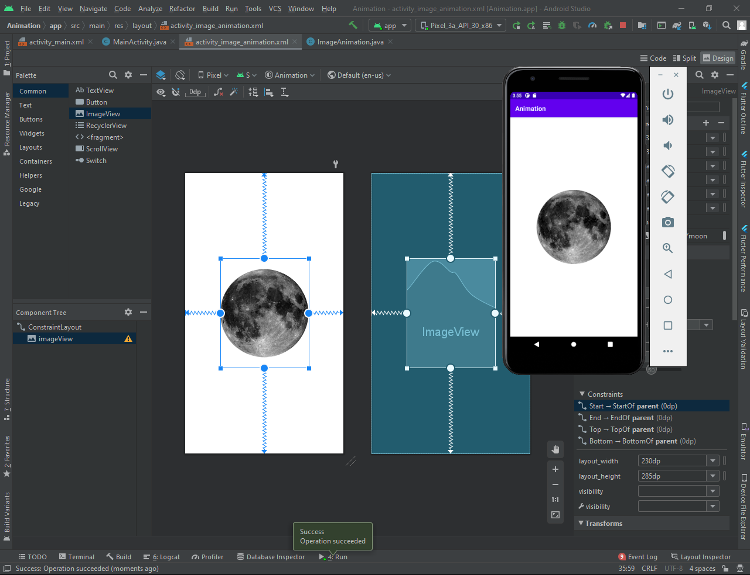

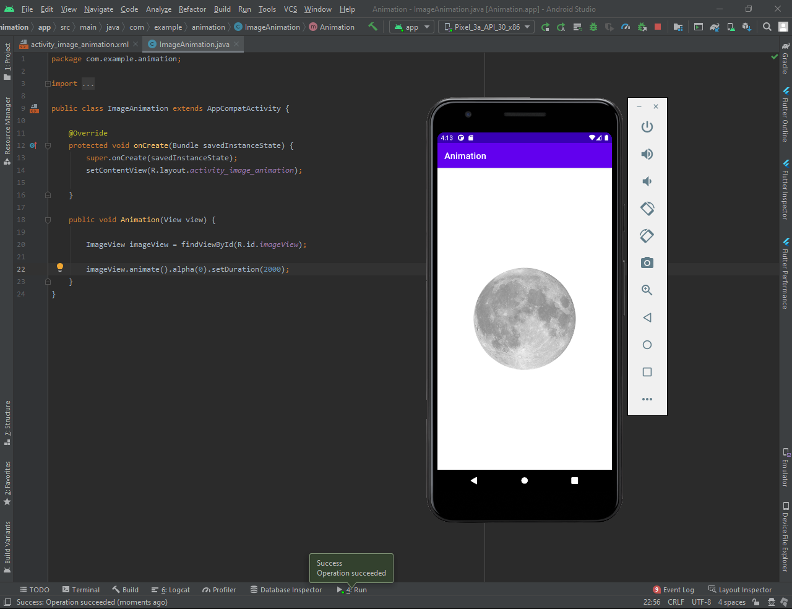

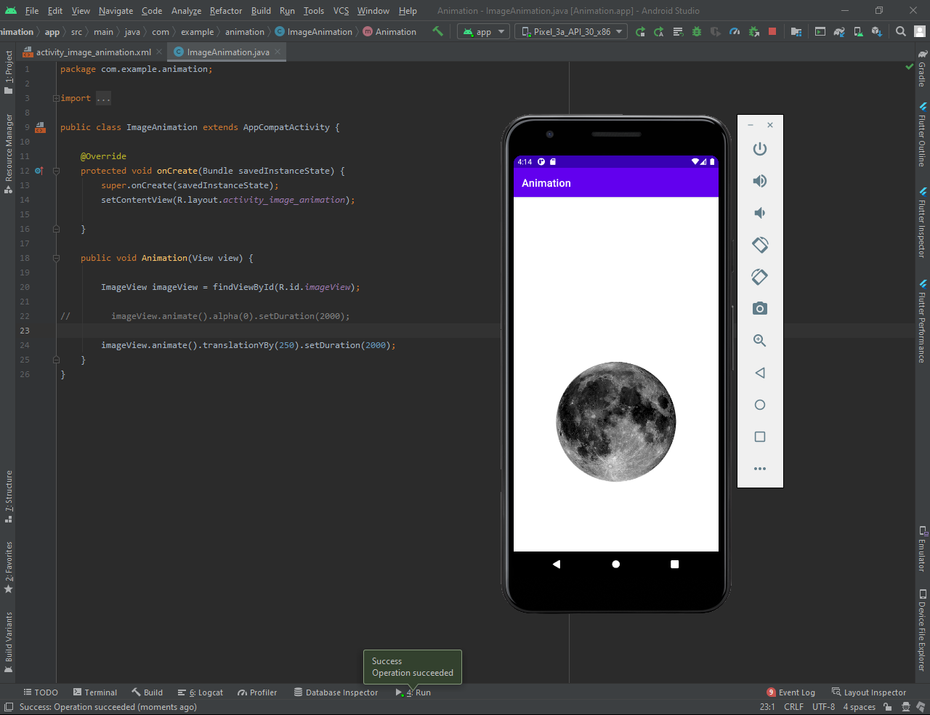

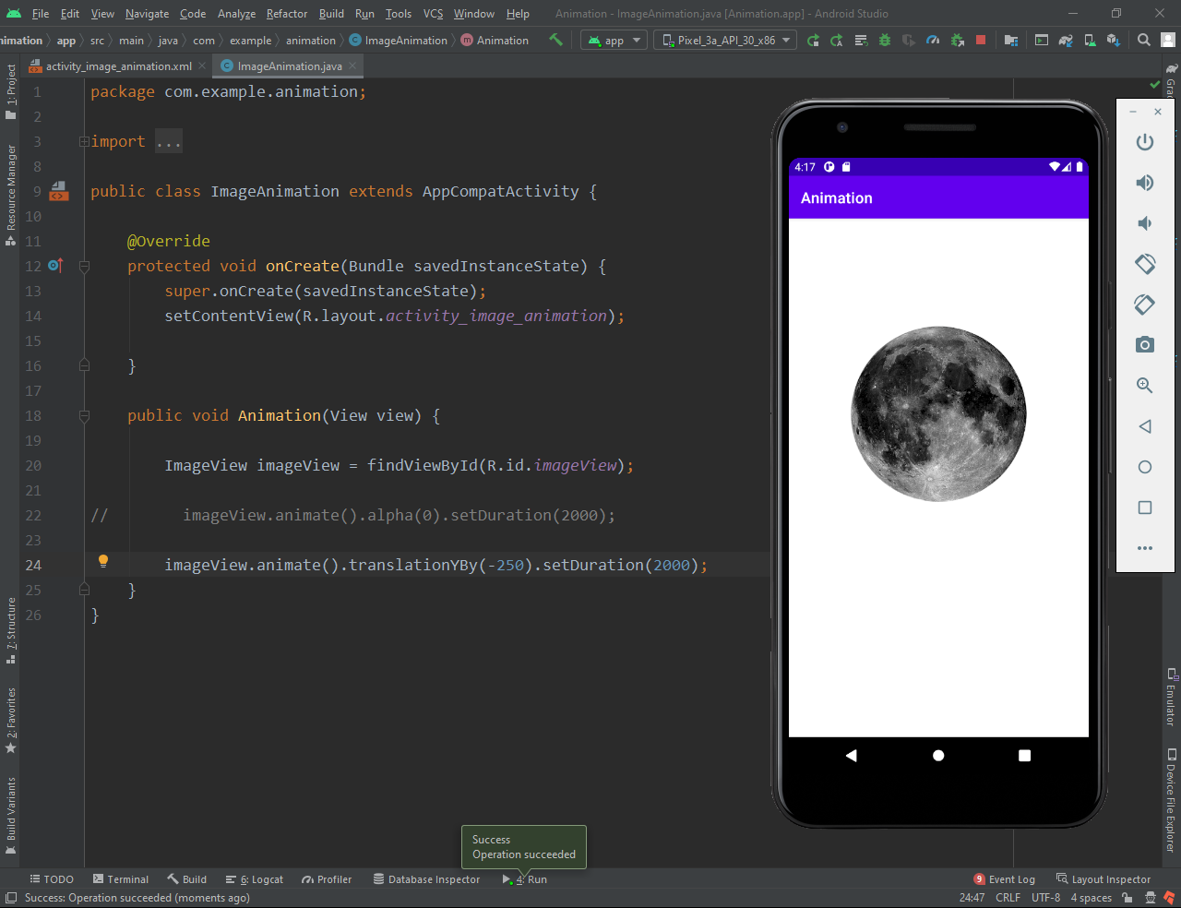

rotation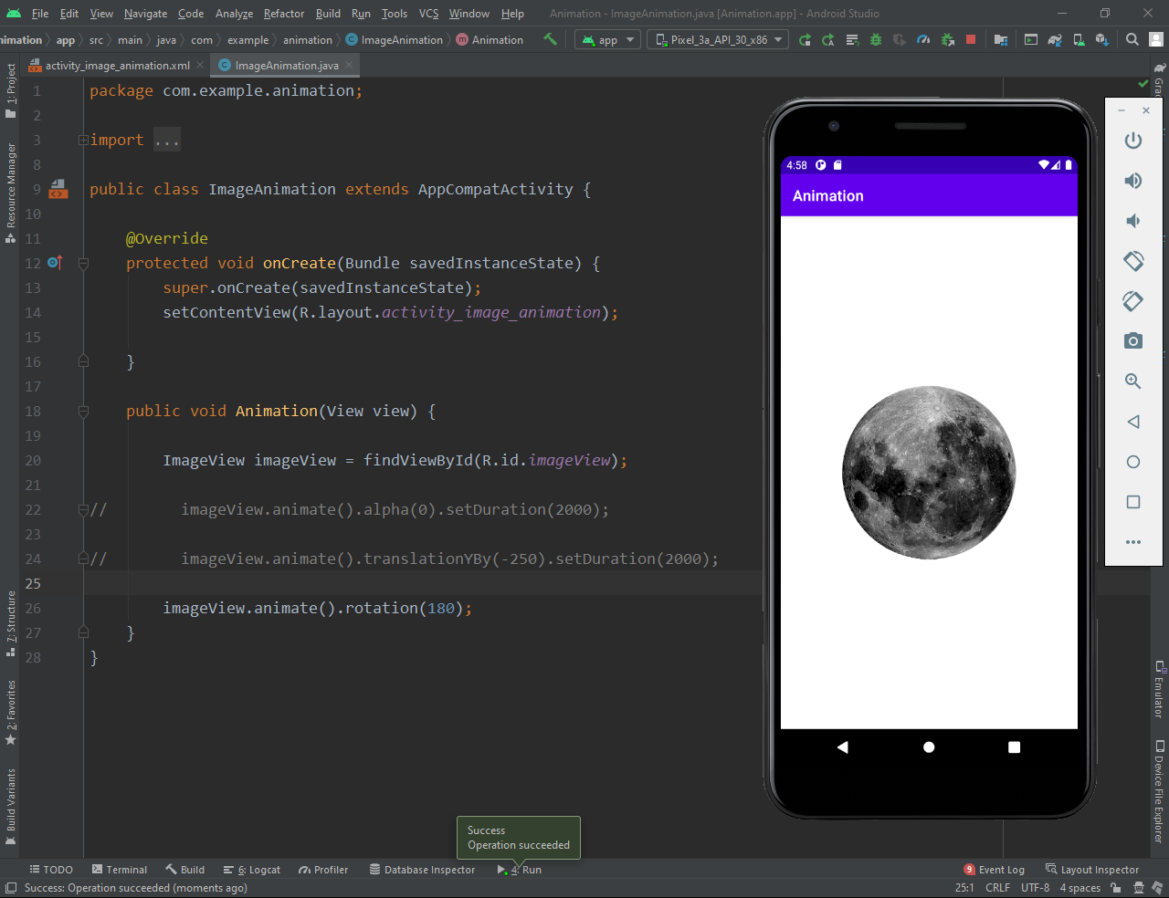

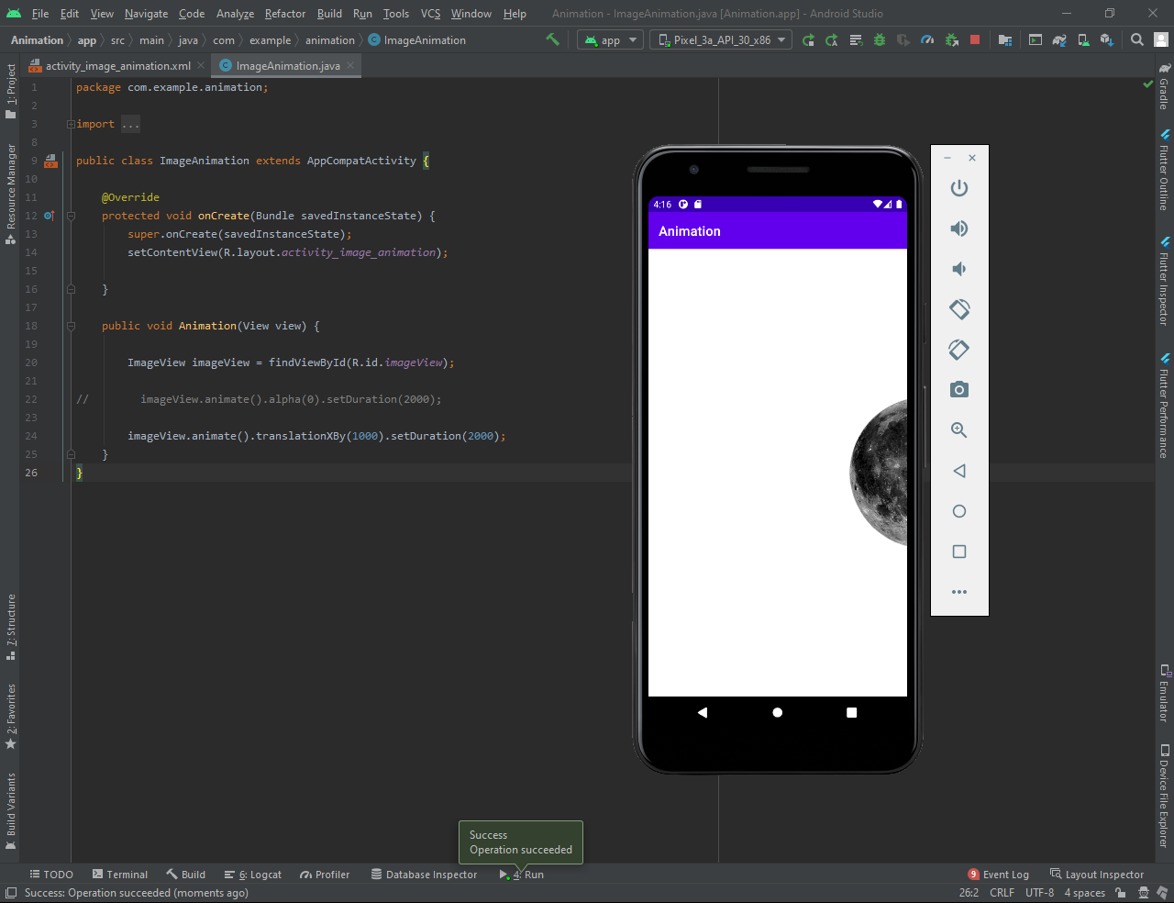

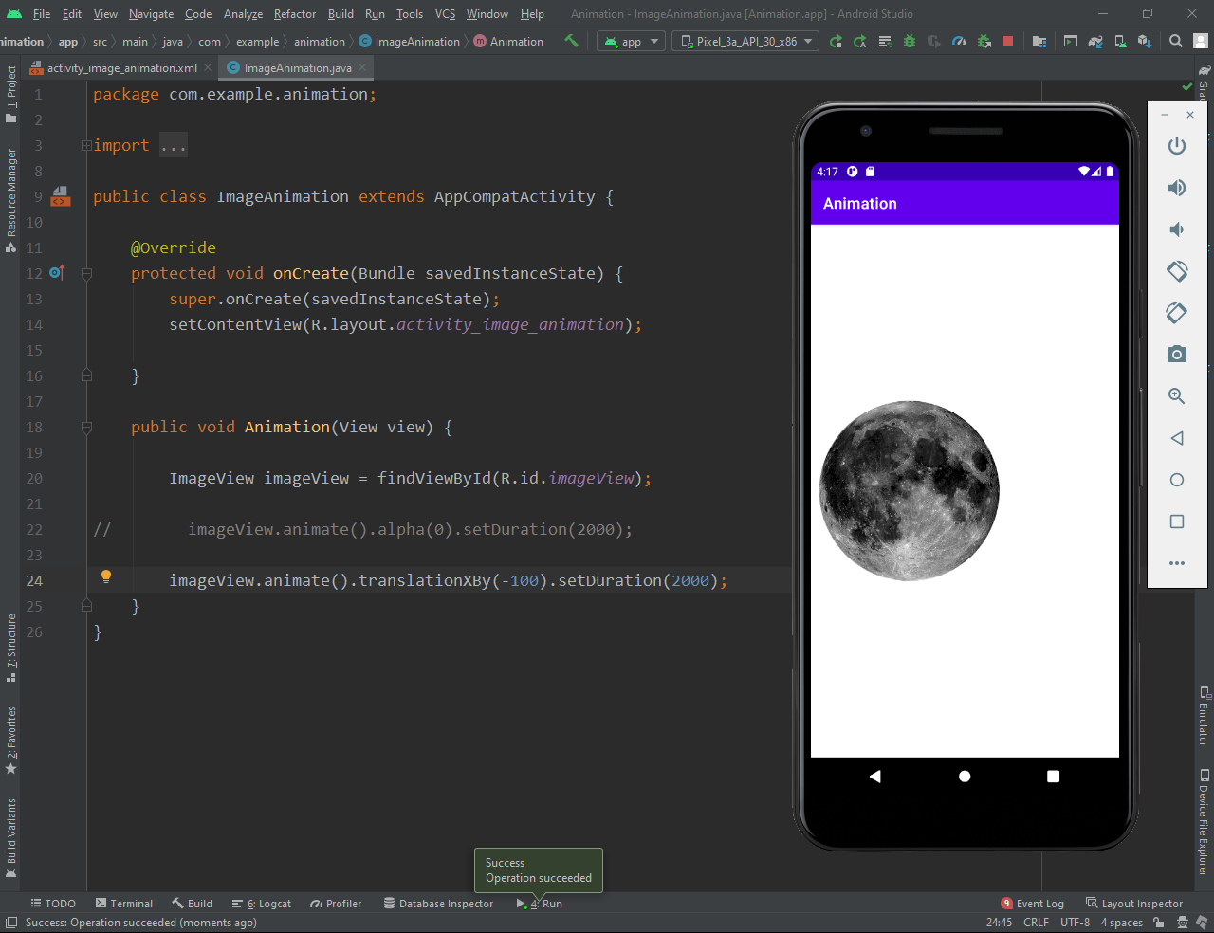

scaleX(value)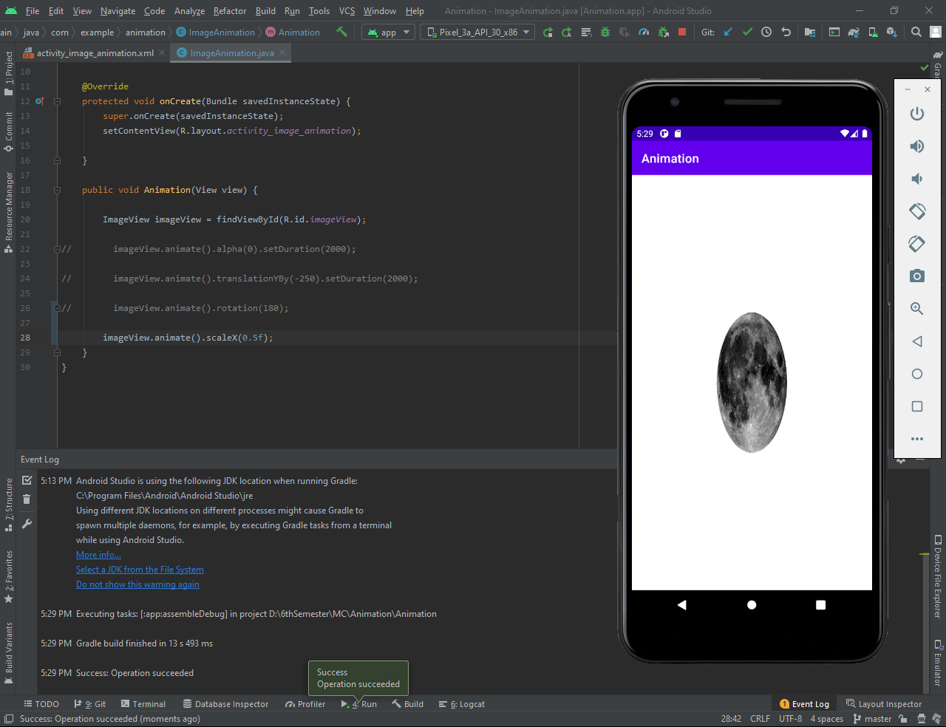

scaleY(value)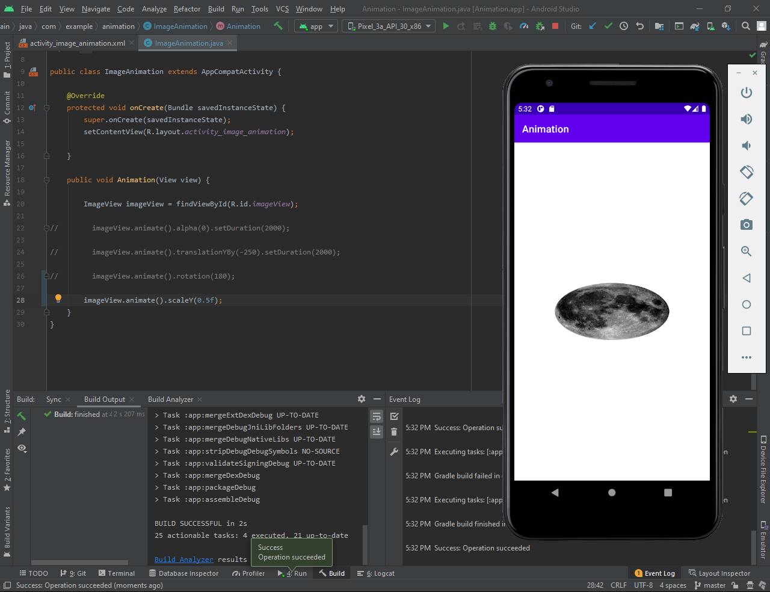

All functions are applied together.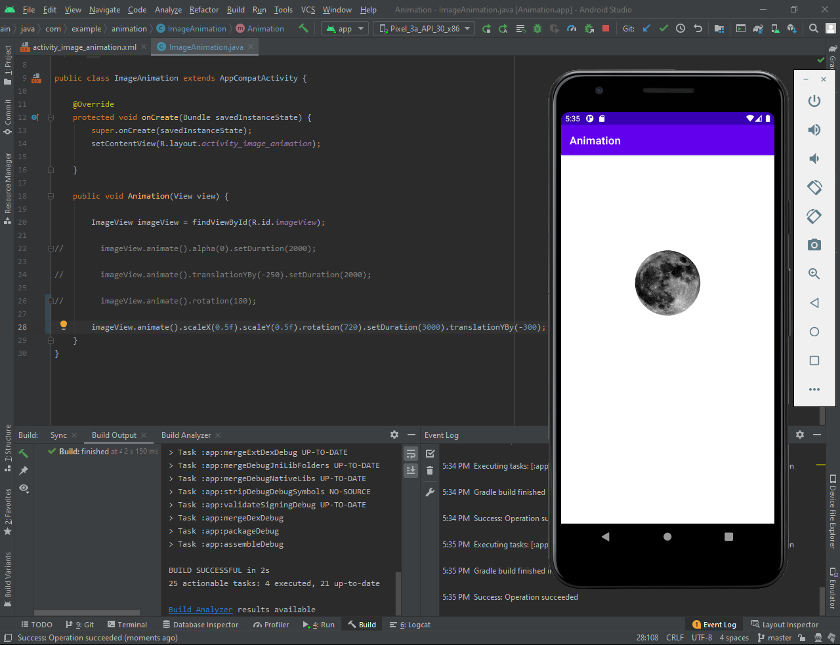

**SQLite** is an **open-source relational database** i.e. used to perform database operations on android devices such as storing, manipulating or retrieving persistent data from the database.

It is embedded in android by default. So, there is no need to perform any database setup or administration task.

In this project we use listview as we discussed in Lecture 10. But the data source which we display in the list view is a SQLite Database instead of Array.

**Design Layout Page:**

**I**n this page we create two plaintext, one for name (which take name as an input from the user) and the other for age ( which take age as an input from the customer) and then we add switch button in the Layout Page (which will check the status of the Customer, Is he/she active or not?) and then we add two button named as “Add Record” and “View Record” to Add the customer detail in the database and to display all the records that are stored in database.

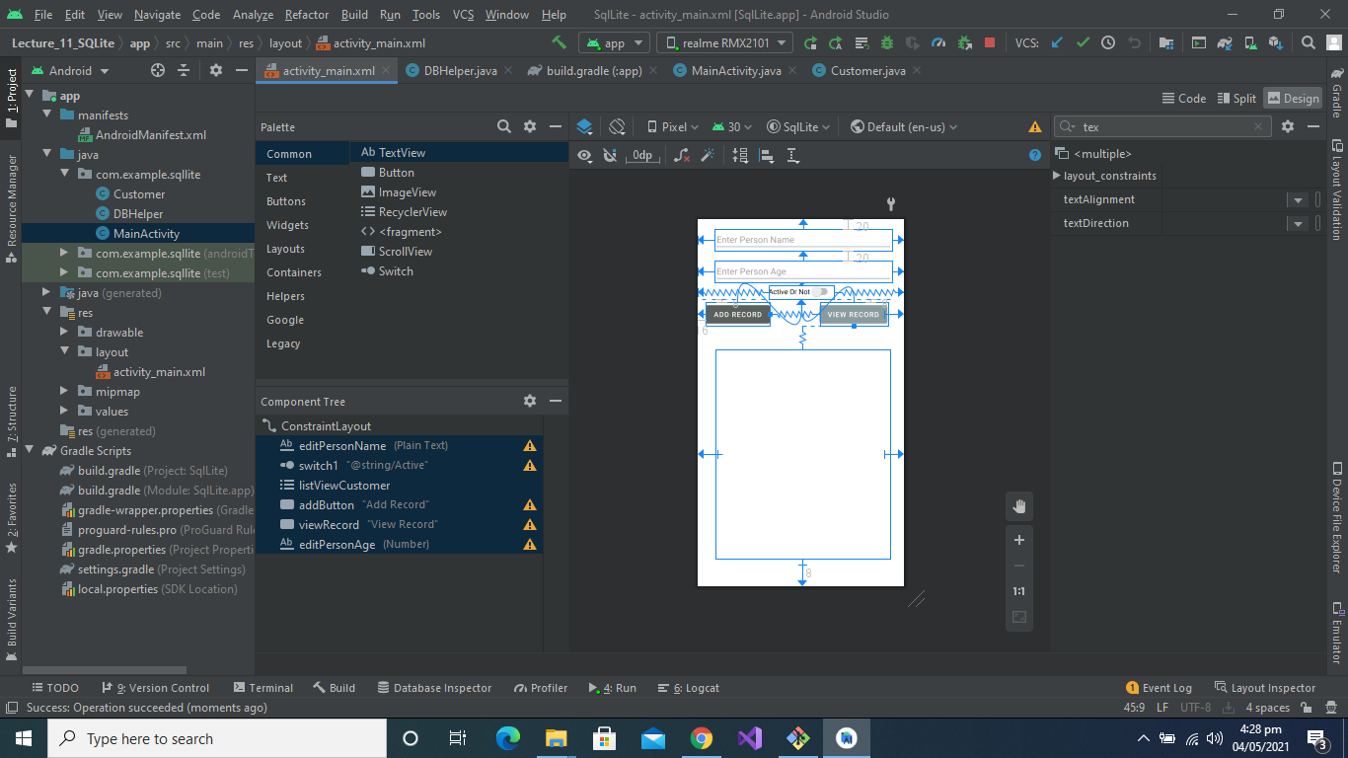

**Here is the Code Part:**

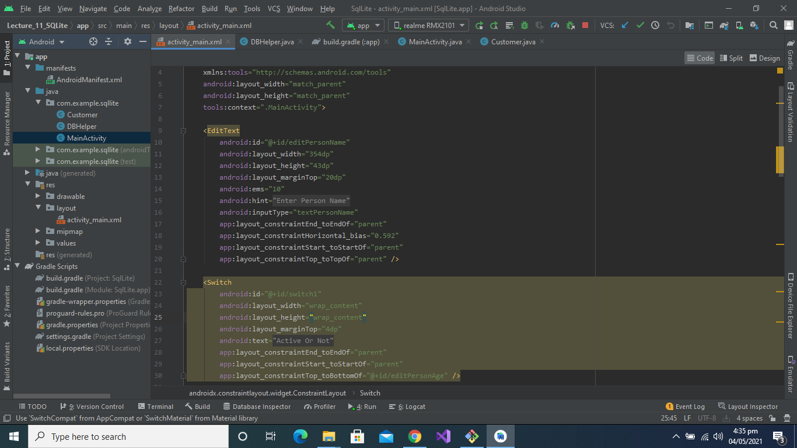

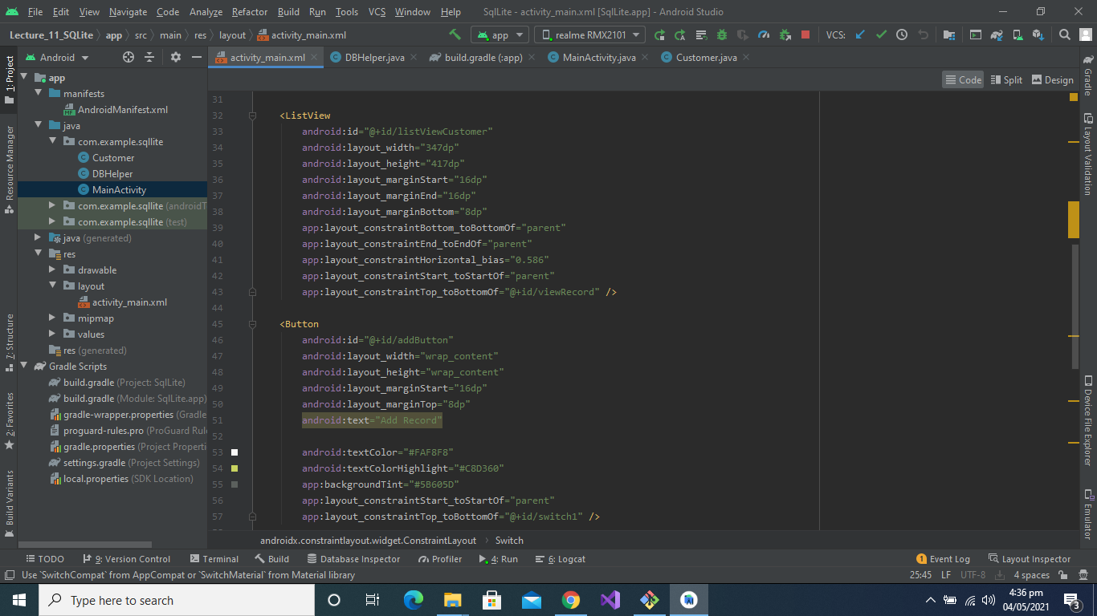

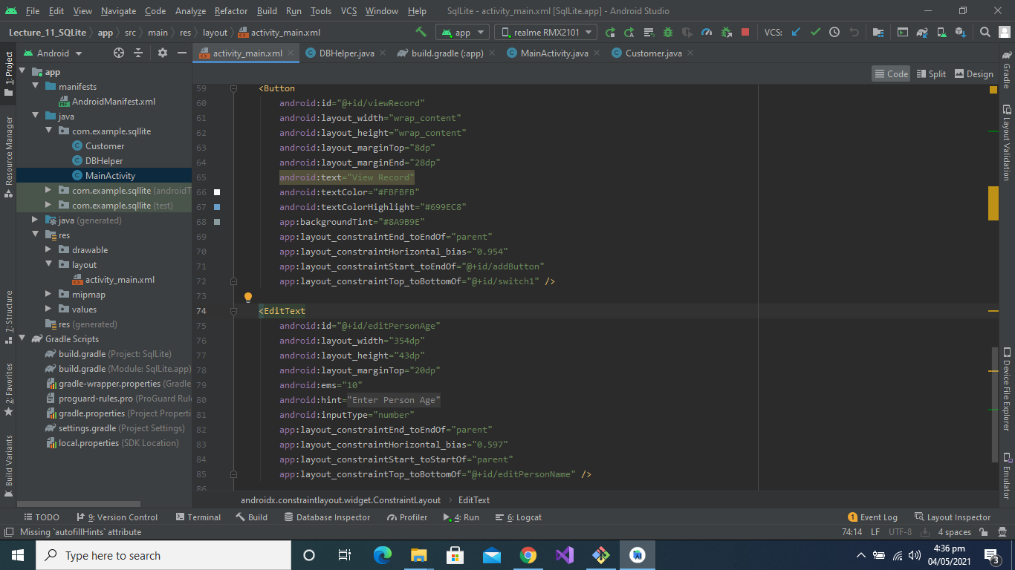

**Here is the Customer class code Part:**

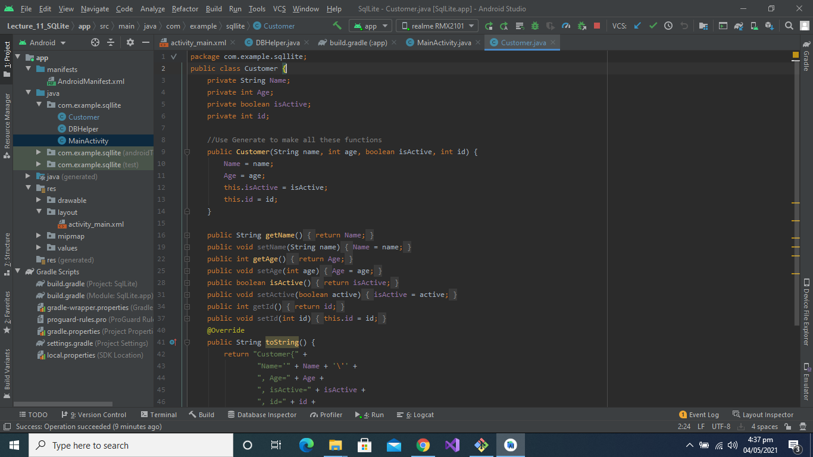

**Here is the Database code Part:**

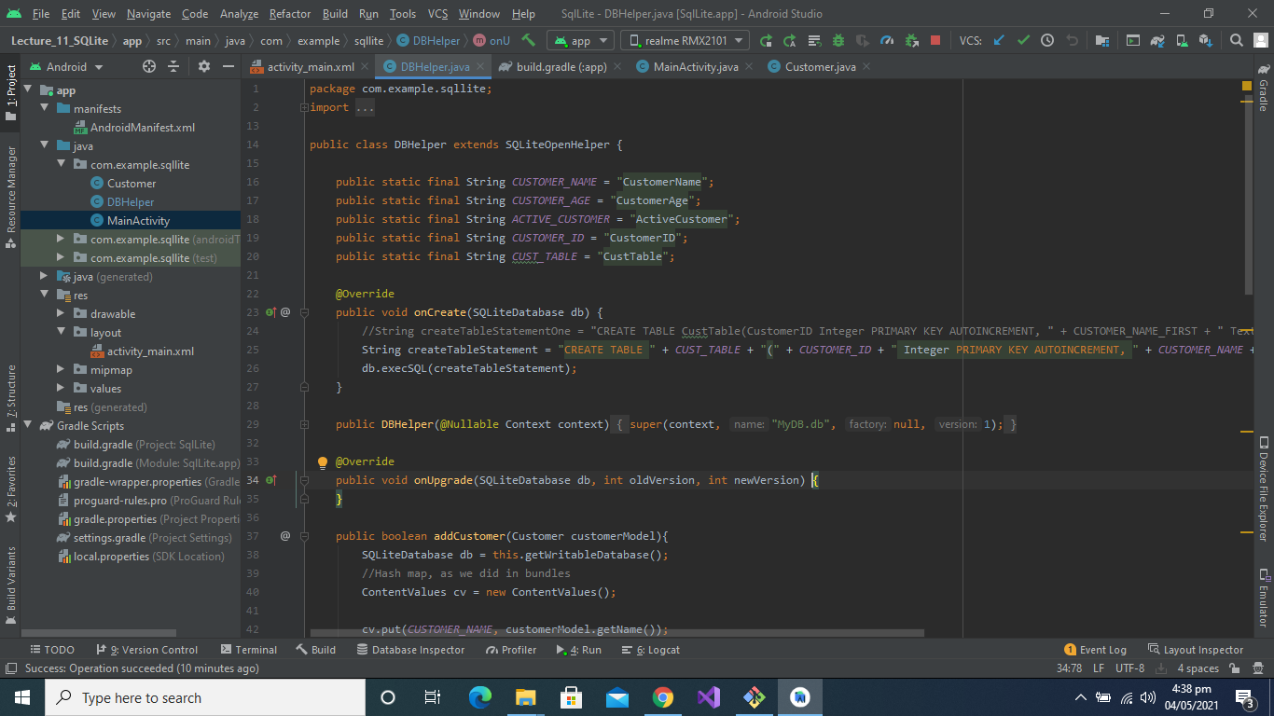

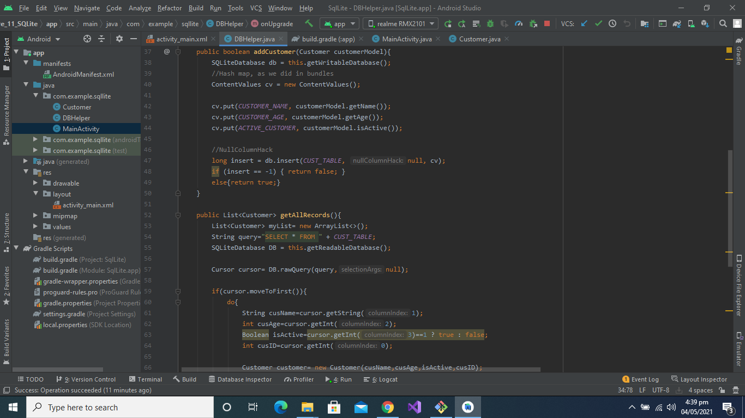

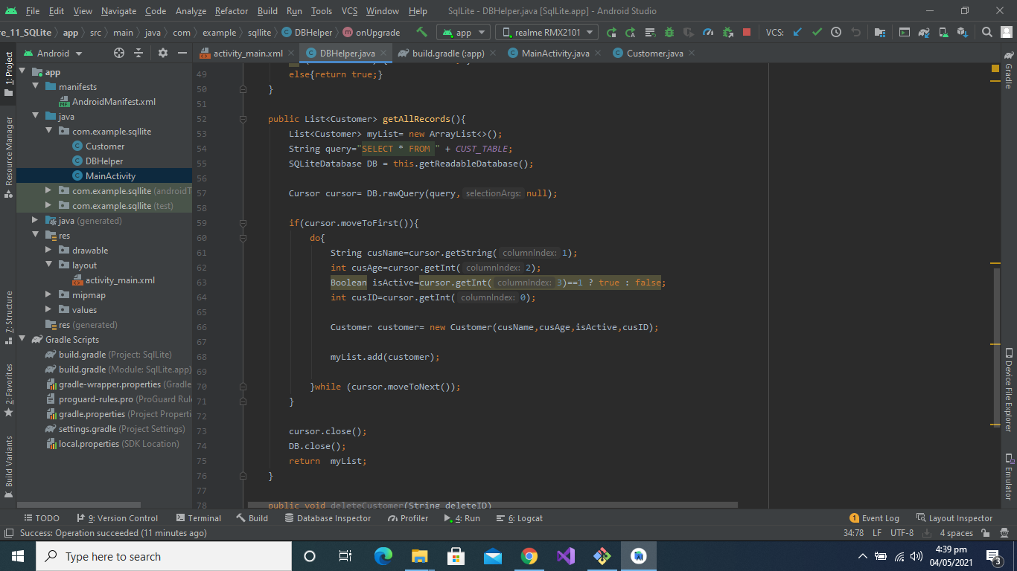

**RecyclerView:**

In **Android**, **RecyclerView** is an advanced and flexible version of ListView and GridView. It is a container used for displaying large amount of data sets that can be scrolled very efficiently by maintaining a limited number of views.

This new widget is a big step for displaying data in Material Design because the ListView and GridView are one of the most commonly used UI widget. In [RecyclerView](https://abhiandroid.com/materialdesign/recyclerview) android provides a lots of new features which are not present in existing ListView or GridView.

In Android, [RecyclerView](https://abhiandroid.com/materialdesign/recyclerview) provides an ability to implement the horizontal, vertical and Expandable List. It is mainly used when we have data collections whose elements can change at run time based on user action or any network events.

In this program we made the list of 10 most beautiful cities in the world:

In **cities.xml** we make **imageView** and **two textViews.**

**City Design Code Part:**

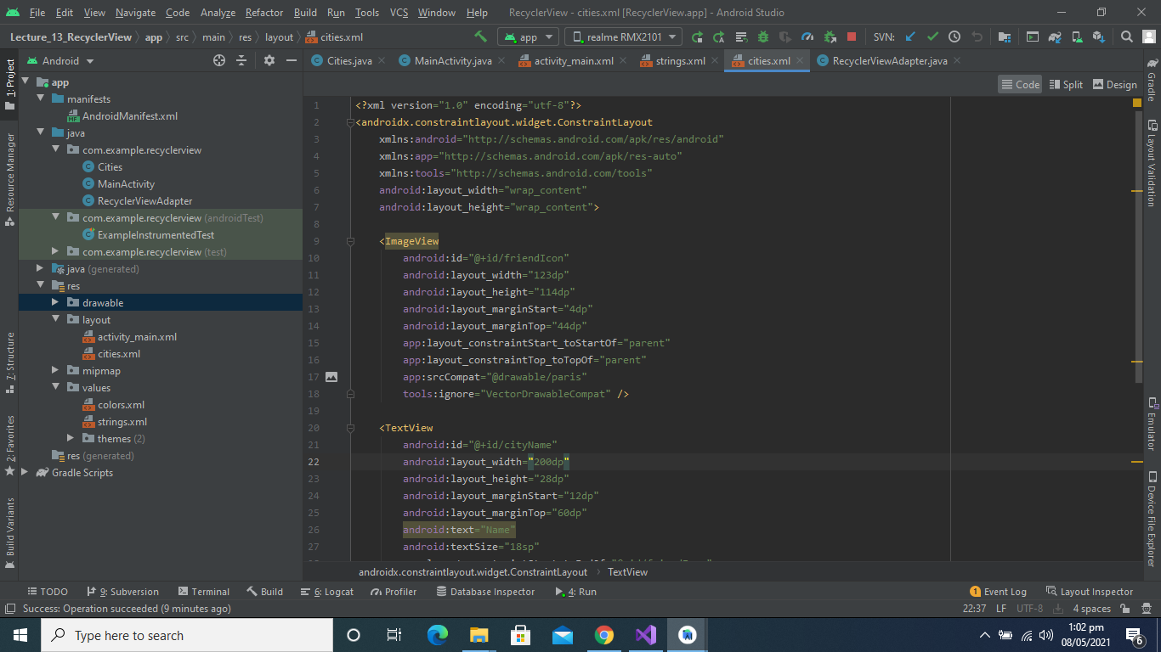

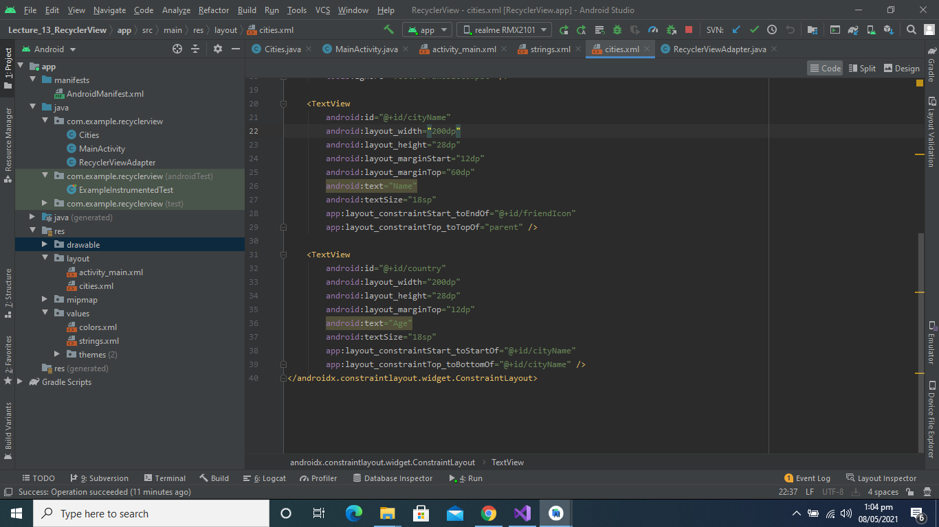

**City Design Page:**

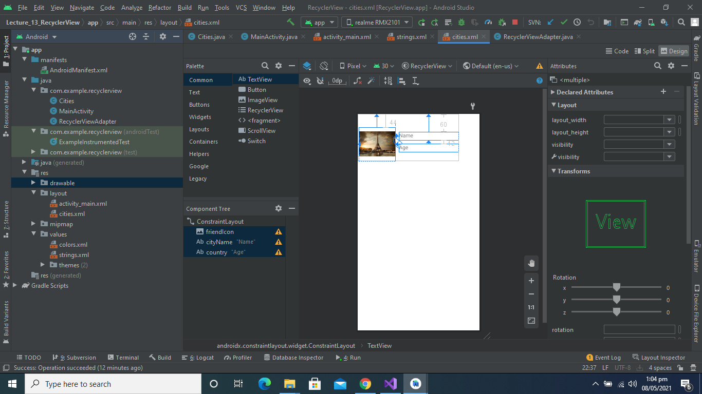

**Code of cities.java:**

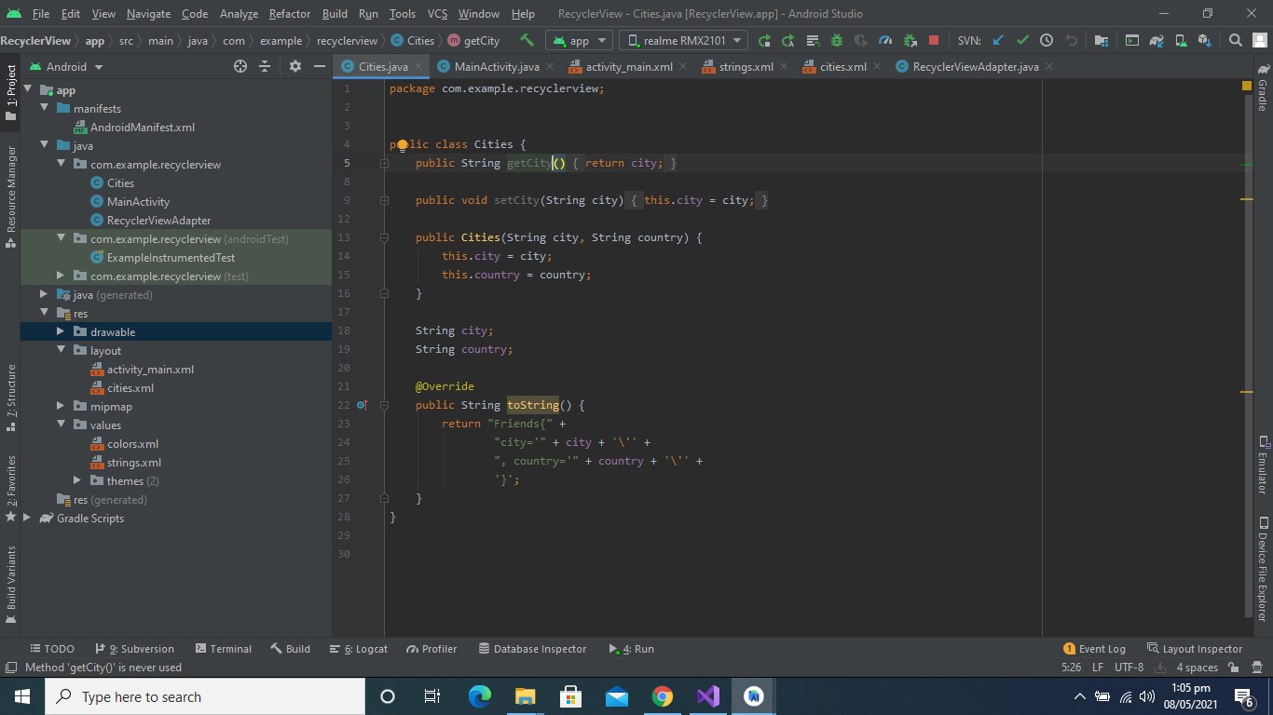

**RecyclerView.java class Code:**

In recyclerView class we make two classes RecyclerViewAdapter and citiesViewHolder.

As you see below

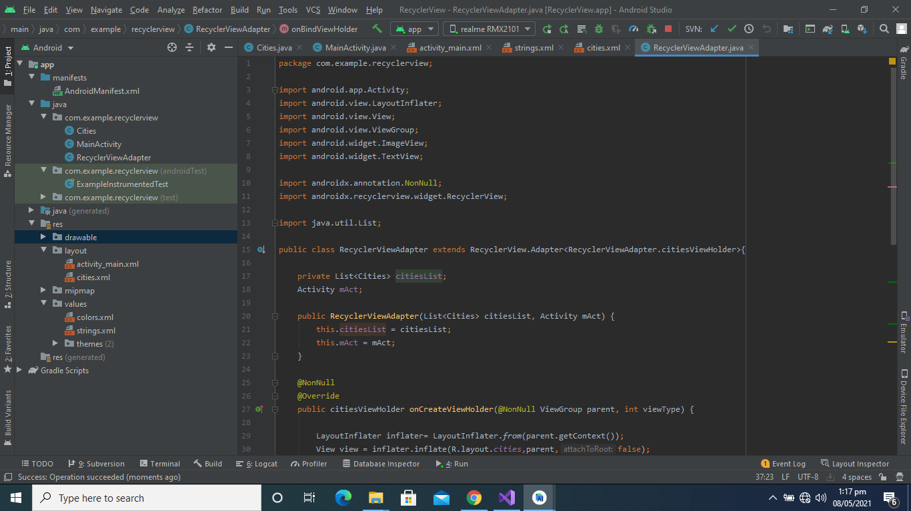

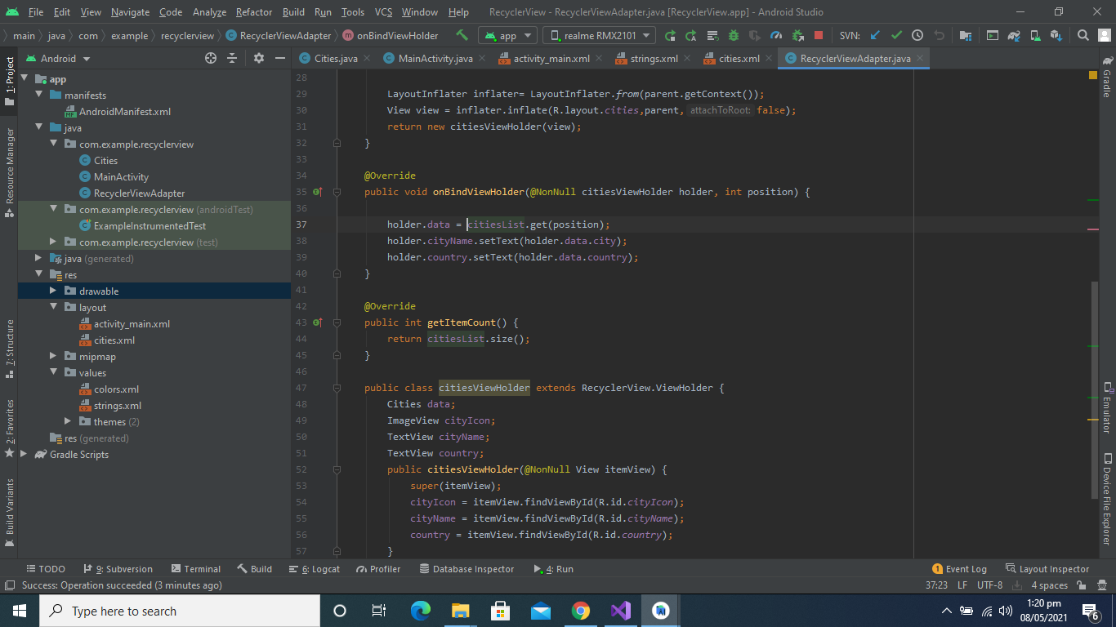

**MainActivity.Java Class:**

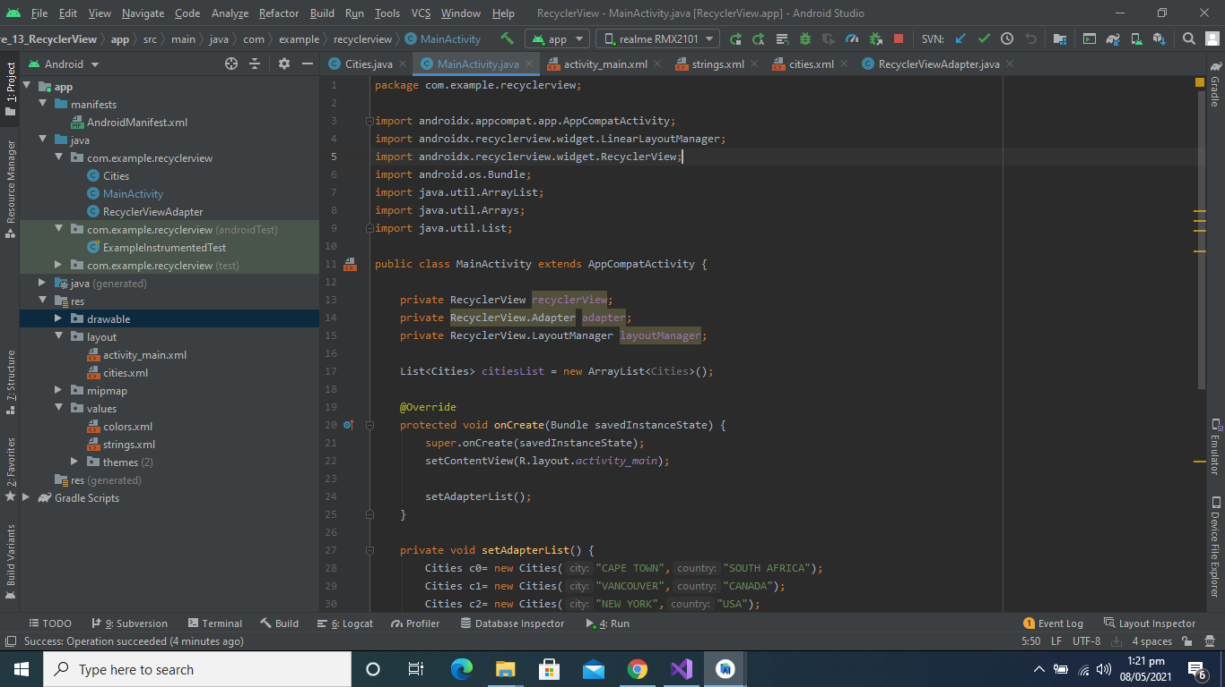

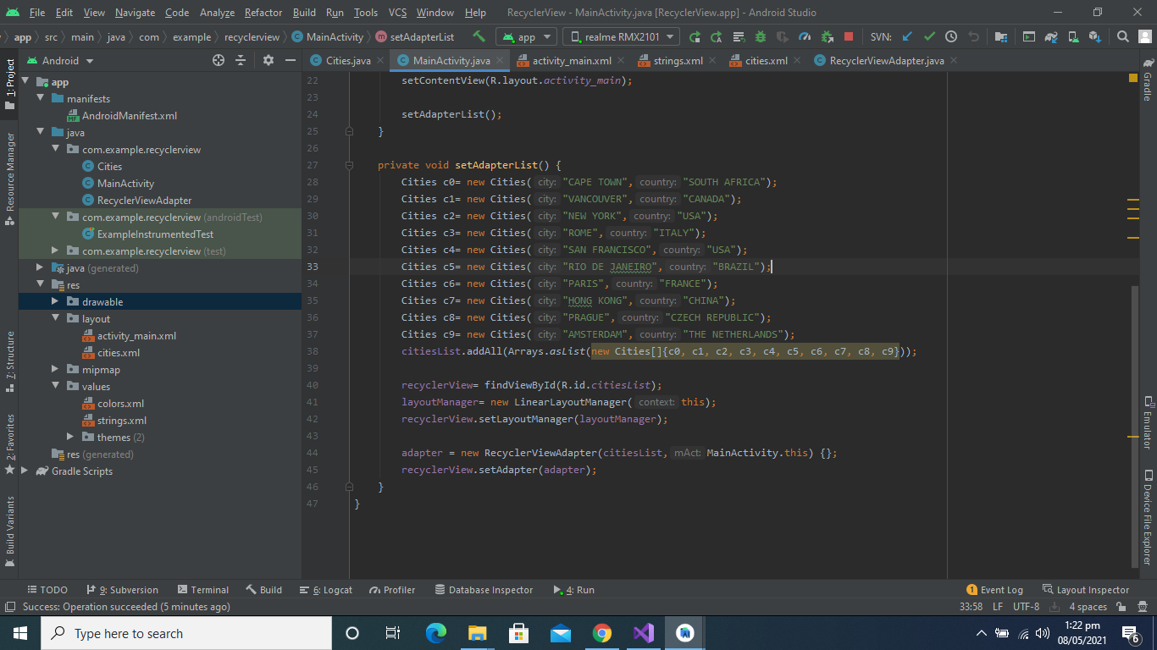

**Activity_main.xml Code:**

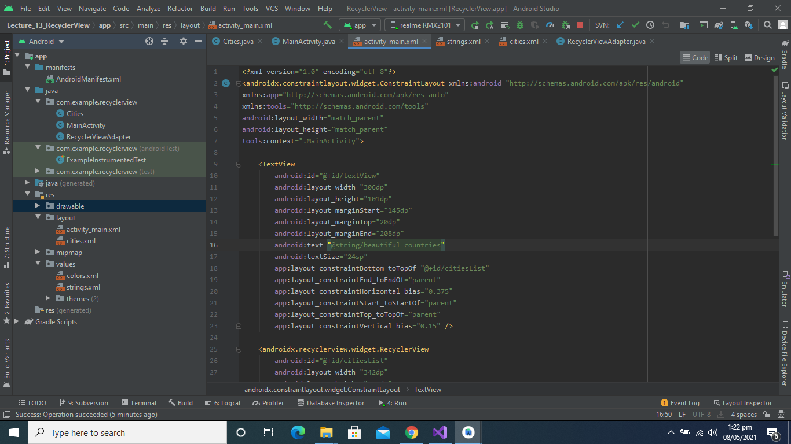

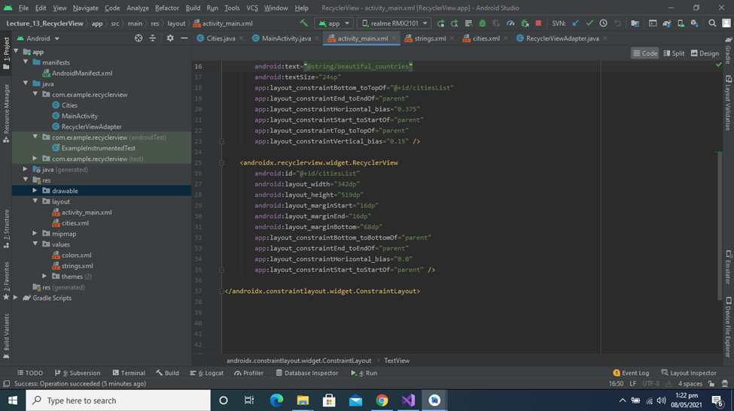

**Activity_main.xml Design:**

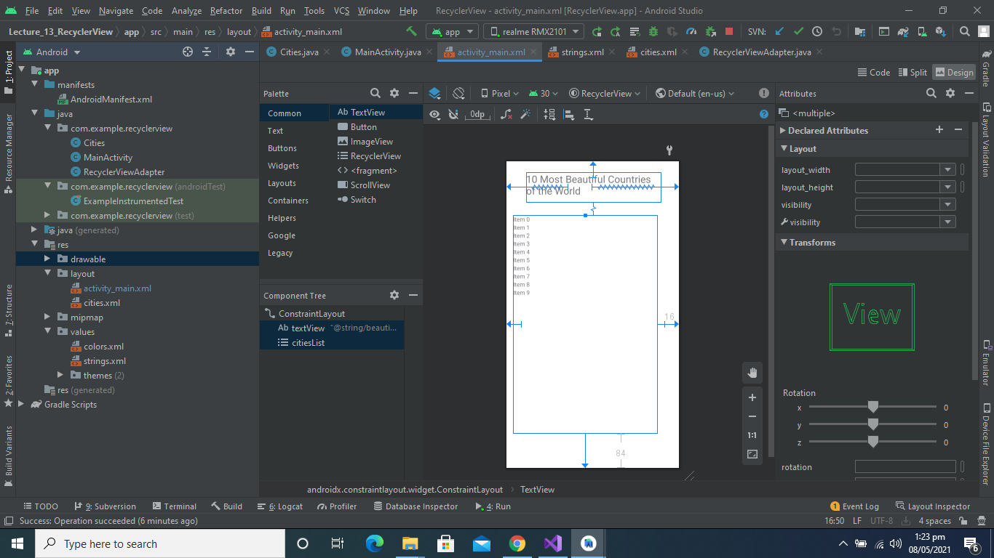

**Dialog:**

**Definition:**

A **Dialog** is small window that prompts the user to a decision or enter additional information.

Some times in your application, if you wanted to ask the user about taking a decision between yes or no in response of any particular action taken by the user, by remaining in the same activity and without changing the screen, you can use Alert Dialog.

In order to make an alert dialog, you need to make an object of AlertDialogBuilder which an inner class of AlertDialog. Its syntax is given below

**AlertDialog.Builder alertDialogBuilder = new AlertDialog.Builder(this);**

Now you have to set the positive (yes) or negative (no) button using the object of the AlertDialogBuilder class. Its syntax is

**alertDialogBuilder.setPositiveButton(CharSequence text, DialogInterface.OnClickListener listener)alertDialogBuilder.setNegativeButton(CharSequence text, DialogInterface.OnClickListener listener)**

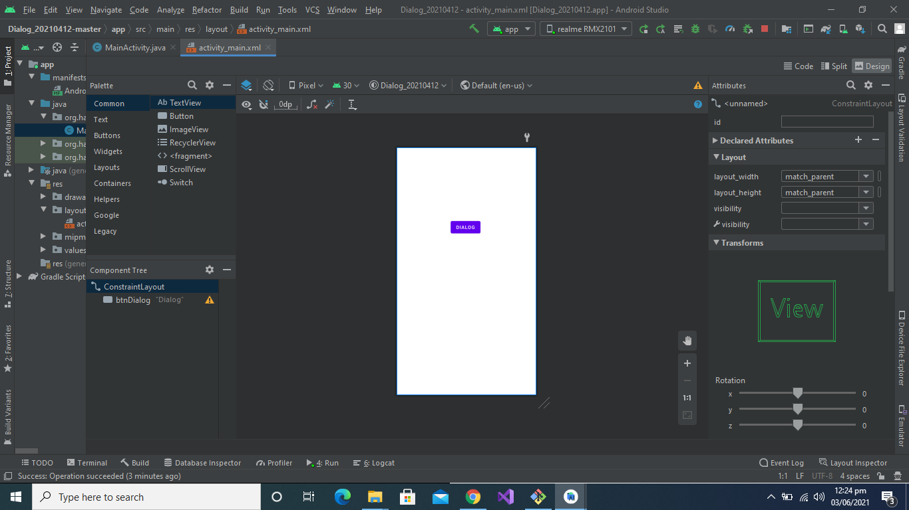

**Main.xml Code Part:**

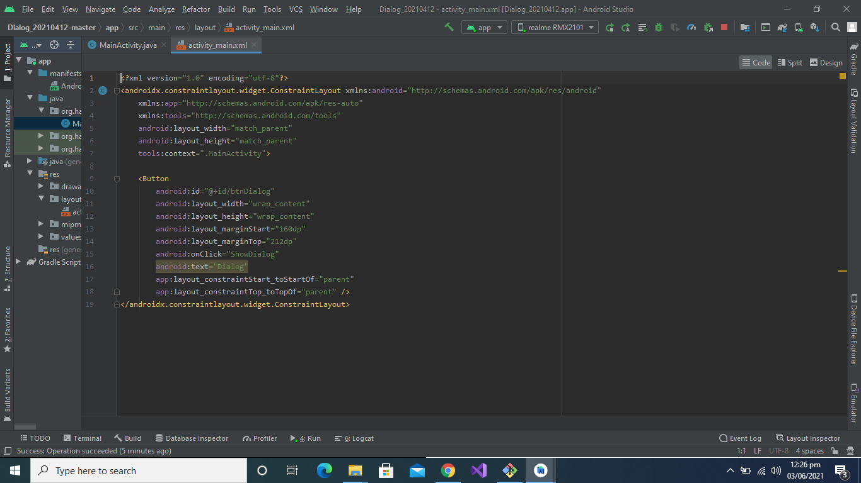

**MainActivity.java**

In MainActivity.java we have a showDialog() function. When user click on the dialog button this function called and dialog box will show to the user in which we have two buttons Named as Positive and Negative and a simple text. 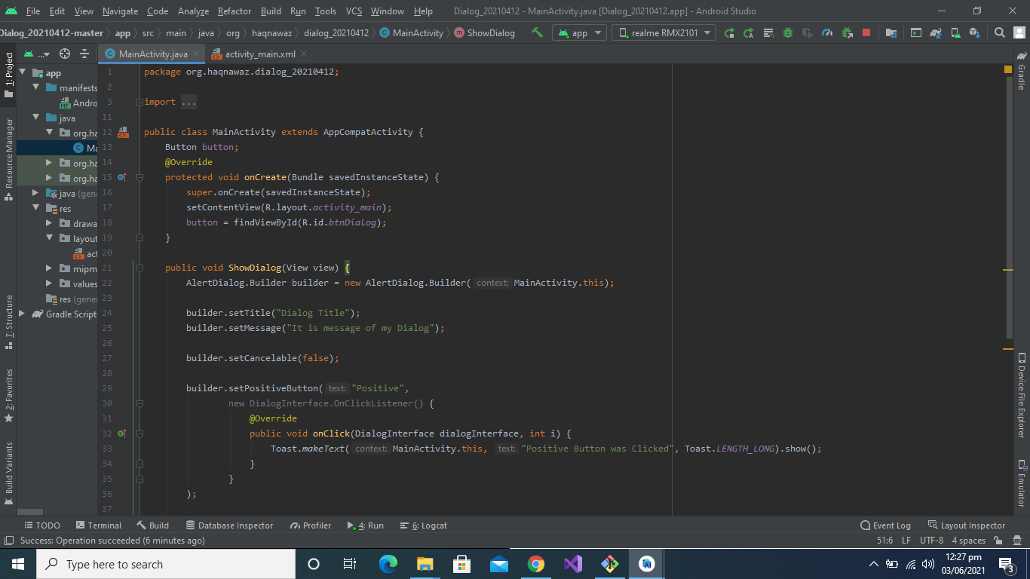**Positive and Negative Button code:**

When user click on the Positive button there will be toast show “**positive button clicked**” and when click Negative button there will be toast show “**Negative button clicked”**

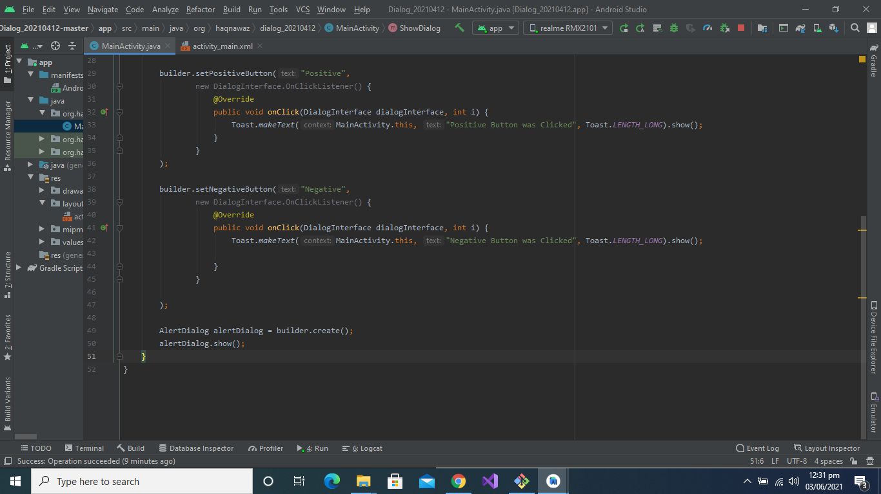

**Output**:

This output will be shown to the user.

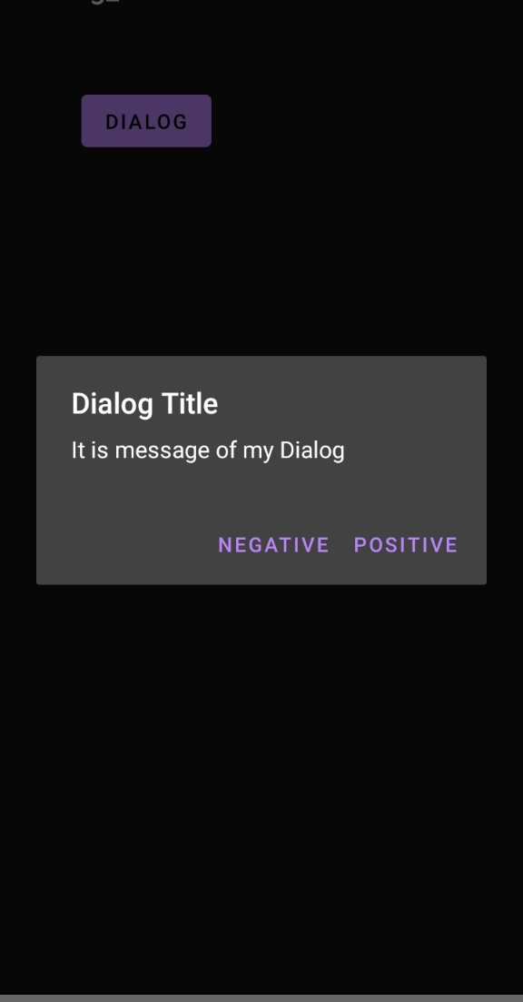

**Example2**:

In this example I have added three buttons with different Functionalities:

**In the Main Layout:**

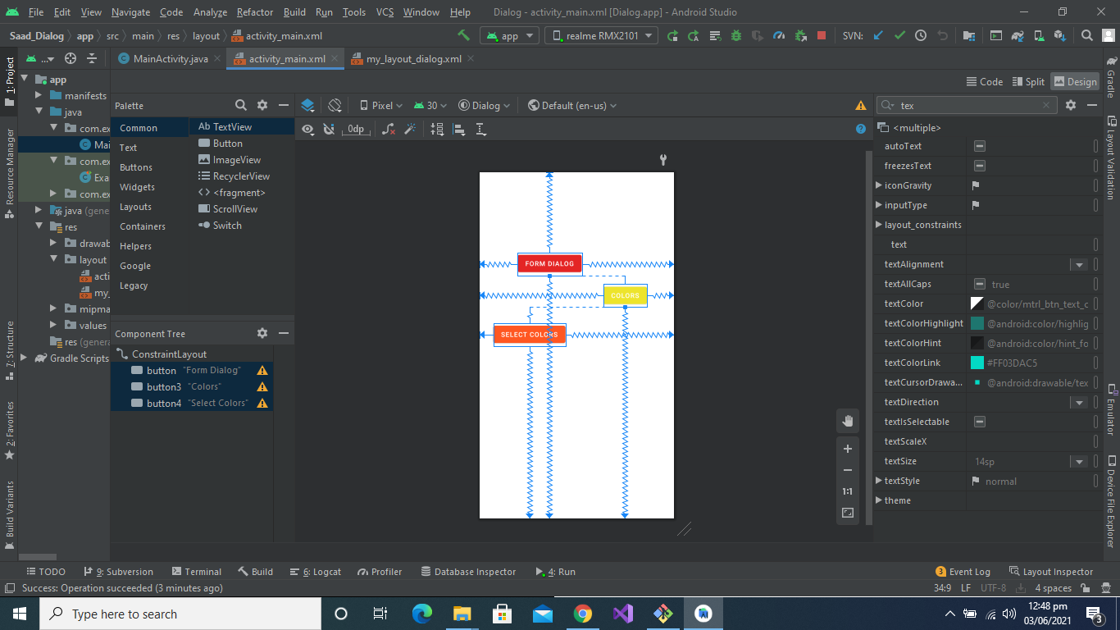

**Main Layout Code Section:**

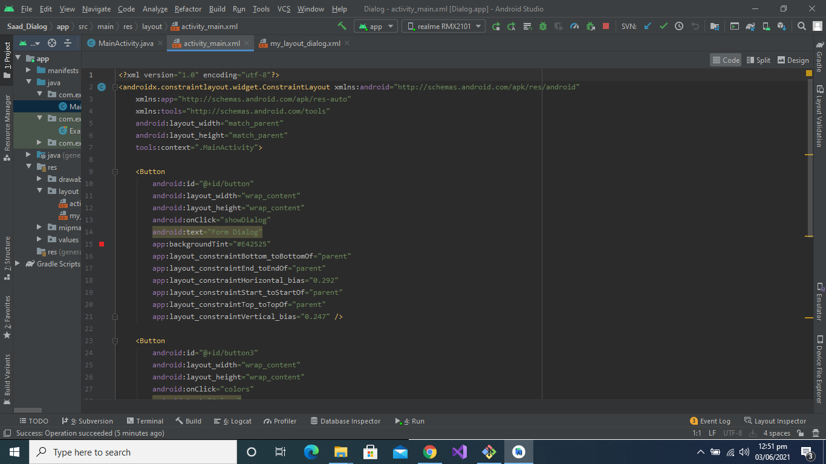

**Functionality of Form Dialog Button:**

When user click on the button there will be a dialog box show in which we show a simple form which we made in the **my_layout_dialog.xml.** Here is the

**Design Part of the my_layout_dialog.xml:**

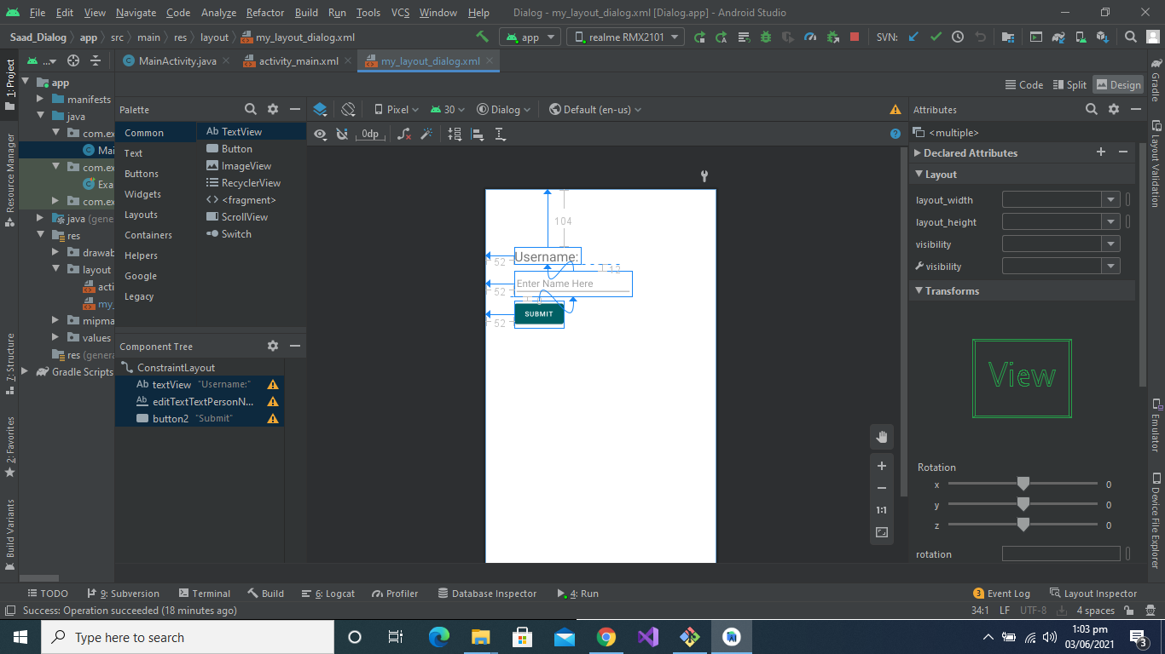

**Code Part of the my_layout_dialog.xml:**

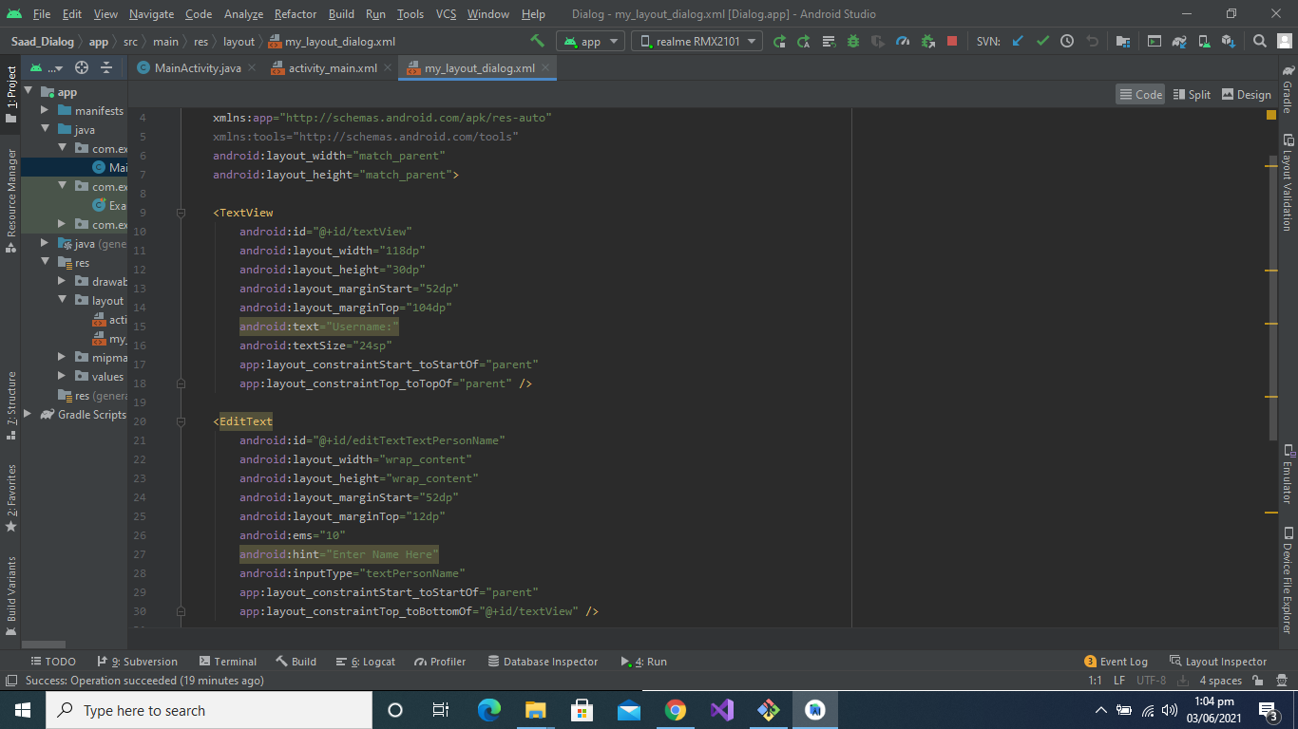

**This function will call when user click on the Form_Dialog button:**

**Also make toast like first example.**

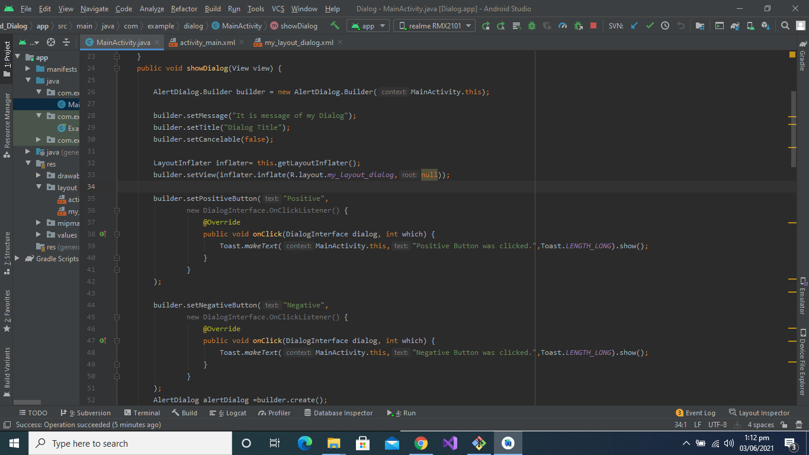

**Output**:

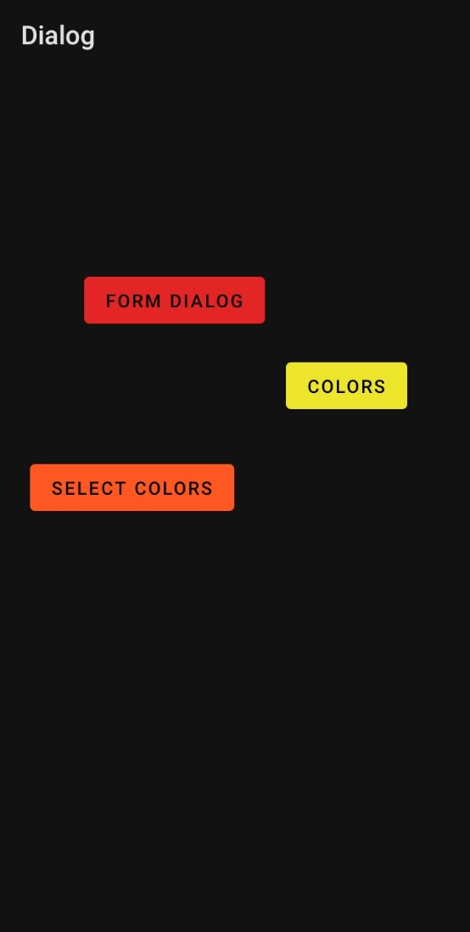

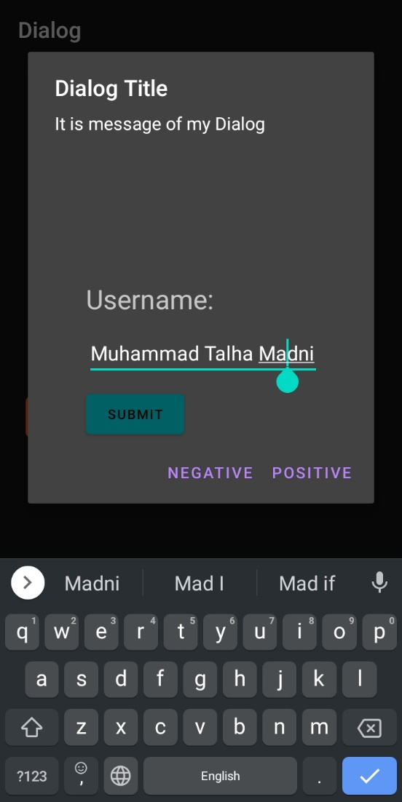

**Functionality of Colors List Button:**

When user click on the **Colors List** button the **colorsList**() function will be called and there will be a dialog box show in which List of Colors will be show to the user

H**ere is the Funtionality code:**

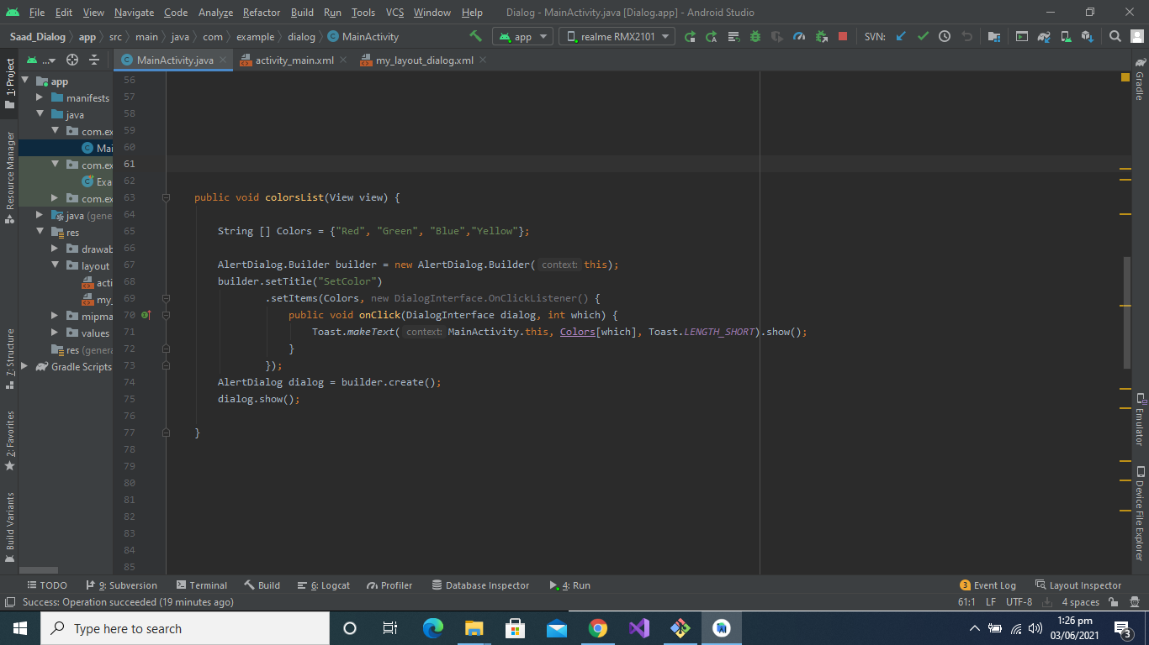

**Design Part of the Colors List button:**

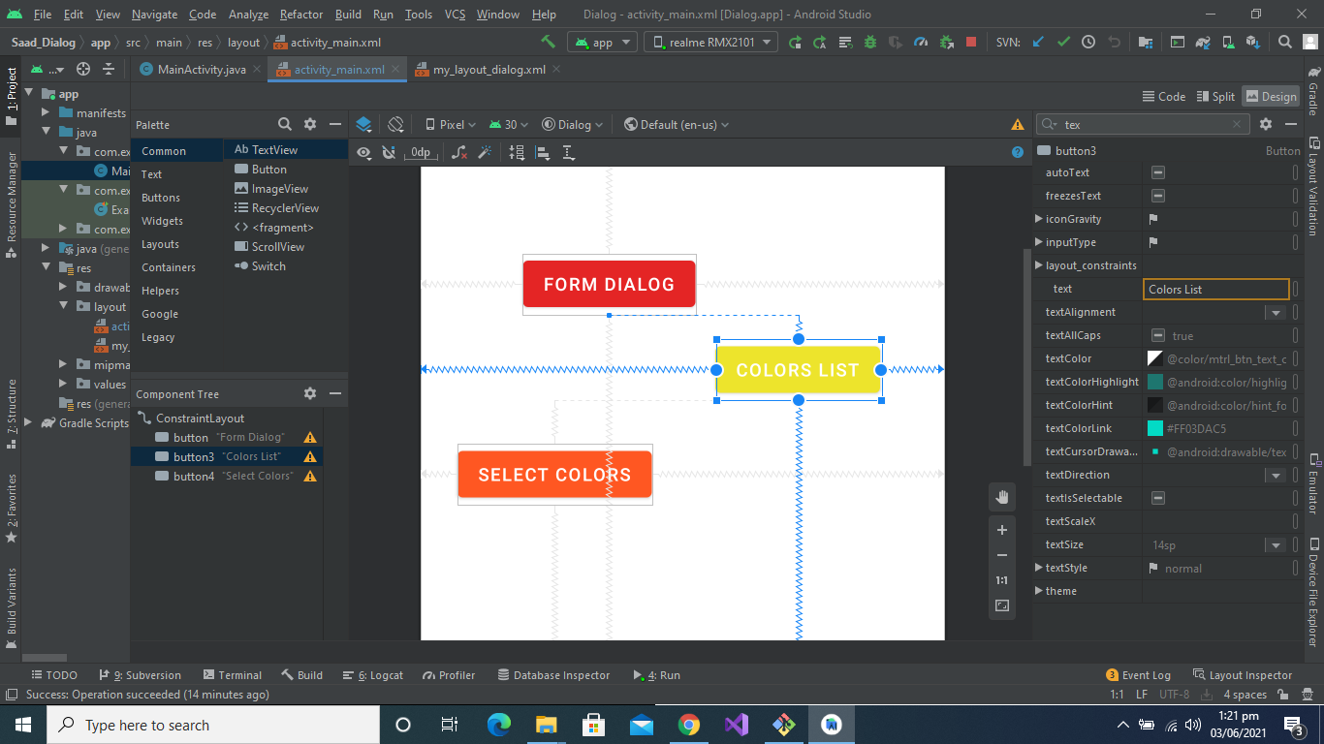

**Code Part of the Colors List button:**

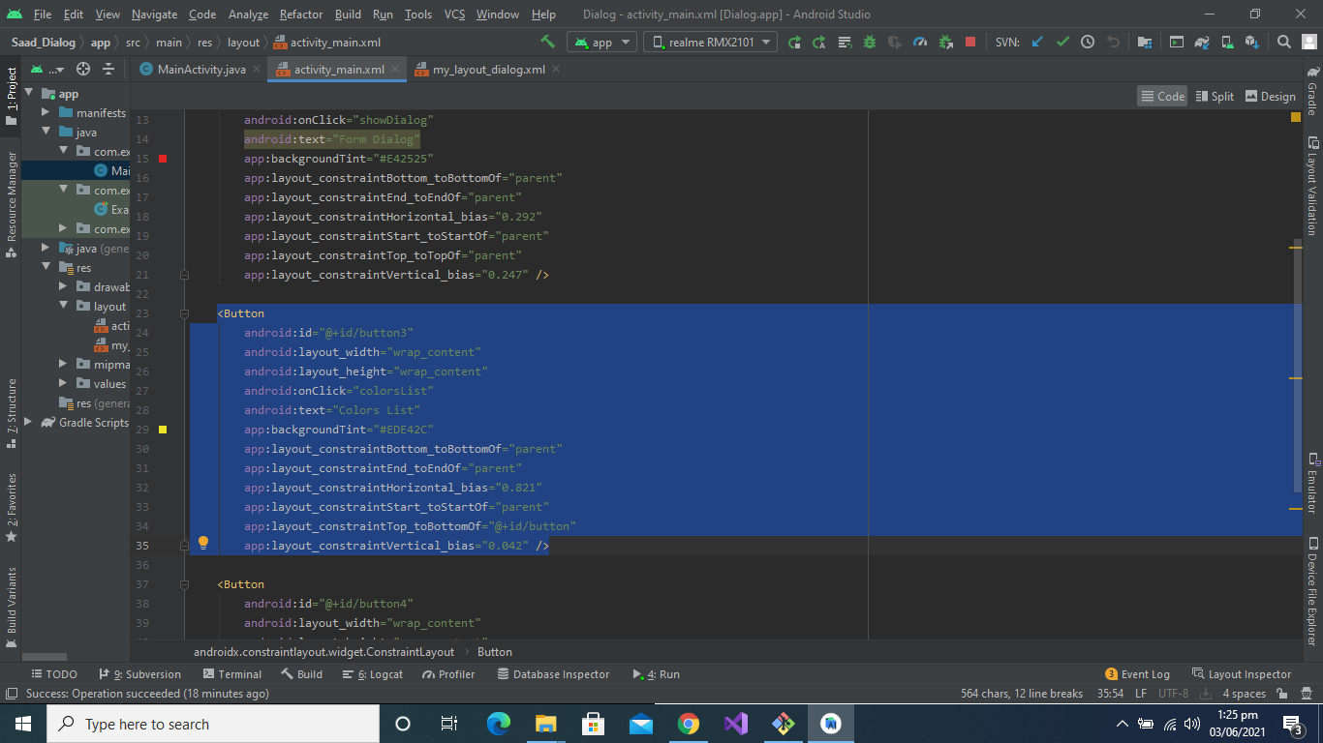

**Output**:

This will be shown to the user:



